


Reporting Other Transactions to FPDS Agency Request Information – v1.0

February 24, 2022
Table of Contents
Section Page
1
Background…………………………………………………………………………………………………………………………….. 3
1.1 Types of Other Transactions Reported within FPDS………………………………………………………. 3
2 Information to be Provided When Requesting to Report Other Transaction Contract Actions within FPDS……………………………………………………………………………………………………………………………….. 3
2.1 Legislative Language Outlining the Agency Other Transaction Authority……………………… 4
2.2 Legislative Language Outlining the Purpose of Reporting Research and Development for Prototype or Production Other Transactions within FPDS……………………………………………………. 4
3 Other Considerations for Reporting Other Transaction Contract Action Reports within FPDS… 4

Background

The purpose of this document is to outline the guidance to Agencies requesting to report FPDS ‘Other Transaction’ Contract Action Reports within FPDS.

Figure 1.1: Other Transaction Contract Action Reporting on FPDS Authenticated Landing Page
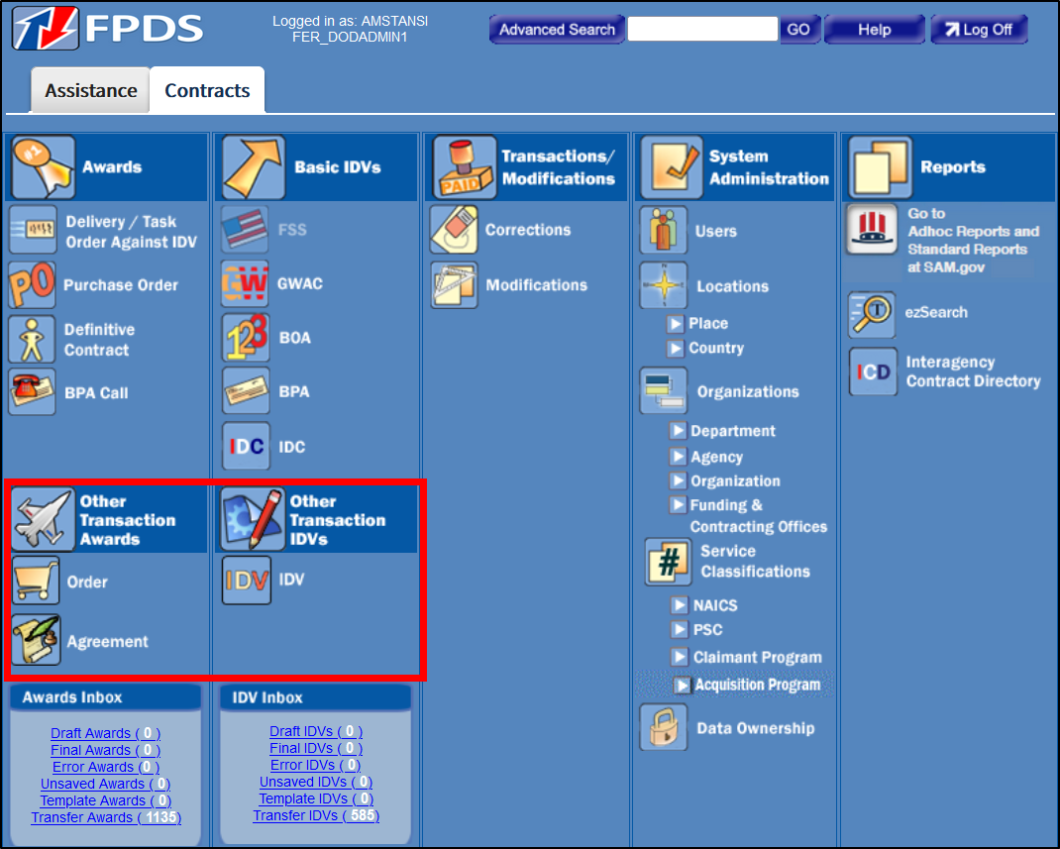

Types of Other Transactions Reported within FPDS

There are numerous Other Transaction (OT) Authorities across the Federal Government. The FPDS OT module was designed in response to the 2008 NDAA Sec. 874 to collect information on a very specific set of OTs awarded for Production or Prototype Research and Development (R&D). Other types of OT awards should not be reported to FPDS because specific prototype and production information is required as a mandatory data element in FPDS.

Information to be Provided When Requesting to Report Other Transaction Contract Actions within FPDS

If an Agency has the specific OT authority for these types of awards and wishes to report them to FPDS, then the following information should be submitted within a new JIRA request to IAE via the Agency CCB representative for review and approval through the CCB charter process.

Legislative Language Outlining the Agency Other Transaction Authority

To report Other Transaction Contract Action Reports within FPDS, the JIRA request must provide the legislative guidance for your Agency that grants OT authority for R&D prototype or production. This legislation will be the overarching guidance that proves that your Agency works with these specific Other Transaction awards.

Legislative Language Outlining the Purpose of Reporting Research and Development for Prototype or Production Other Transactions within FPDS

Within the legislative language that supports the utilization of Other Transaction contracts, please outline the specific legislation, provisions, or guidance that outline your Agencies use of Research and Development for prototype or production Other Transaction awards.

Other Considerations for Reporting Other Transaction Contract Action Reports within FPDS

Please note that when considering reporting these specific types of Other Transactions, Agency CCB representatives should consider discussing the benefits and drawbacks with the Procurement Committee for E-gov co-chairs.

