FPDS-NG

Using FPDS-NG XML Data Archives

Prepared by:



Global Computer Enterprises, Inc.

10780 Parkridge Blvd., Suite 300

Reston, VA 20191

May 9, 2005
Document Release Log

Version | Release Date | Contact | Remarks
1.0 | 4/20/2005 | Pothiraj | Document created.
1.1 | 5/6/2005 | John Dean | Formatting and editing revisions completed.
1.2 | 5/9/2005 | Kristy Woollum | Formatting and editing revisions completed.

Table of Contents
Section Page
1 PREREQUISITE INFORMATION 1
1.1 FPDS-NG Website 1
1.2 Cautions about Using the XML Archives 1
1.3 XML Archive Files 1
2 Using FPDS-NG XML Data Archives 3
2.1 Introduction 3
2.2 Scope of this Document 3
2.3 XML Archive File Hierarchy 4
2.3.1 Fiscal Year 04 – Specification 4
2.3.2 Fiscal Year 05 - Specification 4
2.3.3 Changes to FY04 – Specification 4
2.4 Tree Structure 5
2.5 Screen Layout 6
2.6 Extraction Process 9
2.7 Scenario 1 - Importing XML data into a database 12
2.8 MapForce Software 14
2.9 Case study: Importing ReverseBatch XML Dump into MS Access 14
2.10 Scenario 2 - Converting XML to any file format (Text, HTML, CSV) 16
2.10.1 XSL - Extensible StyleSheet Language 16
2.10.2 XSLT 16
2.10.2.1 Client-side Transformation 16
2.10.2.1.1 Transforming an XML file into a Comma Separated Variables (CSV) file 17
2.10.2.2 Server-side Transformation 18
3 REFERENCES 20

List of Figures

Figure Page
Figure 1. Tree Structure 5
Figure 2. First Level 6
Figure 3. Second Level (Clicking on FY04) 6
Figure 4. Third Level (Clicking on FY04) 7
Figure 5. Second Level (Clicking on FY05) 7
Figure 6. Third Level (Clicking on FY05) 8
Figure 7. Second Level (Clicking on Changes to FY04) 8
Figure 8. Third Level (Clicking on Changes to FY04) 9
Figure 9. Extracting Archive File 9
Figure 10. Extracting Archive File - WinZip 10
Figure 11. Extracting Archive File – Department/ Quarter 10
Figure 12. Extracting Archive File – Department/Quarter 11
Figure 13. Extracting Archive File – Agency/ Quarter 11
Figure 14. Extracting Archive File – Award/IDV data for a quarter 12
Figure 15. Importing XML data in MS Access 13
Figure 16. MapForce Design Model showing a XML document mapped to a database 14
Figure 17. Mapping XML elements to Access table columns 15
Figure 18. Text Import/Export Tool of Mapforce 18

PREREQUISITE INFORMATION
  - FPDS-NG Website
FPDS-NG website tools are used for accessing FPDS-NG data. The advanced search facility available on the web portal enables searching for a particular PIID or a PIID starting with a string of characters. It also enables searching by vendor name or document status.
The reporting facility available on the portal displays value-added data based on the type of the report. For example, the “Socio Economic Accomplishment report” categories the contracts created by a particular agency based on the socioeconomic indicator for the vendor.
Use the FPDS-NG online system Advanced Search if you want to find individual transactions and:
- Are looking for specific transactions by a specific agency or for a specific contractor.
- Are searching for specific socioeconomic indicators.
- Are searching for large contracts.
- Are searching for recently awarded contracts.
- Are searching for a specific contract number or award number.

Use the FPDS-NG Standard and Ad hoc Reports if you want:

- Socioeconomic contracting trends.
- Specific contracts by certain agency or for a certain contractor.
- Functional (NAICS, PSC); Geographical (Place of performance, State etc) distribution of government contracts.

For people with specialized knowledge and needs, the FPDS-NG system makes the XML Archives available.
  - Cautions about Using the XML Archives
The XML Archives contain raw data. That means it is intended for use by people who have a great deal of experience with procurement data (arcane), XML technology (relatively new), and large volumes of data. The XML archives are generally unusable by others.

FPDS-NG collects information about millions of individual transactions each year. It collects this information for the primary purpose of providing management information, and the data is full of procurement minutiae, jargon, arcane “hair splitting,” and seemingly unexplainable anomalies.

The user is cautioned that the size of FPDS-NG data exceeds the capability for many common office productivity software packages. Most spreadsheet programs, for example, have a limit of about 65,000 rows (but FPDS-NG contains millions each year).

The use of XML data typically requires a high level of user sophistication (equivalent to a computer science degree) and special, sometimes costly software.

The FPDS-NG help desk will provide technical support in using the XML Archives, but it is not permitted to provide training about XML for non-technical users.
  - XML Archive Files
The XML Archive file is used by the public, government agencies, and VARs (Value Added Resellers) for various analyses and comparison of data. The XML Archive file contains all the records created by an agency for a particular quarter. The file contains records that are in final status only (it excludes “work in progress”).

Use these XML data archives if:

- You have a long term need for any of the following:
  - An enterprise-level Business Intelligence system needs to merge FPDS-NG data with other data.
  - Value-added information on top of FPDS-NG data needs to be packaged as a sellable package or service
  - The Advanced Search, Canned Reports and Ad Hoc Reports features do not provide sufficient capabilities, and it is necessary to perform custom analysis or research on the data.

Using FPDS-NG XML Data Archives
  - Introduction
Extensible Markup Language (XML) is a text-based language for creating different markup languages, and for describing different kinds of data. XML is an official W3C recommendation, and its primary purposes are to describe structured data and to facilitate its sharing across the Internet.

XML provides a convenient and appropriate way to represent data in a simple, easy-to-understand, human and machine-readable format. It has a number of advantages that make it very suitable for data representation, storage, and processing.

Some of the features that make XML an attractive option for data transfer and storage are:
- Hierarchical structure suitable for most type of documents.
- Support for Unicode to represent all types of characters.
- Self-describing format that documents the type of data being represented.
- Platform independent, since it is just plain text.
- Ability to represent different types of data structures such as trees, lists, etc.
- Strict syntax can be enforced in conjunction with Schemas or Document Type Definitions (DTDs), that make parsing easy and efficient.

However, XML has some disadvantages that make it inappropriate for certain situations including:
- It is very verbose and often the XML tags that describe the data and its structure are larger than the data itself.
- Requires a parsing program or tool that can read the XML document and convert it into a format that can be used by computer tools that do not accept XML.
- Not suitable in situations where network bandwidth or storage is at a premium.
- Mapping XML data to databases is not trivial.

In FPDS-NG, XML is the preferred data-interchange format and is used extensively as part of the different Web Services technologies and also to represent the FPDS-NG data that is used.
  - Scope of this Document
This document describes how the FPDS-NG data is provided in the form of XML archives and how to use them.
Three key problems/requirements are addressed in this document with sample case studies:
- Importing XML data into a database
- Converting XML to any file format (Text, HTML, CSV)
- Producing PDF reports from XML data

This document also describes how:
- The requirements above can be accomplished with other XML-compliant technologies such as:
- Extensible StyleSheet Language (XSL)
- XALAN
- XSL-FO
- Apache FOP
- The task of mapping XML data to different formats and producing reports from XML documents can be alleviated using third-party software programs such as:
- Altova MapForce
- Altova StyleVision
  - XML Archive File Hierarchy

Fiscal Year 04 – Specification
Prior to FY05, archiving was completed every quarter and there was one file available for each quarter for Awards and IDVs. Starting FY05, we would have one file for each month in FY05 (October 1st 2004 – September 30th 2005) for Awards and IDVs.
All files for a particular Fiscal year are available under the folder FY##. Under this folder, we have folders for each department in FPDS-NG. Each of these folders contains four zip files which pertain to each of the four quarters. The zip files in turn contain zip files for each of the agencies under that department. The Agency zip file contains two files, one for IDV and one for Award.
The hierarchy is depicted as follows:

Screen I: FY## Folder (Fig. 3.1)
Screen II: -> Department Folder (Fig. 3.2)
Screen III: -> Each Quarter Zip Files (Fig 3.3)
-> Agency Zip Files (On extracting one of the above Zip file)
-> Award File/ IDV File. (On extracting one of the Agency Zip file)

Fiscal Year 05 - Specification
Starting FY 05, the XML Archive file will be generated for every month and will be uploaded to the Archives location the first Sunday of the following month. However, the initial file will be generated for the first four months (October 1, 2004 to February 28, 2005); hence forth the archive file will be generated every month as mentioned above.
The archive file will contain the contracts created for that month (PREPARED DATE) or modified in that month (LAST MODIFIED DATE) for Fiscal Year (DATE SIGNED between October 1, 2004 and September 30, 2005).

Changes to FY04 – Specification
Starting FY 05, the XML Archive file for “Changes to FY04” will contain contracts that have been modified in FY05 and will be generated for every month and will be uploaded to the Archives location first Sunday of the following month. However, the initial file will be generated for the first four months (October 1, 2004 to February 28, 2005); hence forth the archive file will be generated every month as mentioned above.
The archive file will contain the contracts created for that month (PREPARED DATE) or modified in that month (LAST MODIFIED DATE) for Fiscal Year 04 (DATE SIGNED between October 1, 2003 and September 30, 2004).

  - Tree Structure
The tree structure of the screen layout is as follows:
Figure 1. Tree Structure
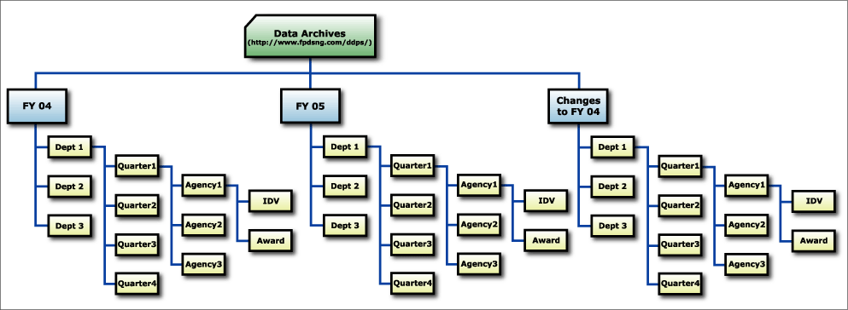
  - Screen Layout
The file hierarchy structure has been depicted as screen layouts in this section. The URL http://www.fpdsng.com/ddps displays the first level screen as shown in Figure 2.

Figure 2. First Level
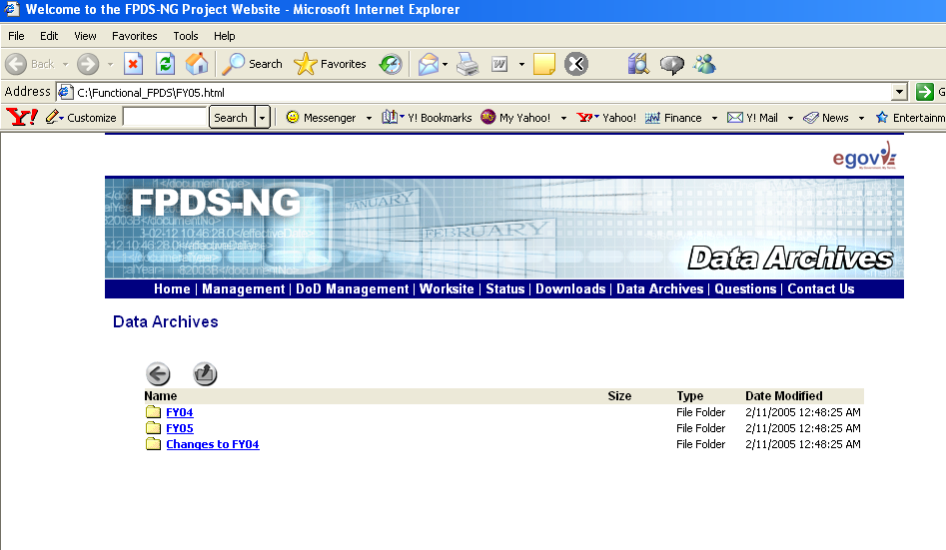

Figure 3. Second Level (Clicking on FY04)
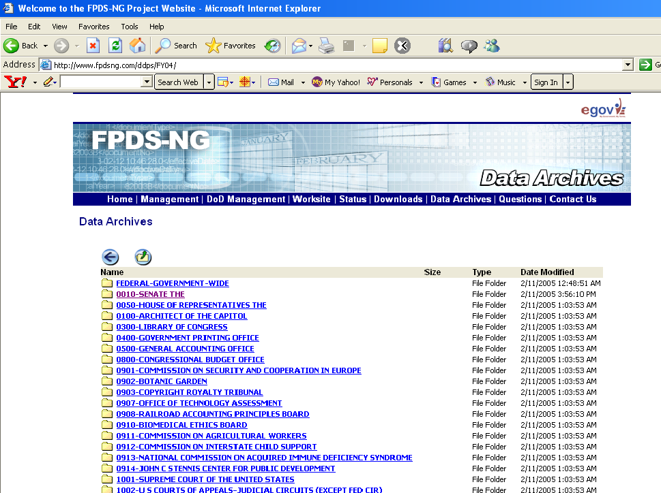

Figure 4. Third Level (Clicking on FY04)
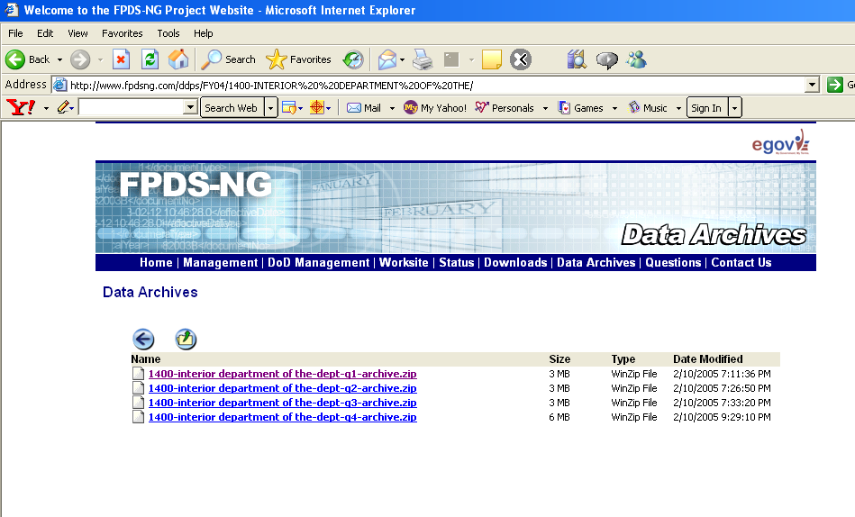

Figure 5. Second Level (Clicking on FY05)
Figure 6. Third Level (Clicking on FY05)
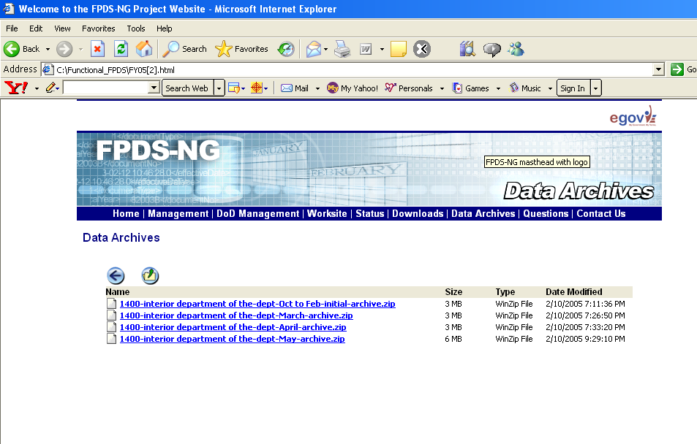

Figure 7. Second Level (Clicking on Changes to FY04)

Figure 8. Third Level (Clicking on Changes to FY04)

  - Extraction Process
This section explains the process of extracting the compressed zip files. At the third level of the screen layouts shown, clicking on one of the links opens up a screen displayed in Figure 9.
Figure 9. Extracting Archive File
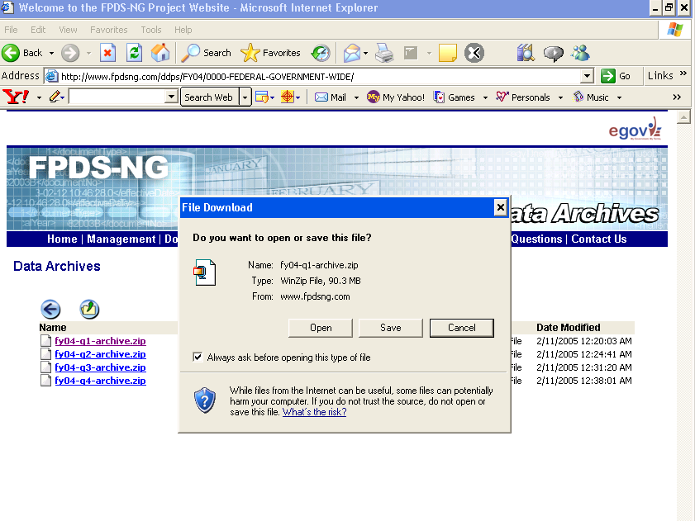
Click on Open to open one of the zip files. To open a zip file, we require an extracting tool (WinZip). The zip file opens in WinZip application as shown in Figure 10. Each file in this level contains data for a department and a quarter.
Figure 10. Extracting Archive File - WinZip
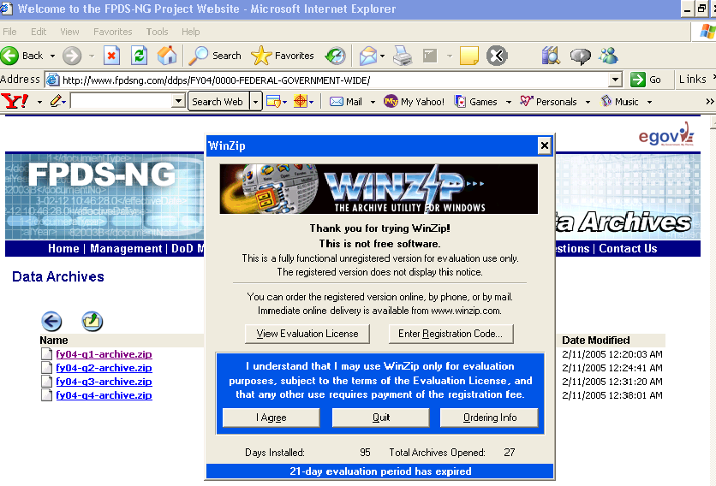
Figure 11. Extracting Archive File – Department/ Quarter
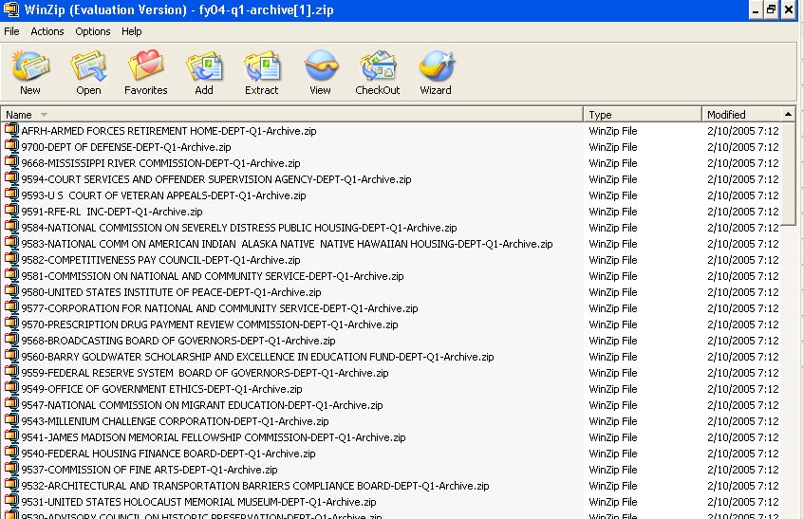
Clicking on a zip file at this level extracts files pertaining to a department and a quarter.
Figure 12. Extracting Archive File – Department/Quarter
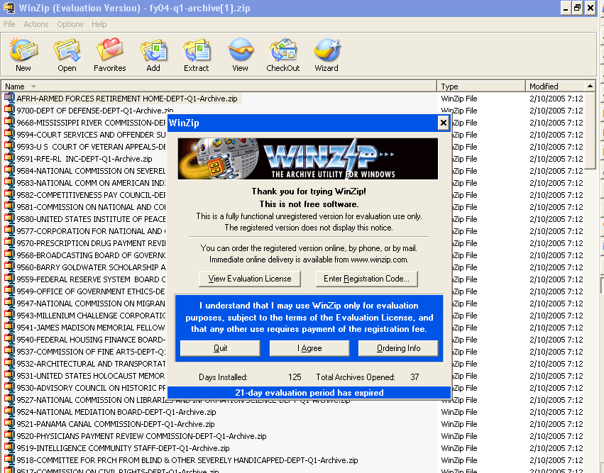

Each of the files in Figure 12 is a zip file in itself, clicking on one of the files opens the agencies for the department as shown in Figure 13.
Figure 13. Extracting Archive File – Agency/ Quarter
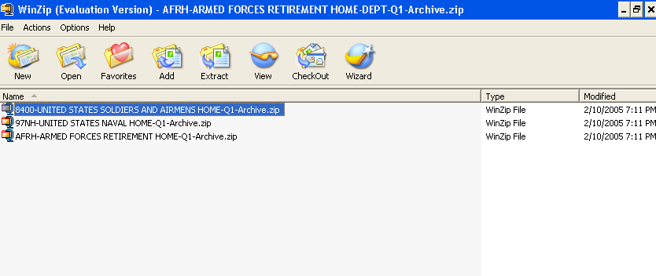
Clicking on each agency zip file in turn opens up the Award and IDV XML file as shown in Figure 14. The XML file can be viewed in an editor tool or using an XML Viewing or Editing software (e.g. XMLSpy).
Figure 14. Extracting Archive File – Award/IDV data for a quarter
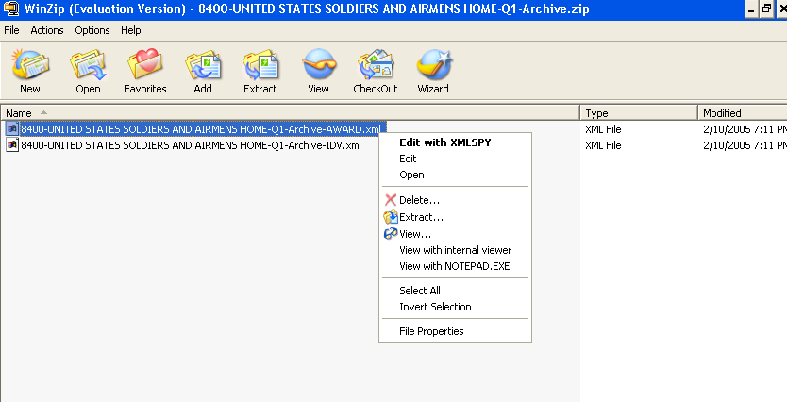
  - Scenario 1 - Importing XML data into a database
XML data can be imported into both relational and object-oriented databases supplied by different vendors. One way to accomplish this is in a programmatic manner, and this approach usually involves the following steps:

- Create a program that can:
  - Parse the input XML file.
  - Create a Document Object Model (DOM) representation of the XML data.
  - Step through the DOM object and create a mapping between the XML data element and its corresponding column in the database table.
  - Insert the XML data into the database.
  - Commit the change.
If multiple XML files are involved, Step 1 is performed iteratively over the list of input XML files. This approach has the following key disadvantages:
- Not easy for users without prior XML programming experience.
- Not feasible when the input XML is very large (DOM is a in-memory representation of the input XML data and creation of the DOM object is limited by the amount of machine RAM available).
- Can be error-prone if the mapping between the XML elements and database columns are done incorrectly.
Microsoft Access provides the user with an option to directly import a XML file into the database. Figure 15 shows a screenshot of importing XML data into Access.
Figure 15. Importing XML data in MS Access
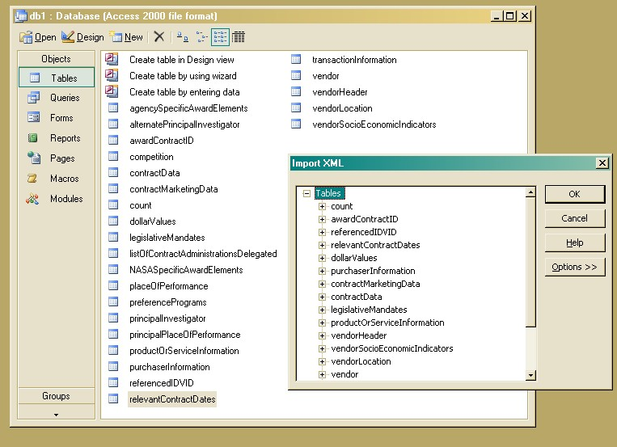

MS Access has the following limitations:
- Cannot import multiple XML files simultaneously.
- Access creates separate tables for each parent element in the XML file. For e.g., if the XML file had the following structure:
<Element1>
<Element2>Sample Text1</Element2>
</Element1>
<Element3>
<Element4>Sample Text2</Element4>
</Element3>
Access will import the data in the above XML, but create two tables Element1 and Element3.
- Database size limit of 2GB.
Another approach to import XML data into different databases is by using a third-party software program such as Altova MapForce.
  - MapForce Software
MapForce is a visual data mapping tool that has the following main features:
- Schema-to-Schema mapping
- Database-to-Schema/XML mapping
- XML-Schema-to-Database mapping
- Database-to-Database mapping
- CSV-to-XML mapping
- Flat file mapping: CSV and Text files as source and target
- On-the-fly transformation and preview of database data, without code generation, or compilation
It has the capability to generate the mapping code in XSLT 1.0 and 2.0, XQuery, Java, C#, and C++. Figure 16 shows a screenshot of an XML document mapped to a database in MapForce.
Figure 16. MapForce Design Model showing a XML document mapped to a database
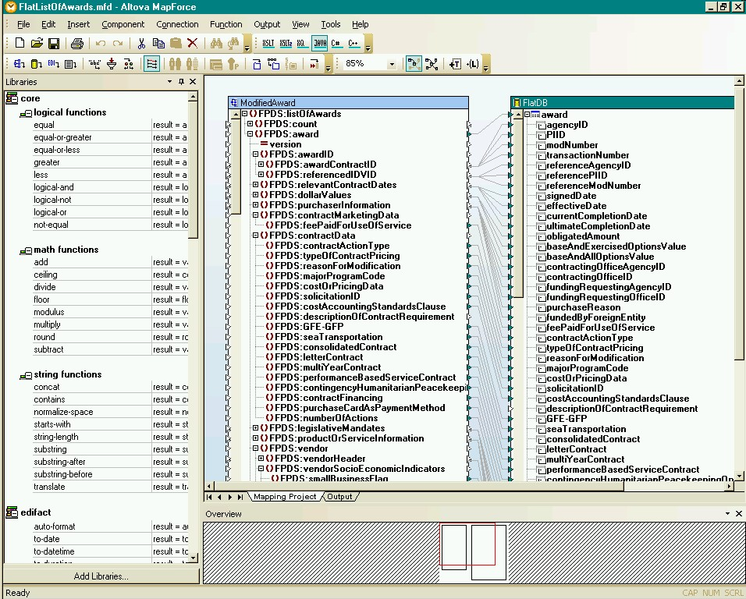
  - Case study: Importing ReverseBatch XML Dump into MS Access
The ReverseBatch XML dump is a set of XML files that contain the FPDS-NG contract data in the form of XML records. Each XML file contains one or more Awards in XML format. The count of the total number of Awards in each file is specified in the top of each file as follows:
<ns1:count>
<ns1:total>2</ns1:total>
<ns1:fetched>2</ns1:fetched>
</ns1:count>

Each of the Award records present in the XML file can be imported into a database such as MS Access using MapForce. The process consists of the following steps:
- Create a database in MS Access. This can be done in two ways:
  - By creating a blank database containing a table called Award and adding the required columns.
  - Importing a XML file with one root element called Award (Access will create a table called Award) and multiple child elements. Each child element will represent the Award contract information and will be created as a column in the Award table. If there is more than one root element, Access will create individual tables for each element.
- Create a MapForce design model by:
  - Inserting a XML component and assigning a XML file containing the actual information to it.
  - Inserting a database component and assigning the Access database created in step 1 to it.
- Create a mapping between the XML element and column in the database to which the data should be mapped. Figure 17 shows a simple mapping done between Award elements in the XML file and the corresponding columns in the Award table in Access.
Figure 17. Mapping XML elements to Access table columns
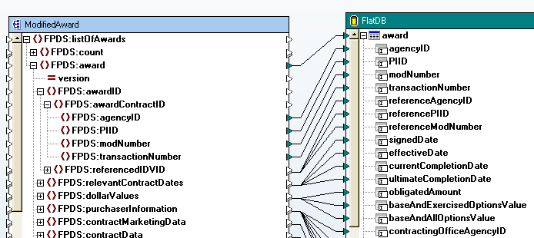

- Once this mapping has been setup, MapForce will create SQL insert statements when the output tab is clicked. (If the destination mapping component is an XML file instead of a database, the mapping statements can be generated in XSLT).
- The generated SQL inserts can be run by clicking on the “Run SQL Script” option under the Output menu.
- The data present in the XML file will be inserted into the appropriate columns in the table in Access.
The same process can be performed for different sets of XML files by changing the XML file associated with the source XML component in the MapForce model. An alternative to changing this manually is to generate Java/C++/C# code from MapForce and customizing the generated code to process multiple XML files.

MapForce supports ADO and ODBC databases from different vendors such as Microsoft (Access, SQL Server), Oracle, MySQL, IBM (DB2), and Sybase.
  - Scenario 2 - Converting XML to any file format (Text, HTML, CSV)
One of the main advantages of having data represented using XML is the multitude of output formats to which it can be transformed.
Converting XML data to a different output format such as HTML usually involves creating a transformation file based on the Extensible StyleSheet Language (XSL).

XSL - Extensible StyleSheet Language
XSL is not a single language, but a family of languages that describes how documents encoded using the XML standard can be transformed and formatted into different output formats.
XSL consists of three parts:
- XSLT: a XML-based language for transforming XML documents
- XPath: a non-XML language for defining parts of an XML document that is used by XSLT
- XSL-FO: a XML-language for visual-formatting of XML documents

XSLT
XSLT stands for Extensible Style Sheet Language Transformation. It is an XML language used to transform XML data to another format such as HTML, XHTML, Text, or CSV that can be understood by a browser.
XSLT can also add new elements, remove, rearrange, or sort existing elements to create the output result file
XSLT uses XPath to identify the sections of the XML document using pattern-matching, on which the transformations need to be performed.
Currently, there are many implementations of XSLT and many browsers such as Internet Explorer (IE), Mozilla, Firefox, and Netscape (Opera currently does not provide support for XSL Formatting Objects and XSLT transformations) provide built-in support for XSL transformation. There are two-types of XSL transformations possible:
- Client-side transformation
- Server-side transformation

Client-side Transformation
In client-side transformation, the client browser is responsible for transforming an XML document into the correct HTML format based on the instructions in the XSL file. If the XML file is associated with an XSL file, the browser will open (or download) the XSL from the specified location and make use of its embedded XSL processor to perform this transformation.
The advantage of using this approach is that it is possible to use client-side scripting languages such as JavaScript or VBScript to instruct the browser to use different XSL files based on certain conditions such as the type of browser etc. The disadvantage is that not all browser-transformations appear the same across all browsers. This disparity is usually evident when a XSL file written for IE is used to open a XML document in a different browser such as Firefox. (IE, until version 6 used to use a non-standard XSL namespace (http://www.w3.org/TR/WD-xsl) and XSLs with this incorrect namespace do not work in other browsers.
The correct XSL namespace is http://www.w3.org/1999/XSL/Transform.

Transforming an XML file into a Comma Separated Variables (CSV) file
Consider the following sample XML file (mail.xml) that lists two <address> elements enclosed within the parent <mail> element.

Listing of mail.xml:

<?xml version="1.0" encoding="UTF-8" ?>
<?xml-stylesheet href="mail.xsl" type="text/xsl" ?>
<mail>
<address>
<street>10780 Parkridge Blvd. #300</street>
<city>Reston</city>
<zip>20191</zip>
<state>VA</state>
<country>USA</country>
</address>
<address>
<street>19201 PLUMMER DRIVE</street>
<city>GERMANTOWN</city>
<zip>20876-1714</zip>
<state>MD</state>
<country>USA</country>
</address>
</mail>

The objective is to transform the XML contents into CSV format that appears as follows:
10780 Parkridge Blvd. #300, Reston, 20191, VA, USA
PLUMMER DRIVE, GERMANTOWN, 20876-1714, MD, USA
This can be achieved using the following XSLT:

Listing of mail.xsl:

<?xml version="1.0" encoding="UTF-16"?>
<xsl:stylesheet version="1.0" xmlns:xsl="http://www.w3.org/1999/XSL/Transform">
<xsl:output method="text" />
<xsl:template match="mail/address">
<xsl:value-of select="normalize-space(street)" />,<xsl:value-of select="normalize-space(city)" />,<xsl:value-of select="normalize-space(zip)" />,<xsl:value-of select="normalize-space(state)" />,<xsl:value-of select="normalize-space(country)" />
<xsl:text disable-output-escaping="yes">
</xsl:text>
</xsl:template>
</xsl:stylesheet>

The method attribute of <xsl:output> indicates that we want the output in Text (XML is the default value). The normalize-space function operates on a string parameter and strips the leading and trailing whitespace characters and replaces them with a single whitespace character. This makes sure that even XML elements appearing as follows will get processed correctly:

<street>
10780 Parkridge Blvd. #300
</street>
The above XSLT file outputs the value of each XML element followed by “,” to create the CSV file. The last <xsl:text> element with the disable-output-escaping attribute makes sure that the carriage return (\n) is processed as such and each XML record (i.e. address element) appears on a new line.
Tools such as MapForce abstract the use of XSLT and provide a more user-friendly interface to perform such transformations. MapForce has a text import/export tool that can be used to create a CSV file from a XML file and vice versa. This can in turn be used to map the generated CSV file into a database.
Figure 18 shows the text import/export tool of Mapforce:
Figure 18. Text Import/Export Tool of Mapforce
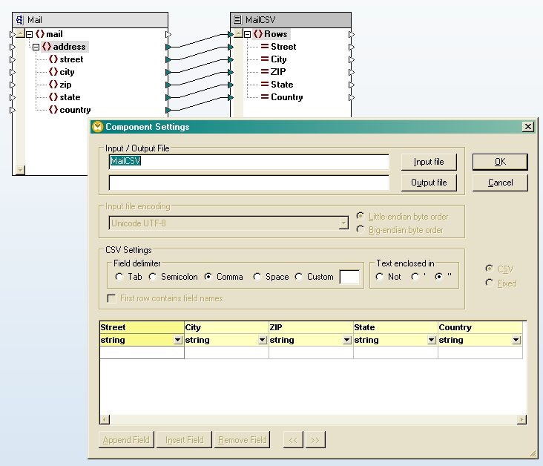

Server-side Transformation
The alternative to client-side transformation is to perform the XML-to-HTML transformation at the server end and present the results of the transformation to the client. The main advantage of this approach is that the client always see the correct output independent of the browser being used, since the results are always sent in HTML (if the HTML contains other display-formatting information such as Cascading Style Sheet or CSS instructions, then the output may not appear uniform across all browsers, since certain browsers do not provide full CSS support).
Currently, there are many server-side transformation implementations available with the main ones being Saxon, XALAN and MSXML. XALAN is widely-used in the Java world, while MSXML is mainly used with ASP, ASP.NET and VB.NET.
According to the XALAN project:
XALAN is an XSLT processor for transforming XML documents into HTML, text, or other XML document types. It implements XSL Transformations (XSLT) Version 1.0 and XML Path Language (XPath) Version 1.0. It can be used from the command line, in an applet or a servlet, or as a module in other program.
The XALAN class, file org.apache.xalan.xslt.Process, is used to transform an input XML file.
A typical usage of XALAN is as follows:

java org.apache.xalan.xslt.Process -IN mail.xml -XSL mail.xsl -OUT mail.csv

where,

-IN the xml file to be transformed
-XSL the stylesheet file
-OUT the generated output

(Note: XALAN requires Java 1.2 or above)
XSLT provides a relatively-easy way to transform XML files to different output formats both at design time and at runtime. The only disadvantage is that a clear understanding of XML, XSLT, and XPath is required on the part of the user to perform XML transformations.
XSLT-editors and tools such as Altova StyleVision help in creating XSLT stylesheets by generating the XSLT code at design time.
XSLT does not restrict the user to transform an XML file into one particular format. The output file can be any other text-based format such as a plain text file, SQL file (with SQL statements such as insert, delete, create, drop etc.) or HTML.

REFERENCES
- http://www.altova.com/products_mapforce.html
- http://xml.apache.org/fop/
- http://www.altova.com/products_xsl.html
- http://www.altova.com/features_XSLFO_s.html
- http://xml.apache.org/xalan-j/index.html
- http://www.xmlfiles.com/xsl/
- http://www.mozilla.org/projects/xslt/

MapForce is a product of Altova and is available at: http://www.altova.com/products_mapforce.html
http://www.opera.com/docs/specs/index.dml#xml

