Federal Procurement Data System-Next Generation
(FPDS-NG)
Ad Hoc Report Quick Start Guide

2300 Dulles Station Blvd.
Herndon, VA 20171

COPYRIGHT NOTICE: This work, authored by IBM employees, was funded in whole or in part by federal funds under U.S. Government contract GS00Q14AJC0009 and is, therefore, subject to the following license: The Government is granted for itself and others acting on its behalf a paid-up, nonexclusive, irrevocable, worldwide license in this work to use, reproduce, modify, prepare derivative works, disclose, distribute copies to the public, and perform publicly and display publicly, by or on behalf of the Government. All other rights are reserved by the copyright owner.

February 2015

Training Document Document Change History
Date | Version Number | Submitted By | Change Reference
01/08/2010 | 1 | Jennifer Lou Strutt | Began initial review of the manual. Testing exercises and content. Replace the screenshots with the current navigation and report screens.
01/11/2010 | 2 | Jennifer Lou Strutt | Created final editing changes and modifications to the manual including exercises, adding current content, and deleting older versions of some subject matter. Replace the screenshots with the current navigation and report screens.
05/19/2010 | 3 | Jennifer Lou Strutt | Created final editing changes and modifications to the manual including exercises, adding current content, and deleting older versions of some subject matter. Replace the screenshots with the current navigation and report screens.
05/21/2010 | 4 | M. Dian Neary | Initial review of the manual. Made changes that consisted of grammar (proper tenses in verbs and changing from singular to plural and plural to singular depending on the sentence) and formatting modifications.
12/03/2010 | 5 | Jennifer Lou Strutt | Updated the date of manual reflected on coversheet from May 25, 2010 to the last update of December 3, 2010.  Reviewed and updated all the information in the manual so that everything is up-to-date.
12/21/2010 | 6 | Jennifer Lou Strutt | Updated the date of manual reflected on coversheet from December 3, 2010 to the last update of December 21, 2010.  Reviewed and updated the metric and the attribute information that is associated with the “Award-IDV Information” and “Other Transaction Information” folders in the manual so that everything is up-to-date.
12/22/2010 | 7 | Linda Hornsby | Made minor changes to the format and capitalization.
03/26/2012 | 8 | Jennifer Lou Strutt | Reviewed the manual and updated the wording and screenshots.
03/27/2012 | 9 | Linda Hornsby | Added new screen shots for Contract Actions under Award - IDV Information and Other Transactions.
03/26/2014 | 10 | Matthew Chen | Changed instances of Global Computer Enterprises (GCE) to Serendipity Now.
12/22/2014 | 11 | Linda Hornsby | Changed Serendipity Now to IBM.

Document Approvers*
Version  Number | Date Approved | Approved By | Role/Responsibility
- *Indicates name of final person authorized by IBM executive management to perform document approval.
- Please note: All IBM process-related documentation must be presented to the IBM Software Engineering Process Group (SEPG) for internal review and approval prior to its upload onto the IBM Process Asset Library (PAL). An approval notification will be emailed to the submitter when the process has been approved. If no approval email is received within 72 hours of submittal, please assume that the process has not been approved.
- For questions or comments, please contact your team’s SEPG Representative or the IBM SEPG Director.
Stakeholders Acceptance Table
Version Number | Date Approved | *Project Stakeholders | Role/Responsibility

*All IBM projects have been reviewed and approved jointly with that project's stakeholders. Project stakeholders are clients and internal IBM employees whom have an equal responsibility towards a project's success.

Table of Contents

Section Page

1 FPDS-NG Ad hoc Reporting Tool 3
1.1 Introduction 3
1.2 Ad hoc Reporting Features 3
2 Creating an Ad hoc report 3
2.1 New and Find Button 3
2.2 To access the new Ad Hoc report screen 3
2.3 To Create a New Ad Hoc Report 3
2.4 To Select Attributes for a New Report 3
2.5 Select metrics and attributes from various folders 3
2.6 To Create Filters on a New Ad Hoc Report 3
2.7 To Updating Filters on a new or existing Ad Hoc report 3
2.8 To Save a Ad Hoc Report 3
2.9 To Generate a Ad Hoc Report 3
2.10 To Format the Ad Hoc Report 3
3 Driiling down 3
3.1 Drill Down Feature 3
3.2 To Drill into a Report 3
4 Highlighting Metric Values 3
4.1 Specifying Ranges 3
4.2 To Create a Highlighting Rule 3
4.3 Modifying a Highlighting Rule 3
4.4 To Modify a Highlighting Rule 3
4.5 Deleting Highlighting Rules 3
4.6 To Delete a Highlighting Rule 3
5 Adding Metrics to an existing Ad hoc Report 3
5.1 To Add Metrics to a Ad Hoc Report 3
5.2 To Add an Attribute to an Existing Report 3

FPDS-NG Ad hoc Reporting Tool

Introduction
This section specifies instructions for creating Ad Hoc Reports based on the users’ selected criteria. The users can create Ad Hoc Reports that answer their business questions and analyze processes. The users have the option to save the reports in a personal folder that is specific to their User IDs.
The report result is limited to 10,000 rows.

Ad Hoc Reporting Features
After logging into the FPDS-NG System, the users can click on the “Ad Hoc Reports” icon  to get to the Ad Hoc reporting tool. After clicking on the “Ad Hoc Reports” icon, the initial Report Screen and the basic tool bar will show on the screen. The “Personal Folder” has all the reports that have been saved by the users.
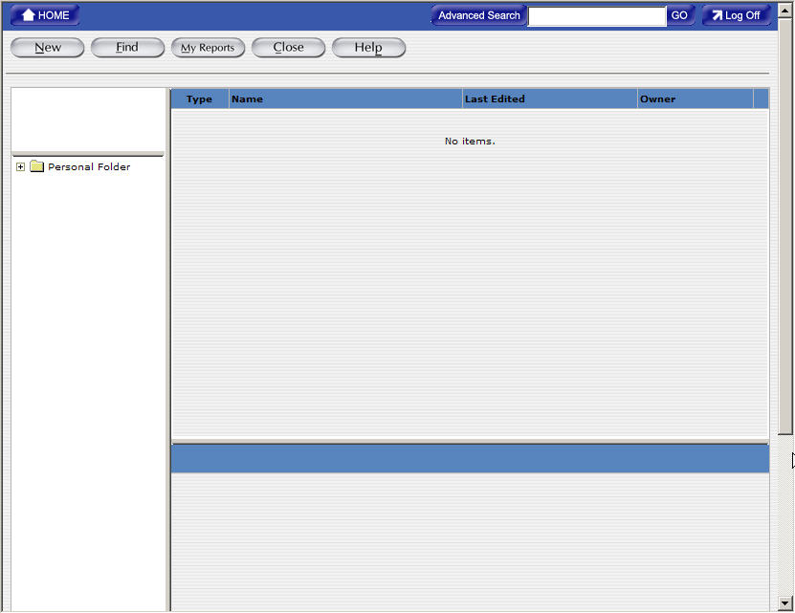

Creating an Ad hoc report
The Ad Hoc Reporting tool is a tool that the users can use to create customized reports that match with the criteria that they specify. The users select the data elements that they want to see in their reports and create filters to set the criteria for the reports. The Ad Hoc report results will be generated based on the filters (criteria) that the users specify for the reports. If the users don’t get any search result, it is possible that there is no data in the FPDS-NG system that matches with the reports’ criteria or there are problems with the settings of the reports’ criteria.

New and Find Button
The “New” Button will take the users to the design part of the Ad Hoc Report. The Ad Hoc Reports can have a set of metrics and attributes, which are the data elements that the users want to see in the reports. In addition to the metrics and attributes, the users can set the filters for the reports so that the reports will be generated based on the criteria that are specified by the users. The reports can always be changed/modified after it is created and generated.
The “Find” Button allows the users to access the reports that have been saved. All the saved reports are stored in the “Personal Folder” and the users can click on the “Personal Folder” icon to locate the reports that have been saved.
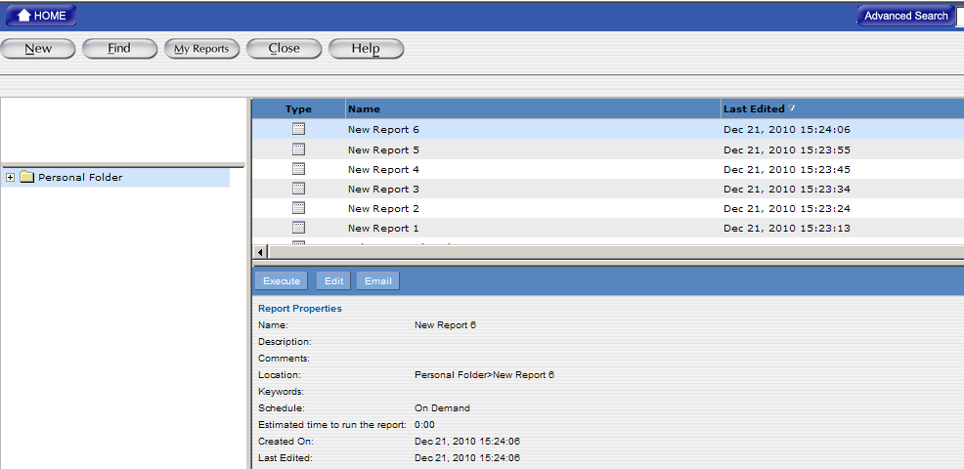

To access the new Ad Hoc report screen
- Click on the “Ad Hoc Reports” icon that is listed on the main navigation screen.
- Click on the “New” Button that is located at the top left side of the report screen to get to the page where the users can create new Ad Hoc reports. The following “Create Report” screen will be displayed after clicking on the “New” button.
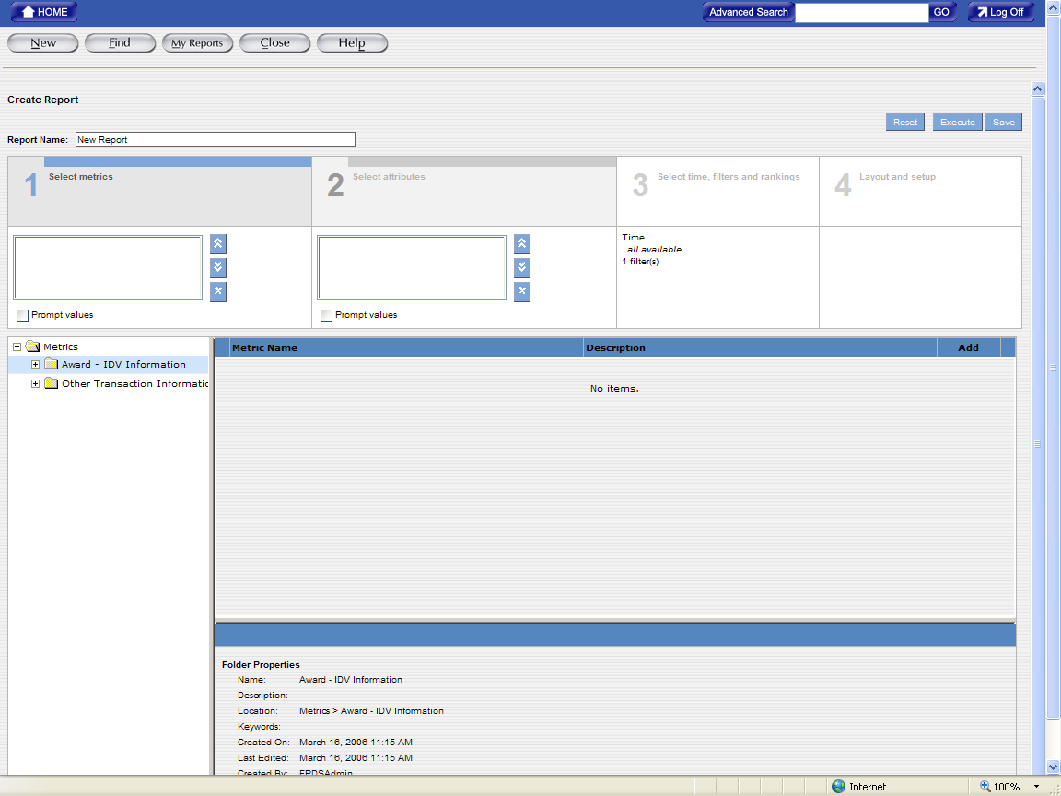
- The “Create Report” screen is divided into four sections, which are designed to select the data elements and create criteria for the Ad Hoc report.

To Create a New Ad Hoc Report
The first step in creating an Ad Hoc report is specifying the data elements for the report. Section 1 “Select Metrics” adds the measures to evaluate a business process and the metrics are always numeric values. For example, Action Obligation, Actions Count, Base and Exercised Options Value, and Base and All Options Value are metrics that can provide measurable information to determine trends in federal spending.
- Click on the “Plus” sign that is listed next to the “Award-IDV Information” folder to open the sub folders that are listed under the main folder “Award-IDV Information.”
- After clicking on the “Plus” sign to open the sub folders, you will see some sub folders being displayed on the screen.
- In order to access all the data elements in those sub folders, you will need to click on the yellow folder icon for each sub folder so that you can access the data elements in those sub folders.
- Select the desired metric(s) and then click on the “Add” button that is next to the desired metric(s). After clicking on the “Add” button, the selected metric(s) is(are) added to the Metric box in Section 1.
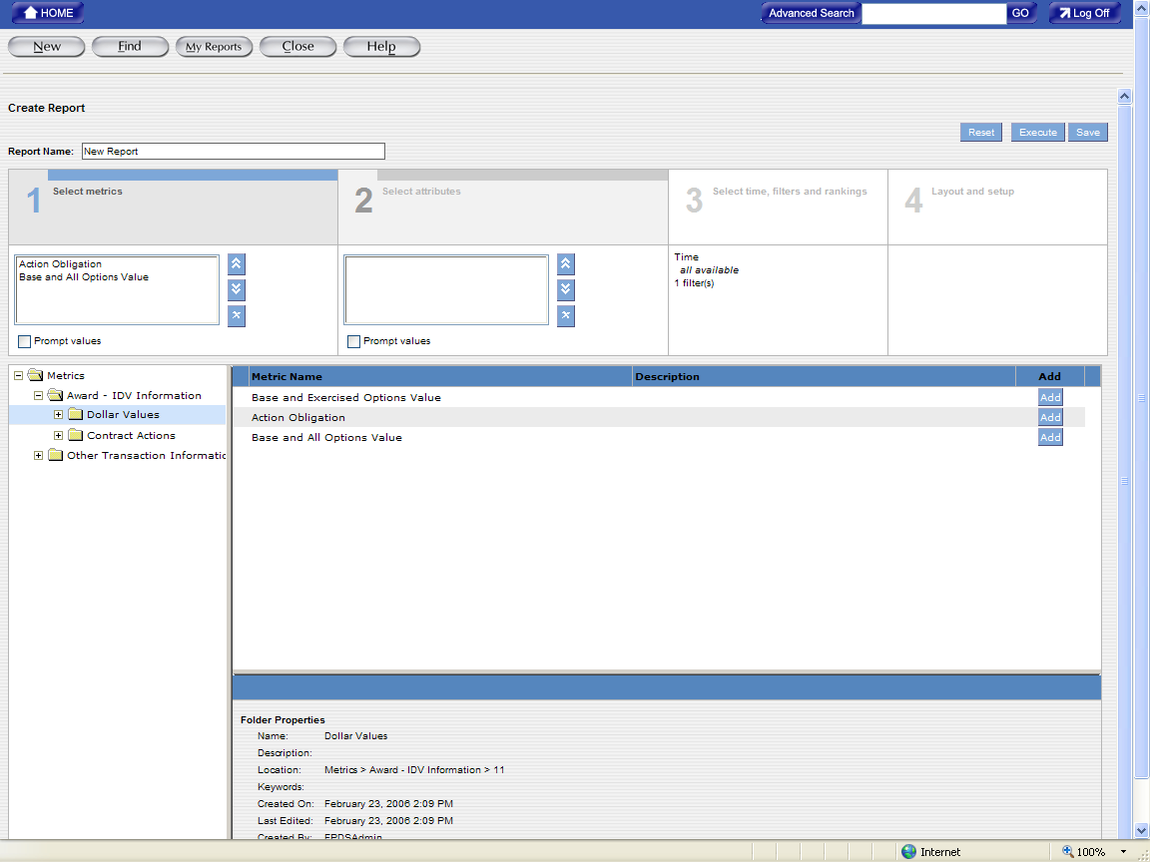

- After selecting the desired metrics, click on Section 2 “Select Attributes” to add attributes to the report.

To Select Attributes for a New Report
Section 2 “Select Attributes” contains various attributes, which are the factors that determine the value of metrics. For example, Date Signed, Product Services Codes, and Contracting Office Names…etc. are attributes. If the users want to create an Ad Hoc report that tracks the total dollars and total actions that are completed by a specific agency, the users need to identify attributes that determine the values of these metrics.
- Click on the “Plus” sign that is listed next to the “Award-IDV Information” folder to open the sub folders that are listed under the main folder “Award-IDV Information.”
- After clicking on the “Plus” sign to open the sub folders, you will see some sub folders being displayed on the screen.
- In order to access all the data elements in those sub folders, you will need to click on the yellow folder icon for each sub folder so that you can access the data elements in those sub folders.
- Select the desired attribute(s) and then click on the “Add” button that is next to the desired attribute(s). After clicking on the “Add” button, the selected attribute(s) is(are) added to the Attribute box in Section 2.
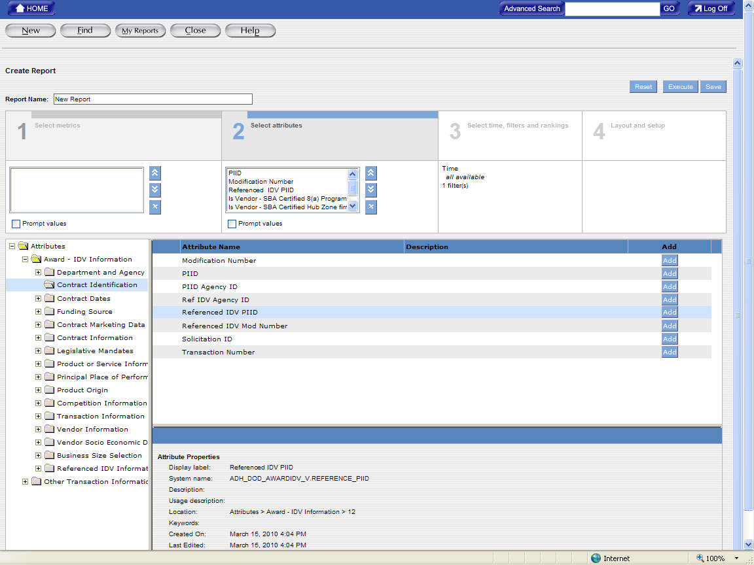

- After selecting the desired attributes, click Section 3 “Select Filters” to set the filter/criteria for the report.
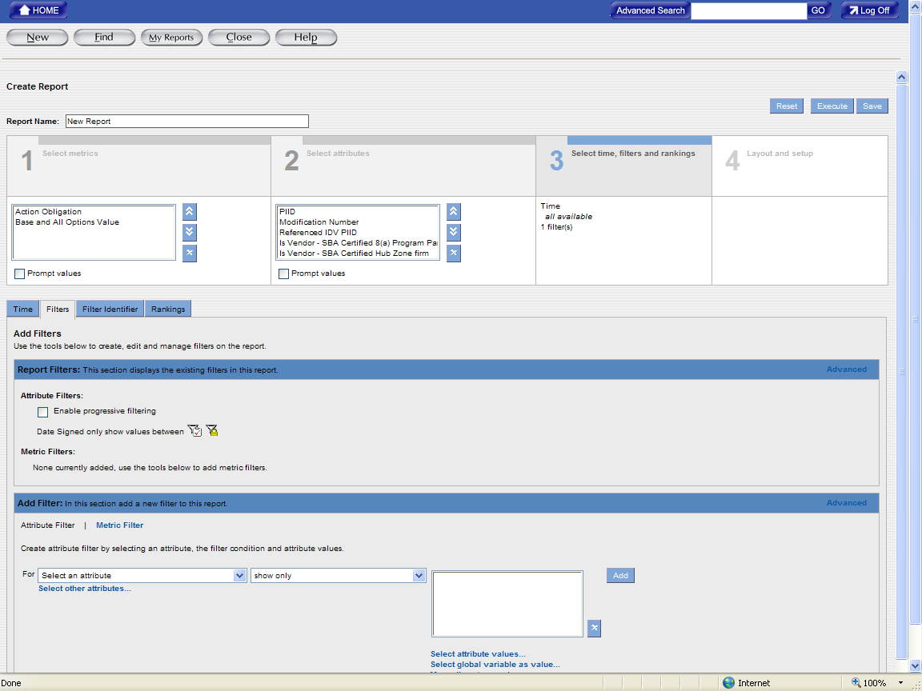

Select metrics and attributes from various folders
The users may select Metrics and/or Attributes from the “Award-IDV Information” folders or the “Other Transaction Information” folders, but never both folders within one report.
Before selecting any metric and/or attribute, the users will notice that there are two folders, “Award-IDV Information” and “Other Transaction Information” folders, listed under the metric section and attribute section.
Both “Award-IDV Information” and “Other Transaction Information” folders have the same 2 sub-folders; one is “Dollar Values” and the other is “Contract Actions”, but each folder contains different data elements that are associated with the main “Award-IDV Information” and “Other Transaction Information” folders.
The following is the screenshot that shows the data elements that are associated with “Dollar Values” folder that is listed under the “Award-IDV Information” folder.
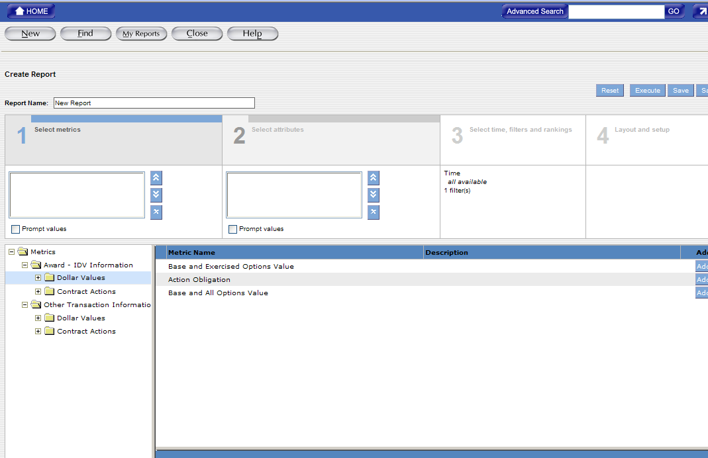

The following is the screenshot that shows the data elements that are associated with “Contract Actions” folder that is listed under the “Award-IDV Information” folder.
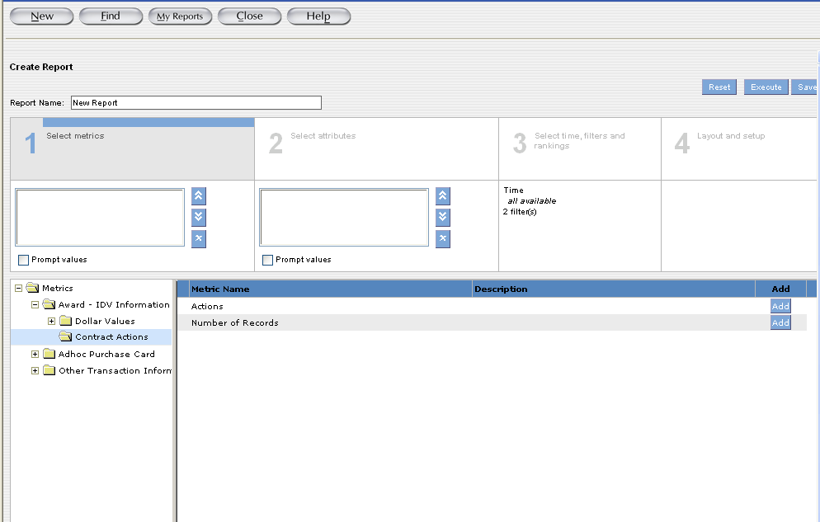

The following is the screenshot that shows the data elements that are associated with “Dollar Values” folder that is listed under the “Other Transaction Information” folder.
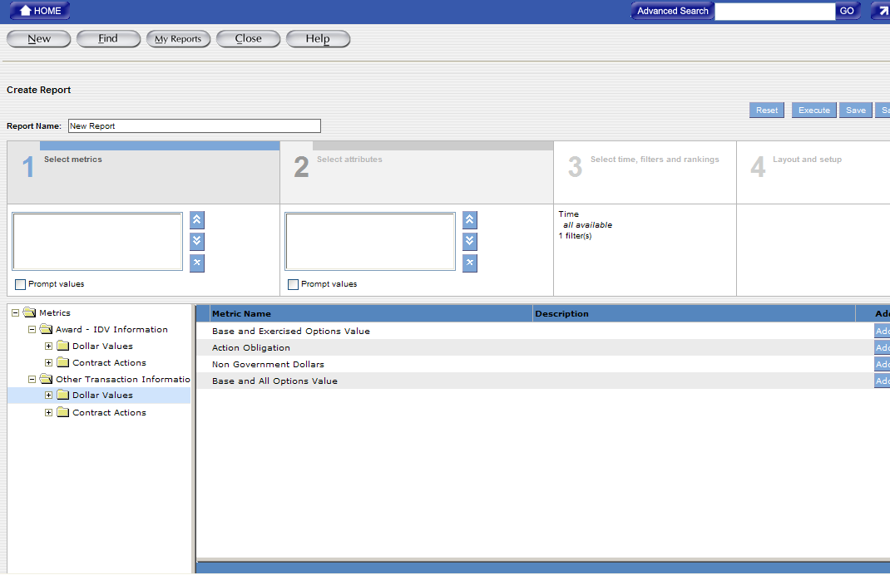

The following is the screenshot that shows the data elements that are associated with “Contract Actions” folder that is listed under the “Other Transaction Information” folder.
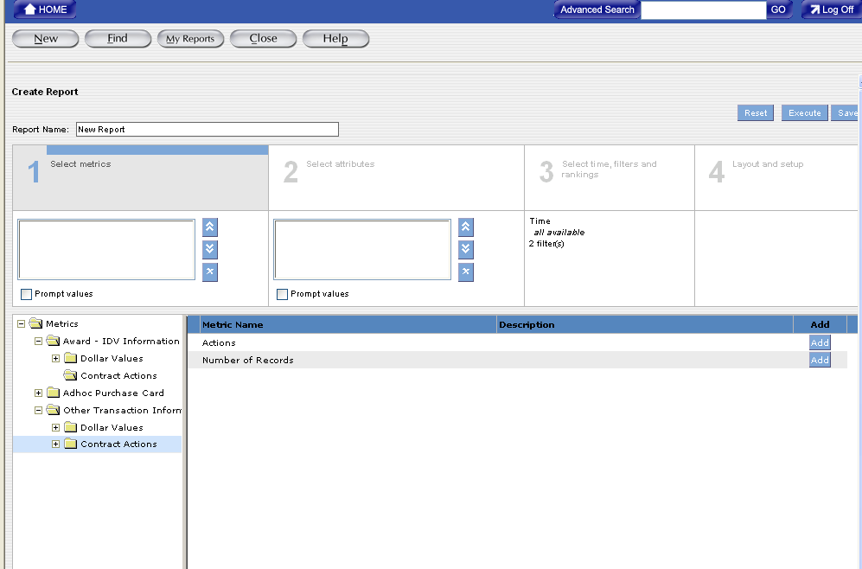

If the users select the metrics from the sub folders that are listed under the “Award-IDV Information” folder at the “Select Metrics” section, the users will only be able to access the “Award-IDV Information” folder and all its sub folders at the “Select Attributes” section.
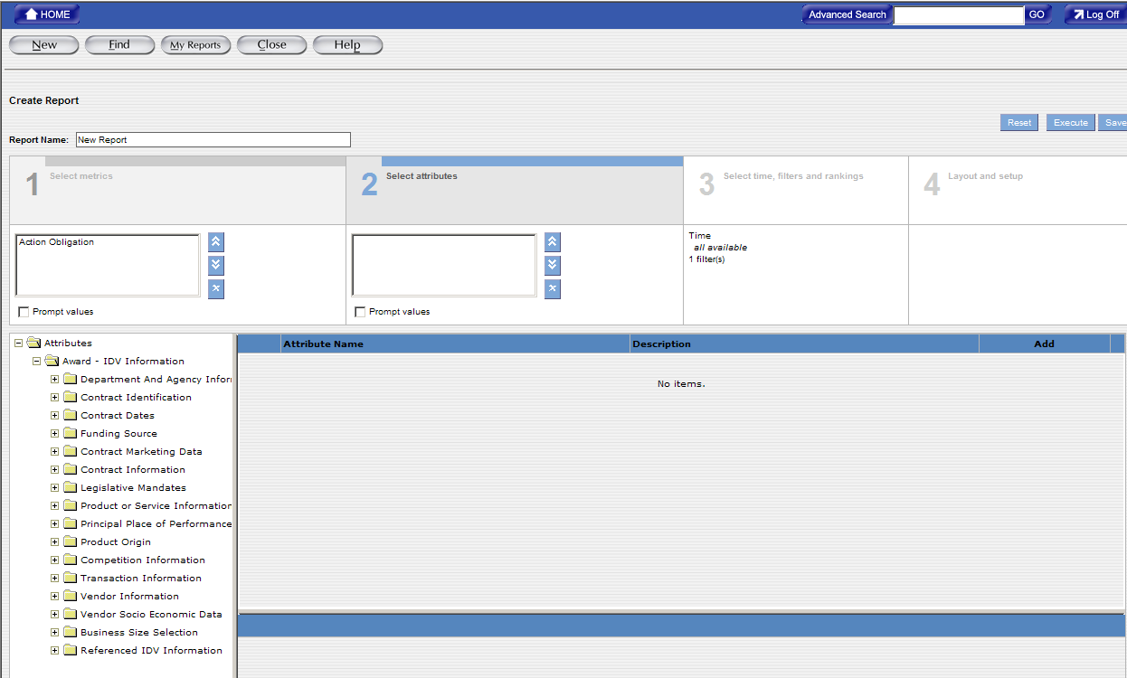

If the users select the metrics from the sub folders that are listed under the “Other Transaction Information” folder at the “Select Metrics” section, the users will only be able to access the “Other Transaction Information” folder and all its sub folders at the “Select Attributes” section.
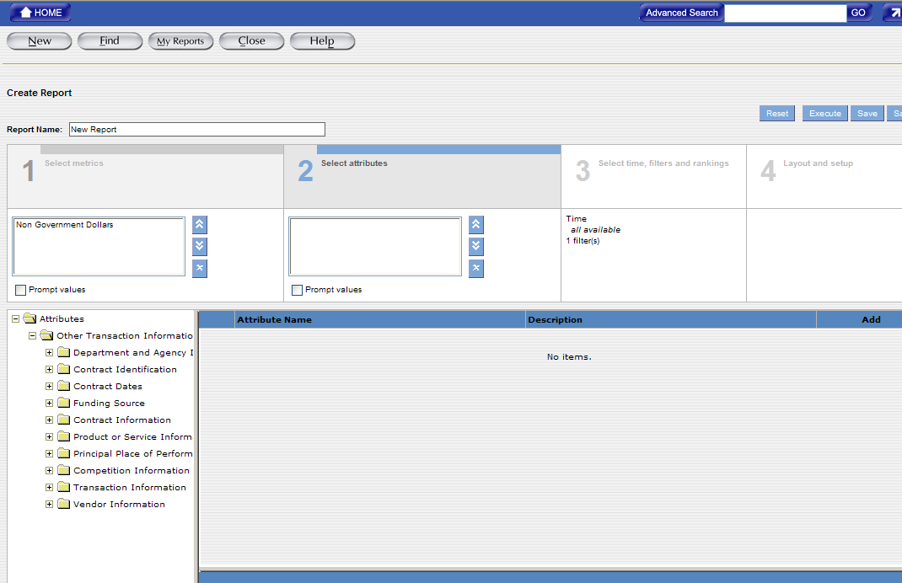

If the users select the metrics from both the “Award-IDV Information” and “Other Transaction Information” folders, the users will not see any folder at the “Select Attributes” section.
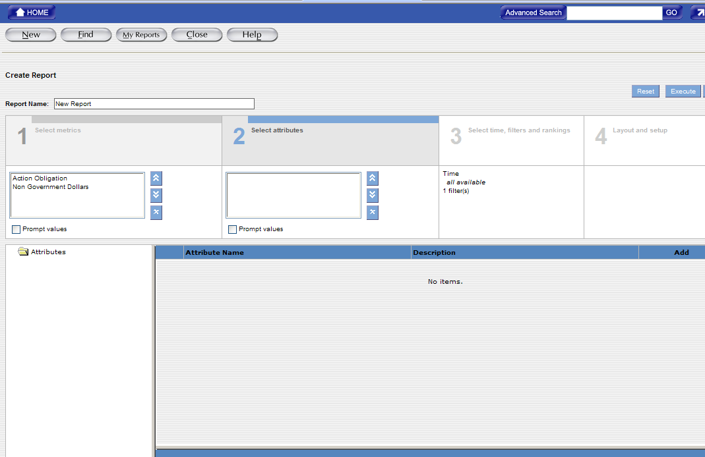 If the users select the attributes first before selecting the metrics, the FPDS-NG system will display different screens.
If the users select the attributes from either the “Award-IDV Information” or “Other Transaction Information” folder, the users will see both “Award-IDV Information” and “Other Transaction Information” folders at the “Select Metrics” section.
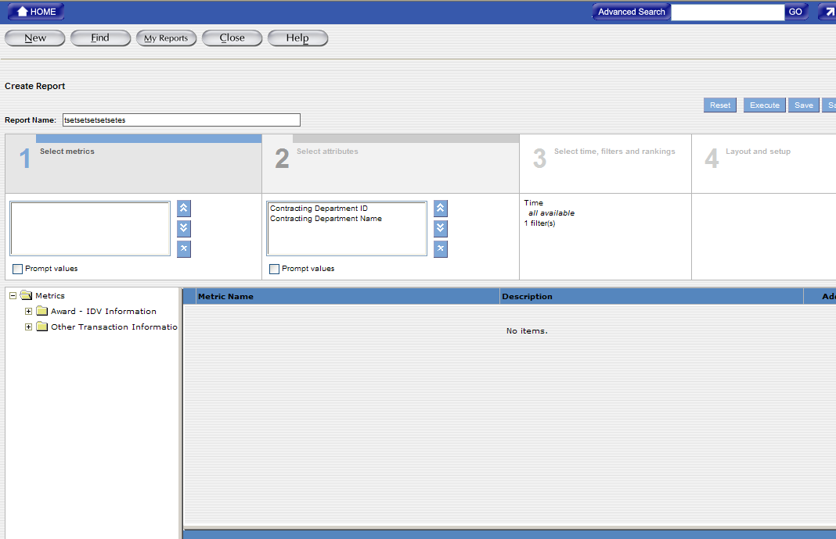
If the users select the attributes from the “Award-IDV Information” folder, the users will need to select the metrics from the “Award-IDV Information” folder; if the users select the attributes from the “Other Transaction Information” folder, the users will need to select the metrics from the “Other Transaction Information” folder.
If the users select an attribute from the “Award-IDV Information” folder and then select a metric from the “Other Transaction Information” folder, the users will see the error message that is similar to the following after getting back to the “Select Attributes” section:
Invalid Report: Attribute "Contracting Agency ID" is not an applicable attribute to metrics "Non Government Dollars".
If the users select an attribute from the “Other Transaction Information” folder and then select a metric from the “Award-IDV Information” folder, the users will also see the error message that is similar to the above error message.
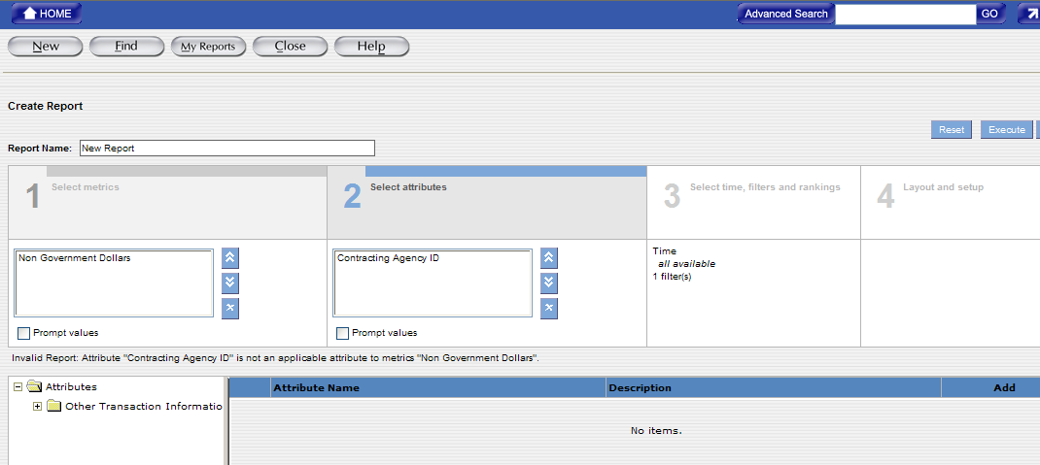

To Create Filters on a New Ad Hoc Report
The users can use filters in the Ad Hoc report to set criteria to capture the report data. When creating a report, criteria are used to limit the search to the users’ specifications. The criteria are set based on the business question that the users want answered.
- The “Attribute Filter” link will be highlighted in black like what is shown in the following example. The “Attribute Filter” link is used to set criteria for each attribute that is included in Section 2. The users’ only need to set the filters for the attributes that will impact the report results; the users do not need to set the filters for each attribute.
- The users can use the attribute dropdown menu to select the attribute that they want to set the filter for.
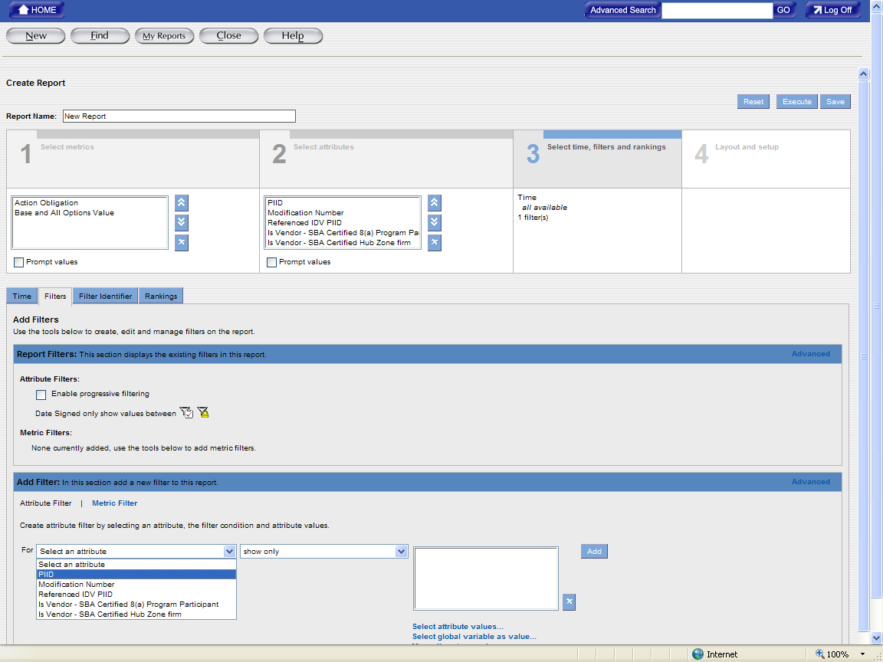
- After selecting the attribute, the users can use the operator dropdown menu to select the operator that provides the criteria for the selected attribute value.
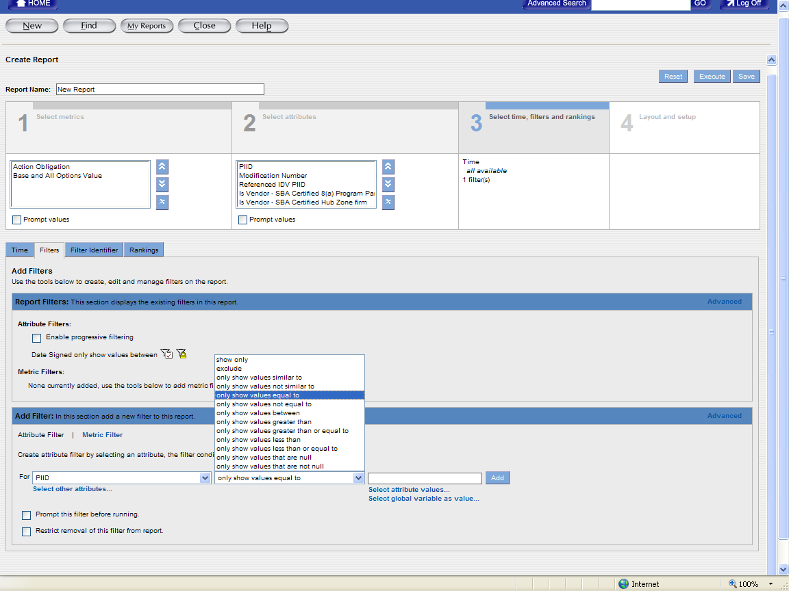
- Provide the criteria for the filter by entering information in the Attribute Value box(s).
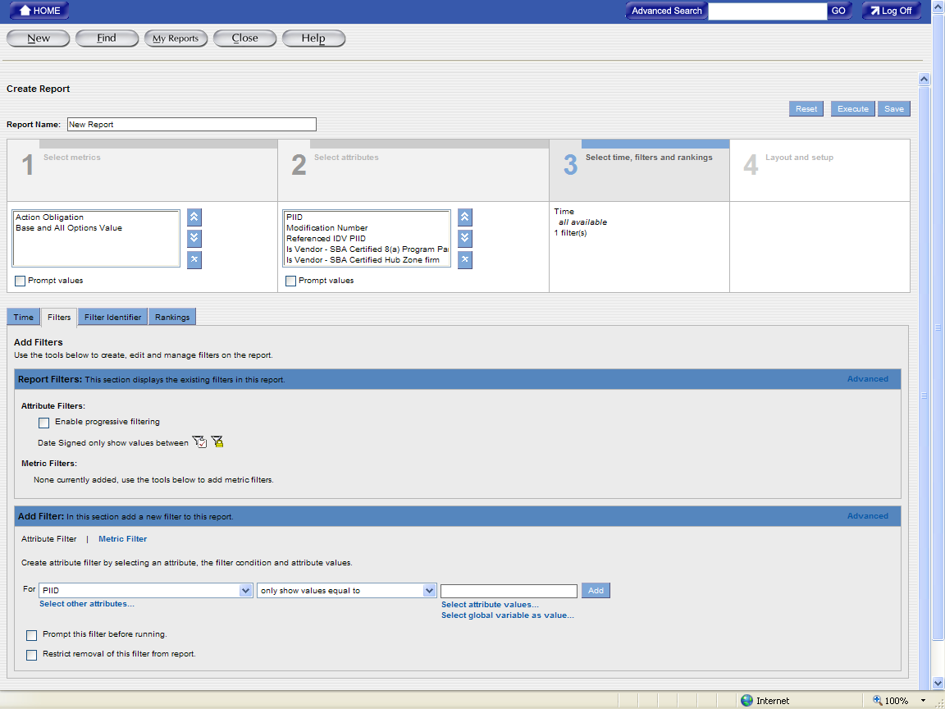

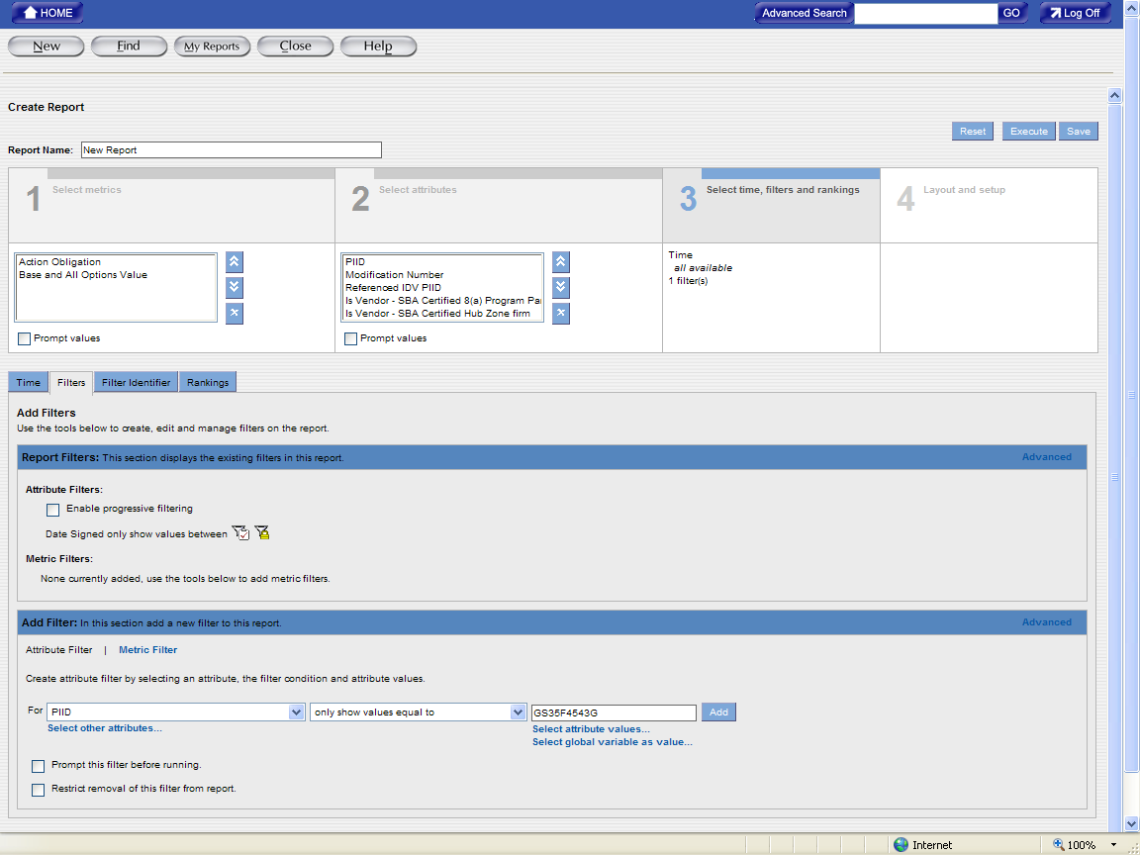
- Click on the “Add” button to save the filter values and the saved filter will be displayed in the Report Filters section of the screen.
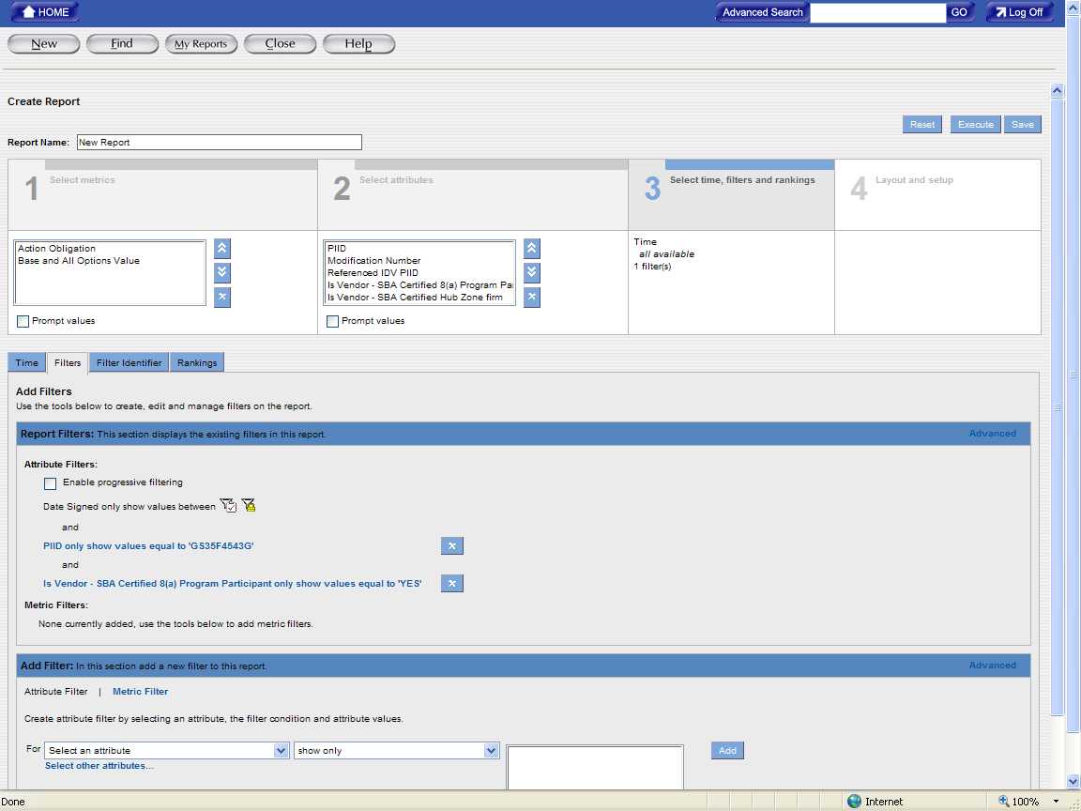
- If the users want to set the filters for the metrics, they can use the “Metric Filter” link that is displayed in the Add Filter section. When the “Metric Filter” link is selected, it is displayed in black like what is shown in the following example. This link is used to access filters for the selected metric value.
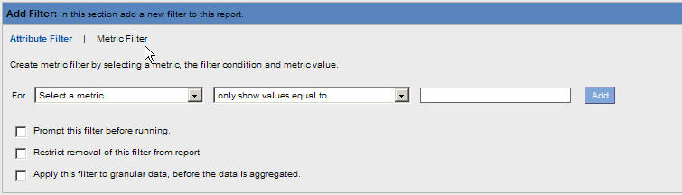
- The users can use the metric dropdown menu to select the metric that they want to set the filter for.
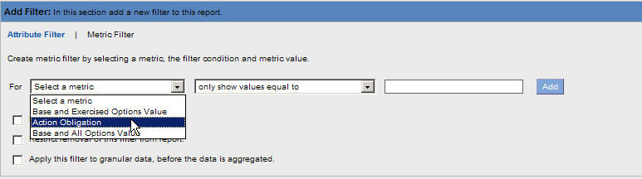
- After selecting the metric that the users want to set the filter for, they can use the operator dropdown menu to select the operator that provides the criteria for the selected metric value.
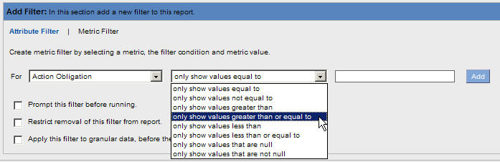
- Provide the criteria for the filter by entering information in the Metric Value box.
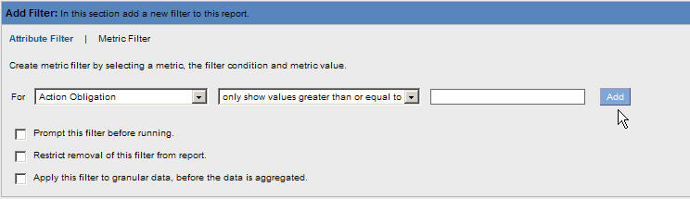
- Click on the “Add” button to save the filter values and the saved filter will be displayed in the Report Filters section of the screen.
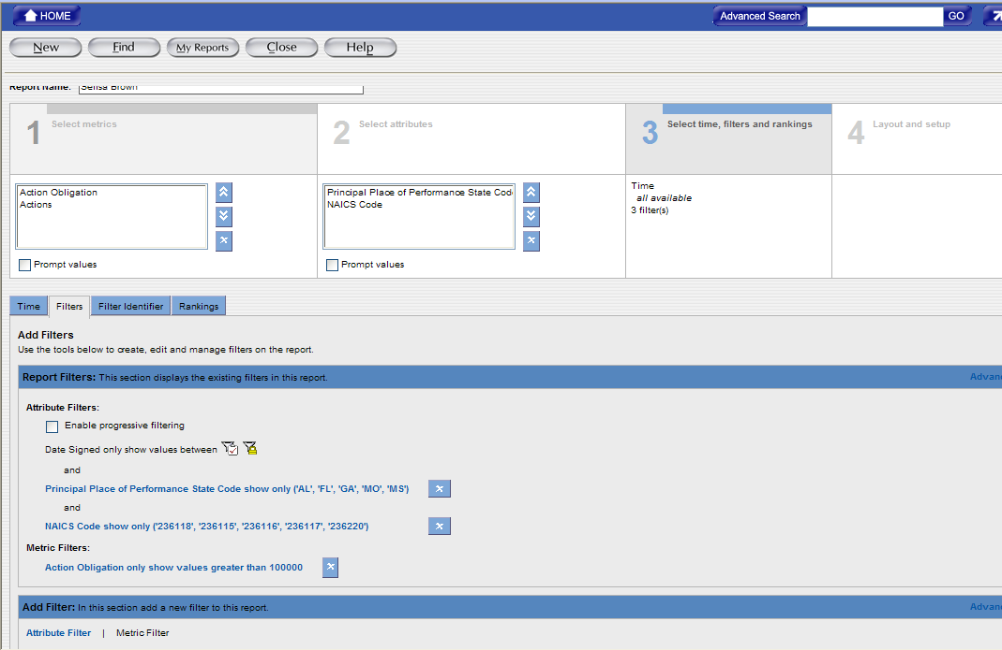

To Updating Filters on a new or existing Ad Hoc report
The filters are stored under the Report Filter Section in Section 3 - “Select Time, Filters, and Rankings.” Use the following steps to update Attribute and Metric Filters.
- To make changes to an existing filter, click on the blue link of the existing filter. For example, click on the filter link:
- The selected filter link is highlighted and the color of the filter will be changed from blue to green. The information that is associated with the selected filter will be displayed in the Edit Filter section.
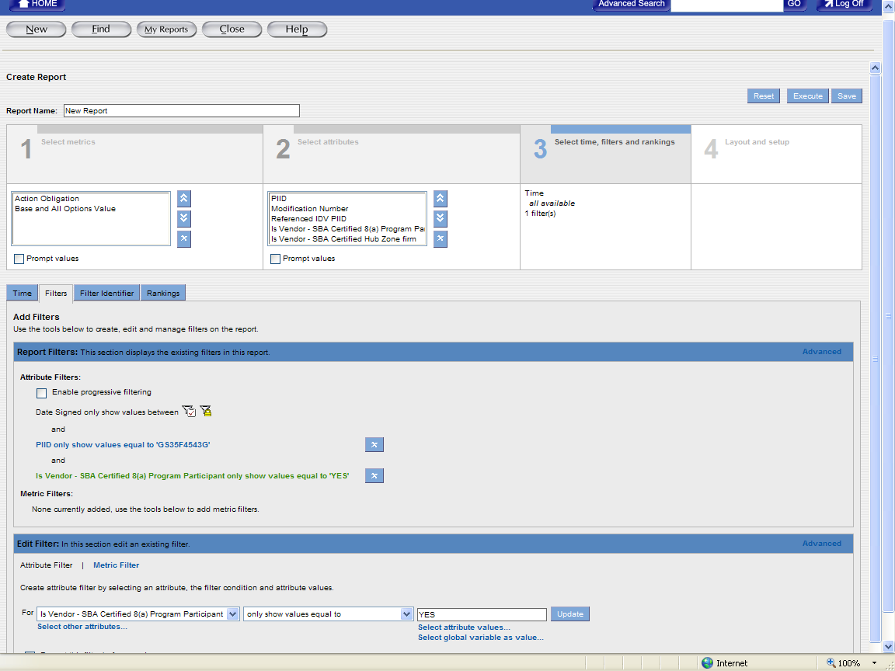
- The users can make the changes to the filter by selecting information from the dropdown menus or entering new information in the Values field(s).
- After the changes are completed, click on the “Update” button to store the changes in the “Report Filters” Section.

To Save a Ad Hoc Report
After a basic report is created, the information can be saved and used again when needed. The users can save the Ad Hoc Report after adding filter information. The users can use the following steps to save the Ad Hoc Report.
- Enter a name in the “Report Name” field like what is shown in the following example:
- Click on the “Save” button to save the report to the personal folder.

To Generate a Ad Hoc Report
After adding the report filters/criteria, the report can be generated. To keep the changes that are made to the report, the users can click on the “Save” button to save the report; the users can also generate the report and then save the report from the displayed report screen.
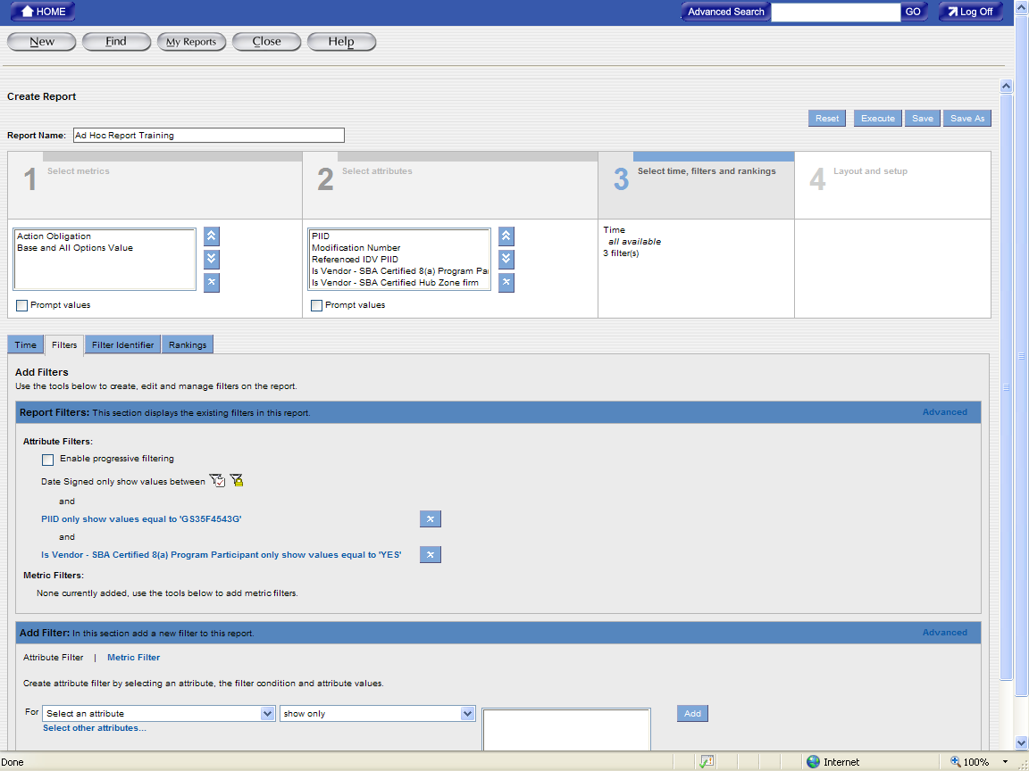
- To generate a report, click on the “Execute” button to generate the report. After clicking on the “Execute” button, the report will display the page where you can specify the time parameter for your report.
NOTE: The new date parameter has been added to the Ad Hoc report. The users can use the “Last Modified Date” to specify the date parameter.
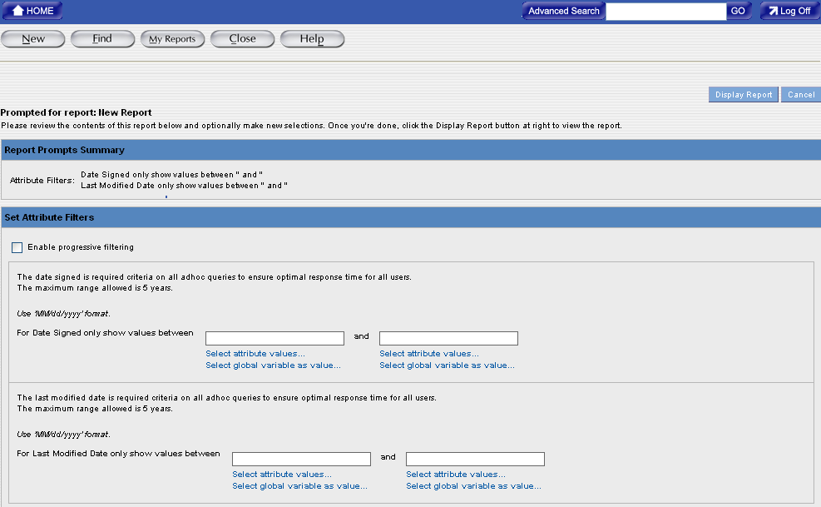

- After specifying the time parameter, the users can click on the “Display Report” button to generate the report. The following is the sample result screen after the report is generated.
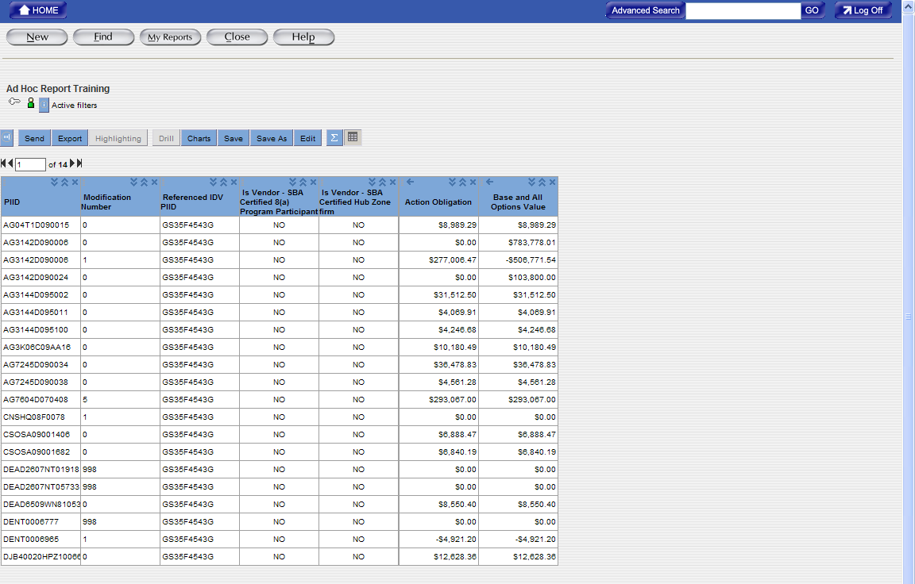

To Format the Ad Hoc Report
The final step in creating the Ad Hoc reports is selecting the formatting for the report. Section 4 “Layout and Setup” is used to customize the visual display of the Ad Hoc reports. Calculations can be added for metric filters in the report. The users can modify the date formats, display, and fonts in the report. The users can use the following steps to format a report.
- To add a sections to a report, select the “Table Layout” Tab.
- To create the report with sections, drag an attribute to the Section Attribute area and the selected attribute will be displayed in the Section Attribute area. You can also drag attributes from the Section Attribute area back to the Row Attribute or Column Attribute areas.
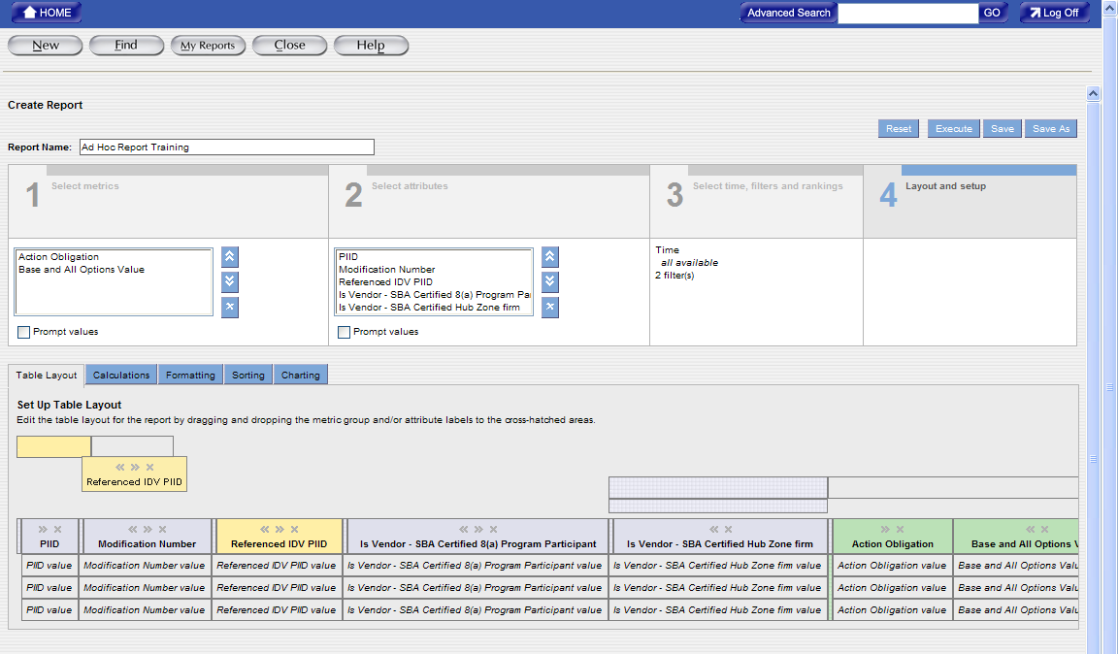
Creating sections in a report will display the report divided by the attribute the users have chosen. For example, choosing the Contracting Agency ID will display the report information in sections for each Contracting Agency ID.
- To add a calculation to the report, select the “Calculating” Tab. The following screen will be displayed.
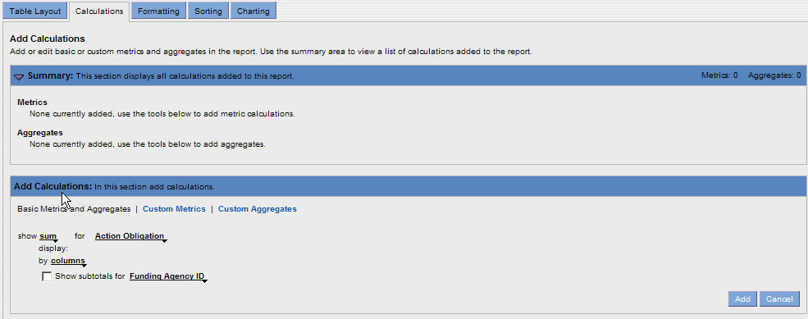
- Click on the dropdown menus next to “Show” like what is seen in the following example.
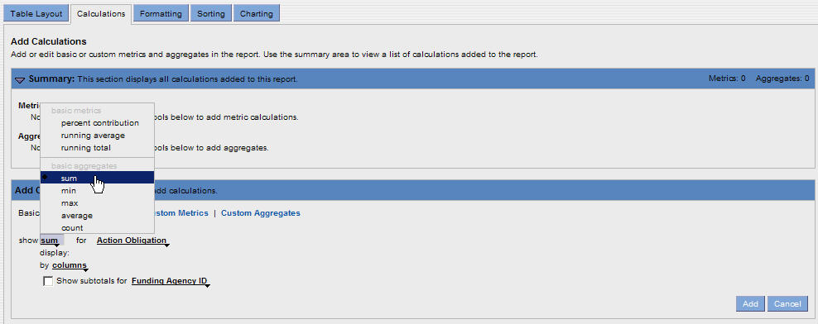
- Select the type of calculation that is desired for a metric filter.
- Click on the dropdown menu to select the metric for the previously chosen calculation.

- To display the subtotals for a specific column, click on the checkbox and then select the dropdown menu for Show Subtotals. Click on the attribute that will display the subtotals.
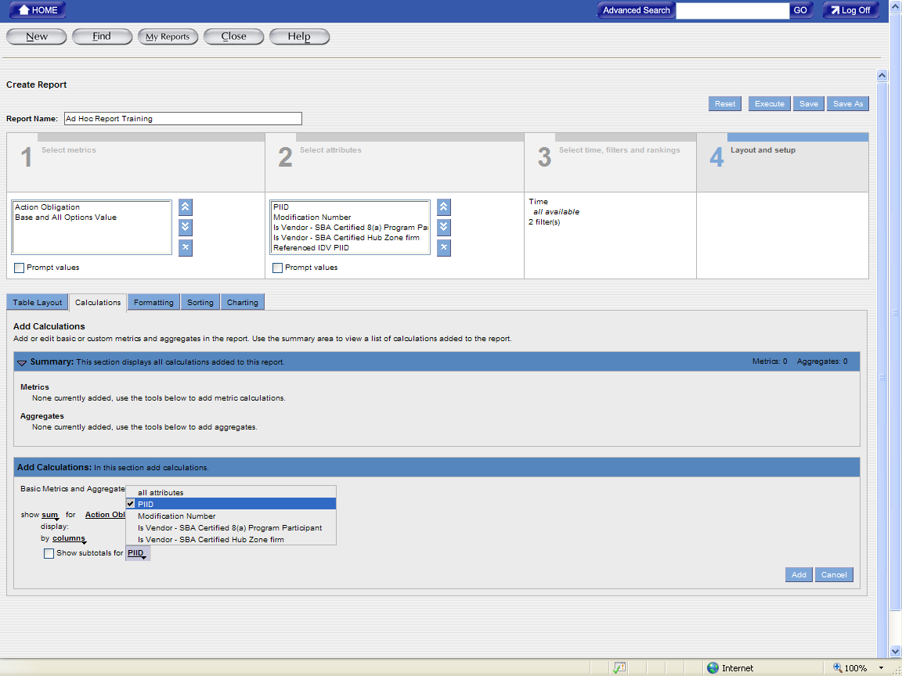
- Click on the “Add” button to place the calculations in the Summary Section.
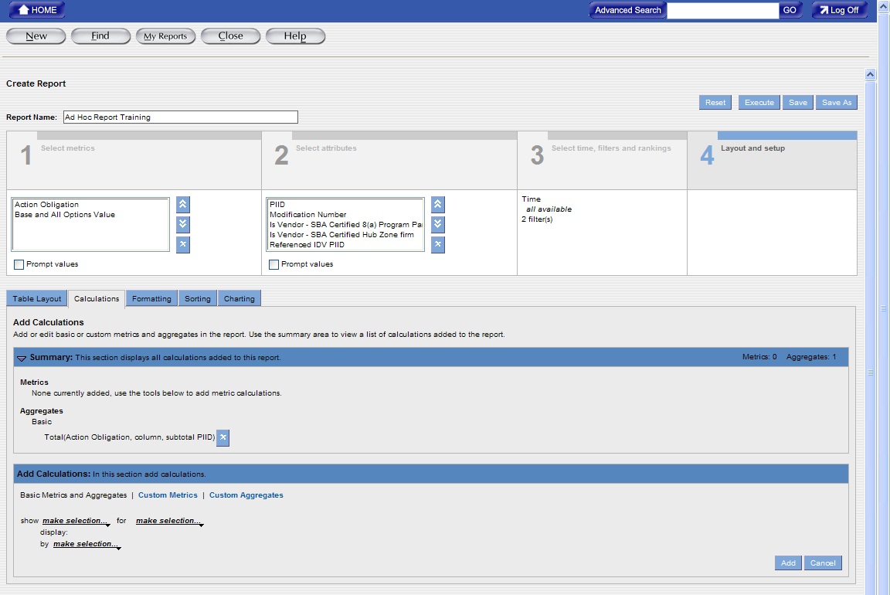
- To change the formatting for the report, select the “Formatting” Tab and the following screen will be displayed.
The users select formats for metrics and attributes on the “Formatting” tab. These formats determine how each data element (metric and attribute) will be displayed in the report table.
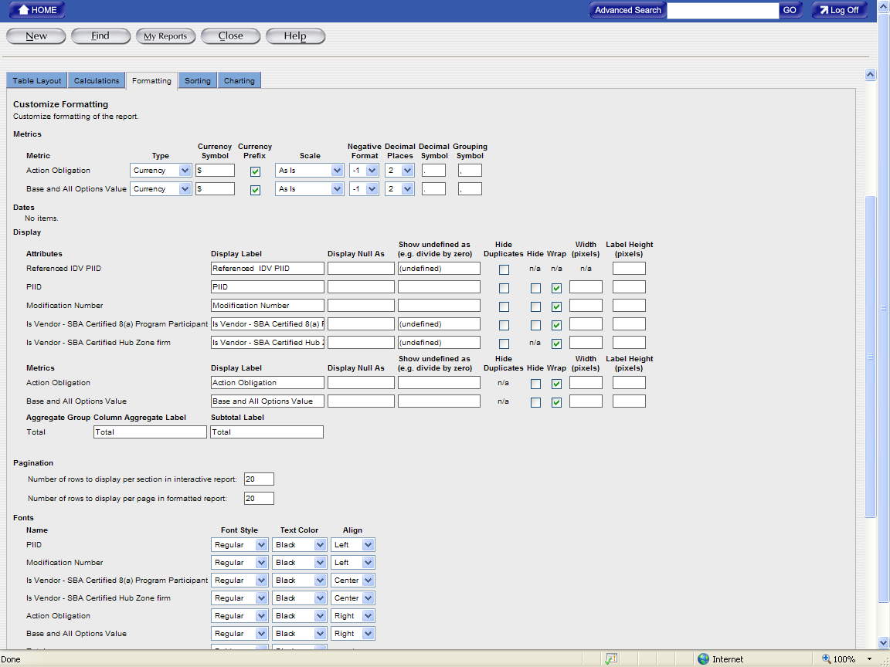
- To keep the changes that are made to the report formatting in the same report, click on the “Save” button and the changes will be saved in the existing Ad Hoc report. To keep the changes that are made to the report formatting in the different report, click on the “Save As” button to save the existing report as a new report with the changes.
Note: The “Save As” function will allow the users to make changes to the report and save the changes in the new report without overwriting the original report.

Driiling down

Drill Down Feature
The drill feature provides other attributes or metrics at a lower level related to the current report that is displayed. The following section explains how to change the Ad Hoc report from a general view of the report data to a more detailed view of the report data by using the drill down feature.
Drilling into a Report
When drilling into a report, certain attribute values are used for the drill. The reporting tool uses these values as a drill filter. The drill filter determines the data seen in the drill results. More than one specified attributes value for the drill can be selected, but the attribute value can only be selected one at a time.

To Drill into a Report
To drill into a report:
- To select the attribute value for the drill feature, the users can click on the header of the attribute to select all the attribute values for the attribute or you can click on the specific cell with the specific attribute value for the attribute. The values will be used for the “Drill” feature to filter the report information.
- Click on the “Drill” button to use the “Drill” feature. The reporting tool displays the available drill paths on the Drill tab.
In order to use the “Drill” feature, one of the following attributes values will need to be included in the “Section 2 - Select Attributes” of the Ad Hoc report:
  - Contracting Department ID
  - Contracting Agency ID
  - Contracting Office Region
  - Contracting Office ID
  - Vendor Name
  - Referenced IDV PIID
  - PIID
  - Modification Number
If the DOD users want to get the information that is associated with their commands or is associated with certain transaction, they will need to include one of the following attribute values in the “Section 2 - Select Attributes” of the Ad Hoc report:
  - Contracting Department ID
  - Contracting Agency ID
  - Contracting Office Region
  - Contracting Office ID
  - Vendor Name
  - Referenced IDV PIID
  - PIID
- Modification Number
- Transaction Number
- Major Command Code
- Sub Command1 Code
- Sub Command2 Code
- Sub Command3 Code
-Or-
In the report result table, right-click on the selected values and then click on the “Drill” to view all the available attributes that can be used in the drill feature.
You can select those attributes from the available drill paths that are not already part of the report (the attributes that are not included in the Section 2 Select Attributes, but are showing as part of the drill path.)
- From the available drill paths, click on the attribute that you want it to be displayed in the report.
For example, if the report currently displays the government wide report for the Department of Homeland Security, you can use the drill feature to select the “Contracting Agency ID” attribute to display the agencies (i.e. U.S. Coast Guard, Transportation Security Administration…etc.) for the Department of Homeland Security. Overall, the report drill filter will show all the agencies that are associated with the Department of Homeland Security for the reporting period.
- To go back to the original report, click on the “Original Table” link on the current drill path header.
Tip: To view a description of the drill filters or the search criteria information, you can click on the information icon. The information icon will display the report filter and search criteria information.
After the drill filter is created, additional attributes can be selected for the report. Drilling into a report allows you to filter attribute values and see additional attributes in the reports. Additional attributes are selected from a predefined drill path. The predefined drill path lists the attributes that are available for selection to display in the reports.

Highlighting Metric Values
The users can use colors, patterns, or symbols to highlight metric values in a report table. The users can highlight metric values in a report that are above, below, or within a dollar range. The Highlighting feature allows the users to draw attention to critical data in a report or pinpoint problem areas.
If the users create the bar chart for the report, the metric values that are used in the “Highlight” rule in the report will also appear in the bar chart. In the charts, the reporting tool displays those highlighting values as colored dots; colored dots are a type of highlighting format.
Creating a Highlighting Rule

Specifying Ranges
When the users create a highlighting rule, they specify three ranges (low, medium, and high) for the values that they want the reporting tool to highlight. The users must enter numeric values that correspond to the values in the report table and these ranges must be in the ascending order.

To Create a Highlighting Rule
To create a highlighting rule:
- Generate the report that you want to use the highlighting rule; the report result will be displayed on the screen after it is generated.
- Click on the header of the metric column (Action Obligation, Based and All Options Values…etc.) for which you want to create the highlighting rule. The reporting tool selects the column for the desired metric.
- Click on the “Highlighting” button to use the “Highlighting” feature.
-Or-
Right-click on the metric header and then choose “Create Highlight.” The reporting tool displays the “Highlighting” button.
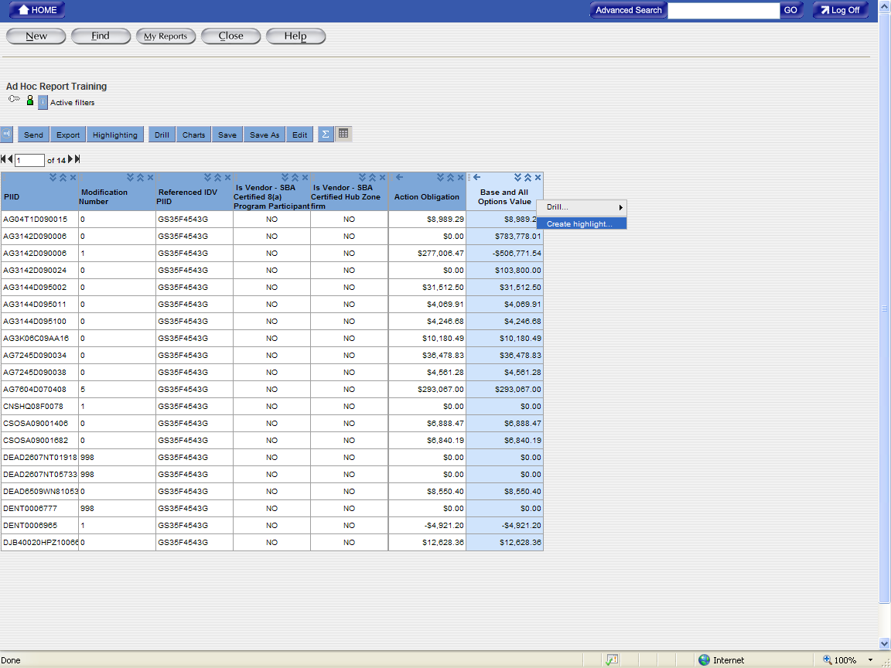
- Enter the following information:
Property | Required/optional | Description
Name the highlighting rule field | This field is required | This field is used to name the highlighting rule. After the highlighting rule is named and saved, it is stored in the report and it can be edited or deleted.
Specify numeric values for each field | These fields are required | The fields are used to specify numeric values for ranges for the metric or calculation.  The ranges must be in ascending order.
Then highlight | This function is optional | Select colors for each range of values. The system defaults with red for low numeric values, yellow for medium numeric values, and green for high numeric values.
Specify formatting for highlighting | This function is optional | Select the type of formatting you want to use for highlighting the range of numeric values. The system defaults with a background color for each numeric value.
- Click on “OK” to complete the creation of the highlighting rule. The highlighting rule will appear in the “Information” area and the highlighting rule will be displayed in the report result.

Modifying a Highlighting Rule
You can modify the name, value ranges, colors, format, state, and user access of a highlighting rule.

To Modify a Highlighting Rule
The following is the sample to modify a highlighting rule:
- To modify any aspect of the highlighting rule, click on the Information buttonand the highlighting rule name that you want to modify will be displayed on the screen.
- To change the state of a highlighting rule, click on the name of the highlighting rule and the highlight rule screen will appear.
On the highlighting rule screen, choose the “Inactive” to inactivate an active highlighting rule or choose the “Active” to re-activate an inactive highlighting rule.
- Make the necessary changes for the highlighting rule and click on OK to save the changes.

Deleting Highlighting Rules
When you delete a highlighting rule, the reporting tool deletes the highlighting from the report and no color specifications will be displayed in the report anymore.

To Delete a Highlighting Rule
The following is the sample to delete a highlighting rule:
- In the Information area, click on the name of the highlighting rule that you want to delete.
- Click on the “Delete” button to delete the desired highlighting rule. The reporting tool deletes the highlighting rule from the report result.

Adding Metrics to an existing Ad hoc Report

To Add Metrics to a Ad Hoc Report
To add a metric to an existing Ad Hoc Report:
- Click on the “Personal Folder” icon to locate the saved report.
- Click on the name of the report once to highlight the link for the report. If you click on the name of the report twice, the system will take you to the “Execution” page directly.
- Click on the “Edit” button to get into the design mode of the Ad Hoc report and the “Select Metrics” section will be the default section that is displayed on the screen.
- Click on the “Plus” sign that is listed in front of the “Award – IDV Information” folder. Some sub folders will be displayed on the screen.
- Click on the folder of the metric folder from where you want to add metrics. Do not click on the “+” sign from those sub folders because there are no more sub folders.
- After clicking on the folder for those sub folders, some metrics will be displayed at the right-hand side. Click on the metrics that will be added to the report.
- Click on the “Add” button for the desired metric. Multiple metrics can be added to the report. The selected metrics will be appearing in the box under the “Select Metrics” section.
- To remove a metric from a report, select the metric that will be deleted from the report and then click on the “Remove” button.
- To change the order of a metric in the report, click on the metric and then click on the “Move Up” or “Move Down” buttons. The order of the metrics that are listed under the Section 1 – Select Metrics determines the order in which the metrics will be displayed in the report result.
- Click on the “Save” button to save the report.

To Add an Attribute to an Existing Report
To add an Attribute to a report:
- Click on the “Personal Folder” icon to locate the saved report.
- Click on the name of the report once to highlight the link for the report. If you click on the name of the report twice, the system will take you to the “Execution” page directly.
- Click on the “Edit” button to get into the design mode of the Ad Hoc report and then click on Section 2 – Select Attributes; the “Select Attributes” section will be displayed on the screen.
- Click on the “Plus” sign that is listed in front of the “Award – IDV Information” folder. Some sub folders will be displayed on the screen.
- Click on the folder of the attribute folder from where you want to add attributes. Do not click on the “+” sign from those sub folders because there are no more sub folders.
- After clicking on the folder for those sub folders, some attributes will be displayed at the right-hand side. Click on the attributes that will be added to the report.
- Click on the “Add” button for the desired attribute. Multiple attributes can be added to the report. The selected attributes will be appearing in the box under the “Select Attributes” section.
- To remove an attribute from a report, select the attribute that will be deleted from the report and then click on the “Remove” button.
- To change the order of an attribute in the report, click on the attribute and then click on the “Move Up” or “Move Down” buttons. The order of the attributes that are listed under the Section 2 – Select Attributes determines the order in which the attributes will be displayed in the report result.
- Click on the “Save” button to save the report.

