Federal Procurement Data System
(FPDS)
System Administrator Training Manual - Civilian

February 28, 2024

Training Document Document Change History
Date | Version Number | Submitted By | Change Reference
1/31/2007 | 1 | Joan Lobato | Began initial review of the manual. Testing exercises and content.
7/29/2009 | 2 | Linda Hornsby | Updated screen shots as appropriate.
08/13/2009 | 3 | Jennifer Lou Strutt | Updated the contents and the screenshots as appropriate.
01/07/2010 | 4 | Linda Hornsby | Added the updated Navigation and Delivery Order screens. Updated the My Favorites screen. Added the Vehicle and OT reports to the How and What categories respectively.
01/18/2010 | 5 | Jennifer Lou Strutt | Reviewed the manual and corrected/updated the wording and screenshots throughout the whole manual.
11/16/2010 | 6 | Linda Hornsby | Added the current functionality for unsuccessful log on attempts. Made minor formatting changes.
12/01/2010 | 7 | Jennifer Lou Strutt | Updated the date of manual reflected on coversheet from May 25, 2010 to the last update of December 1, 2010.  Reviewed and updated all the information in the manual so that everything is up-to-date.
12/02/2010 | 8 | M. Dian Neary | Review of manual and updated various format issues.
03/26/2014 | 9 | M.Chen | Changed instances of Global Computer Enterprises (GCE) to Now.
12/22/2014 | 10 | Linda Hornsby | Changed instances of Serendipity Now to IBM.
4/1/2016 | 11 | Taylor Rodriguez | Removed instructions on creating and adding offices.
6/13/2016 | 12 | Dian Neary | Updated the new Civilian Funding and Contracting Office screens and information on the fields that are available to be edited on a given AAC.
03/13/2020 | 13 | Taylor Rodriguez | Removed instructions for managing offices.
10/17/2020 | 14 | Linda Hornsby, Aniqa Rashid | Review of manual and removal of instructions related to Reports.
11/06/2020 | 15 | Aniqa Rashid | Updated content related to login and added content related to Login.gov integration.
6/12/2021 | 16 | Aniqa Rashid | Updated vernacular throughout the document including:  - Updating any instance of ‘Vendor,’ ‘Contractor,’ ‘Company,’ and ‘Recipient’ to ‘Entity’.  - Updating any instance of ‘Vendor Name’ data element name to ‘Legal Business Name.’
1/29/2022 | 17 | IBM/Octo | Updated screenshots to reflect current system.
4/2/2022 | 18 | IBM/Octo | Updated screenshots to reflect current system.
6/24/2023 | 19 | IBM/Octo | - Updated date-format for End Date in “Searching for Locked/Disabled User” section.  - Added instruction to enter an End Date in “Enable a User” section.
2/28/2024 | 20 | IBM | - Removed references to System Administrator class and computer-based training.  - Added steps to request Agency System Administrator and link to request-form.

Stakeholders Acceptance Table
Version Number | Date Approved | *Project Stakeholders | Role/Responsibility

*All IBM projects have been reviewed and approved jointly with that project's stakeholders. Project stakeholders are clients and internal IBM employees whom have an equal responsibility towards a project's success.

Table of Contents
Section Page
1 INTRODUCTION 1
1.1 Manual Layout 1
2 COMMON SYSTEM FEATURES 2
2.1 Login Screen 2
2.2 Initial Login Screen 2
2.3 Expired Login Session 3
2.4 Navigation Screen 3
2.5 Web Form Toolbar 4
2.6 Search Function 5
2.7 Advanced Search 8
2.8 Exercise: Login Screen 13
3 SYSTEM ADMINISTRATION 14
3.1 Civilian Organizations 15
3.2 Organization 15
3.3 Requesting a New AAC 15
3.4 Funding and Contracting Offices 15
4 USER MANAGEMENT 17
4.1 General Functions: User Types 19
4.2 User Privileges 25
4.3 Available and Current Privileges 25
4.4 User Privileges for FPDS 25
4.5 Roles and User Privileges 26
4.6 Exercise: Users – General Functions 27

List of Tables
Table Page
Table 1. Training Manual Structure 1
Table 2. User Types Descriptions 26

List of Figures
Figure Page
Figure 1. General Login Screen 2
Figure 2. Expired Login Screen 3
Figure 3. Navigation Screen 4
Figure 4. User Management Standard Toolbar 4
Figure 5. User Selection Screen with existing information 5
Figure 6. User Selection Screen without existing information 6
Figure 7. User Selection Defined 7
Figure 8. User Selection Screen 7
Figure 9. Advanced Search Screen 8
Figure 10. Contract Search Results 10
Figure 11. Migrated PIID Search Results 11
Figure 12. FPDS Login Screen 12
Figure 13. FPDS Navigation Screen 13
Figure 14. Government Office Screen (Civilian Users) 15
Figure 15. User Management Screen 17
Figure 16. Government User Type 22
Figure 17. Available and Current User Privileges Screen 24

INTRODUCTION
This training manual is designed to act as a guide for authorized Agency System Administrators who operate the System Administration function within the Federal Procurement Data System (FPDS). To establish an authorized Agency System Administrator, the following form must be completed, signed by the Department/Agency authority, and sent to fpdscmanage@gsa.gov. System Administrator Registration Form
In addition to this training manual, further instruction is available via the following online tools:
- User Guide
- Help System

Manual Layout
This training manual provides how-to guides, exercises, and examples that describe the FPDS System Administration functions and processes. The training manual is an available resource tool for Agency trainers and other authorized users. The System Administrator Class participants are encouraged to use this manual at their respective work locations as a reference and tool for Agency in-house training.
Table 1 describes the training manual layout and design.
Table 1. Training Manual Structure
Manual Section | Section Purpose
Overview | Defines and explains the importance of each section.
How To | Provides answers to frequently asked questions with simple, easy to follow instructions.
Examples | Illustrates specific functions to provide understanding for section tasks.
Exercises | Exercises are used as a tool for class participants to gain hands on experience. The course exercises are discussed in class to measure and reinforce the participant’s comprehension.
Review | Summarizes topics that allow participants to work independently and provides feedback that is used as a performance measurement for training.

COMMON SYSTEM FEATURES

Login Screen
Government and Public users can register for an FPDS account by themselves via Login.gov. The users can access the initial FPDS login screen where they can click ‘Login’ to begin the login and registration process.
After registration:
- Public users are provided with the access to view records and generate queries within the FPDS system.
- Government users will not be able to log back into FPDS until the Agency System Administrator has approved the user profile and assigned the appropriate system roles.
If an existing FPDS Government user requires roles within an additional Activity Address Code (AAC) than those already assigned to the current user profile, their Agency System Administrator may create additional user profiles for the user.
Note: Agency and Non-Agency personnel that will not be entering data in FPDS may not have an Agency System Administrator.

Initial Login Screen
The following figure is the Login screen, which is the initial screen provided for the FPDS users. To log into FPDS, the users click on the button. Upon clicking the ‘Login’ button, users will be re-directed to Login.gov to begin the login process. The initial FPDS Login Screen is show below.
Figure 1. General Login Screen

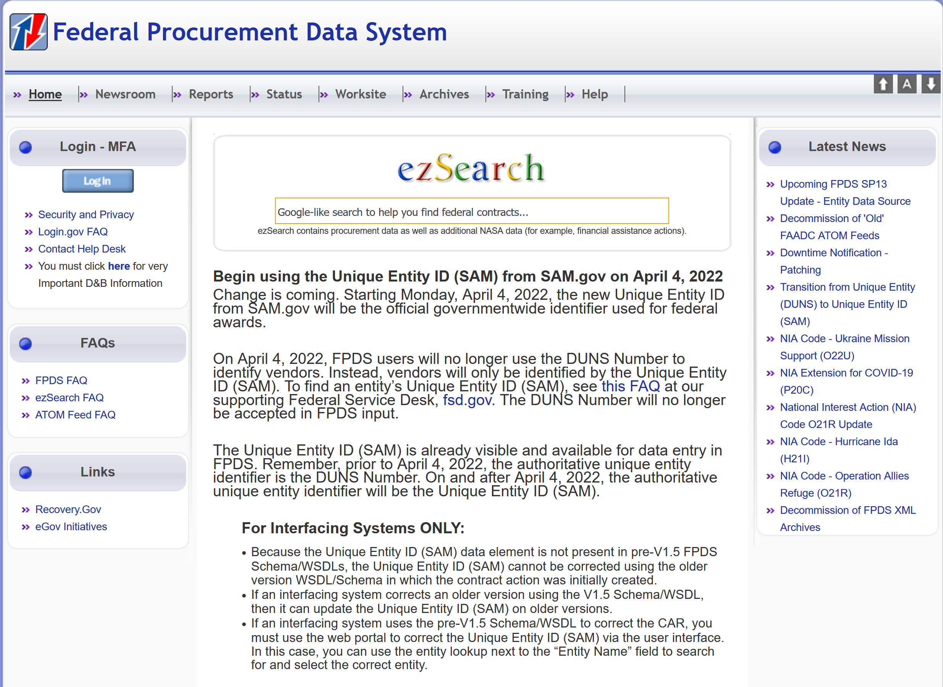

Expired Login Session
If the users stop using the FPDS system after 15 minutes, the FPDS system will automatically end the users’ sessions. The users will need to click on the button to log into the FPDS system again. On a successful login, the FPDS system will open the Navigation screen, which is shown in the following section.
Figure 2. Expired Login Screen

Navigation Screen
The FPDS Navigation screen that is shown in the following figure is organized in five sections: Awards, Basic IDVs, Transactions/Modifications, System Administration, and Reports. Each section contains a list of tasks that are related to the section and each task links to a specific Web-based form on which users enter and submit data in FPDS. The Reports section allows the user to search for data within FPDS. Please note that the FPDS standard and ad-hoc reports functionality has been decommissioned and has been migrated into https://www.sam.gov/.
Figure 3. Navigation Screen
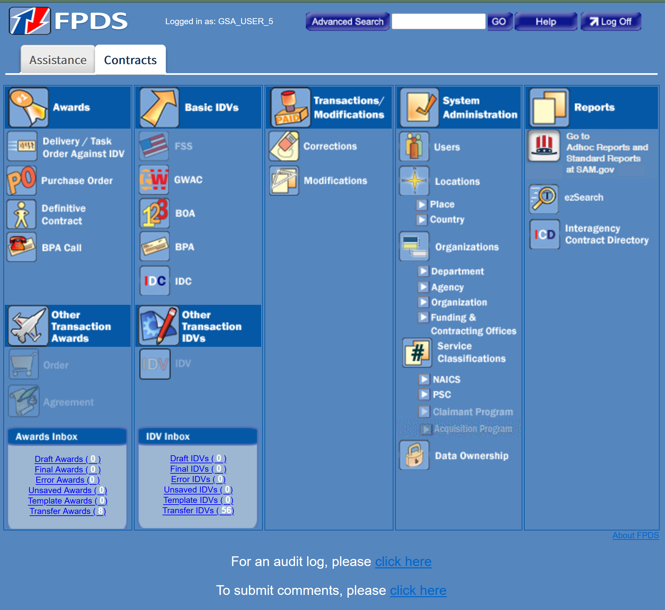

Web Form Toolbar
The search functions are available throughout the System Administration section in FPDS. The Agency Administrators can use those functions to access their users’ FPDS accounts and the Funding/Contracting Offices that belong to their agencies. The Agency Administrators have the privileges/authorities to create/update Funding/Contracting Offices for their agencies in the FPDS system.
A standard toolbar, which is similar to the one that is listed in Figure 4, is available for each Web form. For example, the following toolbar is located at the top of the Users screen. The agency administrators will see the toolbar after clicking on the “Users” icon, which is located under the “System Administration” section.
Figure 4. User Management Standard Toolbar
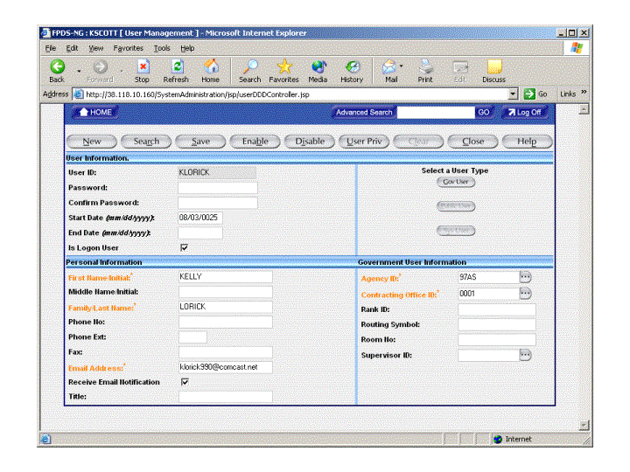

Search Function
The Search function is one of the common features in the FPDS system. For example, to search for the users in the Web forms, the Agency Administrators can click on the “Search” button that is located on the standard toolbar that is shown in Figure 4. The Search function is available for all the administrators and other users who have the privileges to perform the searches in the FPDS system.

Use the Search Function to Find a User
- From the Navigation screen, click on the “Users” icon  that is located under the System Administration section.
- Click on the “Search” button that is located at the top of the User Management screen on the standard toolbar.
- The User Selection screen will be displayed like what is shown in Figure 5 and the users’ own information will be displayed on the screen.
Figure 5. User Selection Screen with Existing Information
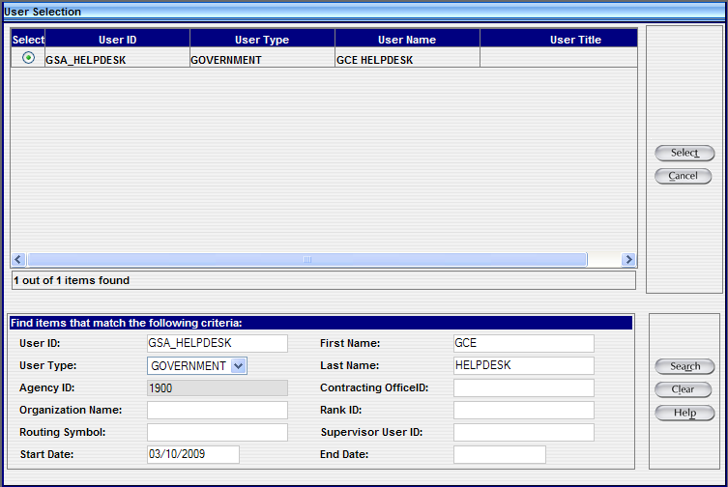

- Click on the “Clear” button that is located on the bottom right corner of the screen to remove the users’ own information. After clicking on the “Clear” button , the original information will be deleted and most of the fields will be blank.
The “User Type” field will always be defaulted to “GOVERNMENT” and the “Agency ID” field may be defaulted to the users’ agency IDs that are listed on their FPDS account profiles.
Figure 6. User Selection Screen without existing information
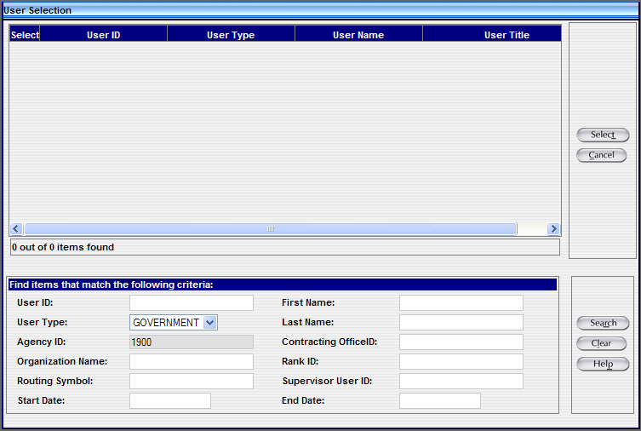

- In the User ID field, located in the lower left corner of the screen, type in a user ID.
For example, enter T% to find all User ID’s beginning with the letter T.
- Click on the “Search” button that is located at the lower right corner of the screen.
Note: The “%” sign is the wildcard character that may be used in the data entry fields; the agency administrators can use a wildcard to search for their users after entering the first part of the data string. For example, when the agency administrators enter “T%” in a “User ID” field, the search will return a list of the user IDs that start with “T”; for example, Thomas.Brown@XXX.gov, Todd.Smith@XXX.gov, Timharris…etc.
- A list of the User IDs will be displayed on the “User Selection” screen based on the search criteria that are used by the agency administrators; like what is shown in Figure 7.

Figure 7. User Selection Defined
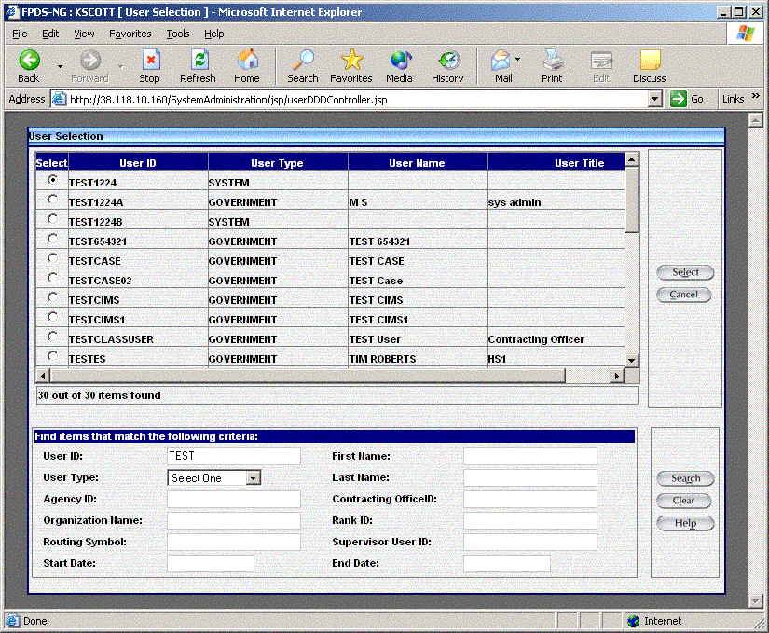

- After locating the user’s FPDS account, select the “Radio” button that is located in the “Select” column that is shown in Figure 7.
- After selecting the account, click on the “Select” button that is located at the top right corner to open the User Information.
The information based on the search criteria will be displayed on the User Information screen, which is shown in the following figure.
Figure 8. User Selection Screen
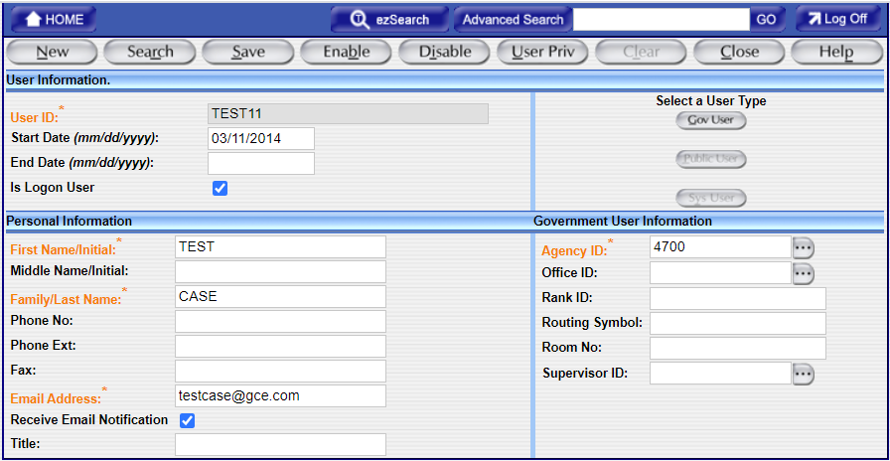

Searching for a Locked/Disabled User
The users that are locked/disabled in the FPDS system will not be displayed in the search results without using the “End Date” field on the search screen.
To search for the locked/disabled users in the FPDS system, a general date will need to be entered (mm/dd/yyyy) in the “End Date” field. The “End Date" value will need to be at least one day prior to the date that the users were created in the FPDS system.
- The date the user was created in FPDS is listed in the “Start Date” field, which is reflected on the User Information screen.
For example: If the user was created in the FPDS system on January 1, 2004 but is disabled in the system, the Agency Administrators can type in a date of December 31, 2003 (12/31/2003) in the “End Date” field.
If you are unsure when the users were created in the FPDS system, but you knew it was before January 1, 2004, you can use any prior date (i.e. 10/01/2003, or 12/10/2003) for the “End Date” field. The FPDS system will display a list of locked and disabled user accounts that have been locked/disabled after the “End Date” value for your agency.
Note 1: Fewer search criteria will produce more results; however, to search the list of users without using a criteria selection, leave all fields blank in the search area that is shown at the bottom of Figure 7and then click on the “Search” button . When the matching criteria fields are empty, the generated list contains a larger selection of the users.
Note 2: Due to the volume of data in FPDS, the search results are limited to a portion of the data available, such as the first 400 records. It is recommended that the agency administrators always enter search criteria to narrow down the search when possible.

Advanced Search
The Advanced Search feature allows the users to perform complex searches for an Award or IDV by using various search criteria. The users can use the PIID number (Procurement Instrument Identifier) or other data fields to perform the Advanced Search. The PIID number is a unique number (in most cases the Contract Number) that is given to the document.
The Data Dictionary that is listed on the FPDS website has all the information for all the data elements in the FPDS system.

Figure 9. Advanced Search Screen
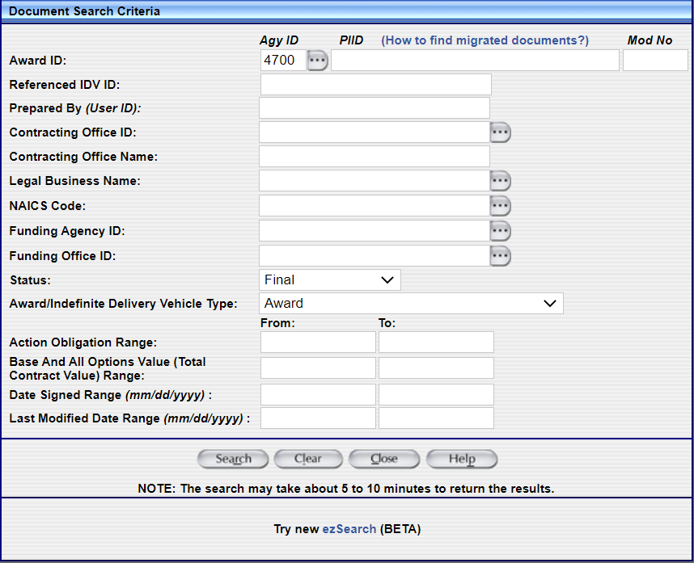
    - Advanced Search Procedure
- To use the detailed Advanced Search feature, the users will need to enter information in at least one or more of the following fields according to the search rules that are defined below.
Note: If the users do not enter information into at least one of the minimum fields, an error message will display: At least one of the fields “Agency ID”, “PIID”, “Prepared By”, or “Legal Business Name” is required. If you use a wildcard (%) for Agy ID, PIID, or Prepared By (User ID) fields, you will still need to enter the minimum number of characters for the respective fields according to the rules below.
- Agy ID (Agency ID) - This value for the Agency ID field is defaulted to the users’ agency ID that is listed on their FPDS account profiles. The users can use the “Ellipsis” button to search for other agency IDs.
For the DoD users, the Agency ID field is still defaulted to the users’ Agency ID that is listed on their FPDS account profiles, but the DoD users will need to change that value from XXXX to 9700 in order to search for any DoD record.
- PIID - The users will need to use at least 4 characters in this field.
- Prepared By (User ID) - There is no minimum constraint on this field.
- Legal Business Name - You must enter at least 3 characters in this field. The users can use the “Ellipsis” button to search for other entity names.
- In the remaining fields, you may enter other information to customize your search. For most fields, you may use the wildcard (%) or you may use the “Ellipsis” button to search for the data from the existing list.
- The users can use the Contracting Office IDs to perform the searches.
- The users can use the Contracting Office Names to perform the searches.
- The users can use the NAICS Code to perform the searches.
- The users can use the Funding Agency ID to perform the searches.
- The users can use the Funding Office ID to perform the searches.
- Select “Final” for the “Status” field if the users want to want to search for the FINAL records.
- The users can use the “Action Obligation” value to search for records that match within a range of the dollar threshold.
- The users can also use the “Base and All Options Value” field to search for records that match within a range of the dollar threshold.
- The users can use the “Date Signed” field to perform the searches. The dates will need to be entered in mm/dd/yyyy format.
- The users can use the “Last Modified Date” field to perform the searches. The dates will need to be entered in mm/dd/yyyy format.
- Click on the “Search” button and a list of documents will be displayed on the screen that matches with the search criteria the users have specified.
- The users can click on the link of the document to view the detail information of the record.
Figure 10. Contract Search Results
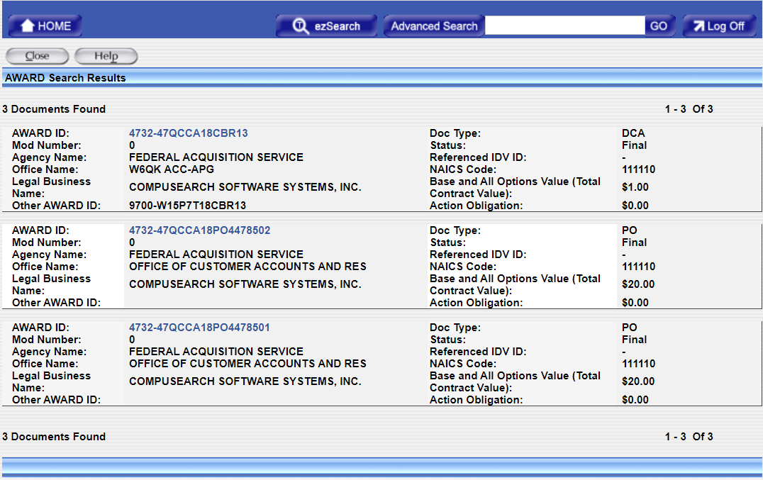

    - Migrated Documents
- To find a migrated document, click on the “Advanced Search” button that is listed on the main navigation screen. After clicking on the “Advanced Search” button , the Advanced Search screen will be displayed.
- For migrated IDVs, the PIID is the same as the original contract number. Enter the contract number in the PIID field.
- For migrated Awards, enter the PIID as a combination of the following:
- Contracting Office Code - This code must be 5 characters long. Add as many leading zeroes as needed.
- Action Date - This date is in the format YYYYMM.
- Contract Action Type - This is a single character (A, B, C, D) that represents the award type (A - BPA CALL, B - Purchase Order, C - Delivery/Task Order, D - Standalone Contract).
- Order Number (if it exists), and
- Contract Number.
- The users can click on the “Search” button and a list of documents will be displayed.
Figure 11. Migrated PIID Search Results

- The users can click on the link of the document to view the detail information of the record.
Example: To find a Delivery Order created in October 1995 based on the following criteria:
  - Agency - U.S. Coast Guard
  - Contracting Office – 23
  - Order Number - DTCG2394FTACX01
  - Contract Number - DTCG2391DTTMB12
The PIID would be calculated by the following:
  - 00023 (Contracting Office ID with leading zeroes)
  - + 199510 (Action Date in YYYYMM format)
  - + C (Contract Action Type - Delivery Order)
  - + DTCG2394FTACX01 (Order Number)
  - + DTCG2391DTTMB12 (Contract Number)
The resulting PIID would be 00023199510CDTCG2394FTACX01DTCG2391DTTMB12. The users can use the complete PIID to perform the searches or the users can use a portion of the PIID with a trailing wildcard (%) to locate the documents.

2.8 Exercise: Login Screen
The Login screen that is shown in Figure 12 is used to sign into the FPDS system. To begin the course exercises, the users can follow the steps below to log into the FPDS system.
- To open the FPDS website, the users can go to the website’s URL that is provided by the instructor and enter the following information to get into the Navigation screen.
- Click on the “Log In” button to be redirected to the Login.gov login screen.
- Enter your Login.gov username and password and click “Sign In”.
- Enter your security code generated from your chosen authentication method and click “Submit” to be redirected to the Navigation screen of the FPDS system.
Figure 12. FPDS Login Screen

SYSTEM ADMINISTRATION

The “System Administration” section can be accessed via the Navigation screen of the FPDS system like what is shown in Figure 13. The System Administration section allows the Agency System Administrators to add and modify their users’ FPDS accounts. The System Administration is divided into the following two administrative tasks:
- Users
- Funding & Contracting Offices
Figure 13. FPDS Navigation Screen
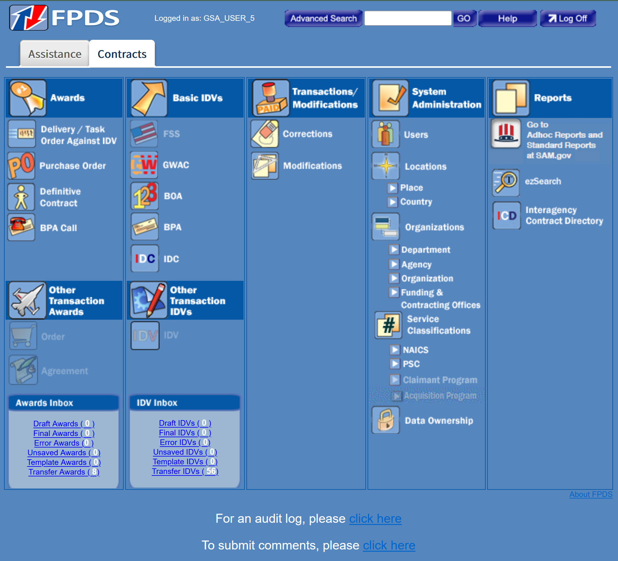

Civilian Organizations

The civilian agencies are now using the SAM.gov site to establish Departments, Agencies, and Activity Address Codes (AACs). All fields shall be disabled and grayed out on the Government Office screen for Civilian users. Civilian users will only be able to view their Office information in FPDS. For any updates, please go to https://www.sam.gov/.

3.2 Organization
The existing civilian hierarchy in the FPDS system can be described as follows: Department → Agency → Contracting Office Region → Contracting Office. Contracting and Funding Offices that were established when the FPDS System Administrators were creating them within FPDS were ‘End Dated’ on March 31, 2016. Activity Address Codes (AACs) were created through the DoDAAD system from April 1, 2016 until December 19, 2019. AAC creation and management is done through the SAM.gov site starting December 20, 2019. Civilian agency points of contact for obtaining an AAC are on the AAC Contact List maintained by the General Services Administration and can be found at https://www.gsaadvantage.gov/images/products/elib/pdf_files/aac.pdf

3.3 Requesting a New AAC
If you need to obtain a new AAC when there is a change in the Department/Agency’s hierarchal structure, go to https://www.sam.gov/.

3.4 Funding and Contracting Offices
The Government Office screen that is shown in Figure 14 is used to reflect the Funding and Contracting Offices. The Funding Office is used to track contract awards for offices that are not established as a Contracting Office. The Funding Offices are referenced in the Award and IDV document section in the FPDS system as the Funding Office and this field indicates the records that have been funded by specific offices.
The Contracting Office allows the System Administrator to designate Agency Contracting Office profiles to track contract awards that are reported in the FPDS system. These reported contracts are entered in the Award or IDV section in the FPDS system. The Contracting Office field indicates the records that have been awarded/procured by specific offices.
The Maintenance screen is used to view the Funding and Contracting Offices details.

Figure 14. Government Office Screen (Civilian Users)
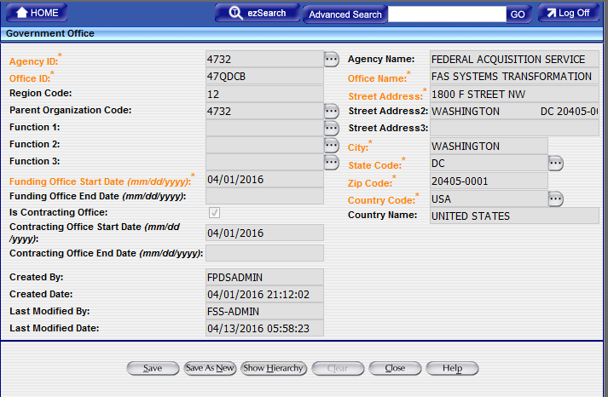

3.4.1 How to Find a Government Office

- From the FPDS home page, click on the “Funding & Contracting Offices” icon that is located under the System Administration section. The Government Office Selection Screen will be displayed, which is like the following screen:
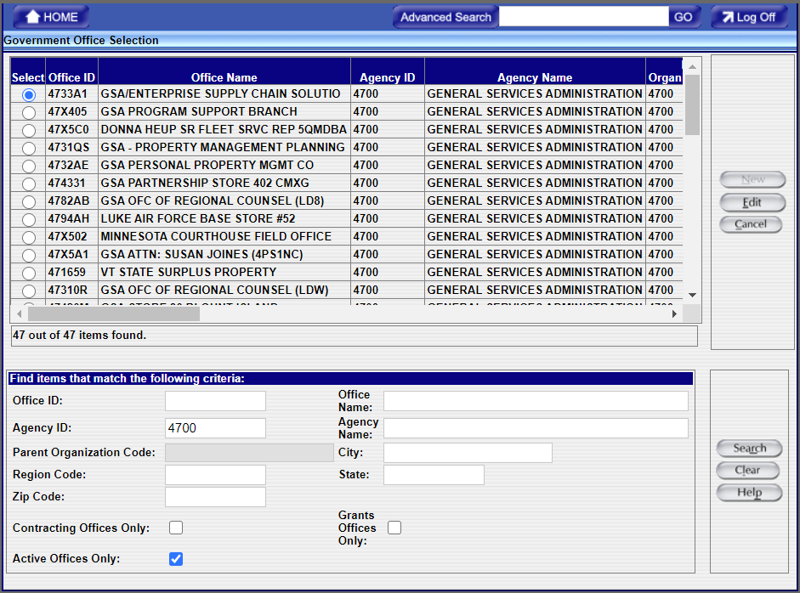

- In the Agency ID field, which is located on the bottom of the screen, enter the Agency ID 4700.
- Click on the “Search” button that is located on the lower right corner of the screen.

- The search criteria information generates the Government Office information for the Agency 4700 in the Government Office Selection Screen on the next page.

- After the search results are displayed on the screen, you can click on the “Radio” Button that is located in the “Select” and select either the Region or Funding Office field for a specific office.

- Click on the “Edit” button that is located in the upper right corner to open the “Government Office” screen. Once you select the “edit button you will see the screen that is shown previously in Figure 14.
- After the information is updated, you can click on the “Close” button to close the page.

USER MANAGEMENT
The User Management screen that is shown in Figure 15 allows the Agency System Administrator to create, update, and enable/unlock/disable the users that belong to their agencies. The Agency System Administrators have the ability to view and update their users’ account profiles and assign privileges to their users’ FPDS accounts.
Figure 15. User Management Screen
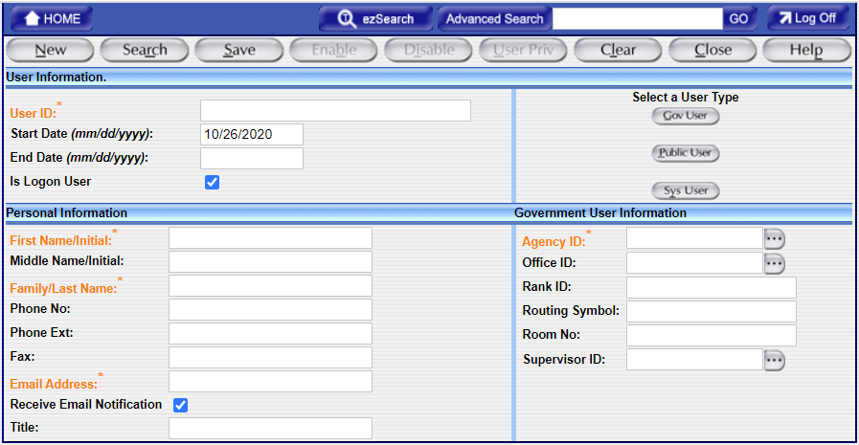

General Functions: User Types
The user types are defined in three categories as it is shown in Table 2. The Agency System Administrators can create, control, and monitor the users’ FPDS accounts that belong to their agencies. The Government Agency users are created as a “Gov User” type and the Agency System Administrators can only create, control, and monitor the “Gov User” type. The “Sys User” Type is created, controlled, and monitored through the FPDS System Administrator. When the Public users register with the FPDS system, their accounts are created as the “Public User” type.
Table 2. User Types Descriptions
User Types | Definition | Security Access
Sys User | System User Interface | Establishes a link between the Contract Writing Systems (CWS) and the FPDS system. The “Sys User” accounts are created, controlled, and monitored by the FPDS System Administrator.
Gov User | Agency personnel | The Government users’ FPDS accounts should be created by their administrators. The Agency System Administrators should create the accounts for their users and assign proper privileges to their users’ FPDS accounts. The users can only access the FPDS system to perform certain tasks based on their user privileges. The user privileges are controlled by the Agency System Administrator.
Public User | All non-agency users | The Public users can register with the FPDS system directly. They can only view the data and generate queries in the FPDS system; they cannot touch any data in the FPDS system.
    - How to Find, Add, and Modify User Accounts
      - Find a User
- Log into the FPDS system as yourself (the Agency System Administrator) and you will see the main Navigation screen. From the Navigation screen, click on the “Users” icon that is located under the “System Administration” section.
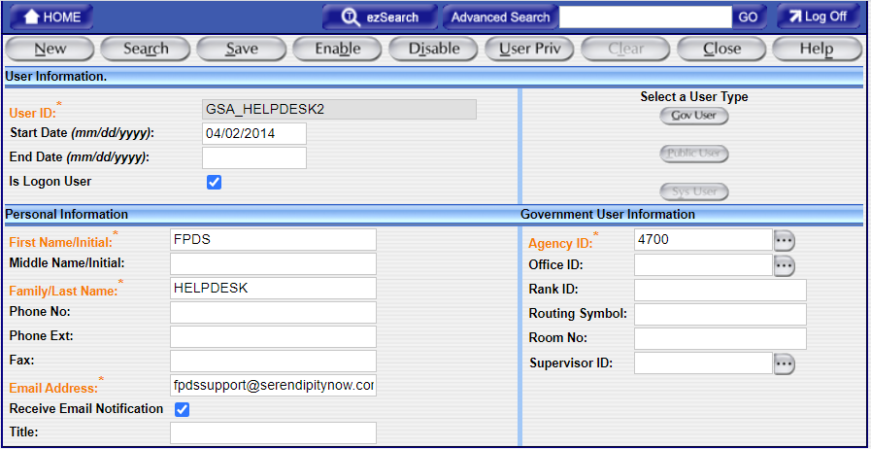
- After clicking on the “User” icon, you will see your own profile information. Click on the “Search” button that is located on the top of the User Management screen.
- The FPDS system will display the “User Selection” screen and your own information will be displayed on the screen.

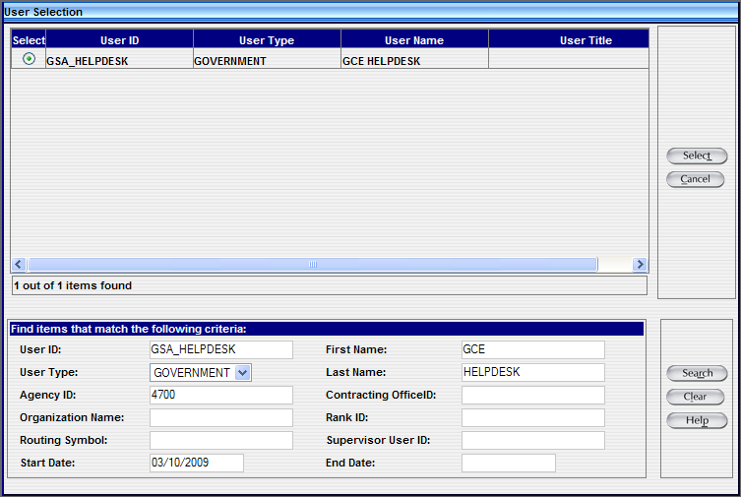
- Click on the “Clear” button to remove your information.
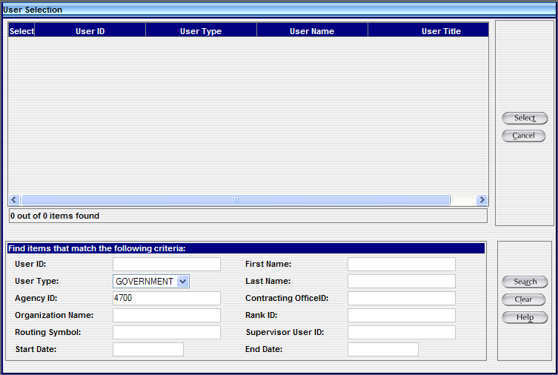
- In the “User ID” field, enter the ID or the First Name and/or Last Name of the user that you want to search in the FPDS system and then click on the “Search” button .
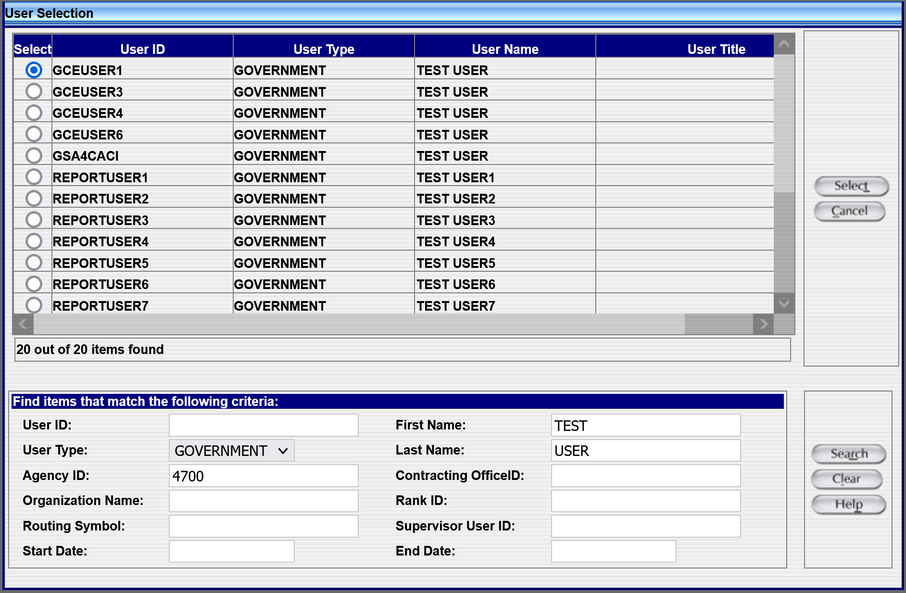
- If you are searching for a specific user, that user’s account will be displayed on the screen. If you are not sure about the ID or the First Name/Last Name of the user, you can use the wildcard “%” to perform the search. When using the wildcard “%” to perform the search, a list of the users will be displayed on the screen based on the search criteria you have entered.
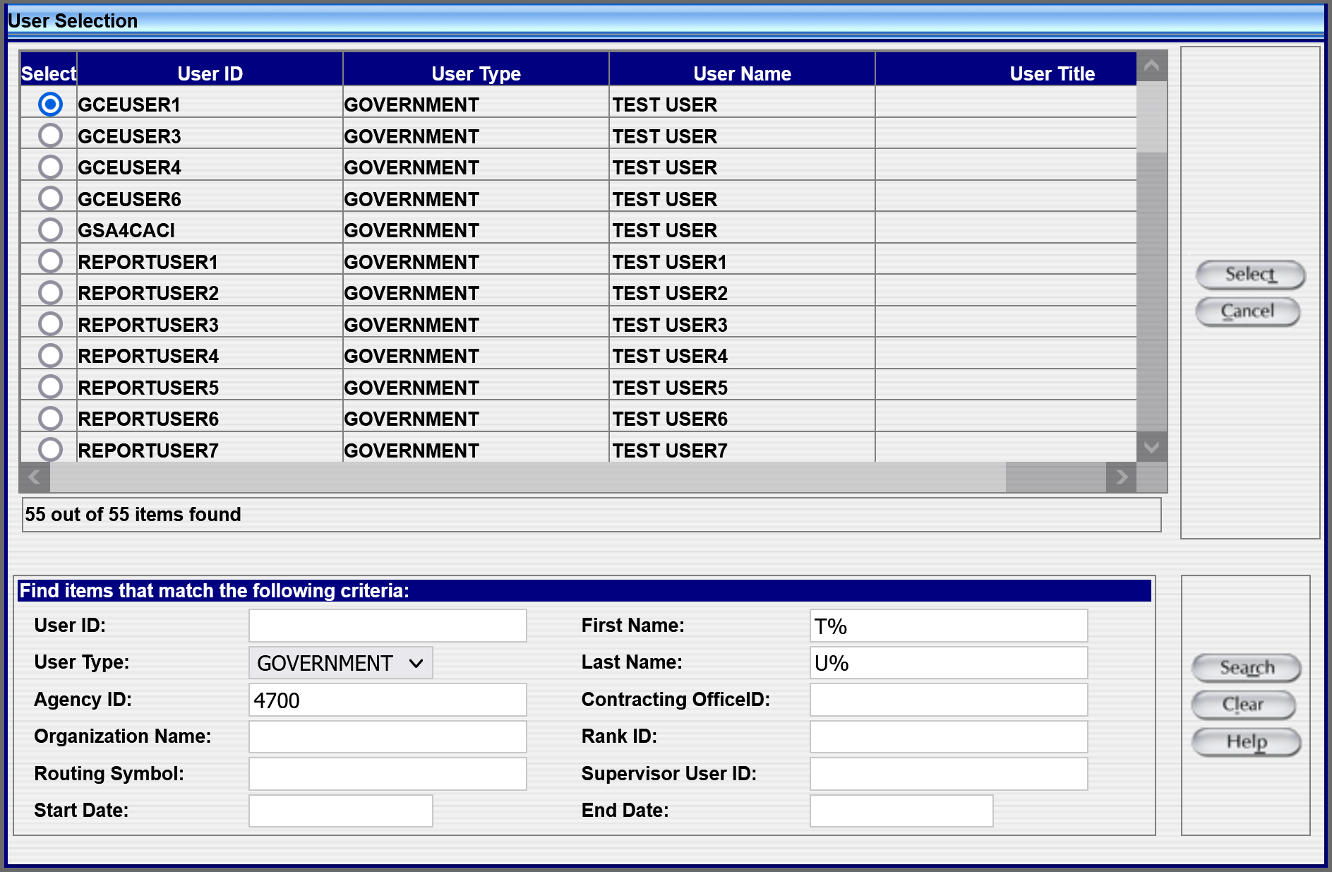
- To select the user from the list, click on the Radio Button located in the “Select” field.
- Click on the “Select” button to access that user’s FPDS account information.
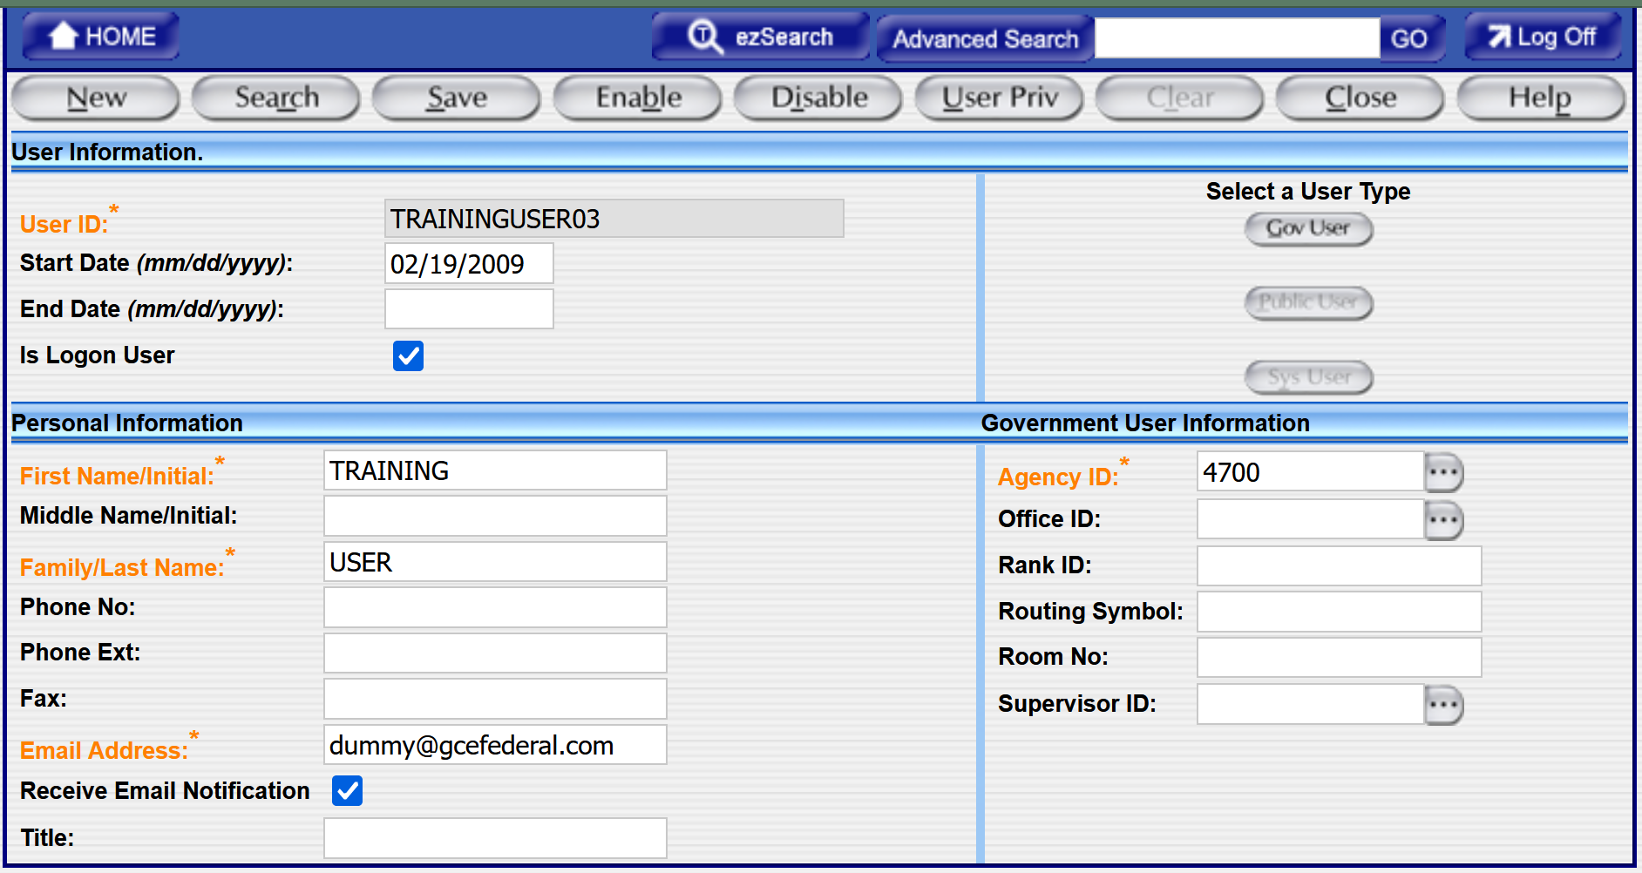
- Close the “Close” button to close the User Management screen.
      - Add a Government User
- From the Navigation screen, click on the “Users” icon that is listed under the “System Administration” section.
- Click on the “New” button from the toolbar.
- Click on the “Gov User” button that is listed under the “Select a User Type” section so that the account can be created as a Government user account.
- The FPDS system will display a blank User Information screen that corresponds to the User Type that has been selected. In Figure 16, the information screen is for a Government User.

Figure 16. Government User Type
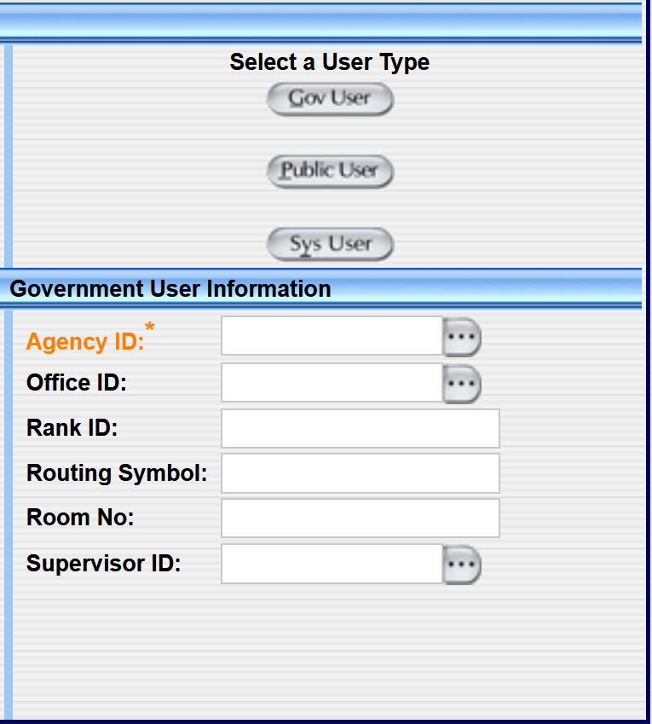
- The Government Users’ profiles and privileges are used to access, maintain, track, and report contract awards in the FPDS system. The privileges that are assigned to the users’ FPDS accounts will determine the level of access the users have in the FPDS system.
- Enter the User Information in the fields that are displayed on the screen. The fields that are marked in orange color are mandatory fields and the Agency System Administrators will need to provide the valid information for those fields.
- In order to determine whether the users have the right to log into the FPDS system directly from the website, the Agency System Administrators will need to check the “Is Logon User” checkbox .
Note: If the Is Logon User box is not checked , the users will not be able to log into the FPDS system directly from the website. This is the default.
- In order to determine whether the users will receive email notifications or not, the Agency System Administrators will need to check the “Receive Email Notification” checkbox .
Note: If the Receive Email Notification checkbox is not checked , the users will not receive notification about the account changes/updates that are sent out from out automatic system.
- After all the mandatory information is completed, click on the “Save” button to save the information.
      - Disable a User
- From the Navigation screen, click on the “Users” icon that is listed under the “System Administration” section.
- Click on the “Search” button that is located at the top of the User Management screen.
- The FPDS system will display the “User Selection” screen.
- You can use the user’s user ID or the First Name/Last Name to perform the search. After entering the search information, click on the “Search” button to perform the search.
- After locating the user’s information, click on the “Select” button to open the User Information for that specific user.
- Click on the “Disable” button that is located at the top of the User Management screen to disable the user’s account.
Note: The system enters an End Date of today’s date, which means the user’s account becomes inactive from today.
- Click on the “Save” button to save the changes.
- Click on the “Close” button to close the User Information page.
      - Enable a User
- From the Navigation screen, click on the “Users” icon that is listed under the “System Administration” section.
- Click on the “Search” button located at the top of the User Management screen.
- The FPDS system will display the “User Selection” screen.
- You can use the user’s User ID or the First Name/Last Name to perform the search. To find disabled/locked User IDs, a general date (ex: 01/01/2000) must be entered in the “End Date” field. After entering the search information, click on the “Search” button to perform the search.
- After locating the user’s information, click on the “Select” button to open the User Information for that specific user.
- Click on the “Enable” button located at the top of the User Management screen to enable the user’s account.
Note: The system will remove the date value from the “End Date” field and the user’s account becomes active from today.
- Click on the “Save” button to save the changes.
- Click on the “Close” button to close the User Information page.

User Privileges
The User Privileges are located in the User Management screen. The Available and Current User Privileges are shown in Figure 17. The user privileges determine the actions that the users can perform in the system. The privileges are assigned to the users based on the users’ user privilege groups that the users belong to. A user that is created under the Agency System Administrator user privilege group will have privileges that are associated with the Agency System Administrator user privilege group.
Figure 17. Available and Current User Privileges Screen
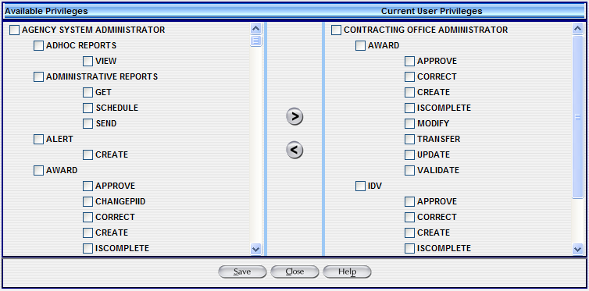

Available and Current Privileges
The selections in Available and Current Privileges are designated for the personnel that function in this capacity. These privileges allow modifications of the IDV (Indefinite Delivery Vehicle) and Award documents. The “Available Privileges” section includes the privileges that the System Administrators can assign to their users and the “Current User Privileges” section included the privileges that the users have, which give them authorities to perform certain actions in the FPDS system.

User Privileges for FPDS
The user privileges that are shown in the users’ profiles provide the levels of privileges that the users can do in the FPDS system based on the roles that are assigned to the users’ FPDS accounts.

Roles and User Privileges
There are three levels of user privileges – Agency System Administrator, Contracting Office Administrator, and Contracting Officer/Specialist. These privileges are defined by roles that are assigned to the User ID.
    - How to Add and Modify User Privileges
      - Assign User Privilege
- From the Navigation screen, click on the “Users” icon that is listed under the “System Administration” section.
- Click on the “Search” button located at the top of the User Management screen.
- The FPDS system will display the “User Selection” screen.
- You can use the user’s user ID or the First Name/Last Name to perform the search. After entering the search information, click on the “Search” button to perform the search.
- A list of users will be displayed on the screen based on the search criteria that you have specified.
- To select the user from the list, click on the Radio Button that is located in the “Select” field.
- After locating the user’s information, click on the “Select” button to open the User Information that you want to modify.
- To assign or modify the user privileges for the selected user, click on the “User Priv” (User Privileges) icon .
- To add an Available Privilege to the selected user’s Current User Privileges, select it from the Available Privileges list.
- Click on the “Directional Arrow” icon and the selected privilege will be added to the user’s Current User Privileges list.
- Click on the “Save” button to save the users’ user privilege information.
- Click on the “Close” button to close the User Privilege screen.
      - Remove User Privilege
- From the Navigation screen, click on the “Users” icon that is listed under the “System Administration” section.
- Click on the “Search” button that is located at the top of the User Management screen.
- The FPDS system will display the “User Selection” screen.
- You can use the user’s user ID or the First Name/Last Name to perform the search. After entering the search information, click on the “Search” button to perform the search.
- A list of users will be displayed on the screen based on the search criteria that you have specified.
- To select the user from the list, click on the Radio Button that is located in the “Select” field.
- After locating the user’s information, click on the “Select” button to open the User Information that you want to modify.
- To assign or modify the user privileges for the selected user, click on the “User Priv” (User Privileges) icon .
- To remove a privilege from the selected User’s Current Privileges, select it from the Current Privileges list.
- Click on the “Directional Arrow” icon and selected privilege will be removed from the user’s Current User Privileges list.
- Click on the “Save” button to save the users’ user privilege information.
- Click on the “Close” button to close the User Privilege screen.

Exercise: Users – General Functions
    - Add a Government User
This exercise provides instructions for creating a Government User Account.
- From the Navigation screen, click on the “Users” icon that is listed under the “System Administration” section.
- To create a new User Account, click on the “New” button that is listed on the top of the User Management screen.
- Click on the “Gov User” button that is listed under the “User Type” section. The FPDS system defaults the selection to “Gov User”.
- Enter the User Information for the new account.
- User ID: You can enter a User ID by using the “first initial and last name” without any spaces.
Example: EJones
- Start Date: The Start Date field is populated with today’s date. Leave this date field with the default date.
- End Date: Leave this field blank. Entering an End Date will disable the user when the date is current.
- Is Logon User: This field defaults with a check mark. Do not change the default setting unless the users are not accessing the FPDS system directly from the website.
Note: If the Is Logon User box is not checked, the user will not be able to login to the web interface for FPDS.
- Enter Personal Information for the user.
- First Name/Initial: Enter your “first name or initial” in this field.
- Middle Name/Initial: Enter your “middle name or initial” in this field. This field is optional.
- Last Name: Enter your “last name or initial” in this field.
- Phone No: Enter “703-555-5000”.
- Phone Ext: Enter “2532”.
- Fax: Enter “703-555-8700”.
- Email Address: Enter “your email address”. This address is the same email address used to sign into Login.gov and used by FPDS to send FPDS information to the user via email (e.g., batch processing information, user profile information, etc.).
Example: classuser@IBM.com
- Receive Email Notification: This field defaults with a check. Do not change the default setting.
Note: If the Receive Email Notification box is not checked, the user will not receive notification on batch transactions.
- Title: Enter “Your Agency Title” in this field.
Example: Contracting Officer
- Enter the Government User Information.
- Agency ID: The Agency ID is 4700.
- Office ID: Enter “AAA00” in the Contracting Office ID field, or click on the “Ellipsis” button to select an existing ID.
- Rank ID: Enter “Rank ID” if applicable to you. This field is for Military personnel only.
- Routing Symbol: Enter “UVF”. This field represents an internal routing system for sending information to offices within an Agency.
- Room No: “102”.
- After entering the Government User Information and data in all required fields are completed, select to save the new User Account.
- The User Management Screen displays the message “User Successfully Created” under the toolbar located at the top of the screen.
- Click on the “Close” button to close the User Privilege screen.
    - Add User Privileges
This exercise demonstrates how to add and modify User Privileges. Initially New User Accounts are created without privileges in FPDS. The user you just created in Exercise 4.6.1 will need rights added to the Current User Privilege list. Follow the steps below to assign User Privileges for the new User.
- To add Privileges for a new or existing user, click on the “User Priv” button that is located on the top of the User Management screen.
- After clicking on the “User Priv” button , the FPDS system will take you to the privilege screen.
  - Available Privileges: Select the “Contracting Office Administrator” from the Available Privileges, which is listed on the left-hand side of the screen.
- After selecting “Contracting Office Administrator” from the list, click on the “Directional Arrow” icon to add these privileges to the Current Privileges area, which is listed on the right-hand side of the screen.
- Click on the “Save” button that is located at the bottom of the screen to save the user privilege information. The message that the user privileges are successfully updated will be displayed at the top of the screen.
- Follow the steps below to log into the FPDS system with the new user that you have just created and verify the privileges that have been assigned to the new account.
- Click on the “Close” button located at the bottom of the screen to return to the User Management page.
- Click on the “Log Off” button that is located at the top right corner of the User Management Screen to log off from the FPDS system.
- After clicking the “Log Off” button, the FPDS system will take you back to the main login screen.
- Sign into the FPDS system by clicking on ‘Login’.
- The system will re-direct you to the interfacing authentication platform, Login.gov. Login with email address associated to the user profile you have created. If this email address does not have an associated Login.gov account, create an account and sign in.
- The FPDS system will then take you to the main Navigation Screen.
- The available features on the Navigation screen are shown based on the user’s user privileges. The users can only access certain features in the FPDS system based on their hierarchy and the user privileges.
- You can try to access Contracting Office or Government Office under the Organization task and you will notice that you do not have privileges for this section of the FPDS system.
- Click on the “Log Off” button to log off from the FPDS system.
- Log back into the FPDS system with the Test User account that you were assigned at the beginning of class. You can log back into the FPDS system to update the user profile and the privileges of the new account that you have created.
    - Find a User
This exercise demonstrates how to find existing User Accounts. The instructions will guide you through the process of using the system search features.

This exercise demonstrates how to find the existing User Accounts.
From the Navigation screen, click on the “Users” icon that is listed under the “System Administration” section.

- Click on the “Search” button that is at the top of the User Management Screen.
- The FPDS system will display the “User Selection” screen.
- Click on the “Clear” button to remove the existing information in the User Criteria Fields.
- Enter the User ID you have just created in the first exercise (section 4.6.1 Add a Government User) in the User ID field.
- Click on the “Search” button that is located in the lower right corner of the screen.
- If more than one account is displayed in the User Selection field, click on the Radio Button that is listed next to the User ID you want to select.
- Click on the “Select” button to open the User Selection information.
- The FPDS system will display the User Management Screen with the User information selected.
- Click on the “Close” button to close the User Management screen.
    - Disable Users
This exercise demonstrates disabling a user account. A user cannot be deleted in the FPDS system as soon as the account is saved/established. If you do not want the users to access the FPDS system directly or from your Contract Writing Systems (CWS), you will need to disable the users’ FPDS accounts.
From the Navigation screen, click on the “Users” icon that is listed under the “System Administration” section.
- Click on the “Search” button that is at the top of the User Management Screen.
- The FPDS system will display the “User Selection” screen.
- Click on the “Clear” button to remove the existing information in the User Criteria Fields.
- Enter the User ID you have just created in the first exercise (section 4.6.1 Add a Government User) in the User ID field.
- Click on the “Search” button that is located in the lower right corner of the screen.
- If more than one account is displayed in the User Selection field, click on the “Radio” Button that is listed next to the User ID you want to select.
- Click on the “Select” button to open the User Selection information.
- Click on the “Disable” button that is located at the top of the screen to disable the user’s FPDS account.
- The FPDS system will enter today’s date in the End Date field, which means the user’s account is disabled since today.
- The User Management Screen will display the message that the user’s account has been disabled.
- Click on the “Save” button to save the changes.
- The User Management Screen will display the message User Successfully Updated
- Click on the “Close” button to close the User Management screen.
    - Enable Users
The User ID you previously added now has a disabled user profile status. This exercise demonstrates how to enable the user’s FPDS account for the user to re-gain the access to the FPDS system.
From the Navigation screen, click on the “Users” icon listed under the “System Administration” section.
  - Click on the “Search” button that is at the top of the User Management Screen.
  - The FPDS system will display the “User Selection” screen.
  - Click on the “Clear” button to remove the existing information in the User Criteria Fields.
  - Enter the User ID you have just disabled in the previous exercise and then enter the date “01/01/2003” in the “End Date” field. After completing the two actions, click on the “Search” button to search the disabled account in the FPDS system.
  - Click on the “Radio” Button that is located in the “Select” field if it is not already selected.
  - Click on the “Select” button to open the User Selection information.
  - Click on the “Enable” button that is located at the top of the User Management Screen to re-enable the user’s FPDS account. The FPDS system will remove the “End Date” information from the user’s profile and the account becomes active again.
  - The User Management Screen will display the message that the user’s account has been enabled.
  - Click on the “Save” button to save the changes.
- The User Management Screen will display the message that the user is successfully updated.
- Click on the “Close” button to close the User Management screen.

