Federal Procurement Data System-Next Generation
(FPDS-NG)
Reports Training Manual

2300 Dulles Station Blvd.
Herndon, VA 20171

COPYRIGHT NOTICE: This work, authored by IBM employees, was funded in whole or in part by federal funds under U.S. Government contract GS00Q14AJC0009 and is, therefore, subject to the following license: The Government is granted for itself and others acting on its behalf a paid-up, nonexclusive, irrevocable, worldwide license in this work to use, reproduce, modify, prepare derivative works, disclose, distribute copies to the public, and perform publicly and display publicly, by or on behalf of the Government. All other rights are reserved by the copyright owner.

February 2015

Federal Procurement Data System-Next Generation
(FPDS-NG)
Reports Training Manual

Table of Contents
Section Page

1 Class Overview 1
1.1 Document Conventions 1
1.2 Training Manual Structure 1
2 Common System Features 2
2.1 Login Screen 2
2.2 Initial Login Screen 2
2.3 Incorrect Logins 3
2.4 Forgotten Password Function 3
2.5 Expired Login Session 4
2.6 Navigation Screen 4
2.7 Web Form Toolbar 5
2.8 Search Function 6
2.9 PIID Use in Advanced Search 11
2.10 Migrated PIIDs 11
2.11 Contract Search Results 12
3 Introduction to Reports 14
3.1 Standard Report List 14
4 Standard Reports 18
5 Available Reports 19
5.1 View Reports 19
5.2 Favorites Screen 20
5.3 Report Categories 23
5.4 Search Name 25
5.5 Search Criteria Features 25
5.6 Search Criteria Tools 26
5.7 Search Criteria Label Conventions 26
5.8 Field Types 27
5.9 Search Criteria Screen Actions/Buttons 27
6 Using FPDS-NG Reports 30
6.1 Report Actions 30
7 FPDS-NG Ad Hoc Reporting Tool 33
7.1 Introduction 33
7.2 Ad Hoc Reporting Basics 33
7.3 Tasks 34
7.4 Terms 34
7.5 Ad Hoc Report Results 35
7.6 Ad Hoc Reports and Table Layouts 35
7.7 Ad Hoc Reports 35
8 Reporting Tabs 36
8.1 Find Button 37
8.2 New Button 38
8.3 Reports with Metrics Only 39
8.4 To access the new report screen in Ad Hoc 39
8.5 To Create a New Report in Ad Hoc 40
9 Selecting Attributes for a Report 42
9.1 Reports with Attributes Only 42
9.2 Adding an Attribute to a Report 42
9.3 Prompts for Attributes in a Report 42
9.4 To Select Attributes for a New Report 42
10 Select metrics and attributes from various folders 46
11 Creating Filters 52
11.1 To Create Filters on a New Report 55
11.2 Updating Filters on a new or existing report 59
11.3 Setting Report Table Layout 65
11.3.1 Tabular Report Tables 65
11.3.2 Cross Tabular Report Tables 65
11.3.3 Sectional Report Tables 65
11.4 Displaying Metrics as Rows 66
11.5 To Format the Report 66
11.6 Creating a Report Table Sort Order from Layout 72
11.7 Adding a Chart to a Report 74
11.8 Displaying Data in a Chart 74
11.9 Report Chart Types 75
11.10 Displaying Metric Formats in a Chart 77
12 Running a Report 79
12.1 Displaying Reports with Prompts 79
12.2 Saving a Report 81
13 Working with Reports 83
13.1 Saving an Existing Report as a New Report 83
13.2 Printing a Report 85
13.3 Exporting Report Data 87
13.4 Exporting Report Data to Excel 89
13.5 Retaining Report Formatting 89
13.6 Emailing a Report 92
14 Working with Report Data 95
14.1 Highlighting Metric Values 95
14.2 Creating a Highlighting Rule 96
14.3 Specifying Ranges 96
14.4 Choosing Formats 96
14.5 State of Rule 96
14.6 Display Options 97
14.7 Steps for Creating a Highlighting Rule 97
14.8 Modifying a Highlighting Rule 101
14.9 Deleting a Highlighting Rule 102
14.10 Drilling into a Report 105
15 ezSearch 109

List of Figures

Figure 2-1 Initial Login Screen 2
Figure 2-2 Forgotten Password Notification Screen 4
Figure 2-3 Expired Login Screen 4
Figure 2-4 Navigation Screen 5
Figure 2-5 Advanced Search Standard Toolbar 5
Figure 2-6 Standard Toolbar for Selection Screens 6
Figure 2-7 Advanced Search Ellipsis Buttons 6
Figure 2-8 Vendor Selection Screen Criteria 7
Figure 2-9 Vendor Selection Screen with Search Results 7
Figure 2-10 Vendor Selection Screen 9
Figure 2-11 Vendor Selection Defined 10
Figure 2-12 Advanced Search Screen 11
Figure 2-13 Contract Search Results Screen 12
Figure 2-14 Delivery Task Order 13
Figure 3-1 FPDS-NG Navigation Screen 17
Figure 4-1 Favorites Screen 18
Figure 5-1 Favorites Screen 19
Figure 5-2 Report Preview 20
Figure 5-3 Favorites Screen 20
Figure 5-4 Favorites Screen 21
Figure 5-5 Search Criteria Screen 25
Figure 5-6 Search/Select Option 26
Figure 6-1 Export Window 31
Figure 6-2 Email Window 32
Figure 7-1 FPDS-NG Navigation Screen 33
Figure 7-2 Metric and Attribute 34
Figure 7-3 Complex Report and Metric and Attribute Location 35
Figure 8-1 Ad Hoc Reporting Screen 36
Figure 8-2 After clicking on the Find button and Personal Folder 37
Figure 8-3. After clicking on the “New” button 38
Figure 8-4 Adding a Metric to a Report (1) 41
Figure 9-1 Attribute Folders Task Area 44
Figure 9-2 Selected Attributes 45
Figure 11-1 Number of Filters in Report 52
Figure 11-2 Attribute Filter Selection Task Area 61
Figure 11-3 Attributes in the Current Report 62
Figure 11-4 Prompt this Filter Before Running 62
Figure 11-5 Nested Sort Order 72
Figure 13-1 Email Report Window 93

List of Tables

Table 1-1 Document Conventions 1
Table 1-2 Training Manual Structure 1
Table 3-1 Report Names 14

Class Overview
This training manual is designed to act as a guide for government and public users who use the reporting features within the Federal Procurement Data System – Next Generation (FPDS-NG). This training manual is used in conjunction with the Reporting Class. In addition to this training manual, further instruction is available via the following online tools:
- User Guide
- Help System
- Computer Based Training (CBT)

Document Conventions
This guide uses the following formatting conventions:
Table 1-1 Document Conventions
If You See… | It Means…
italicized text | The word or set of words are especially emphasized
boldfaced text | Emphasized subjects
Note: | The following paragraph provides additional facts.
Tip: | The following paragraph provides suggested uses.
Warning: | The following paragraph notes situations where you can overwrite or corrupt data, unless you follow the specified procedure.
monospaced text | This is a code example.
bold monospaced text | This is an operating system command you enter from a prompt to execute a task.

Training Manual Structure
This training manual provides how-to guides, exercises, and examples that describe FPDS-NG Reporting functions and processes. As such, the training manual is a valuable resource tool for authorized government and public users. Class participants are encouraged to use this training manual at their respective work locations as a reference and training tool for in-house use. The following table describes the training manual layout and design.
Table 1-2 Training Manual Structure
Manual Section | Section Purpose
Overview | Defines and explains the importance of each section.
How To | Provides answers to frequently asked questions with simple, easy to follow instructions.
Examples | Illustrates specific functions to provide understanding for section tasks
Exercises | Exercises are used as a tool for class participants to gain hands-on experience. The course exercises are discussed in class to measure and reinforce the participant’s comprehension.
Review | Summarizes topics that allow participants to work independently and provides feedback that is used as a performance measurement for training.

Common System Features

Login Screen
The Agency System Administrators should create user IDs and passwords for their users within respective agencies. Public users can register with the FPDS-NG system by themselves and are provided with the access to view records and generate reports in the FPDS-NG system. The users can access an initial login screen and enter their user IDs and passwords.
Note: Agency and Non-Agency personnel that will not be entering data in FPDS-NG may not have an Agency System Administrator. Under these circumstances, the users will create their own User IDs and Passwords by registering under the registration section located on the lower left corner of the Login screen.

Initial Login Screen
The following figure is the Login screen, which is the initial screen provided for the FPDS-NG users. To log into FPDS-NG, the users enter their user IDs, passwords, and then click on the button. A successful login will open the Navigation screen that is shown below.
Figure 2-1 Initial Login Screen
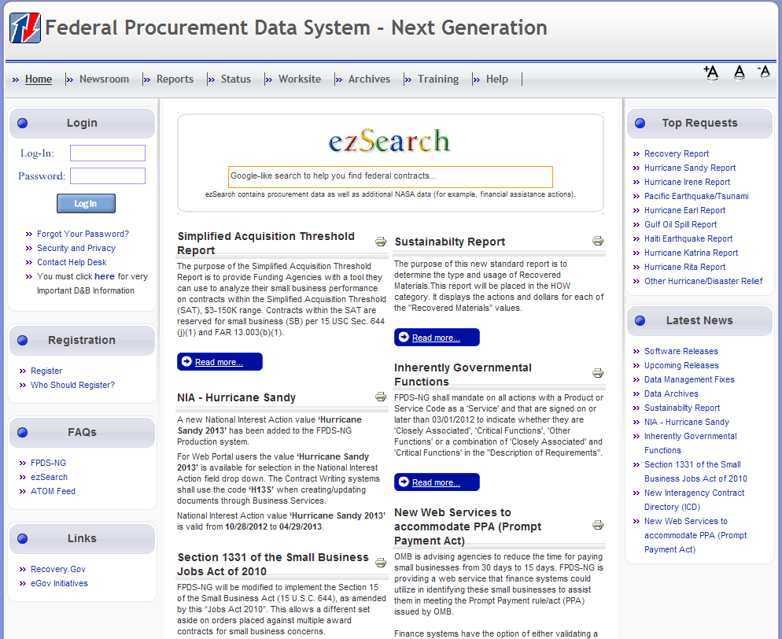

Incorrect Logins
If the users enter incorrect passwords, the FPDS-NG system will fire the error message “Invalid username/password”. If the users enter incorrect passwords, the FPDS-NG Login screen allows the user four attempts to enter the correct password. After the fourth attempt, the users are automatically redirected to the “Forgot Your Password” screen. “Four” is a cumulative number; it is not the number that is calculated on that same day. The users could log into the FPDS-NG system incorrectly few months ago and that incorrect login attempt would be counted as the first time.
In V1.4 Service Pack 16 the CAPTCHA process was implemented in FPDS-NG. CAPTCHA is a type of challenge-response test used in computing as an attempt to ensure that the response is generated by a person. CAPTCHAs are used in attempts to prevent automated software from performing actions which degrade the quality of service of a given system, whether due to abuse or resource expenditure. The following Figure 2-2 is an example of what the user will see and be requested to enter:
Figure 2-2 Incorrect Logins with CAPTCHA
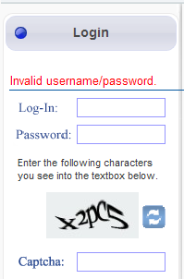

Forgotten Password Function
If the users have forgotten their passwords, the passwords can be recovered by following the 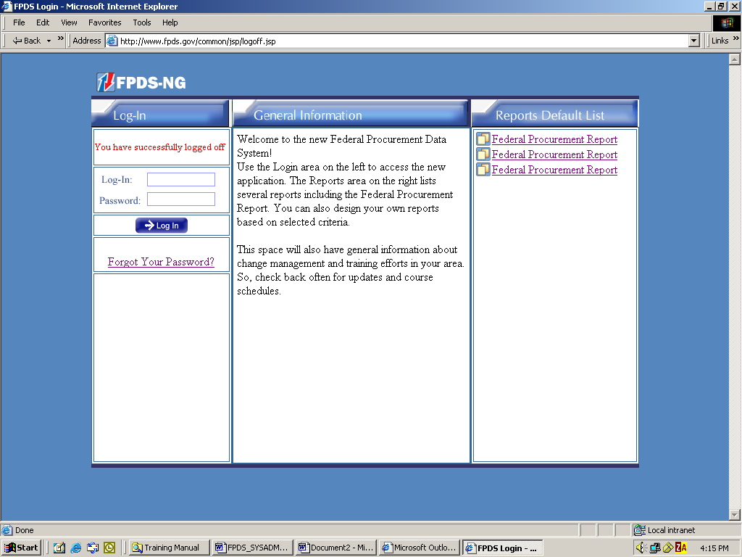 link. The following Figure 2-3 is the screenshot of the screen that the users will see after clicking on the “Forgot Your Password?” link. The users enter their user IDs, and then click on the 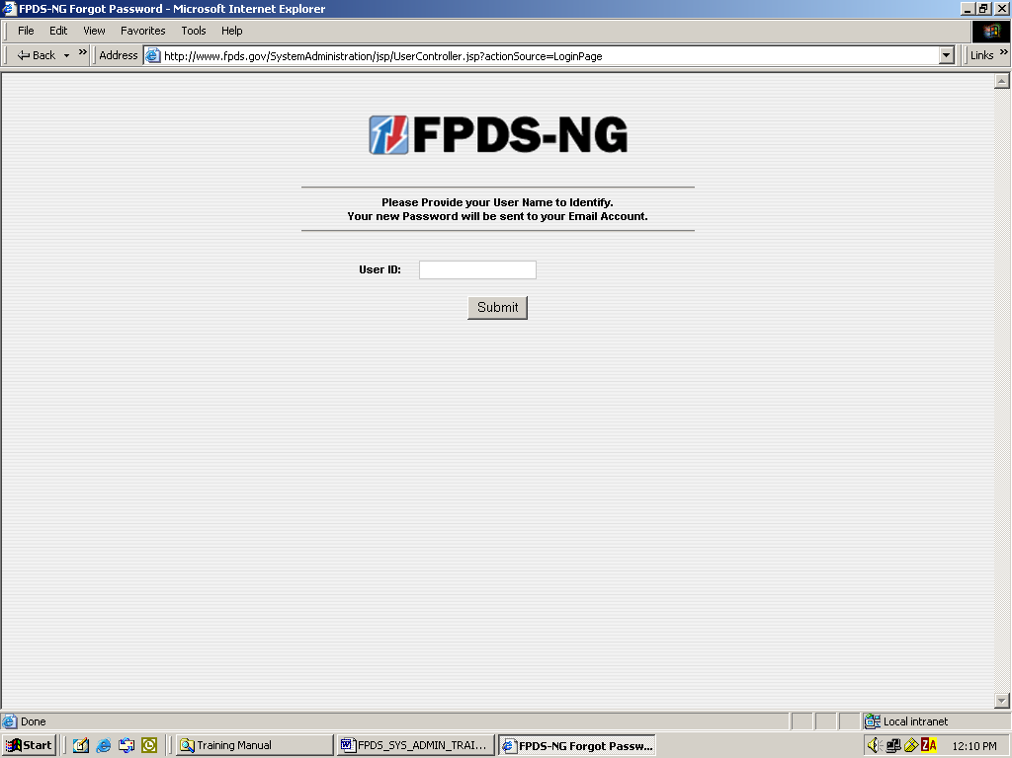 button to request the temporary password. Once the user IDs have been submitted, the “Forgot Password” feature will email the temporary password to the users. The temporary password emails are automatic system-generated emails and the emails will be sent to the email addresses that are listed on the users’ FPDS-NG account profiles.

Figure 2-3 Forgotten Password Notification Screen
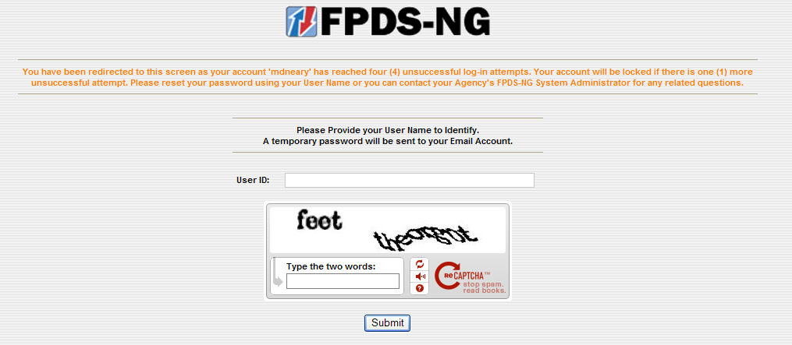

Expired Login Session
If the users stop using the FPDS-NG system after approximately 15-20 minutes, the FPDS-NG system will automatically end the users’ sessions. The following figure is the screenshot of the screen that the users will see after the sessions are expired. The users will need to re-enter their login IDs, the passwords, and then click on the button to log into the FPDS-NG system again. On a successful login, the FPDS-NG system will open the Navigation screen, which is shown in the following section.
Figure 2-4 Expired Login Screen
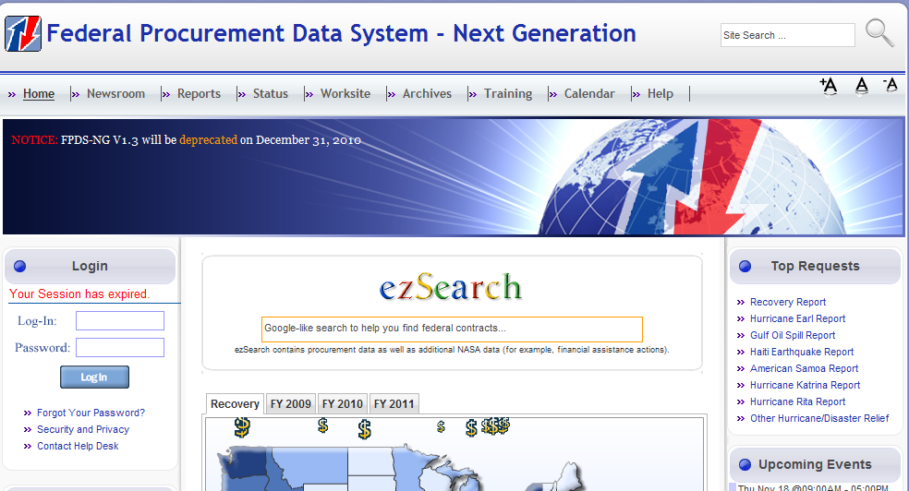

Navigation Screen
The FPDS-NG Navigation screen that is shown in the following figure is organized in five sections: Awards, Basic IDVs, Transactions/Modifications, System Administration, and Reports. Each section contains a list of tasks that are related to the section and each task links to a specific Web-based form on which users enter and submit data with the exception of the Reports section. The Reports section retrieves and displays Federal Procurement data that is stored in the FPDS-NG database.

Figure 2-5 Navigation Screen
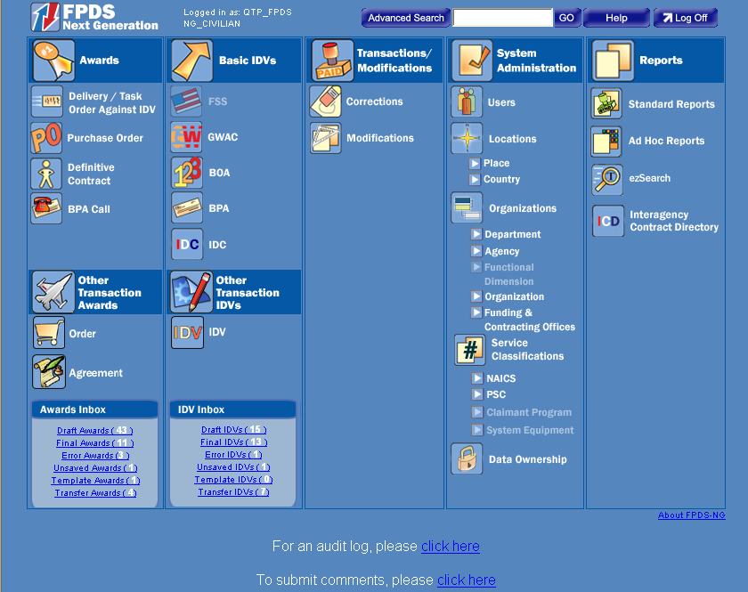

Web Form Toolbar
The search functions are available throughout the FPDS-NG system. These functions are used to access documents, organizations, service classifications, vendor information…etc. A standard toolbar, which is similar to the one that is displayed in the following figure, is available for each Web form. For example, the toolbar that is displayed below is located at the bottom of the “Advanced Search” screen.
Figure 2-6 Advanced Search Standard Toolbar
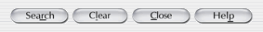
The toolbar that is shown in the following figure is accessible on the right side of the selection screens (i.e., Vendor, Contracting Office ID, and Service Classifications selection screens.) The selection buttons may vary based on the data elements that the users try to search the data for.

Figure 2-7Standard Toolbar for Selection Screens
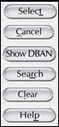

Search Function
The “Search” function is one of the common features to most Web forms in the FPDS-NG system. For example, in order to search for vendors in the Web forms, the users can click on the “Ellipsis” button , which is located on the “Advanced Search” Screen that is shown in the following figure.
Figure 2-8 Advanced Search Ellipsis Buttons
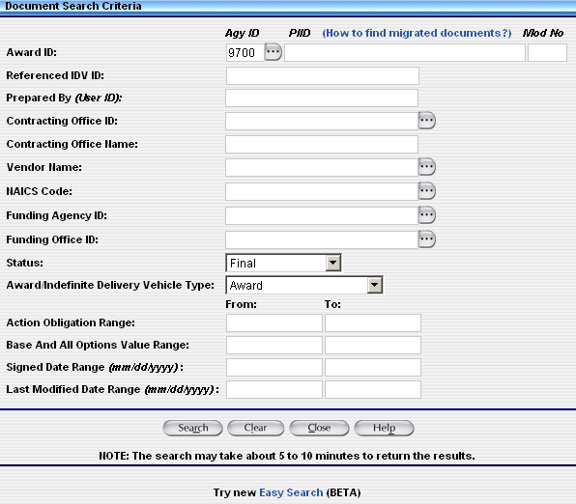

The screenshot below is the “Vendor Selection” screen:
Figure 2-9 Vendor Selection Screen Criteria
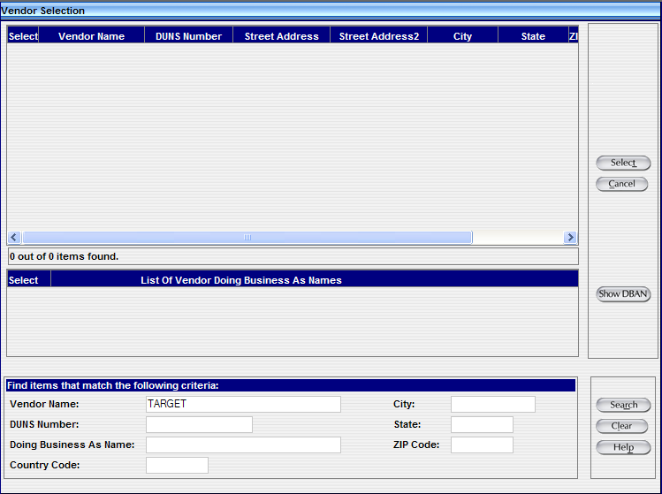
To find a vendor by its name, the users can type in part or all of the vendor’s name and use the search function to locate a list of Vendors that match with the name that the users have specified. The screenshot below shows the search result after searching by the vendor’s name. The “Search” function is available for all the users.
Figure 2-10 Vendor Selection Screen with Search Results
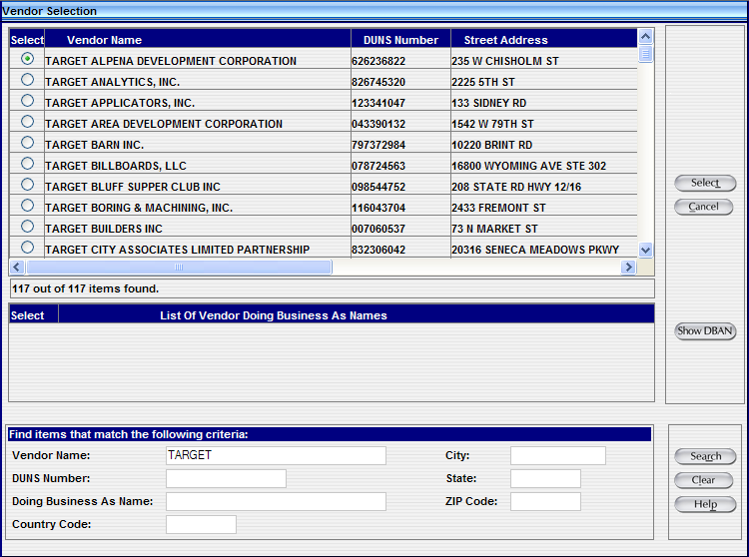
Use the Search Function
- From the Navigation Screen in Figure 2-5, click on the “Advanced Search” button that is located at the top middle section of the screen.
- To search for a vendor, click on the “Ellipsis” button that is located next to the Vendor Name field.
- The Vendor Selection screen is displayed.
- Type in all or part of the vendor’s name and then click on the button that is located at the lower right corner of the screen.
- The “Vendor Selection” screen displays a list of the vendors.
Create a New Search
- To clear the search criteria and then search for the new Vendor information, click on the “Clear” button on the bottom right corner of the screen. The fields are now blank like what is shown in the following figure.
Figure 2-12 Vendor Selection Screen
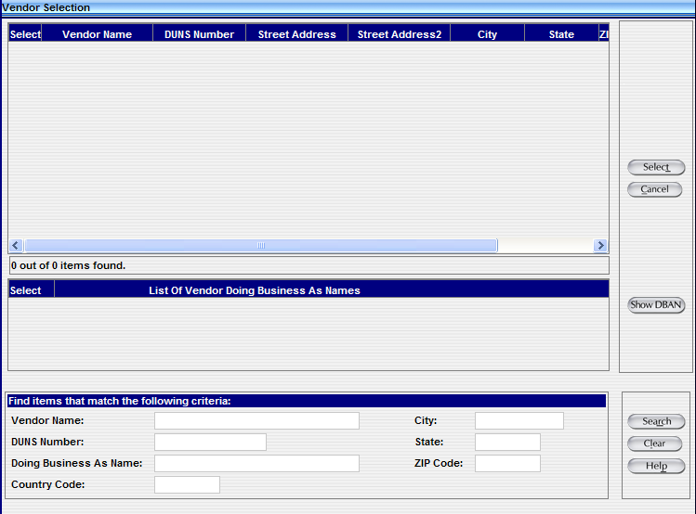

- In the DUNS Number field, located in the lower left corner of the screen, type in a Vendor’s DUNS Number and then click on the “Search” button that is located in the lower right corner of the screen
- The vendor’s information will be displayed on the screen based on the Vendor’s DUNS number that the users specify. The screenshot below shows the search result.

Figure 2-32 Vendor Selection Defined
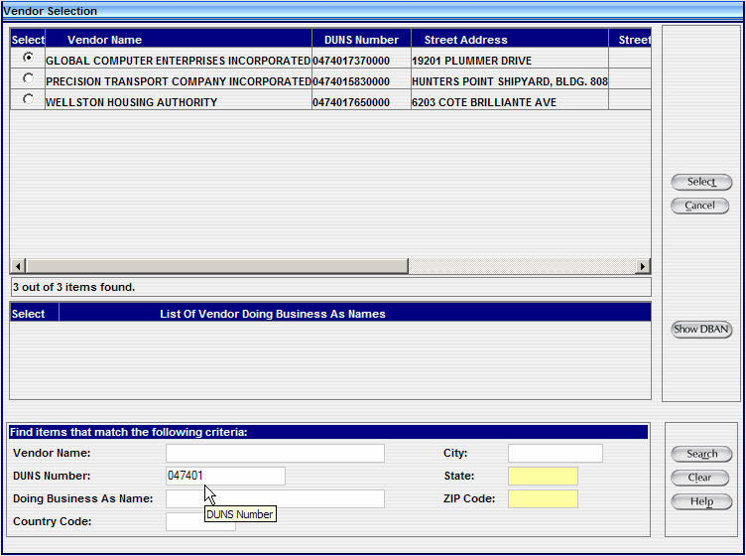
- To select the appropriate Vendor, select the “Radio” button , which is located in the left upper corner of the screen, of the vendor that the users want to get the data for.
- After selecting the radio button that is next to the Vendor that the users want to get the data for, click on the “Select” button that is located in the top right corner to select the vendor’s information. The Vendor information will be displayed in the Advanced Search Screen.
Notes:
Fewer search criteria will produce more results; however, to search the list of vendors without using a criteria selection, leave all fields blank in the bottom of the screen and then click on the “Search” button .
When the matching criteria fields are empty, the generated list contains a larger selection of vendors. Due to the volume of data in FPDS-NG, the selection results are limited to a portion of the data available, such as the first 200 records. It is recommended that you always enter search criteria to narrow the selection when it is possible.

PIID Use in Advanced Search
When performing an Advanced Search, a Procurement Instrument Identifier number (PIID) can be used to quickly access a contract. The PIID field can be found on the Advanced Search screen as shown in the following figure. Entering the Agency ID, PIID number, and selecting the Status for the contract will display the contract with a link to allow access to the contract.
Figure 2-43 Advanced Search Screen
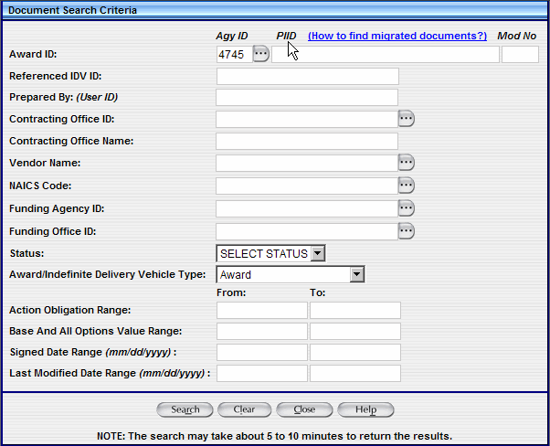

Migrated PIIDs
For migrated IDVs, the PIID is the same as the original contract number. For migrated awards, the PIID is a combination of the following:
- Contracting Office Code
- Action Date (format "YYYYMM")
- Contract Action Type (A, B, C, D)
- Order Number (if it exists)
- Contract Number
The formula used for the PIID number can be used to perform an advanced search. For example, to find a Delivery Order created in October 1995 with:
- Agency – U.S. Coast Guard (6950)
- Contracting Office – 23
- Order Number – DTCG2394FTACX01
- Contract Number – DTCG2391DTTMB12
The PIID is calculated by the following:
- "00023" (Contracting Office ID with leading zeroes)
- +"199510" (Action Date in YYYYMM format)
- +"C" (Contract Action type - Delivery Order)
- +"DTCG2394FTACX01" (Order Number)
- +"DTCG2391DTTMB12" (Contract Number)
The PIID would equal 00023199510CDTCG2394FTACX01DTCG2391DTTMB12.
Notes:
The PIID Number format must be uppercase, alphanumeric with no embedded spaces or special characters. FPDS-NG will convert lowercase letters to uppercase, remove leading or trailing blank spaces, and remove any non-alphanumeric characters prior to validation.
The Contract Action type is a single character representing the award type.

Contract Search Results
The Advanced search generates a list of documents that match the search criteria that are entered on the screen. The list of the documents is displayed with links to those matching contracts on the “Contract Search Results” screen that is shown in the following figure. The search results screen displays a list of ten contracts out of the number of contracts found. Click on the link that is located in the top right corner of the screen to display the next ten contacts on the screen.
Figure 2-54 Contract Search Results Screen
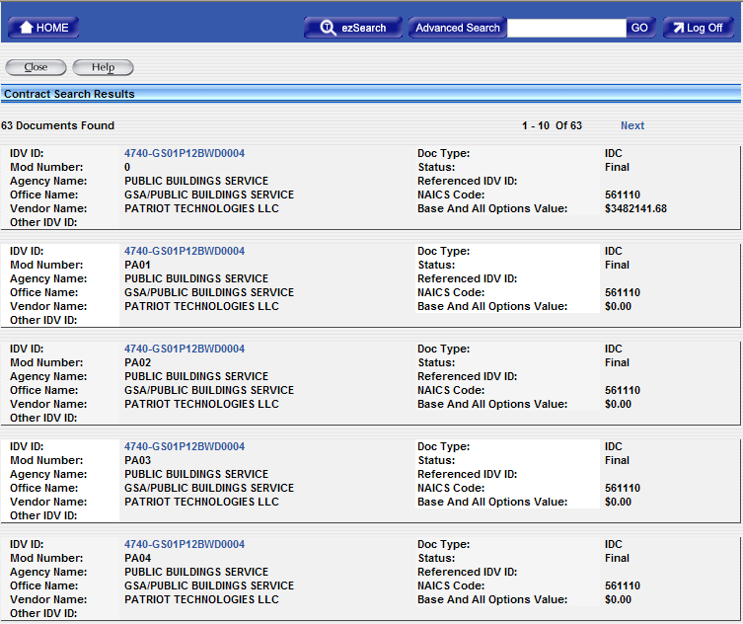

To access a contract, click on the link 4740-GS01P12BWD0004 of the contract that the users want to open.
Figure 2-6 Delivery Task Order
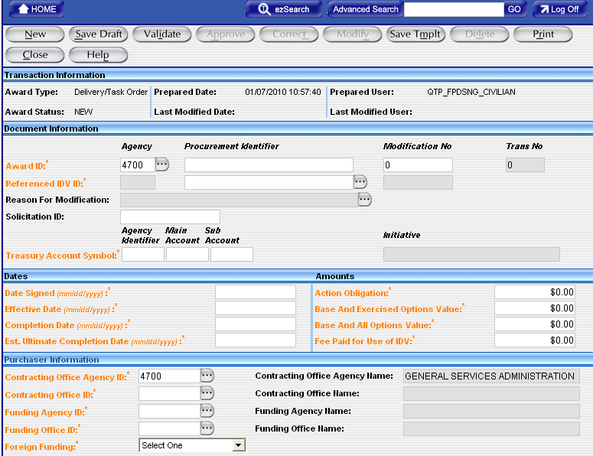

Introduction to Reports
The Reports document describes the standard and customized reporting capability in the FPDS-NG system. The report features are divided into sections including the required steps for generating reports. The following is the description of the reports:
- Description of what the report displays
- Mandatory/optional criteria for the report
- Fields/data displayed on the report
- Primary sort criteria used in the report
- Secondary sort criteria used in the report
- Search criteria available for the report

Standard Report List
The following table displays a list of reports that are provided in the FPDS-NG system based on their report grouping category. The standard report formats are designed to anticipate the needs of government and public users. These reports provide quick accessibility to information that is needed on the regular basis.
Table 3-3 Report Names
Report Name / Report Category
Who (Who is winning government contracts by vendor name or type?)
Awards by Contractor Type
Contractor Search
Orders Referencing Incorrect IDV
What (What types of products and services the government has been buying?)
Contract Detail Report
Federal Contract Actions & Dollars
Inherently Governmental Functions Actions and Dollars
Other Transaction Actions and Dollars Report (This report is for DoD and DHS only)
Procurement History for Market Research Report
Total Actions by NAICS Report
Total Actions by PSC Report
Trade Agreement Report
Where (Where is the government spending its money, both in the US and abroad?)
Buy American Act Place of Manufacture Report
Geographic Report by Place of Performance
Geographic Report by Vendor Location
When (When were the procurements made?)
Contract Detail Report
Procurement History for Market Research Report
How (How did the government make the award (small business, type of competition, purchase card, etc.)? How is the government meeting its statutory goals?)
Bundled and Consolidated Contracts Report
Buying Through Government Acquisition Vehicles Report
Competition Report (This is the official Competition Report)
Competition Report – OLD
Competitive Procedures, but One Offer Report
Contract Termination for Default – Cause Report
Funding Report
IDVs Whose Orders are Over the Ceiling Amount
Local Area Set Aside Report
Official Small Business Goaling Report for FY 2005 and FY 2006
Official Small Business Goaling Report for FY 2007
Orders placed after IDV’s Last Date to Order
Performance Based Acquisition Report
Potential Vendor Anomaly Report
Purchase Card as Payment Method Report
Recycled Content Product Purchasing Data Report
Small Business Achievements by Awarding Organization Report
Small Business Competitiveness Demonstration Program Report
Small Business Goaling Report
Subcontracting Plan Report
Sustainability Report
Unique Vendors
System Administrator
Audit Procedures Report
Contracting Office Report
Individual Data Item Oversight Tracker
List of Users
National Interest Action
Rerepresentation Eligible Actions Report
Rerepresentation Report
Status of Actions Report
Transfer Action Report
Workload Report

NOTE: If the report results are less than or equal to 5,000 records, the report results can be downloaded to the Excel, CSV, HTML, and PDF files.
If the report results are more than 5,000 records, the report results can only be downloaded to the CSV file.
FPDS-NG will be enhancing the standard reports to have more data available with faster reporting speeds. The users can search for up to 5 years worth of data. Once the report results are retrieved, Fiscal Year drill path will be available to allow users to still access one FY worth of data
The users will be able to export 30,000 records of data for further research and the report results should be retrieved within seconds. For the reports that have not been enhanced, the users will be able to export 15,000 records of data for further research.

The users can get more information about the Standard Reports Enhancements (Phase I and Phase II) at:

https://www.fpds.gov/wiki/index.php/Standard_Reports_Enhancements-_Phase_I https://www.fpds.gov/wiki/index.php/Standard_Reports_Enhancements-_Phase_II

Some anomaly reports will be included under the “How” category of the Standard Reports. The users can get more information at: https://www.fpds.gov/wiki/index.php/Anomaly_Reports
Reports Format

The Report functions are accessed via the Navigation screen that is shown in the following figure. The FPDS-NG reporting tools allow the Federal Government to track users, performance, and contract statistics. The FPDS-NG system gathers the information on reported procurement transactions and stores this information in a database for analysis and reporting. The reports are generated using two types of functionality:
- Standard Reports
- Ad Hoc Reports
Figure 3-7 FPDS-NG Navigation Screen
The following sections provide instructions for accessing and generating reports in the FPDS-NG system. The government and public users have similar procedures for accessing reports and both procedures are provided in this manual. To access the reports in the FPDS-NG system, you will need to register with the FPDS-NG system as government or public users. The following instructions can be used based on the designation of the user (government or public); some reports are not accessible by the public users.

Standard Reports
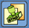
The “Favorites” Reports module is used to acquire and store selected reports for a defined period of time. The FPDS-NG report results are generated based on the data that agencies submit in the Awards and IDVs sections. The selection of reports is determined by the users’ profiles.
The government users can access the Standard and/or Ad Hoc reports if they have the privileges; the public users can access both the Standard and Ad Hoc reports.
The Standard Reports screen that is shown in the following figure, stores a list of selected reports in the “View” list. The different categories contain different reports and those reports match with the business scenario that is listed for the categories.
- Who
- What
- Where
- When
- How
- Sys Admin
The reports that are listed on the Standard Reports screen are displayed based on the users’ FPDS-NG account privileges. The “Favorites” screen is the default folder that the users will see when they access the Standard Reports for the first time. There will be no reports to be displayed on the “Favorites” category when the users access the Standard Reports for the first time.
If the users want to add the reports that they use often to the “Favorites” category, the users will need to click on the “Favorites” icon to add the reports to the “Favorites” category. The reports that are listed under each category have the “Favorites” icon listed in front of the reports’ names. The users need to click on the “Favorites” icon that is listed in front of the report’s name in order to add that report to the “Favorites” category.
Figure 4-8 Favorites Screen
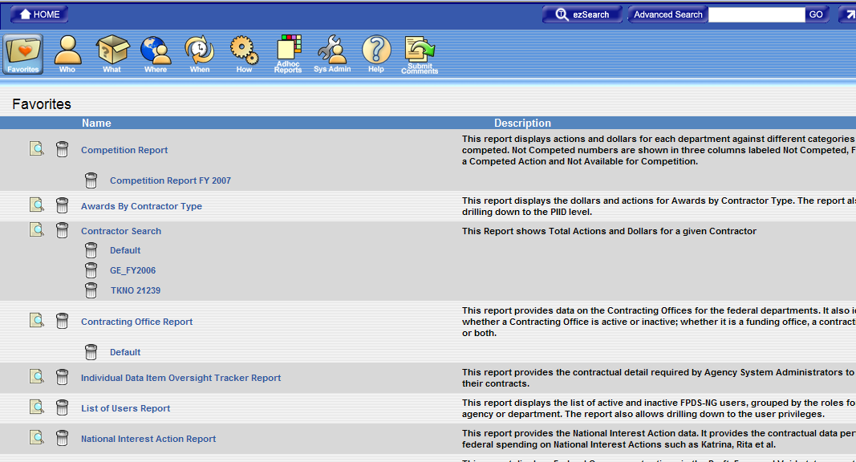

Available Reports
The screen that is shown in the following figure is broken down into categories for the various types of reports and information offered in the FPDS-NG system. Again, these categories are: Favorites, Who, What, Where, When, How, Ad Hoc Reports, and System Administration reports; as well as Help and Submit Comments.
As previously mentioned, each report category includes a “Favorites” icon and the users can use this icon to add the specific report to the “Favorites” category that is specifically suited to their reporting needs. The “Preview” icon allows the users to review the sample layout of the report results without executing it. All the reports that are listed on the “Favorites” category include the “Delete” icon and the users can use this icon to delete the reports from the “Favorites” category. The reports are only deleted from the “Favorites” category; they will not be deleted from the categories that the reports belong to.
Overall, if you are a new user, the “Favorites” category will initially be blank until reports are added to this category by the user. If you are a current user, all the reports that have been added to the “Favorites” category will appear automatically when the users log into the FPDS-NG system.
Figure 5-9 Favorites Screen

View Reports
The users may view the sample layout of the reports before adding them to the Favorites screen by clicking on the preview icon 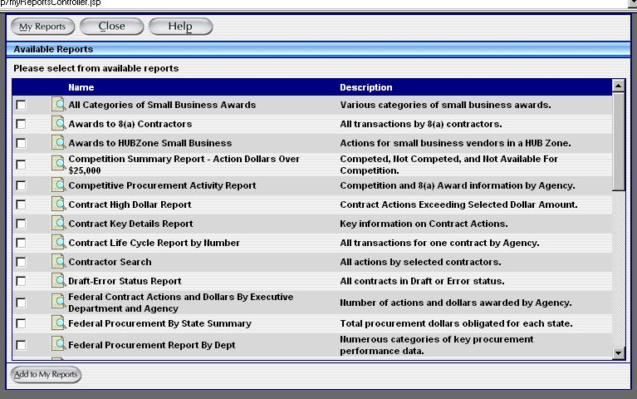 that is located in front of each report. The sample layout of the report format is displayed as shown in the following figure. The sample layout of the report is different for each Standard Report.

Figure 5-10 Report Preview
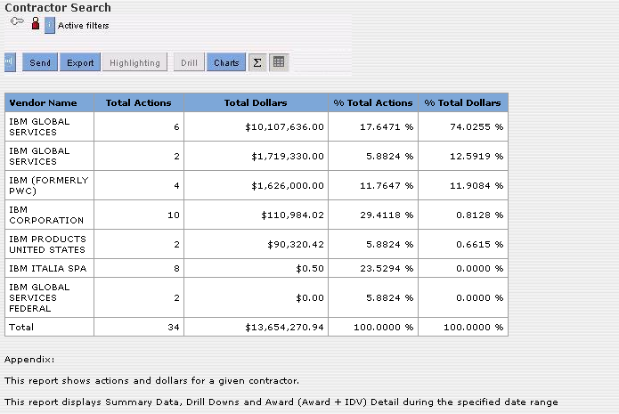

Favorites Screen
Once reports are selected from the various Reports categories, the users will be able to generate the report from the “Favorites” category that is shown in the following figure.
Figure 5-11 Favorites Screen
Exercise – Login to FPDS-NG and Access the “Favorites” folder

The following steps are provided to assist government users in logging into FPDS-NG and accessing standard reports.
- Go to the URL provided by the instructor.
- Log in to FPDS-NG with the user ID and password provided by the instructor.
Opening the Standard Reports Screen
The Standard Reports screen, shown in Figure 5-11, displays a list of selected reports associated with the user’s profile. Use the following steps to access the Standard Reports.
- To open the Standard Reports screen from the Main Navigation screen, click on the “Standard Reports” icon .
- The FPDS-NG system will display the Standard Reports screen that is shown in the following figure.
Figure 5-12 Favorites Screen

Selecting Available Reports
The Reports can be accessed and generated under the “Favorites” category or any other categories. To add the reports from their own categories to the “Favorites” category, the users can use the following steps.
- Click on one of the six Report category buttons
Figure 6-5 Report Buttons
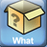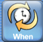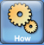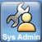

- Click on the Add to Favorites icon next to the specific report you want to add
Figure 6-6 How Reports Screen 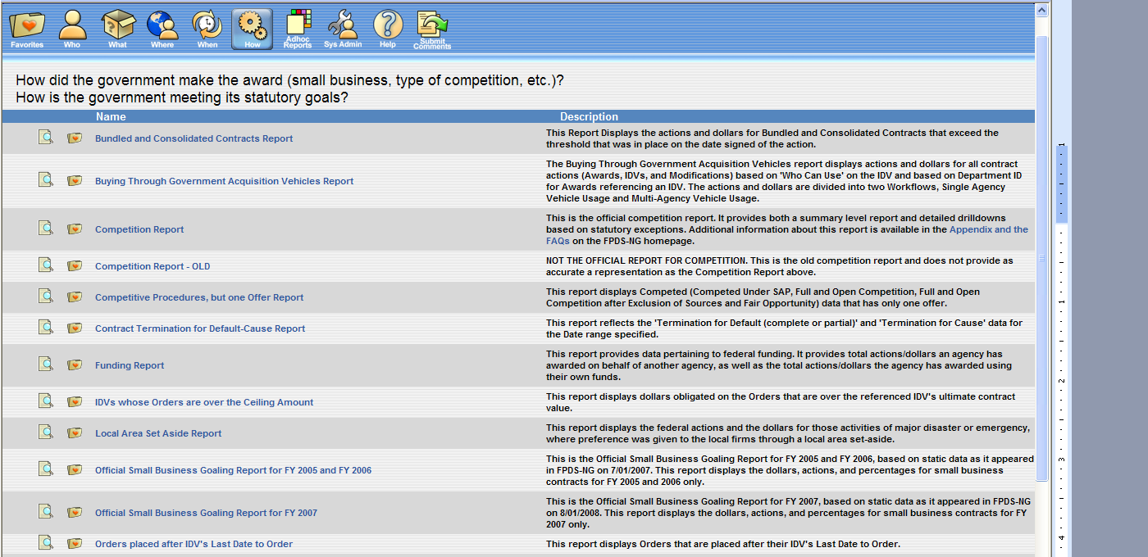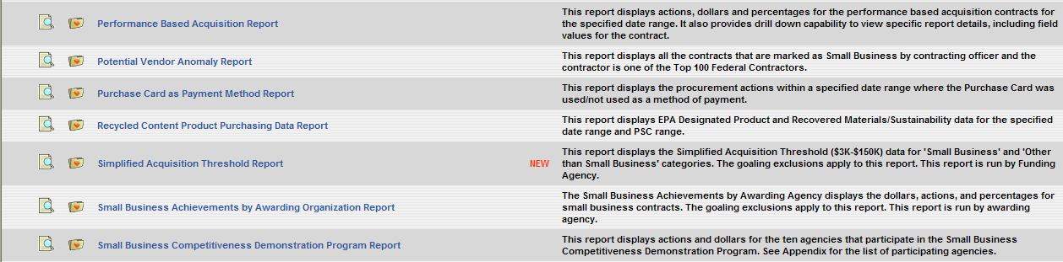

- The report along with any search criteria will be added to the “Favorites” category
- You can then access the report from either the Favorites category or the Report category by clicking on the name of the report.

Report Categories

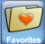 Favorites Category is defined by the users and a collection of reports that have been specifically chosen. If the user is a new user, this section will be blank until the user adds the reports to the “Favorites” category; otherwise, the “Favorites” category will be populated with the reports that have been added to this category.

 Who Category is defined as:

Who is winning government contracts by vendor name or type?

The reports in this section include:
Awards by Contractor Type
Contractor Search Report
Orders Referencing Incorrect IDV

 What Category is defined as:

What types of products and services the government has been buying?

The reports in this section include:
Total Actions by PSC Report
Total Actions by NAICS Report
Procurement History for Market Research
Inherently Governmental Functions Actions and Dollars
Federal Contract Actions & Dollars
Contract Detail Report
Other Transactions Report (This report is for DoD and DHS only)
Trade Agreement Report

 Where Category is defined as:

Where is the government spending its money, both in the US and abroad?

The reports in this section include:
Buy American Act Place of Manufacture Report
Geographic Reports by Place of Performance
Geographic Report by Vendor Location

 When Category is defined as:
When were the procurements made?

The reports in this section include:
Procurement History for Market Research Report
Contract Detail Report

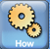 How Category is defined as

How did the government make the award (small business, type of competition, purchase card, etc.)? How is the government meeting its statutory goals?

The Reports in this section include:

Bundled and Consolidated Contracts Report
Buying Through Government Acquisition Vehicles Report
Competition Report (This is the official Competition Report)
Competition Report – OLD
Competitive Procedures, but One Offer Report
Contract Termination for Default – Cause Report
Funding Report
IDVs whose Orders are Over the Ceiling Amount
Local Area Set Aside Report
Official Small Business Goaling Report for FY 2005 and FY 2006
Official Small Business Goaling Report for FY 2007
Orders placed after IDV’s Last Date to Order
Performance Based Acquisition Report
Potential Vendor Anomaly Report
Purchase Card as Payment Method Report
Recycled Content Product Purchasing Data Report
Small Business Achievements by Awarding Organization Report
Small Business Competitiveness Demonstration Program Report
Small Business Goaling Report
Subcontracting Plan Report
Sustainability Report
Unique Vendors

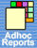 Ad Hoc Reports are defined as:
Custom reports created by the users. This section will be blank until the user creates a custom Ad Hoc report.

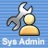 System Administrator Reports

The reports in this section include:
Audit Procedures Report
Contracting Office Report
Individual Data Item Oversight Tracker
List of Users
National Interest Action
Rerepresentation Report
Rerepresentation Eligible Actions Report
Status of Actions
Transfer Action Report
Workload

Search Name
The “Search Name” that is shown in the following figure is displayed with the name “Default.” This field is used to name the search criteria that are entered for a selected report. Saving the search criteria with a designated name stores the information under the name of the report. The users can retrieve this information by clicking on the “Search Name” that is saved and listed under the name of the report. This function eliminates the process of entering the same search information for recurring reports.

Search Criteria Features
The search criteria screens are used to run all reports. After clicking on the name of the report, the search criteria screen is displayed. The users can enter the search criteria on this screen that determines the data that is displayed in the report.

Figure 5-13 Search Criteria Screen
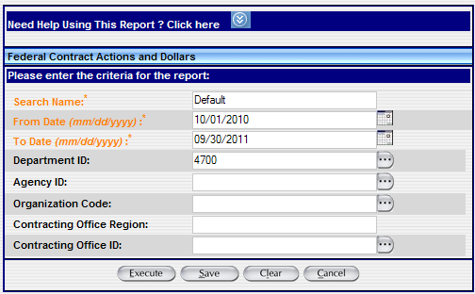

As with other screens in FPDS-NG, the fields labeled with “Ellipsis” buttons can be auto-filled by selecting the button and using the associated Search/Select screen as shown in the following figure. If the users already know the values for the search criteria, the users can also enter the search criteria manually without using the “Ellipsis” button.

Figure 5-14 Search/Select Option
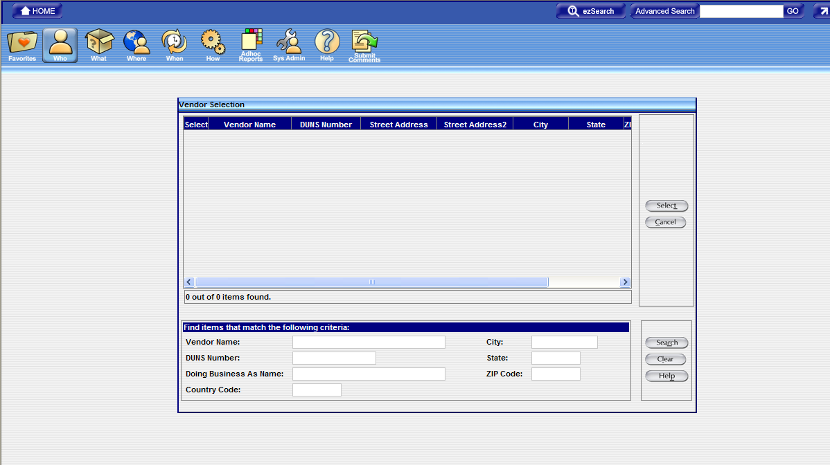

Search Criteria Tools
Wildcard
The “%” sign is the wildcard character that may be used in the data entry fields; the users can use a wildcard after entering the first part of the data string. For example, when the users enter “COM%” in a data field, the search will return anything that starts with “COM”; for example, company, complete, composition…etc.
Saving Report Criteria for Multiple Report Runs
The “Search Name” field allows the user to save the report criteria so that it can be executed multiple times without having to enter all of the search criteria again. The users may save as many different search criteria for a report as they wish. The name of the search criteria is displayed under the name of the report.

Search Criteria Label Conventions
Government Wide
All reports can be generated as Government Wide reports. The drill down feature allows the users to access more detail data in the system to further filter information provided on the standard reports.

Department
The Department label is a drill down feature that specifies the department or agency you are selecting. For example, GSA or DoD.
Agency
The Agency label is a drill down feature that specifies the organization or service under the department. An example would be, the Federal Supply Service of GSA or Navy of DoD.

Field Types
Mandatory Fields
Fields in the search criteria that are orange with an asterisk (*) are mandatory and must have a value. A value must be entered before the report can be executed. An error message will be displayed when no data is entered in the mandatory field.
Non-mandatory Fields
Fields in the search criteria that are blank without an asterisk (*) are not required and may be left blank. When left blank, all values for that field are shown in the report.

Search Criteria Screen Actions/Buttons
The “Execute” button runs the report based on the criteria entered in the search criteria screen. If mandatory fields are not filled in, an error message will be displayed.
The “Save” button saves the search criteria with the name that is entered in the “Search Name” field. The saved search is then placed below the name of the report.
The “Clear” button removes any information that is placed in the search fields by the user and displays the system generated default search criteria.
The “Cancel” button closes the search criteria screen. The report is not executed and the search criteria are not saved.
Exercise - Saving Report Search Criteria
The Search Criteria screen provides the user the ability to name and save information entered for reports that are frequently used.
To save a report with specific search criteria information, open the Standard Reports screen using the following steps.
- Open the Standard Reports screen from the Main Navigation screen. Click on the “Standard Reports” icon .
- The “Favorites” category is displayed with a list of reports that have been added to this category from other categories. The “Favorites” category will be blank initially for the first time users.
- Click on the “Add” icon to add the desired reports to the “Favorites” category. The “Add” icon is listed next to the name of each report.
- Click on the “Favorites” category icon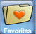 to see the reports that are added to the “Favorites” category and the links for those reports will be displayed on the “Favorites” screen.
- Click on the name of the report that you want to generate.
- The search criteria screen will be displayed with the value “Default” listed in the “Search Name” field.
- Enter a name or description in the Search Name field.
- Specify the “From Date” and “To Date” values that are associated with the criteria for the selected report.
- Click on the “Save” button , which is located at the bottom of the screen, to save the search criteria.
- The Search Criteria screen will display the message “The Search Criteria was saved successfully.”
- Click on the “Cancel” button. The system will take you back to the original report page.
- The saved search name or description will be listed below the name of the report.

Generating Reports

The Favorites screen provides a list of the desired reports that the users have added to the “Favorites” category from other categories.
- Click on the name of the report for the report that will be generated.
- Enter the search criteria for the chosen report and then click on the “Execute” button.
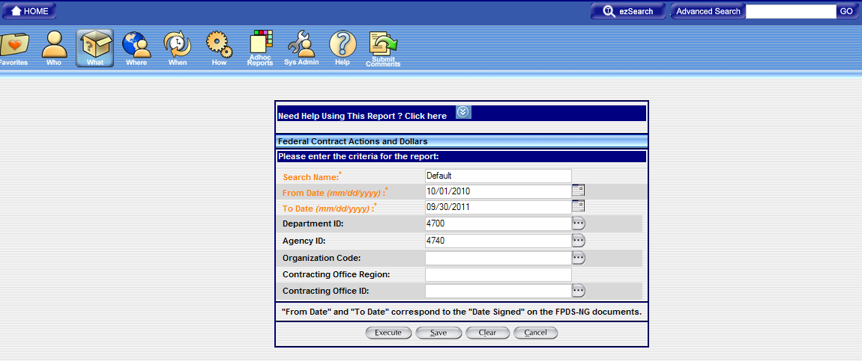

- The report is generated and displayed based on the information that is specified on the search criteria page.
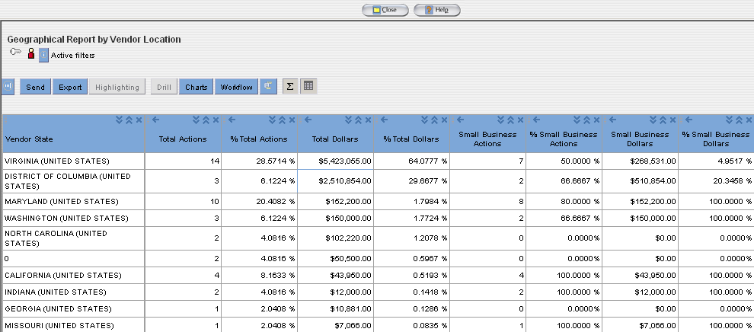

Using FPDS-NG Reports

FPDS-NG produces reports automatically by querying the FPDS-NG database and creating a report based on your search criteria. This section covers the following general use concepts:
- Report Actions
- Search Criteria Features
- Public User Procedures for Reports
- Government User Procedures for Reports
- Summary Reports

Report Actions
Export
The export functionality provides the ability to save the data as HTML, Microsoft Excel, PDF, or Comma Separated Values (CSV) file.
Send
The send functionality provides the ability to send the report in an email. The user enters the email addresses for the desired recipients and the report is sent by the system.
Close
The close functionality closes the report screen.
Exercise - Exporting or Sending Reports
The “Export” feature is used to save the report results to the users’ own machines by using the file formats that are provides to the users. The “Export” feature provides the users the ability to save, review, and open the reports in various formats. The “Send” feature is used to email the report results to other people; the report results can also be specified in various formats.

The following four formats are provided for exporting and sending/emailing reports: Microsoft Excel, HTML, PDF, and CSV (Comma Separated Values).
- Click on the name of the report for the report that will be generated.
- Enter the search criteria information; if the selected link is a “saved search criteria”, please skip this step.
- Click on the “Execute” button to generate the report.
- Click on the “Export” button to open the export report window.
- To export a report, use the preferred format by selecting one of the options shown in the following figure. The format is always defaulted to “Microsoft Excel – Retain PA Formatting.”
Figure 6-15 Export Window
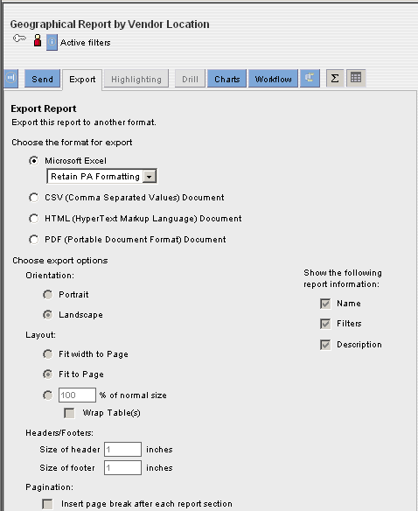
- To open and save the report in the selected format, select the “Export” button and then save the report results to your own machine.
Or
- To email the report results to yourself or other users, click on the “Send” button .
- After clicking on the “Send” button , the email report window will be displayed like what is shown in the following figure.

Figure 6-16 Email Window
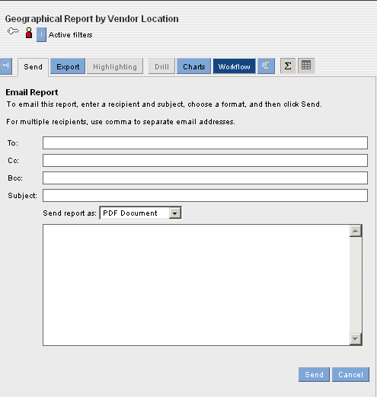
- Enter the email address and select the format from the drop down menu to email the report.
- Click on the “Send” button to email the report.

FPDS-NG Ad Hoc Reporting Tool

Introduction
This section specifies instructions for creating reports based on the criteria that are specified by the users.
The Ad Hoc reporting tool is a tool that is designed for all levels of users. The custom reports are created using queries and a query is one or more statements that request data from a database. If the data is available, the requested data returns in the form of a table that contains rows and columns.
Figure 7-17 FPDS-NG Navigation Screen
Note: The government users will need to have the privileges to access the Ad Hoc report; the public users already have the Ad Hoc report privileges automatically.

Ad Hoc Reporting Basics
The Ad Hoc reporting tool is a tool that the users can use to create customized reports based on their own criteria.
- Analyze the contract data that is reported by the Federal Government.
- Prepare and generate reports in the ways that match with specific business questions.

Tasks
The government users can access the Ad Hoc reporting tool based on their privileges. If the government users need to access the FPDS-NG system to generate customized reports, the system administrator needs to assign the Ad Hoc privileges to those users’ accounts. The following are the basic features for the Ad Hoc reporting tool:
- Set up metrics and attributes that are used to create reports.
- Find and view any report in your personal folder.
- Easily make changes to existing reports to explore more details and gain further insight into different aspects of the business processes.

Terms
This section discusses some key terms that the Ad Hoc Reporting tool uses.
- Metrics
- Attributes
Metrics and attributes are central to the analytics process. Any analysis of a business process involves measurements of its performance. In the Ad Hoc reporting tool, a measurement is recognized as a metric. Metrics are the factors used to evaluate a business process. For example, a procurement executive might say that she needs to analyze “the average dollars obligated to small businesses in Virginia for the previous fiscal year by quarters.” In this case, the measurement, or metric, that the procurement executive wants to evaluate is the average dollars obligated.

The parameters involved in a metric are called attributes. In the previous example, the attributes that affect the metric are awards (Dollars Obligated), Place of Performance (Virginia), and time (last fiscal year). Attributes are the factors that determine the value of the metric. The users create reports based on the available metrics and attributes.

In a simple report, where there is one attribute and one metric, attributes are the values that are listed at the left column and metrics are the values that are listed at the right column. Metrics are always numeric values. The following figure shows a sample of a simple Ad Hoc report layout and the location of the metrics and attributes:

Figure 7-18 Metric and Attribute
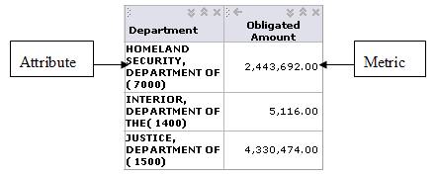
In a complex report with more than one attribute and more than one metric, multiple columns of attributes and metrics will be displayed. The attribute columns are at the left and the metric columns are at the right. In some cases, there can be multiple columns of the same metric for different attributes.

The following figure shows a sample of a complex report and the location of the metrics and attributes:
Figure 7-19 Complex Report and Metric and Attribute Location
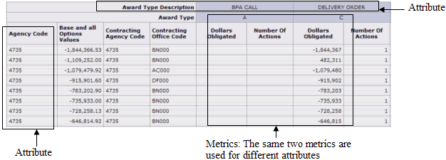

Ad Hoc Report Results
Ad Hoc report’s results are displayed as metrics and attributes.
The report table displays the report data in a tabular form. The report chart displays the report data as a chart. The following features are associated with the Ad Hoc report:
- Filters - A filter displays report data based on certain conditions.
- Highlighting - Highlighting draws attention to critical data in a report and helps pinpoint problem areas.

Ad Hoc Reports and Table Layouts

The report table presents the report data as rows and columns in a table. There are three types of report tables:

- Tabular - A tabular report table contains row headers only.
- Cross tabular - A cross tabular report table contains row and column headers.
- Sectional - A sectional report table displays the report data as sections. Each section of the report table provides the data for a unique attribute value.

Ad Hoc Reports
Ad Hoc reports can be created using “Prompts” feature. This allows the limits to be placed on the contents of the report by displaying only the data wanted. Prompts for reports can be created based on the following report components:
- Metrics
- Attributes
- Attribute and metric filters

Reporting Tabs

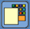
Click on the “Ad Hoc Reports” icon and the query panel and tabs will be displayed on the screen. The Ad Hoc Reporting Screen contains personal settings that are applied by the users. The first time the query panel is accessed by the user, the reporting screen will display without information or settings like what is shown in the following figure.
Figure 8-20 Ad Hoc Reporting Screen
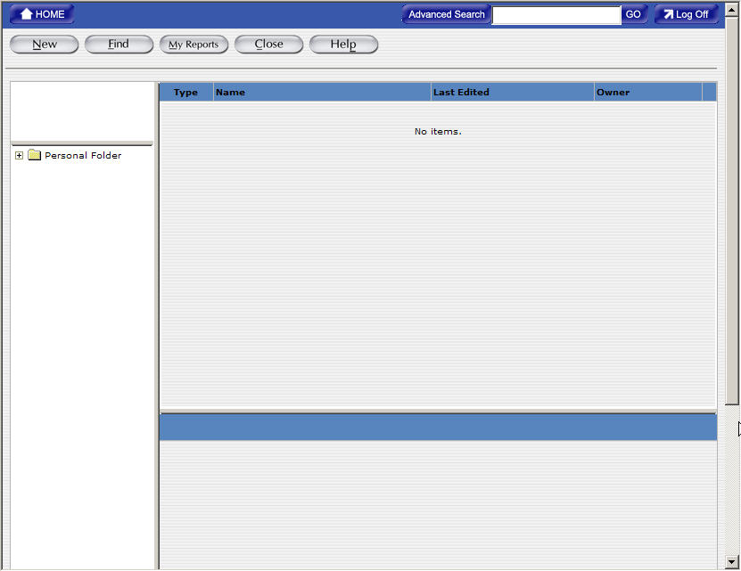

Find Button
The “Find” button allows the users to search for the saved reports that they want to access. The Ad Hoc reporting tool keeps all reports in each user’s Personal Folder. The users can browse through the “Personal Folder” to locate the reports that they want to generate. While browsing the “Personal Folder” , the user can organize reports by creating new folders and moving reports to these new folders.
After the users locate the reports that they want to access, there are two ways that users can use to access the reports:
- If the users want to edit some information in the reports, they need to click on the name of the reports once and they will be able to see the “Execute” , “Edit” , “Email” , and “Delete” buttons. They can click on the “Edit” button to get to the design part of the report.
- If the users want to execute the reports directly without getting into the design part of the report, they need to click on the name of the reports twice and the FPDS-NG system will prompt the users to the execute page directly.
Figure 8-21 After clicking on the Find button and Personal Folder
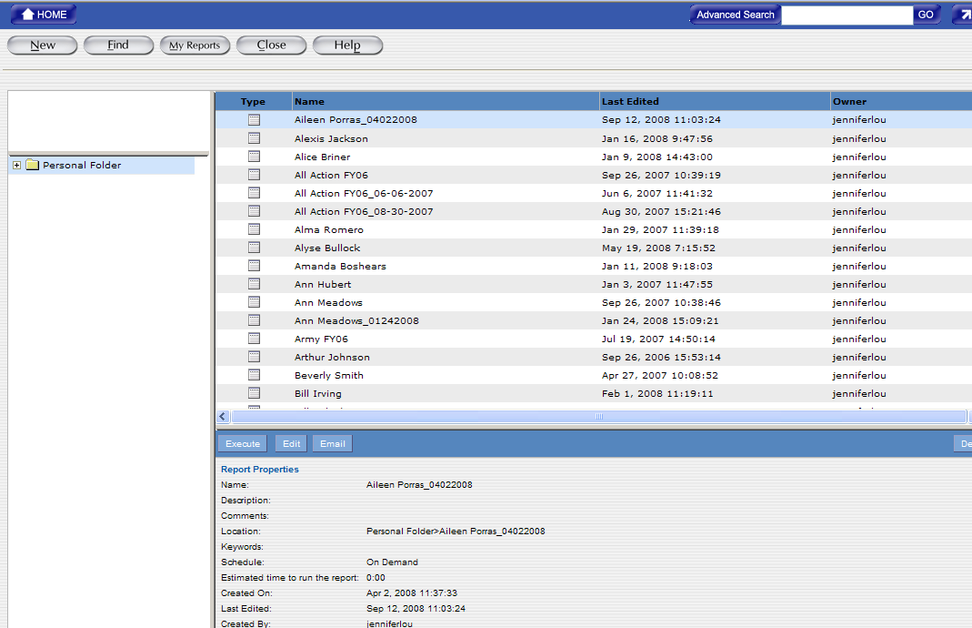

New Button
The “New” button allows the user to create the Ad Hoc reports that show the data that is retrieved from the FPDS-NG system. A report consists of a set of related metrics and attributes. When the users create reports, one or more queries are created and the queries are based on metrics, attributes, filters, and rankings that the users specify in the report. When the users run the reports, the Ad Hoc Reporting tool runs the queries and displays the data that is retrieved from the database. The users can modify the data and the format of the reports after the reports are generated.
Figure 8-22. After clicking on the “New” button
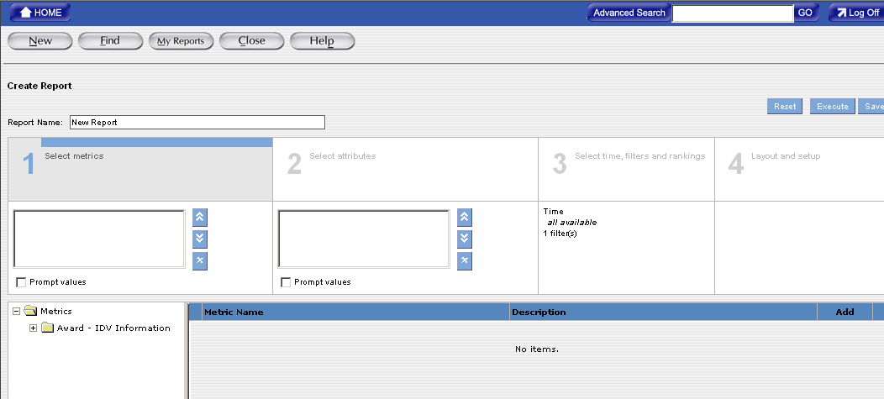

Creating Reports
- The first step in creating reports is specifying the data and the format for the report.
- Click on the “New” button to create a new Ad Hoc report.
- Depending on the data that will be displayed in a report, one or more of the following steps will be completed:
  - Select metrics for the report
  - Select attributes for the report
  - Set filters for the report
  - Set Layout and Format for the report

After the report is displayed, the users can use the “Edit” button to return to the report to update the design of the report. Do not click on the browser’s “Back” button. If the “Back” button on the web browser is used, the FPDS-NG system may clear the data on the page.
Selecting Metrics for a Report
This section describes selecting metrics for a report. Metrics are the measures used to evaluate a business process. Metrics are always numeric values, such as Action Obligation, Count of Actions, Base and Exercised Options Value, and Base and All Options Value. Those are metrics that are used to report trends in federal government procurement. The metric folders in the “Select metrics” section contain the metrics values.

Reports with Metrics Only
A report can be created using only metrics. Creating a report using metrics will only display how various metrics are related to each other.
For example: To find out how much money the federal government awarded to a company, the user can create a report with the federal government information and the Action Obligation information.

To access the new report screen in Ad Hoc
- Access the Ad Hoc reporting tool from the main navigation screen.
- Click on the “New” button , which is located at the top left side of the reporting screen. After clicking on the “New” button , the “Create Report” screen will be displayed:
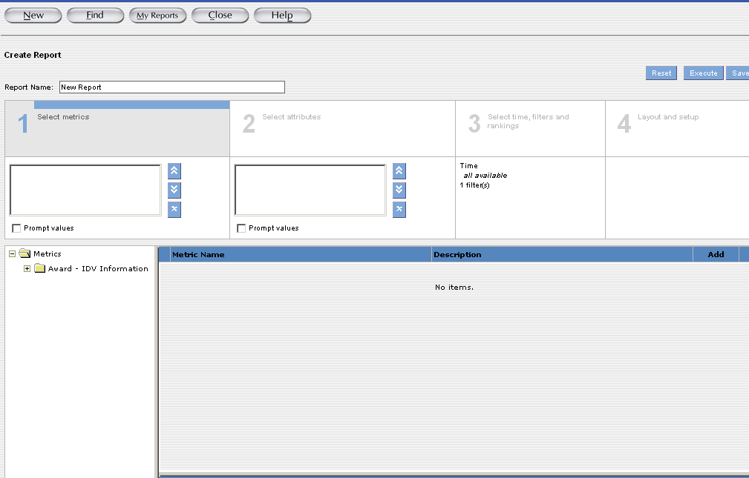
The “Create Report" screen is the design part of the report. This screen is divided into four sections that are designed to create the queries for the report.
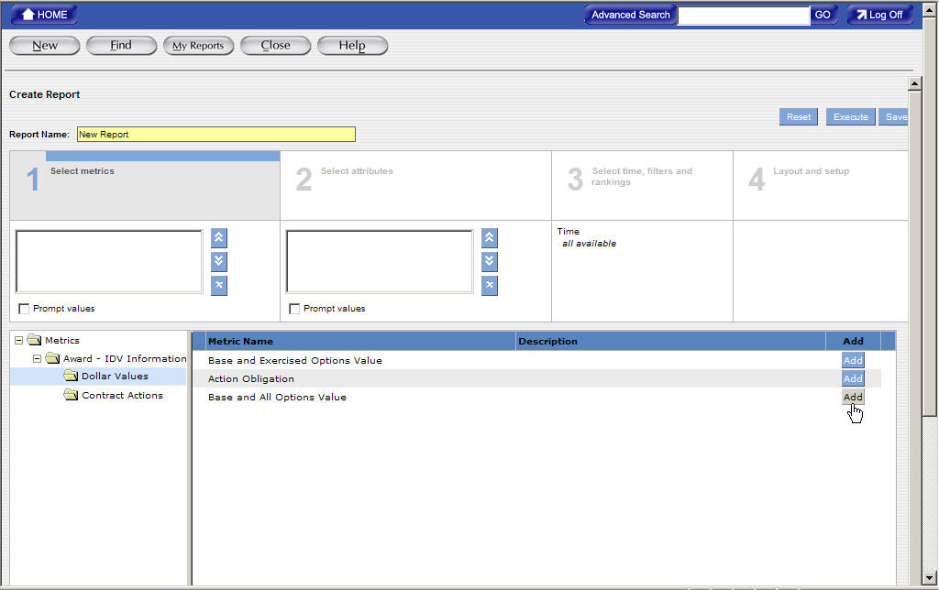

To Create a New Report in Ad Hoc
The first step in creating a report is specifying the data for the report.
Section 1: Select Metrics adds the measures to evaluate a business process. Metrics are always numeric values. For example, Action Obligation, Count of Actions, Base and Exercised Options Value, and Base and All Options Value are all metric values. Those are metrics that provide measurable information that is used to determine trends in federal spending.
Click on the “Add” button next to the desired metric(s) and the chosen metric(s) is added to the metric box in section 1.
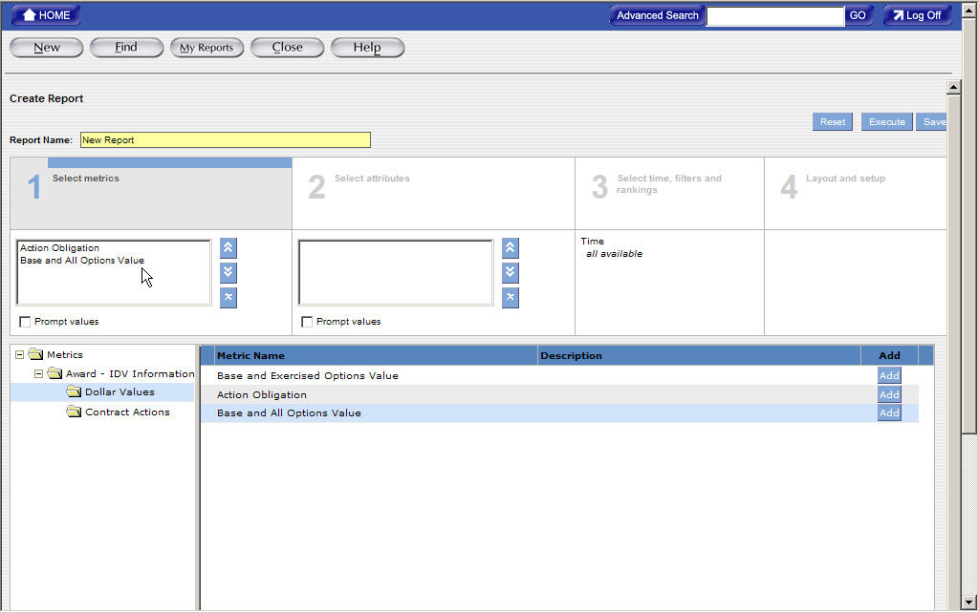

Exercise for Adding a Metric to a Report

To add a metric to a report:
- Click on the Section 1: “Select metrics” and then click on the “+” sign to open the “Award-IDV Information” folder. A list of available metric folders will be displayed in the Metric Folders task area. Click on the available metric folders and a list of the available metrics will be displayed in the Results task area.
Figure 8-23 Adding a Metric to a Report (1)
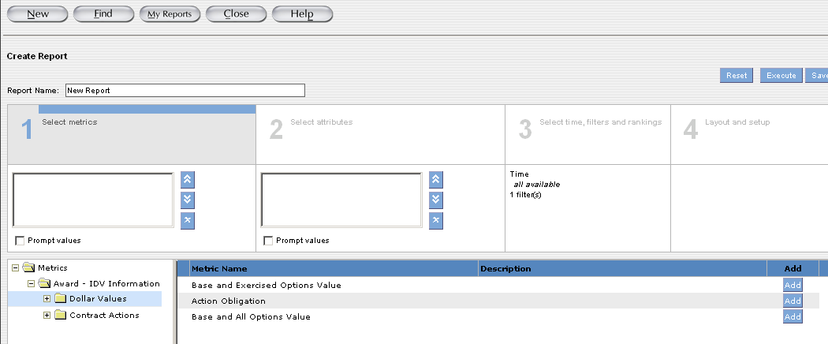
- Click on the “Add” button that is listed next to the metric that you want to add it to your report. Multiple metrics can be added to the report. The selected metrics will appear in the box under Section 1: Select metrics.
- To remove a metric from a report, click on the metric that will be deleted from the report and then click on the “Remove” button to remove the metric.
- To change the order of a metric in the report, click on the desired metric and then click on the Move Up or Move Down buttons to re-arrange the order of the metrics. The order of the metrics in the report determines the order in which the metrics are displayed in the report table.
- Click on the “Save” button to save the report.

Selecting Attributes for a Report
This section describes selecting attributes for a report. Attributes are the factors that determine the value of the metrics.
For example: Contracting Department ID, PIID, Product Services Codes, Contracting Office ID…etc. are attributes. If you want to create a report that tracks total obligated amount and total actions for a specific agency, you need to identify the attributes that determine the values of these metrics.

Reports with Attributes Only
You can create a report with attributes only. You might want to create a report with only attributes to display attribute details.
The attribute section displays all the available attribute folders.

Adding an Attribute to a Report
You can add attributes to the report from the attribute folders that are listed on the “Section 2: Select attributes” page.
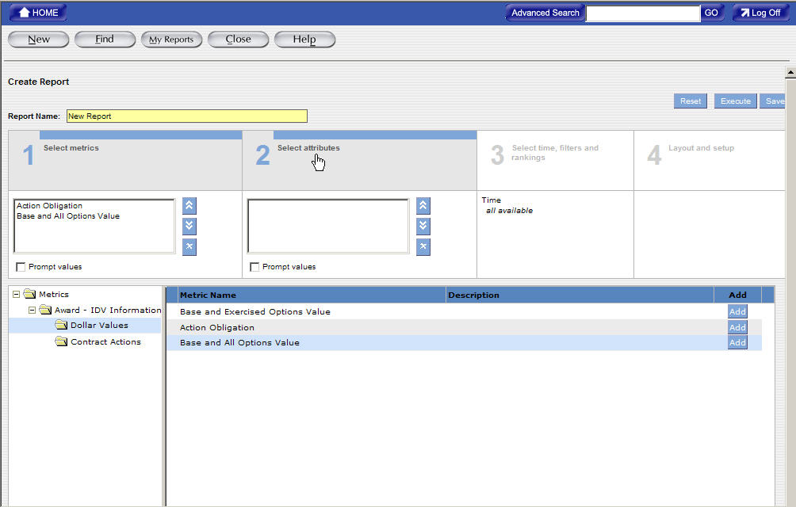

Prompts for Attributes in a Report
You can create prompts for attributes in a report. The “Prompt” feature allows the user to specify a specific value for a specific attribute when generating the report. The user has the option to change the value every time when they generate the report.

To Select Attributes for a New Report
The attributes are the factors that determine the value of a metric.
Click on the “Add” button that is listed next to the desired attribute(s). The chosen attributes are added to the attribute box in section 2.
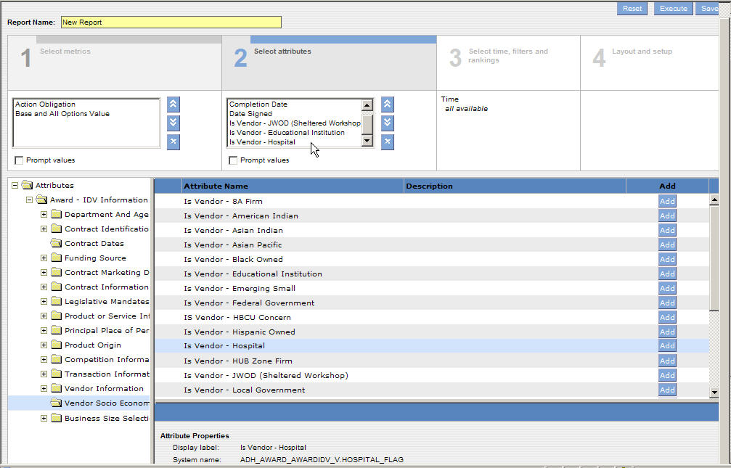
Exercise for Adding an Attribute to a Report
To add an attribute to a report:
- Click on the Section 2: “Select attributes” and then click on the “+” sign to open the “Award-IDV Information” folder. A list of available attribute folders will be displayed in the Attribute Folders task area. Click on the available attribute folders and a list of the available attributes will be displayed in the Results task area.
Figure 9-24 Attribute Folders Task Area
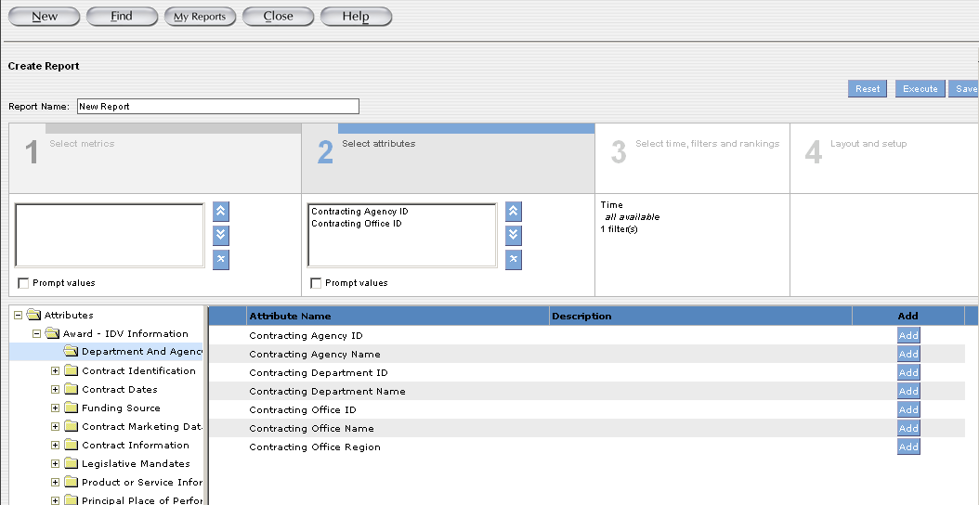
- Click on the attribute folder that contains the attributes you want to add to the report.
- Click on the attribute you want to add to the report.
- Click on the “Add” button to add the desired attribute to the report.
You can add more than one attribute to the report. The selected attributes will appear in the box under the Section 2: Select attributes.

Figure 9-25 Selected Attributes

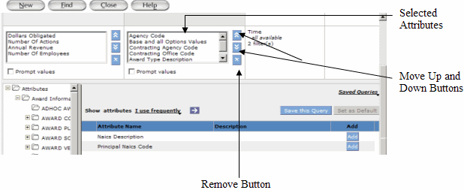

- To remove an attribute from the report, click on the attribute you want to remove and then click on the “Remove” button .
- To change the order of an attribute in the report, click on the attribute and then click on the Move Up or Move Down buttons.
- The order of the attributes in the report determines the order in which the attributes display in the report result.
- Click on the “Save” button to save the report.

Select metrics and attributes from various folders
The users may select Metrics and/or Attributes from the “Award-IDV Information” folders or the “Other Transaction Information” folders, but never both folders within one report.

Before selecting any metric and/or attribute, the users will notice that there are two folders, “Award-IDV Information” and “Other Transaction Information” folders, listed under the metric section and attribute section.

Both “Award-IDV Information” and “Other Transaction Information” folders have the same 2 sub-folders; one is “Dollar Values” and the other is “Contract Actions”, but each folder contains different data elements that are associated with the main “Award-IDV Information” and “Other Transaction Information” folders.

The following is the screenshot that shows the data elements that are associated with “Dollar Values” folder that is listed under the “Award-IDV Information” folder.
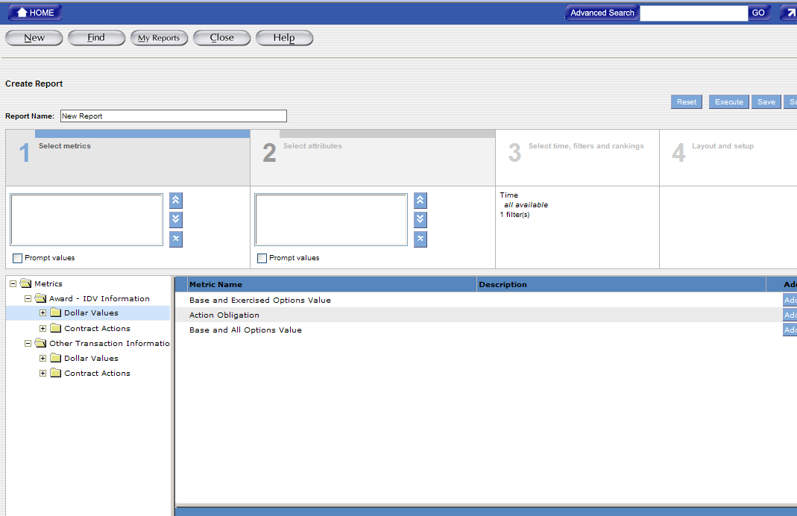

The following is the screenshot that shows the data elements that are associated with “Contract Actions” folder that is listed under the “Award-IDV Information” folder.
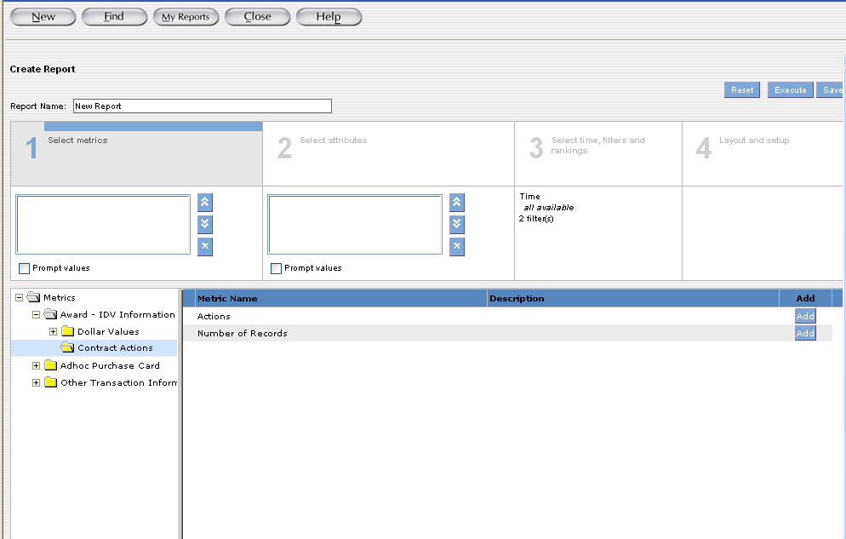

The following is the screenshot that shows the data elements that are associated with “Dollar Values” folder that is listed under the “Other Transaction Information” folder.
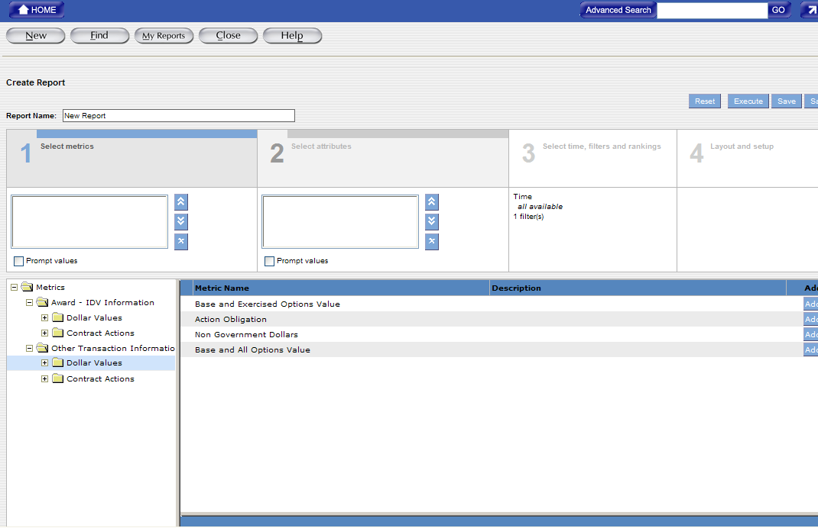

The following is the screenshot that shows the data elements that are associated with “Contract Actions” folder that is listed under the “Other Transaction Information” folder.
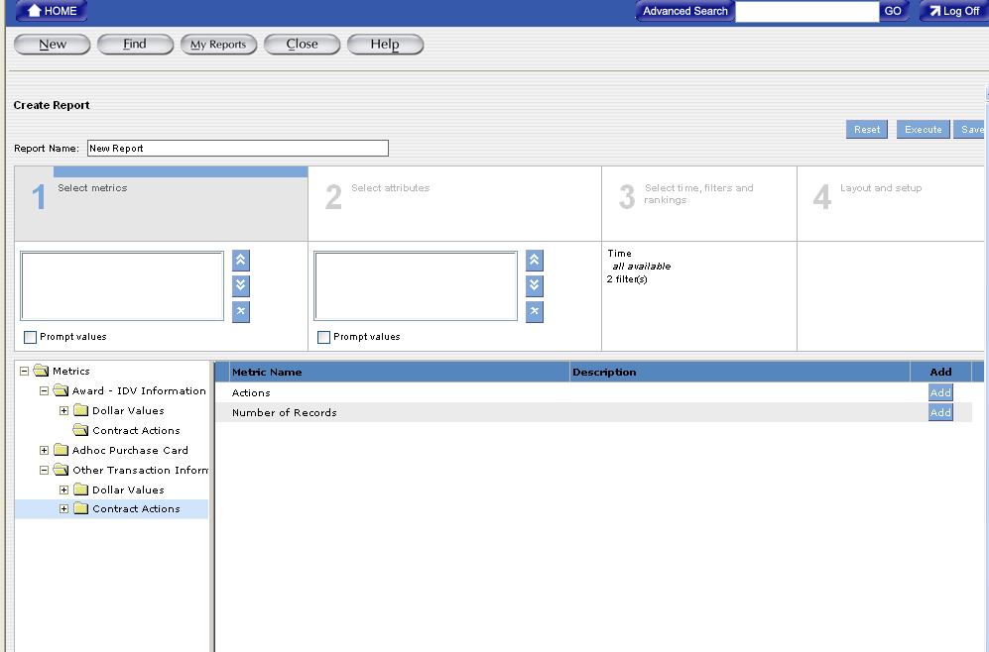

If the users select the metrics from the sub folders that are listed under the “Award-IDV Information” folder at the “Select Metrics” section, the users will only be able to access the “Award-IDV Information” folder and all its sub folders at the “Select Attributes” section.
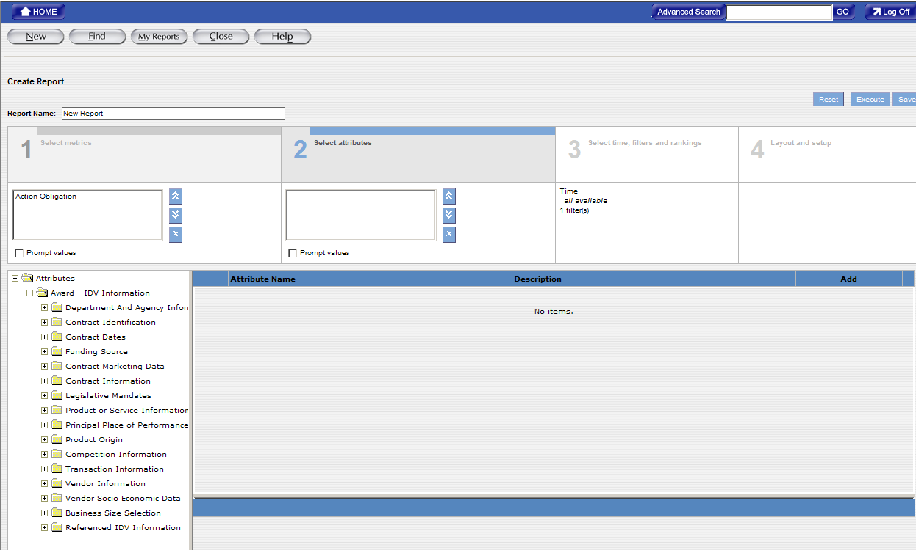

If the users select the metrics from the sub folders that are listed under the “Other Transaction Information” folder at the “Select Metrics” section, the users will only be able to access the “Other Transaction Information” folder and all its sub folders at the “Select Attributes” section.
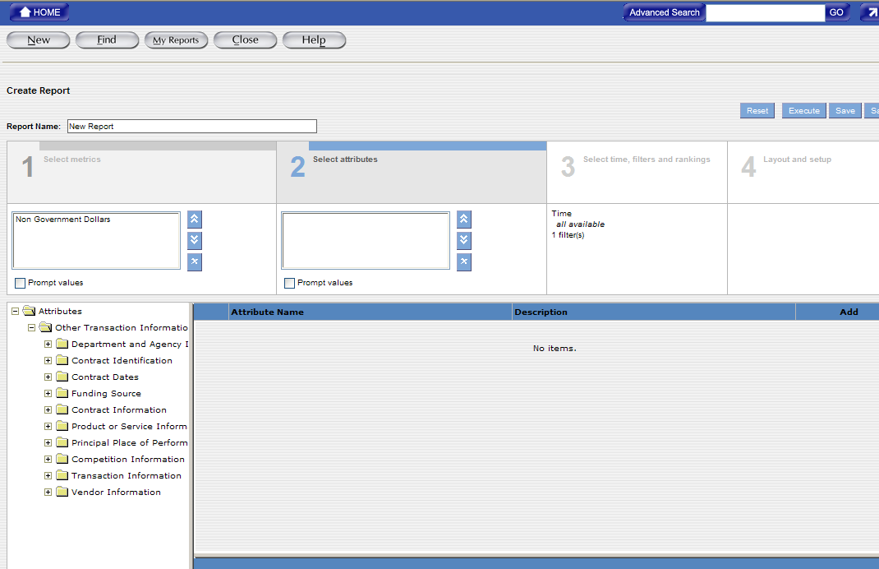

If the users select the metrics from both the “Award-IDV Information” and “Other Transaction Information” folders, the users will not see any folder at the “Select Attributes” section.
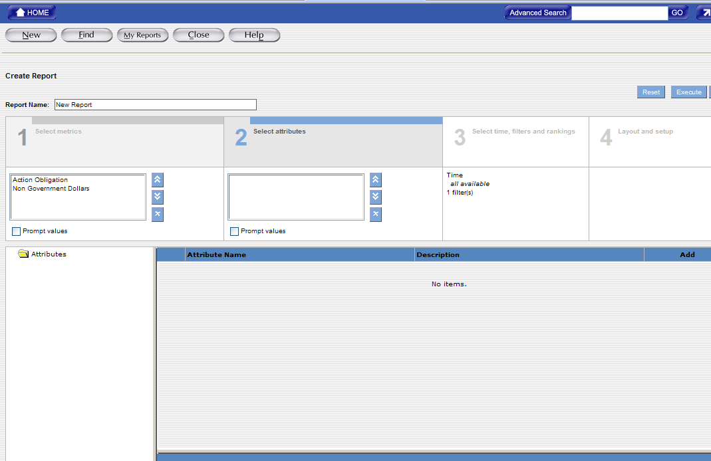
If the users select the attributes first before selecting the metrics, the FPDS-NG system will display different screens.

If the users select the attributes from either the “Award-IDV Information” or “Other Transaction Information” folder, the users will see both “Award-IDV Information” and “Other Transaction Information” folders at the “Select Metrics” section.
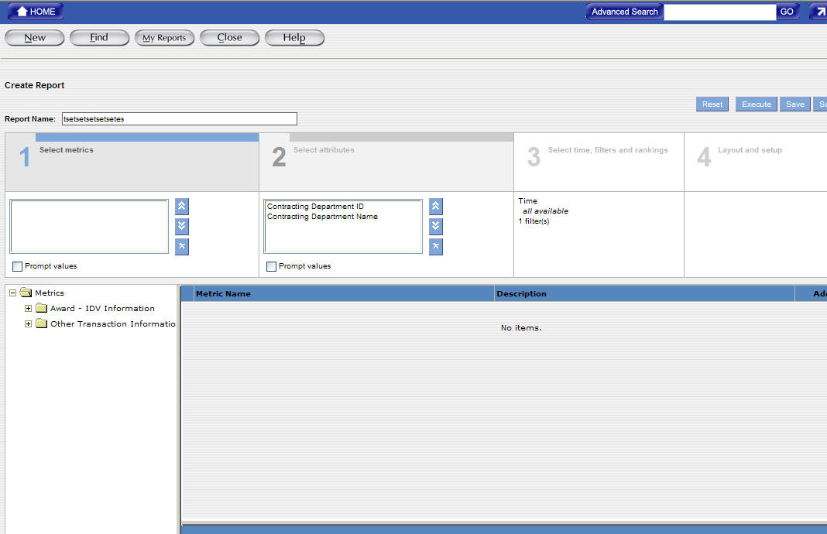

If the users select the attributes from the “Award-IDV Information” folder, the users will need to select the metrics from the “Award-IDV Information” folder; if the users select the attributes from the “Other Transaction Information” folder, the users will need to select the metrics from the “Other Transaction Information” folder.

If the users select an attribute from the “Award-IDV Information” folder and then select a metric from the “Other Transaction Information” folder, the users will see the error message that is similar to the following after getting back to the “Select Attributes” section:

Invalid Report: Attribute "Contracting Agency ID" is not an applicable attribute to metrics "Non Government Dollars".

If the users select an attribute from the “Other Transaction Information” folder and then select a metric from the “Award-IDV Information” folder, the users will also see the error message that is similar to the above error message.
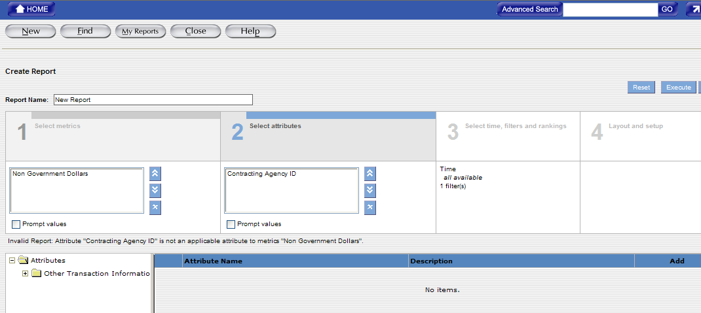

Creating Filters
This section describes creating filters. After you select metrics and attributes for a report, the user can enhance the report by completing the following tasks:
Creating Filters - Filters allow the users to set criteria for the data they want to display in the report. The filters are created based on the business question that the users need the answers for. The users can create the following types of filters:
- Attribute Filters - An attribute filter sets the criteria for the report data based on selected attribute values. The users select the attribute values by selecting an attribute name, an operator for the filter, and value(s) for the attribute.
- Metric filters - A metric filter sets the criteria for the report data based on selected metric values. The user selects the metric values by selecting a metric name, an operator for the filter, and value(s) for the metric.
The users can create reports with both the attribute and metric filters and create more than one attribute or metric filters for the report. The users can also create filters on attributes or metrics that are not part of the report.

For example: In the report, the users can set a filter to view the data for a specific government agency. In this case, the user can set the filter on the “Contracting Agency ID” attribute, which may not be part of the report. When you create a filter, by default, the filter displays in the basic mode. In the basic mode, the filter displays the metric or attribute name, an operator for the filter, and values for the metric/attribute.

Figure 11-26 Number of Filters in Report

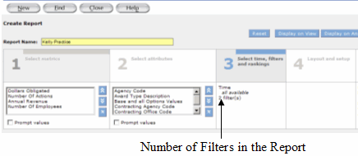

After the report results are displayed on the screen, the filters that are set for the report can be located in the section; the users don’t have to go back to the design part of the report to check the filters of the report. The users can remove the filters from the report; however, you can restrict the users from removing filters from reports.

The report always displays the data based on the filters (the criteria) that are set for the report. The default filter is the “Date Signed” filter.

When the users are ready to generate the report, the system will give the user an opportunity to fill in the time parameter for the report.
- After selecting attributes, click on Section 3: Select time, filters and rankings to add criteria to the report.

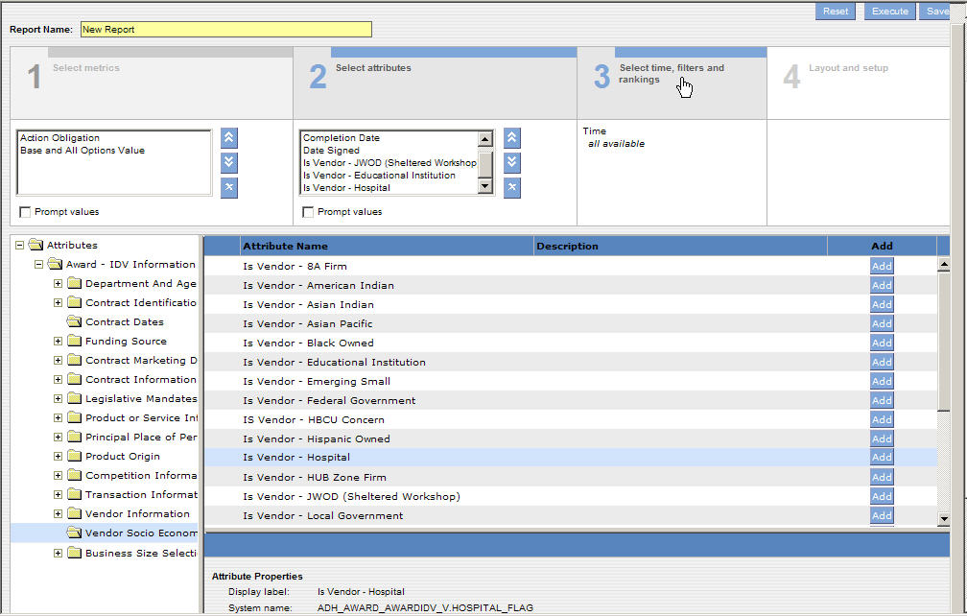

To Create Filters on a New Report
The users can use the filters in the report to set the criteria for the report data. When creating a report, the filters are used to limit the search of the query to the specifications. The filters are created based on the business question that the users want the answer for.
- The Attribute Filter link will be highlighted in black as it is shown in the following screen. This link is used to access filters for each attribute that has been selected under Section 2: Select attributes.
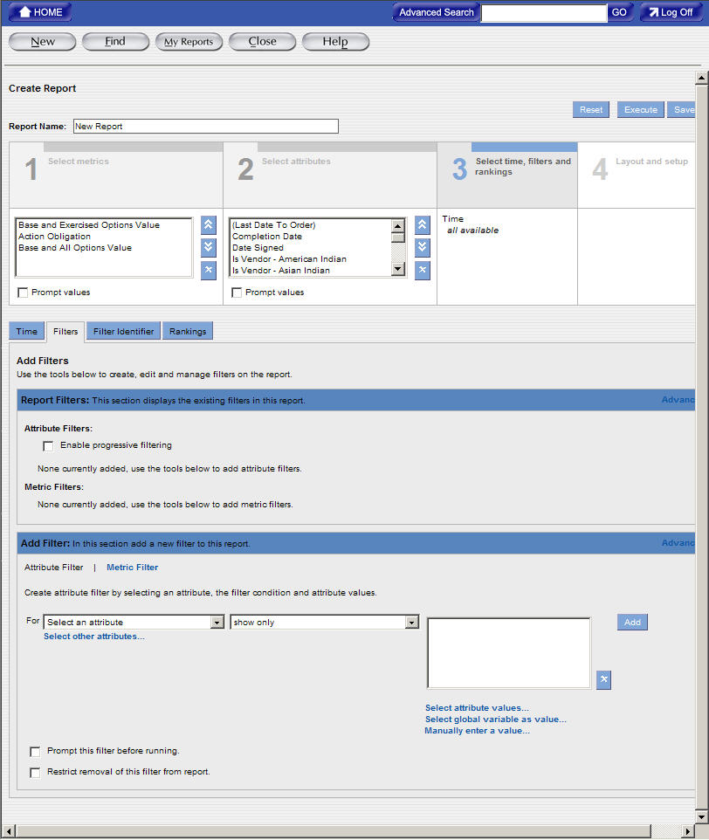
- The users can use the dropdown menu to highlight and select the attribute value that they want to set the “Attribute Filter” for.
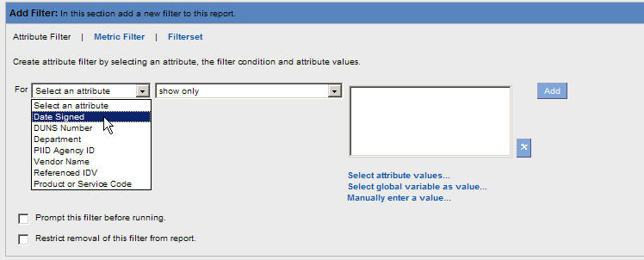
- After selecting the attribute value that the users want to set the Attribute Filter for, they can use the dropdown menu to highlight and select the operator that provides the criteria for the attribute values.
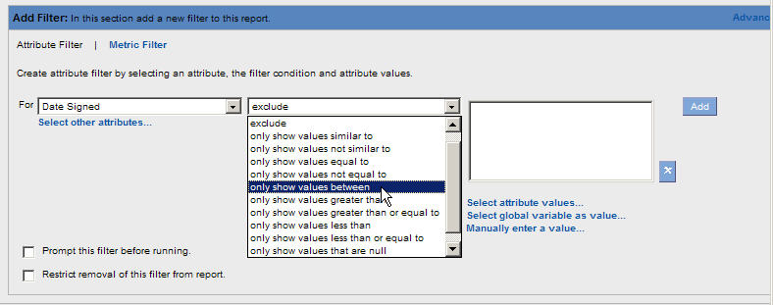
- Provide the criteria for the filter by entering information in the Attribute Value boxes.
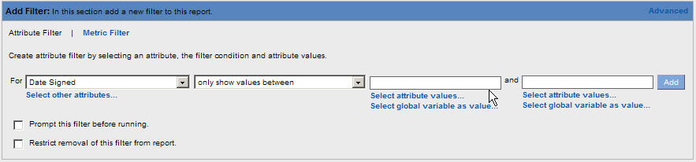
* Note: Different operators will determine the values that you can enter in the Attribute Value boxes.

- Click on the “Add” button to add the filter values in the Report Filters section of the screen.
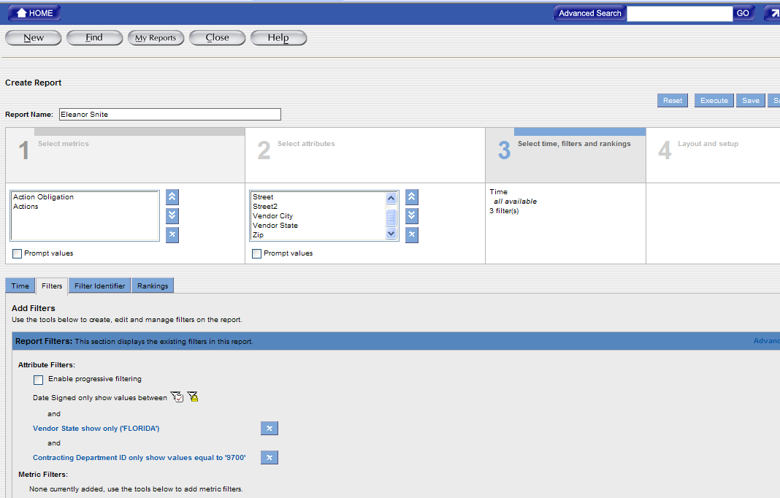

- The Metric Filter link will be highlighted in black as it is shown in the following screen. This link is used to access filters for each metric that has been selected under Section 1: Select metrics.
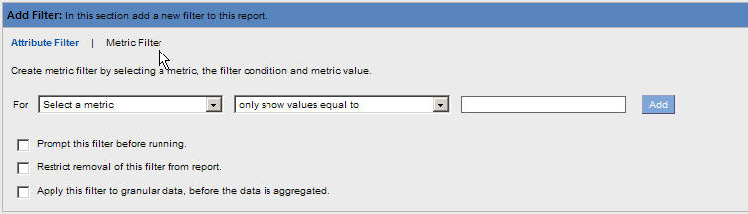

- The users can use the dropdown menu to highlight and select the attribute value that they want to set the “Metric Filter” for.
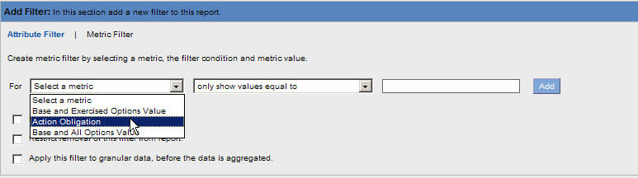
- After selecting the Metric Filter, use the dropdown menu to highlight and select the operator that provides the criteria for the Metric values.
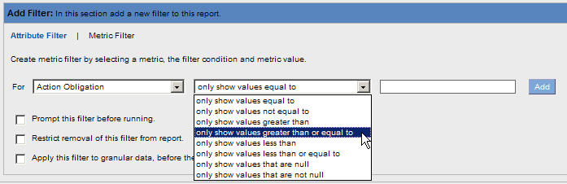
- Provide the criteria for the filter by entering information in the Metric Value boxes.
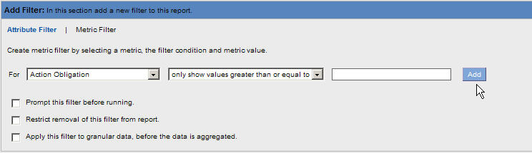
* Note: Different operators will determine the values that you can enter in the Metric Value boxes.

- Click on the “Add” button to add the filter values in the Report Filters section of the screen.

Updating Filters on a new or existing report
- Filters are stored under the Report Filter Section in Section 3: Select time, filters and rankings. Use the following steps to update Attribute and/or Metric Filters.
- To make changes to an existing filter, click on the blue link of the filter and the color of the filter will be changed to green link. For example:.
- The selected filter link is highlighted in green and the criteria of the filter are listed in the Edit Filter section.
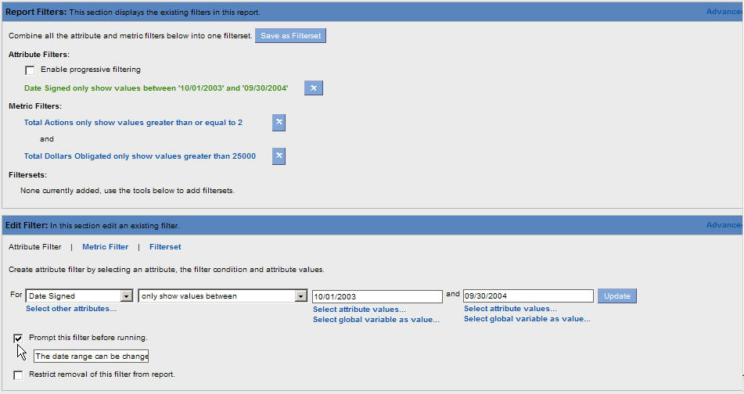
- Make the changes to the filter by selecting information from the dropdown menus or entering new information in the Values field(s).
- After the changes are completed, click on the “Updated” button to store the changes in the Report Filters Section.
Exercise for Creating an Attribute Filter

- Click on the Section 3: Select time, filters and rankings

- Set up the filters. The Filters tab displays.

Figure 11-27 Attribute Filter Selection Task Area

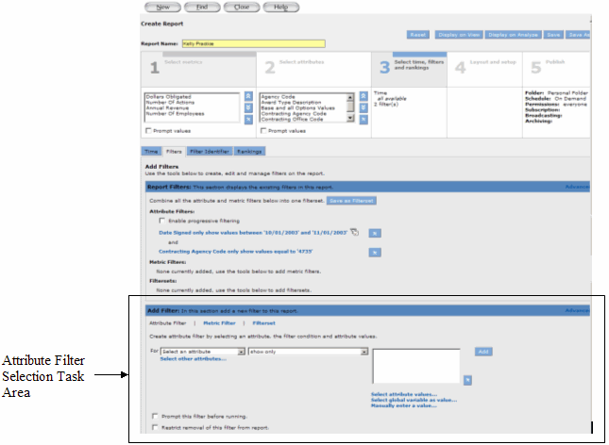

- In the Attribute Filter Selection task area, click on the “Select an Attribute” dropdown menu to select an attribute value for the attribute filter.

The attribute list displays the attributes that are added to the Section 2: Select attributes.

Figure 11-28 Attributes in the Current Report

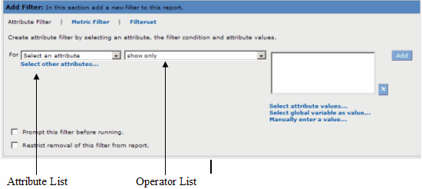

- From the operator list, select an operator for the filter. If you create a prompt for the attribute filter, you do not need to enter attribute values for the filter. You can skip the following step. If you pre-defined the attribute with a specific attribute value, the Ad Hoc report will populate the prompt with the pre-defined values.

- Select values for the filter by choosing one of the following options:
- To select values for the filter from the list of available values, click on “Select Attribute Values.”
- The Choose Attribute Values window appears with the first 100 values.
Informatica recommends that you select less than 100 attribute values for each attribute filter. The length of each filter is limited to 255 characters, including letter, numbers, signs, and spaces…etc.

-Or-
To manually enter an attribute value, click on “Manually Enter a Value.” Enter an attribute value for the filter, and then click on OK. Or, enter a value or values in the text box. Depending on the operator you selected the text box might display differently for the attribute values.

- To create a prompt for the attribute filter, select Prompt this Filter Before Running

Figure 11-29 Prompt this Filter Before Running
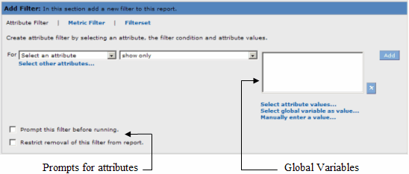

- To restrict users from removing a filter from the report, select Restrict Removal of this Filter from Report.

- To add another attribute filter to the report, repeat steps 3 to 7. After you add a filter to the report the reporting tool displays another set of filter options in the Attribute Filter Selection task area. The filters are applied to the report in the order in which they appear in the Attribute Filter Selection task area.

- To remove an attribute filter, click the Remove button to remove the filter.

- To save the report, click on the “Save” button to save the report.
Exercise for Creating a Metric Filter

- Click on Section 3: Select time, filters and rankings. The Ad Hoc report defaults this section to the “Filters” tab.
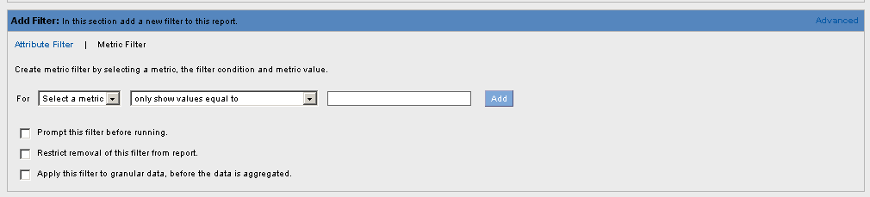
- In the Metric Filter Selection task area, click on the “Select a metric” dropdown menu to select a metric for the filter. The metric list displays the metrics that have been added to the Section 1: Select metrics.

- From the operator’s dropdown menu, choose the operator for the filter/criteria.

- Enter a value for the filter.

- To create a prompt for the metric filter, check the “Prompt this Filter before Running” checkbox.

- When you create a prompt for the metric filter, you are not required to enter metric values for the filter condition. When you are ready to generate the report, the reporting tool will prompt you to select the metric values you want to display in the report.

- To restrict the users from removing a filter from the report, select “Restrict Removal of this Filter from Report.”

- To add another metric filter to the report, repeat steps 3 to 7. After you add a filter to the report, the system displays another set of filter options in the Metric Filter Selection task area.

- To change the order in which the filters are applied to the report, click the Move Up or Move Down button to change the order in which the filter appears in the Metric Filter Selection task area.

- To remove a metric filter, click the Remove button to remove the filter.

- To save the report, click on the Save button to save the report.

Setting Report Table Layout

There are three types of report tables:
- Tabular
- Cross tabular
- Sectional

Tabular Report Tables
A tabular report table displays attributes as row headers only. By default reports are created with tabular report tables. You can change the table layout to create a report with a cross tabular or sectional report table. A cross tabular report table displays attributes as row and column headers.

Cross Tabular Report Tables
A cross tabular report table displays attributes as row and column headers. By default, reports with time settings are cross tabular. The time settings display as column headers in the report table. If the report contains other attributes, you can place them as column headers or row headers.

Sectional Report Tables
A sectional report table displays the report data in sections. The sections are based on an attribute and each section in the report table represents a unique attribute value. Within each section, attributes can display as row and column headers. If you have a report with a large number of rows, you can divide the report table into sections based on an attribute in the report. Each section represents a unique attribute value.

You can create sectional report tables based on more than one attribute.

When you add a chart to a report with a sectional report table, by default, the chart is created for the first section in the report. After you add charts for the other sections, the report displays separate charts for all the sections.

Displaying Metrics as Rows
By default, all metrics in a report display as columns. If you want to create a report that displays metrics as rows, you can change the table layout. You cannot create a report with metrics as rows and columns. You can display metrics as rows in tabular, cross tabular, and sectional report tables.

To Format the Report
The final step in creating reports is selecting the format for the report. Section 4: Layout and setup is used to customize the visual display of your report. Calculations can be added for metric filters in the report. You can also modify the date formats, display, and fonts in the report. The users can use the following steps to format a report.

- To add a sections to a report select the Table Layout Tab.
- To create the report with sections, drag an attribute to the Section Attribute area. The selected attribute displays in the Section Attribute area. You can also drag attributes from the Section Attribute area to the Row Attribute or Column Attribute areas.

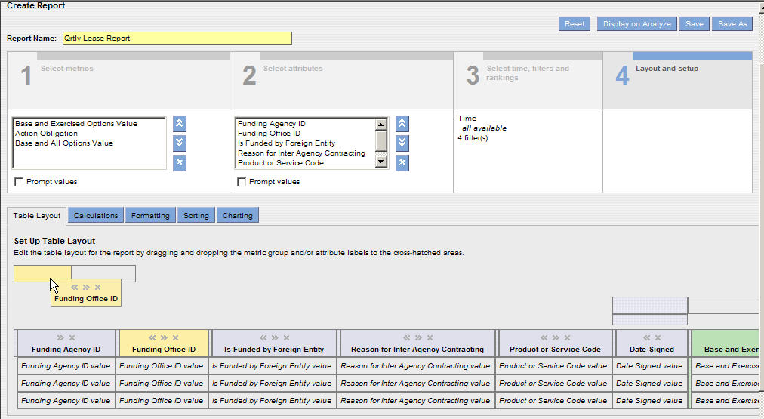

- Creating sections in a report will display the report divided by the attribute you have chosen. For example, choosing the funding agency ID will display the report information in sections for each ID.

- To add a calculation to the report, select the Calculations Tab. The following screen will display.

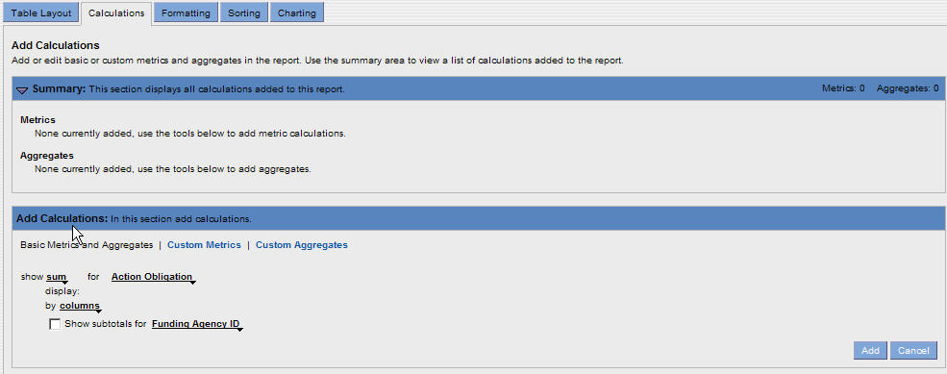

- Select the dropdown menus next to the word “Show” that is seen in the following screen.

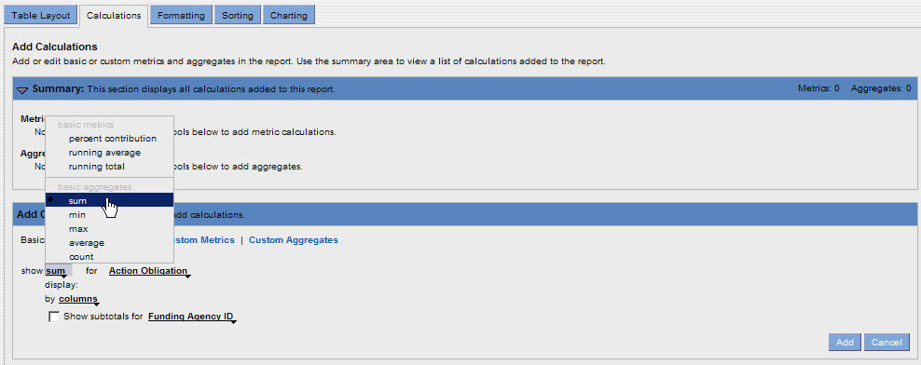

- Select the type of calculation desired for a metric filter.
- Select the dropdown menu to select the metric for the previously chosen calculation.

- To display the subtotals for a specific column click the check box and select the dropdown menu for Show Subtotals. Click on the attribute that will display the subtotals.

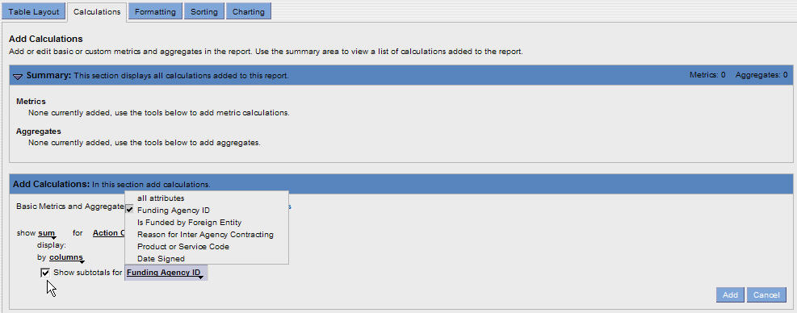

- Click on the “Add” button to place the calculations in the Summary section.

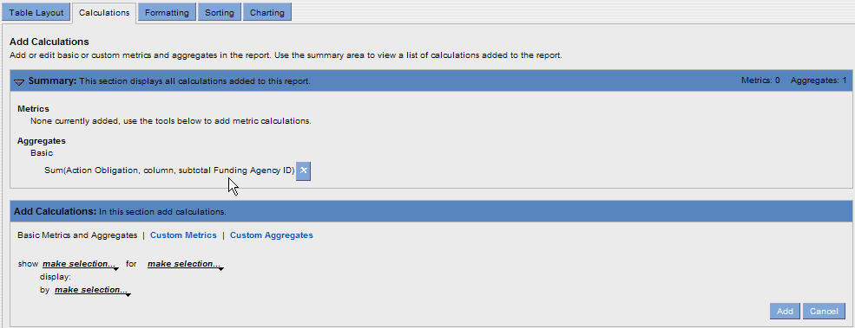

- To change the formatting for the report, click on the “Formatting” Tab. The following screen will display.
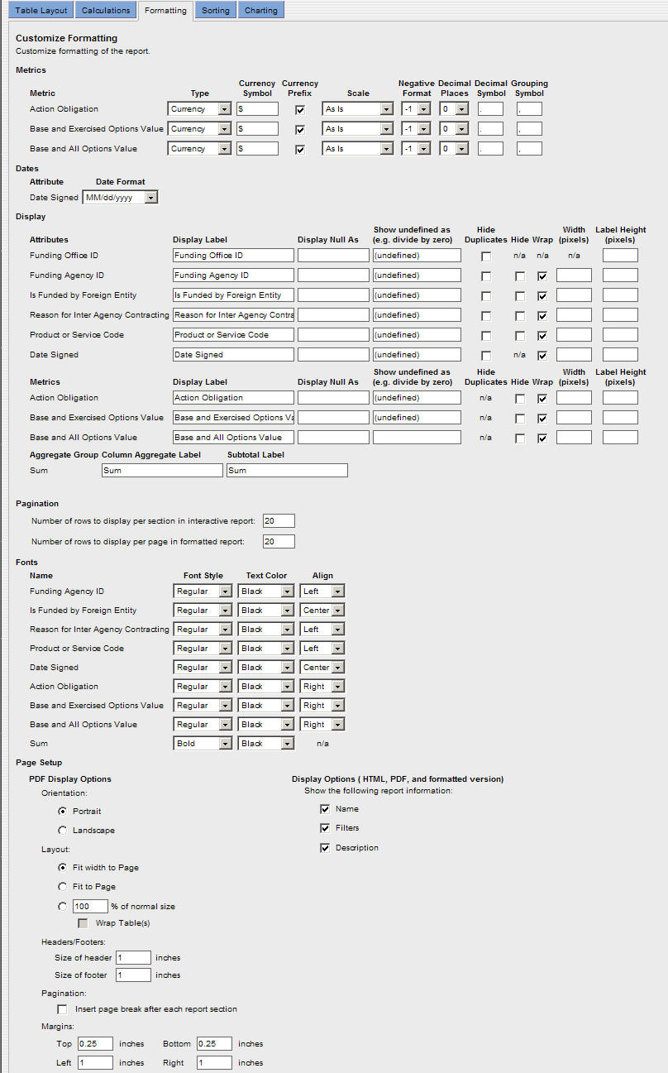

- The user can select formats for metrics and attributes on the Formatting tab. These formats determine how the metrics and attributes display in the report table.

- To keep the changes made to the report formatting click on the “Save” button to save the report or click on the “Save As” button to save the existing report as a new report with a new name.

- The “Save As” feature will allow the users to make changes to the report and save the changes without overwriting the original report.
Exercise for Setting Report Table Layout

- Select Table Layout.
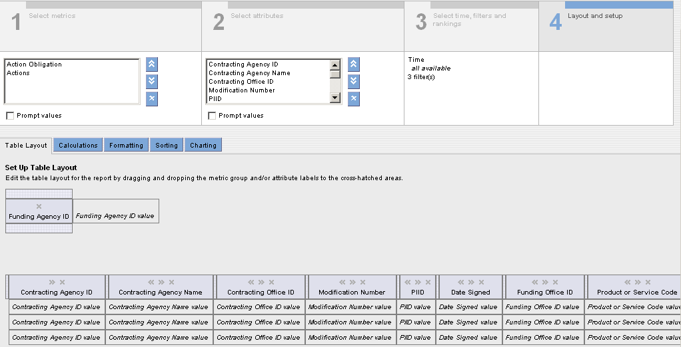

- To create a Sectional report, from the Row Attribute area, drag an attribute to the Column Attribute area. The selected attribute displays in the Column Attribute area.

- The report will display in sections as defined by the attribute you selected.

- To save the report, click on the “Save” button to save the report.

Exercise for Creating a Calculation in a Report

- Select the Calculations Tab.
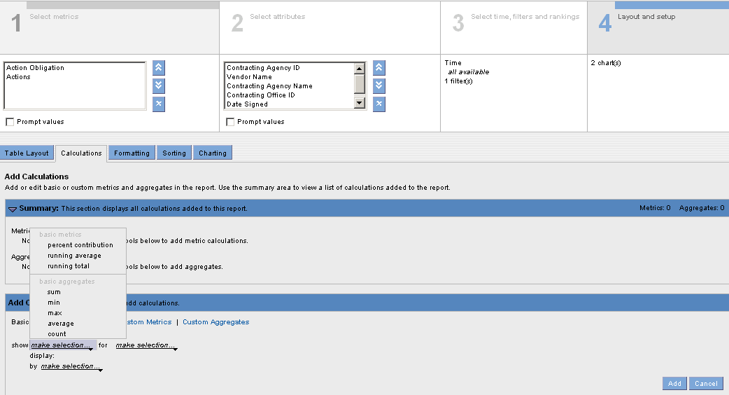
- Select the type of Calculation.
- Select the drop down menu next to Show and choose an operation.
- Select the drop down menu next to for and choose the metric for the calculation.
- Select Add to place the calculation in the Report.

Creating a Report Table Sort Order from Layout
The users can create a sort order to sort the rows in a tabular report table based on attribute or metric values. The users can also create a sort order to sort the columns in a cross tabular report table or the sections in a sectional report table. The users will be able to sort the report rows, columns, and sections in ascending or descending order; they can also create a nested sort order. If the users sort report data based on an attribute and if the report contains many rows with the same attribute values, they can sort these rows based on another attribute or metric.

The following figure shows a report table sorted on the category attribute and then the actions count attribute.

Figure 11-30 Nested Sort Order
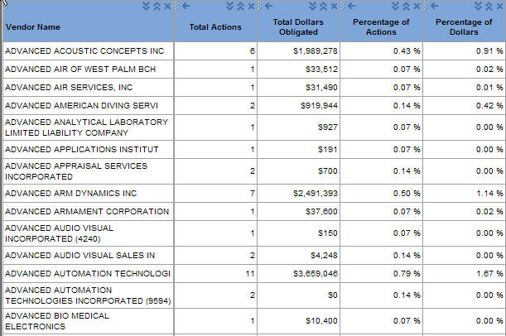

Rows are first sorted on these values
Rows are sorted secondary on these values

In a report with multiple attributes, if one or more attribute has a sort sequence, the reporting tool sorts all the attributes in the report table by default. When you sort report data, the reporting tool treats any null metric value as the smallest value. In a report with time settings, the reporting tool uses row totals to sort the rows in the report table. If the report has multiple time settings, the reporting tool sorts the columns in the first time setting only.

Exercise to Create a Report Table Sort Order

- Select Layout and Setup

- Select Sorting.

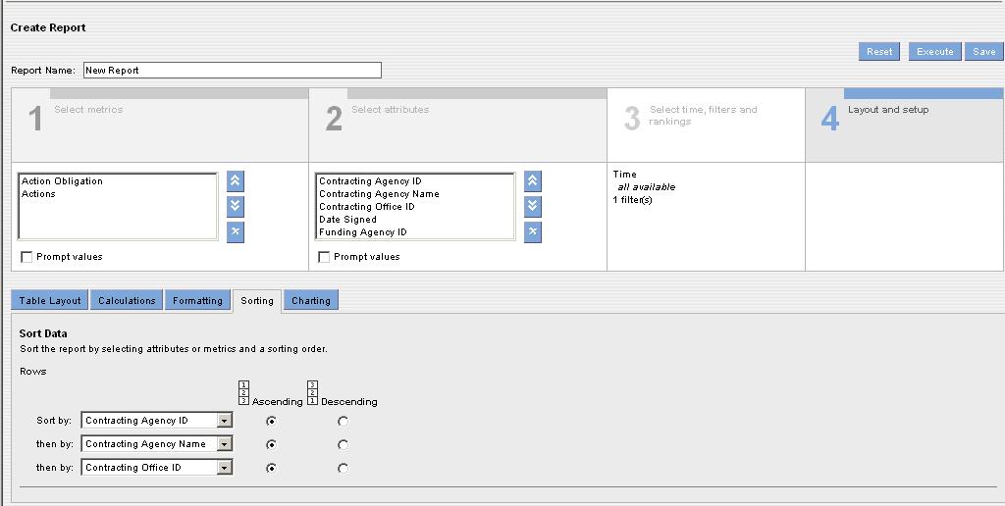

- The Sorting tab displays. If the report has a tabular report table, the Sorting page displays the sort options for the rows in the report.

- To sort the rows, select an attribute or metric in the first Sort By list.

- Select Ascending or Descending as the sort order.

- To create a nested sort order you can create three levels of nested sorting.

- To save the report, click on the “Save” button to save the report.

- Click on the “Execute” button to execute the report.

- Enter a Date parameter (for example 10/01/2009 to 09/30/2010).

- Click on the “Display Report” button to generate the report.

Adding a Chart to a Report
The users can create charts for their reports; they can create multiple charts for one report. The reporting tool displays the report chart along with the report results.

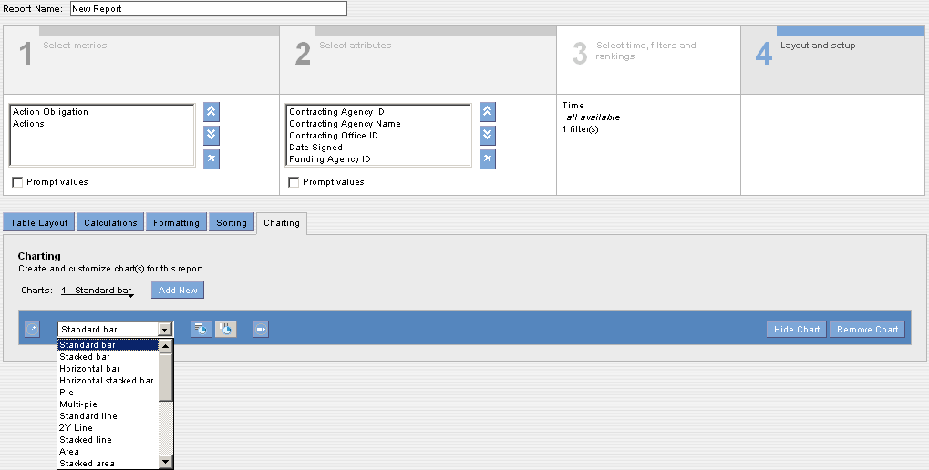

Displaying Data in a Chart
When you display data in a bar, line, or combo chart, the chart contains the following components:
- Groups - Categories that the reporting tool uses to organize data in a chart. For example, on a standard bar chart, groups display on the x-axis.
- Series - Data items for each group. The reporting tool displays each data series in a unique color.
For example: On a standard bar chart, series display on the y-axis. Each group contains a series of data. Except for pie and multi-pie charts, the reporting tool displays labels for series on the chart legend. You need at least one group and one series to plot a chart.
Depending on the chart type, you may need more groups or series of data.
For example: You need at least three groups of data to display bubble and waterfall charts. When you display a chart, the reporting tool displays an error message if you do not have enough groups or series of data in your table. Report charts display up to 500 data points. You can calculate the number of data points in a report by multiplying the number of rows by the number of columns. You can also set the size of the report chart. If the report chart size is too small for the report labels, the report chart displays cropped labels.

You can plot the chart in the following ways:
- Draw series along table rows - The reporting tool plots each row in the table as a series on the chart. 
- Draw series along table columns - The reporting tool plots each column in the table as a series on the chart.

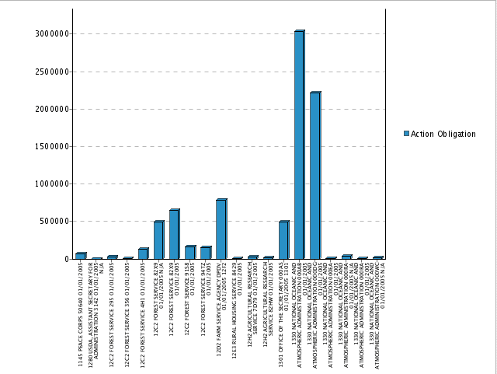

Report Chart Types
You can create the following types of charts for reports:
- Standard bar - Displays data as vertical rectangular bars.
- Stacked bar - Displays data as vertical rectangular bars stacked on each other, where each stack represents a series of values.
- Horizontal bar - Displays data as horizontal rectangular bars.
- Horizontal stacked bar - Displays data as horizontal rectangular bars stacked on each other, where each stack represents a series of values.
- Pie - Displays percentage data values as proportionally-sized slices of a pie.
- Multi-pie - Displays data as pies, where each pie represents the metric values for each of the report metrics.
- Standard line - Displays data as lines.
- 2Y line - Displays data as two lines, each with its own Y axis. Both lines share the same X axis. The two Y axes may have different scales. You can use a 2Y line chart to compare values of two series of data.
- Stacked line - Displays data as lines stacked on each other, where each line represents the metric values for each of the report metrics.
- Area - Displays data as lines with the area beneath the lines filled in. An area chart can plot two or more data points.
- Stacked area - Displays data as filled-in lines stacked on each other, where each area represents a series of values. A stacked area chart can plot two or more data points.
- Combo - Displays data as a combination of bar and line charts. The reporting tool displays the first series in the report as a bar chart and the second series as a line chart, each with its own Y axis. Both series share the same X axis. The two Y axes may have different scales. If the report consists of a single metric, the combination chart is equivalent to a bar chart.
- Stacked bar combo - Displays data as a combination of stacked bar and line charts. The reporting tool displays the first three series of data in the report. The first two series of data in the report display as a stacked bar chart and the third series display as a line chart. The first two series display with their own Y axis. Both series share the same X axis. The two Y axes may have different scales. If the report consists of a single series of data, the combination chart is equivalent to a stacked bar chart.
- Scatter - Displays data as points, where each point represents two metric values. In a scatter chart, both X and Y axes represent metric values. A scatter chart can plot two or more data points.
- Standard waterfall - Displays data as cumulative metric values, where each value is the sum of the previous value and the current value. The reporting tool displays the next incremental values as bars. The standard waterfall chart resembles a staircase. When you update the report, the reporting tool automatically updates the chart with the new values. You can use a standard waterfall chart to show a trend in metric values along an attribute.
- Horizontal waterfall - Similar to the standard waterfall chart displays cumulative values as horizontal bars, where the positions of the X and Y axes are reversed.
- 2Y bar - Displays two bar charts, each with its own Y axis. Both bar charts share the same X axis. A horizontal line separates the two bar charts. For better readability, the reporting tool displays the Y axis labels on the alternate sides of the chart. You can use a 2Y bar to compare values of two metrics or attributes.
- 3Y bar - Similar to the 2Y bar chart displays three bar charts.
- 4Y bar - Similar to the 2Y bar chart displays four bar charts.
- 5Y bar - Similar to the 2Y bar chart displays five bar charts.
- Bubble - Plots metrics as bubbles on the chart, where each bubble represents three metric values in the first series of the first three groups. The first metric value determines the x-axis position of the bubble, the second metric value determines the y-axis position of the bubble, and the third metric value determines the size of the bubble. Each bubble displays in a different color or pattern. You can create bubble charts for reports with tabular and sectional report tables. If the report contains more than three metrics, you can select any three metrics to plot the bubble chart. If you do not select any metrics, the reporting tool uses the first series of the first three groups in the report to plot the bubble chart. You can use the bubble chart in a report when you want to compare the metric values against each other.
- Pareto - Plots data as cumulative percentage to display the importance of differences between groups. A Pareto chart displays each group along the x-axis and the first series along the y-axis up to the percentage threshold you specify. Data groups that are greater than the percent threshold display in a
- Geographic - Provides a map representation for attributes that represent geographical regions. You can display a geographic chart for a report with one attribute and a tabular report table.

Displaying Metric Formats in a Chart
When the users select a metric for a chart, they can also select an axis that they want to display according to the format for the metric. They can select formats for metrics on the Formatting tab; these formats determine how the metric displays in the report table.
For example: The users can display a metric in the currency format, or they can display a metric with the thousand scales.

To select a metric for a chart
- Select Show More Chart Options
- Select Show Values for
- Select a metric

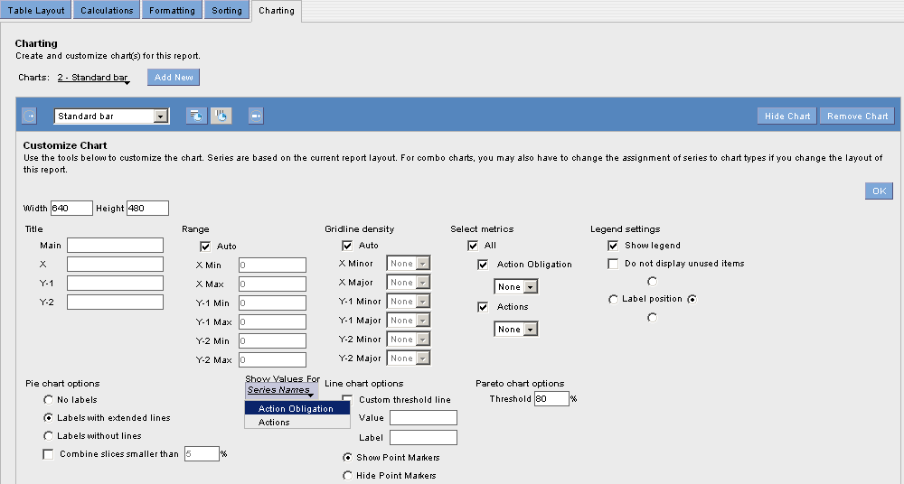
Exercise to Add a Report Chart

When you add a report chart, you can specify the type and size of a chart. The reporting tool auto sizes any text in the chart and uses a default font for the text. When you add a chart to a report with a sectional report table, by default, the reporting tool creates the chart for the first section in the report.

To add a report chart:

- From the Layout and Setup page, click Charting.

- Click on the “Add New” button and the chart toolbar will be displayed on the screen.

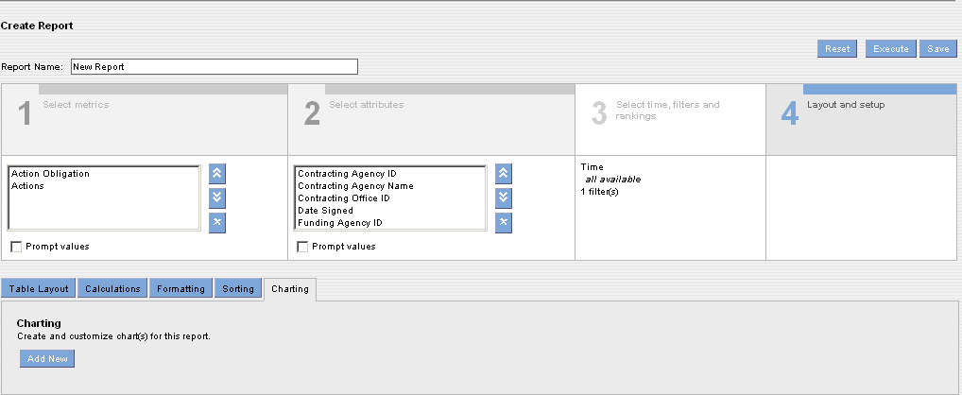

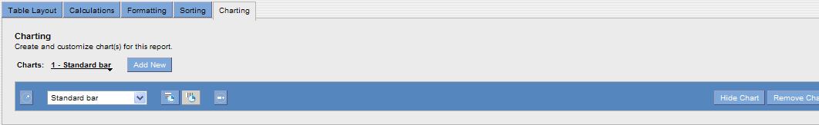
- To display the chart based on row or column data, click Draw Series along Table Rows or Draw Series along Table Columns.

- To hide the report chart, click on the “Hide Chart” button. By default, the reporting tool displays the report chart when you add a chart to the report.

- Select chart type

- Click on Show More Options

- Click on Show Values for

- Select a metric

- Click OK.

- To add another chart to the report, click Add New Chart.

- To view the chart, click Save. You will see the chart in the Layout box. Click Execute.

- To save the report, click Save. After you add charts to a report, the reporting tool displays the number of charts in the Layout tab.

Running a Report
After you create a report, you can check the report to ensure that it displays the information you want. If the report does not display the data you want, you can edit the report to get the information you need.

The users will be able to save the Ad Hoc reports that they create to the “Personal Folder.” They can perform the following tasks after the reports are created:

- Display report results
- Save the report

Displaying Reports with Prompts
You can save reports with prompts as on-demand reports only. You might want to use prompts to modify the data you want to display in the report. When you view a report with prompts, the reporting tool displays a summary of the components of the report for which you can create prompts. The summary includes the current values for metrics, attributes, attribute filters, and metric filters.

Note: For reports with tabular report tables, all attributes display in the By Row task area. For reports with cross tabular report tables, attributes display in the By Column or By Row task area. For reports with sectional report tables, attributes display in the By Section, By Column, or By Row task area.

When you view a report with a prompt based on an attribute or metric filter, the reporting tool prompts you to enter the values you want to display in the report. When you created the filter, you can enter specific values for the filter condition. The reporting tool displays these existing values in the prompt.

You can add or delete values. If you did not enter values for the filter condition when you created the filter, the reporting tool does not display any values in the prompt. You can select values for the filter. If the prompts are based on more than one attribute filter, you can use progressive filtering in the prompts.

Progressive filtering allows you to select attribute values for a second filter based on the attribute values you select for the first filter.
By default, the reporting tool displays the prompts every time you run the report. If you select certain prompt settings, you can choose to display those settings the next time you run the report. When the reporting tool prompts you the next time you run the report, the reporting tool displays the settings you selected the last time you ran the report.

The following screen is the screenshot of the time parameter. The users can use either the “Date Signed” field to generate the contract data that was signed within the time parameter specified or the “Last Modified Date” field to generate the contract data that was last modified within the time parameter specified.
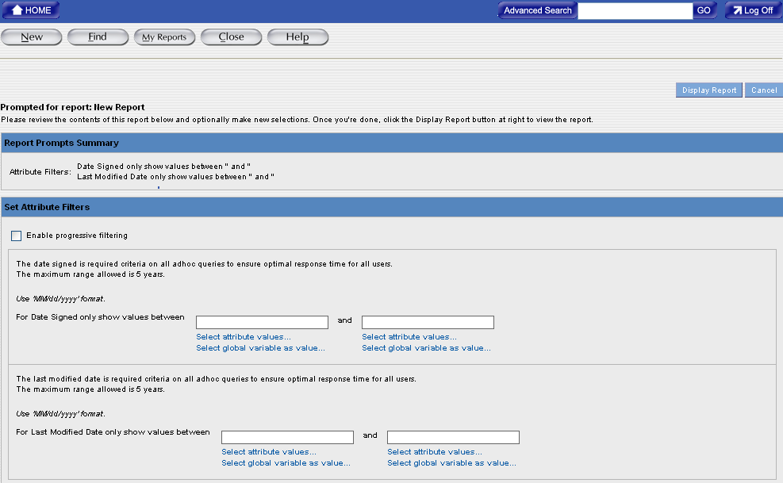
Exercise to Display Report

- From the Create Report tab, click the Display Report button.
-Or-
Open a report from the Find tab.

For an on-demand report with prompts, the reporting tool prompts you to select the settings to display in the report.

- To display the selected prompt settings the next time you view the report, click on “Prompt me with These Settings the Next Time I Run the Report.”

- Select values you want to display in the report:

  - If the prompts are based on attributes or metrics, clear the check boxes for any attribute or metric you do not want to display in the report.
  - If the report prompts are based on a filter, select attribute values you want to display in the report.
  - To add additional attributes values to an attribute filter, click the Select Attribute Values link. Click the attribute values, and then click OK.
  - If the prompts are based on a metric filter, enter a value for the filter condition.

- If the prompts are based on attribute filters, to display attributes values in a progressive manner, click Enable Progressive Filtering.

- Click on the “Display Report” button.

- The user can click on the “Edit” button to edit the report after the report data is generated. The report will appear in the Create Report tab and the user can make all the necessary changes and save the report.

Saving a Report
You can save a new report from the Create Report tab or you can also save an existing report as a new report. When you save a report, the reporting tool prompts you to enter values for the following report properties:
- Comments
- Description
- Keywords

Exercise to Save a Report

- On the Create Report tab, click on the “Save” button.

Note: The Save Report window displays options to configure report settings and properties the first time you save a report. All subsequent saves do not display these settings and properties.

- Enter a name for the report in the Report Name field. Maximum length for the report name is 255 characters. The report name can include any character except a space, tab, new line character, and the following special characters: / \ : * ? “ < > |

- Click Select Folder to select a location to save the report. The Select Folder window appears. In the Select Folder window, navigate to the location you want to save the report, and then click OK.
- Enter the following report properties
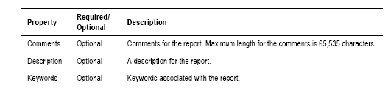
- Click on the “OK” button.

Working with Reports
You can perform the following tasks when working with a report:
- Save an existing report as a new report
- Print a report
- Export a report
- Email a report
- Display a report as a PivotTable
- Edit a report

Saving an Existing Report as a New Report
The users might want to save an existing report as a new report when they edit the report. Once you save an existing report as a new report, you can change the comments, descriptions, and keywords associated with the report. You can also select the category, department, and query governing settings for the report. When you save an existing report as a new report, the reporting tool does not save the highlighting rules associated with the report. You must create these rules again in the new report.
Exercise to Save an Existing Report as a New Report

- Open the report that you want to save as another report.

- Click Edit.

- Click Save As.

The “Save As” Window appears.

- Enter a name for the report in the Report Name field. Maximum length for the report name is 255 characters. The report name can include any character except a space, tab, new line character, and the following special characters: / \ : * ? “ < > |

- Click Select Folder to select a location to save the report. The Select Folder window appears.

- In the Select Folder dialog box, navigate to the location you want to save the report.

- Click OK to close the Select Folder window.
- Enter the following information for the report.
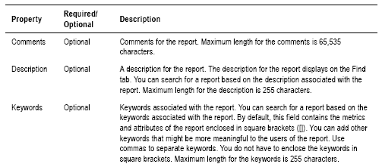
- Click OK. The reporting tool saves the report to the repository.

- Click Close.

Printing a Report
The users can print the report with a portrait or landscape orientation. The Name, Filters, and Description of the report will only be displayed on the HTML or PDF reports. For a report with sectional report tables, the users can display each section on a separate page. Before they print a report, the reporting tool displays the report as a PDF document in a new browser. You need Adobe Acrobat Reader version 4.0 or higher to display the report. If you do not have Adobe Acrobat Reader installed on your machine, the reporting tool prompts you to save the report as a PDF document to your computer. After you install Adobe Acrobat Reader, you can view and print the PDF document.

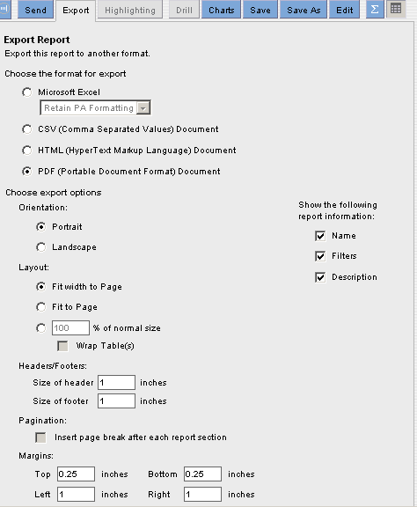

Exercise to Print a Report

- Open the report you want to print.

- Display the report.

- Click on the “Export” button . The Export window appears.

- Select the format and Display options in the Export window.

- Click Excel or PDF.

- Click on the “Export” button and then click on the “Open” button.

- Excel or Adobe Acrobat launches in a new browser window to display the report.

Exporting Report Data

The users can export report data to a file in any of the following formats:
- Microsoft Excel – Retains the report formatting when exported to an Excel spreadsheet.
- Comma Separated Value (CSV) Document
- HTML Document - If the report contains any filters, you can hide the filters in the HTML document.
- PDF Document - The users can export the file in the portrait or landscape orientation. For a report with sectional report tables, the users can display each section on a separate page. If the report contains any filters, the users can hide the filters in the PDF document. When the users export the report to PDF format, the reporting tool displays the report as a PDF document in a new browser window. They need Adobe Acrobat Reader version 4.0 or higher to display the report as a PDF document in a new window. If the users do not have Adobe Acrobat Reader installed on their machine, the reporting tool prompts they to save the report as a PDF document to their computers. After they install Adobe Acrobat Reader, they will be able to view the PDF document.
When they export report data, the reporting tool creates a file in the specified format. They can save this file to their local drive. Exporting a report to another format allows them to send the report to someone outside their organization.

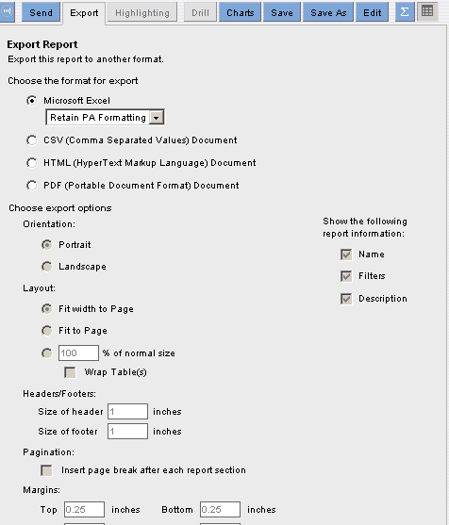
Exercise to Export Report Data

- Open the report you want to export.

- Click Execute to run the report.

- Click on the “Export” button to export the report.

The Export window appears.

- Select the format for export. If you select HTML format, to hide filters in the exported report, select the Hide Filters in Exported Report check box. If you select PDF format, select the orientation and display options.

- Click .
- Save the file to your local drive.
Note: If the report name contains a period (.), the reporting tool replaces the period with an underscore (_) in the exported file name.

Exporting Report Data to Excel
You can choose several ways to export report data to an Excel file. You can choose to retain the reporting tool formatting in the Excel file or use the formatting and functions in an Excel template. You can also export the report data to an Excel PivotTable to use advanced Excel functions. The Excel file retains custom metric and formatting. When you export report data to an Excel file, choose from the following options:
- Retain report formatting - The reporting tool creates a new Excel file and writes the report data to the file. You can then view and save the file.
- Export to Excel PivotTable - The reporting tool creates a new Excel PivotTable that uses a macro to refresh data. An Excel PivotTable is an interactive report that summarizes data and allows you to rotate columns and rows. The Excel PivotTable does not contain any formatting you set in the reporting tool. Choose Export to Excel PivotTable if you want to use Excel to perform further analysis on the report data using advanced Excel functions. For details on using Excel PivotTable reports, see your Microsoft Excel documentation.

Note: Before you can export to an Excel PivotTable or use a template, you must set Excel to Medium Security level permission to enable macros. You can set security level in Excel by choosing Tools > Macros > On Security level.

Retaining Report Formatting
When you choose the Retain the reporting tool Formatting option, the reporting tool creates an Excel file that contains the data in the format you see on the screen. You can edit and format the Excel file after you export the report.
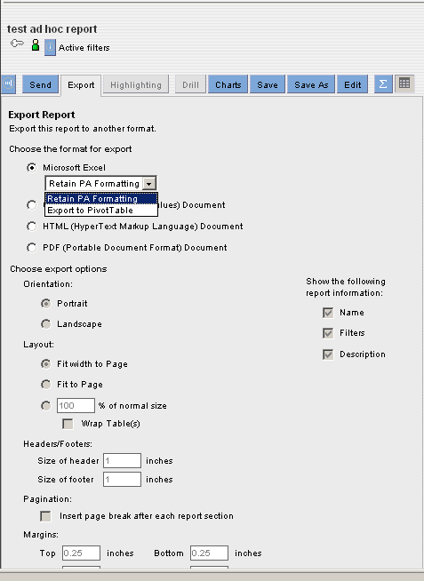

When you choose the Retain the reporting tool Formatting option, the reporting tool retains the formatting you see on the screen. The following figure shows the Excel file created by exporting the report, using the Retain The reporting tool Formatting option.
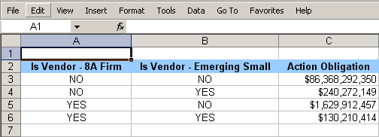
Exercise to Retain report Formatting when Exporting Report Data to Excel
To retain the reporting tool formatting when exporting report data to Excel:

- Open the report you want to export.

- Execute to run the report.

- Click on the “Export” button. The Export Report window appears.

- Click Microsoft Excel.

- Choose Retain the reporting tool formatting.

- Click on the “Export” button and then click on the “Open” button, the Excel file displays in a new browser window.

- Save the Excel file to your local drive. You can now edit and format the Excel file.

Emailing a Report
You can email a report from the Analyze tab or the Find tab. The reporting tool attaches the report to your email in the format you select. You can attach the report in the following formats:
- PDF Document
- Embedded HTML
- Microsoft Excel
- Comma Separated Value (CSV) Document

Exercise to Email a Report
- Execute the report you want to email.
-Or-
On the Find tab, click on the report you want to email.

- Click on the “Email” button from the Ad Hoc reports or click on the “Send” button from My Reports to email the reports to other users.

- Choose the format to send the report.

- Click on the “Send” button.

Note: On the Find tab, the Details task area displays the Email Report button. The Email Report window appears.

Figure 13-31 Email Report Window
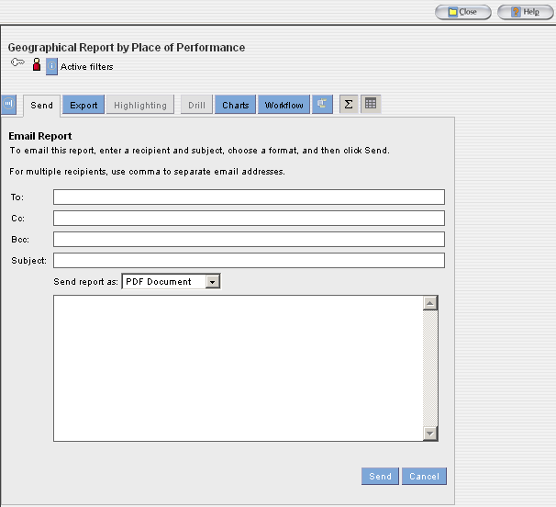

- Or you will see this email screen if you are emailing an Ad Hoc report
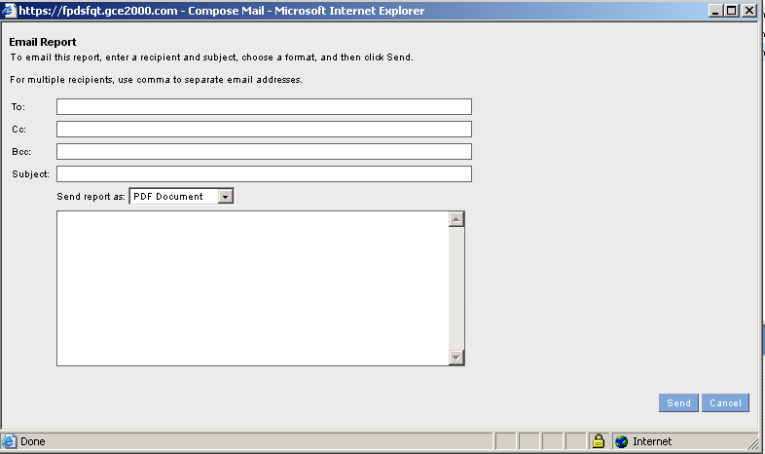

- If you do not have a reply-to email address, enter your email address in the “From” field.

- Click on the “Send” button. The reporting tool sends the email to the specified recipients.

Working with Report Data
After the users open a report, they can view report data and they can also modify the report data. The report data displays as a table and the report table consists of attributes and metrics. These attributes and metrics display as row or column headers in the report table. The users can perform the following tasks to customize report data:
- Highlight metric values - They can highlight metric values to identify important data, trends, and patterns at a glance.
- Add or remove a filter - They can set attribute or metric filters on the data.
- Drill into a report - They can drill into a report to display other attributes or metrics related to the current report.
In order to use the “Drill” feature with all the available attributes, one of the following attributes values will need to be included in the Ad Hoc report – Section 2 Select attributes:
  - Contracting Department ID
  - Contracting Agency ID
  - Contracting Office Region
  - Contracting Office ID
  - Vendor Name
  - Referenced IDV PIID
  - PIID
  - Modification Number
If the DOD users want to get the information that is associated with their commands or is associated with certain transaction, they will need to include one of the following attribute values in their Ad Hoc report – Section 2 Select Attributes:
  - Transaction Number
  - Major Command Code
  - Sub Command1 Code
  - Sub Command2 Code
  - Sub Command3 Code
- Display report charts - They can add the chart for the report. There are various chart options and you can choose the one that matches to your report data.
- Change the data display - They can change the way the reporting tool displays the data in the report table.

Highlighting Metric Values
The “Highlighting metric values” in a report table is accomplished by using colors, patterns, or symbols. The users can highlight metric values in a report that are above, below, or within a range. Highlighting draws attention to critical data in a report or pinpoints problem areas. This is useful in reports with multiple metrics or many rows of data.

The first step to highlight values in an on-demand, cached, or real-time report is to create a highlighting rule. A highlighting rule can be created for any metric or calculation in the report. After a highlighting rule is created, the reporting tool highlights the values in the report table. The name of the highlighting rule is displayed in the active filters task area.

If metric values are highlighted in a report, the highlighting also appears in all bar charts, bar chart indicators, or table indicators created for that report. In the charts and chart indicators, the reporting tool displays highlighting as colored dots. Colored dots are a type of highlighting format.

Note: The reporting tool does not highlight null values. The users cannot modify the highlighting directly in the charts or indicators. To modify highlighting in the charts or indicators, you must modify the highlighting rule.

Creating a Highlighting Rule
To create a highlighting rule, you can specify the following properties for the highlighting rule:
- Ranges
- Color codes
- Formats
- State of Rule
- User access
- Additional display options

Specifying Ranges
Three ranges are used when creating a highlighting rule to specify the low, medium, and high for the values the reporting tool will highlight. Numeric values that correspond to the metric values in the report table must be entered and these ranges must be in ascending order. For example, to create a highlighting rule for the Total Dollars Obligated metric decide the low, medium, and high ranges for this metric.
After specifying ranges, set a color code for highlighting each range or use the system default color. The color code provides a visual cue about the highlighted values. For example, if the highlighting rule is for the dollars obligated metric, you can specify the high values as green. If the highlighting rule is for the Total Actions metric, you can specify the high values as red. If the highlighting rule does not cover certain ranges, the reporting tool does not highlight the values within those ranges.

Choosing Formats
The users can choose a format for the highlighting rule. The format determines how the reporting tool highlights the values in the report table. Choose from one of the following formats:
- Colored dots - The reporting tool displays colored dots next to each highlighted value. The color of the dot depends on the color code you select in the highlighting rule.
- Background color - The reporting tool displays a background color for each highlighted value. The background color depends on the color code you select in the highlighting rule.
- Harvey images - The reporting tool displays black-and-white dots next to each highlighted value. The type of dot depends on the color code you select in the highlighting rule. A full dot represents high values, a half full dot represents medium values, and an empty dot represents low values.
- Arrow indicators – The reporting tool displays black-and-white arrows next to each highlighted value. The type of arrow depends on the color code you select in the highlighting rule. An up arrow represents high values, a dash represents medium values, and a down arrow represents low values.
- Symbols - The reporting tool displays colored symbols next to each highlighted value. The type of symbol depends on the color code you select in the highlighting rule. A green dot represents high values, a yellow triangle represents medium values, and a red square represents low values.

State of Rule
The users can set the state of a highlighting rule as active or inactive. An active highlighting rule highlights values in the report table. An inactive highlighting rule is stored in the report, but does not highlight values in the report table. Multiple highlighting rules can be created for any metric or calculation in the report; however, the reporting tool only allows one active highlighting rule for each metric or calculation. In the Highlighting task area, a green dot marks an active highlighting rule and a red dot marks an inactive highlighting rule.

Display Options
The users can choose to display highlighting only in the report table and hide the metric values. They can use this option if the metric value is incidental in the report and you want to focus on a visual representation only.
The users may want to highlight the suppliers according to their ratings so that they can identify their best and worst suppliers at a glance. The actual rating numbers are not important. They can create a highlighting rule where the reporting tool displays highlighting only in the report table and hides the rating values. In a cross tabular report table or in a report with time settings, by default, the reporting tool highlights all occurrences of the selected metric.

Steps for Creating a Highlighting Rule
- Execute the report that you want to create a highlighting rule for.
- Click on the header of the metric that you want to create the highlighting rule for.
- Click on the “Highlighting” button. You can also right-mouse click on the header of the metric and then choose “Create Highlight” from the menu to create the highlighting rule.

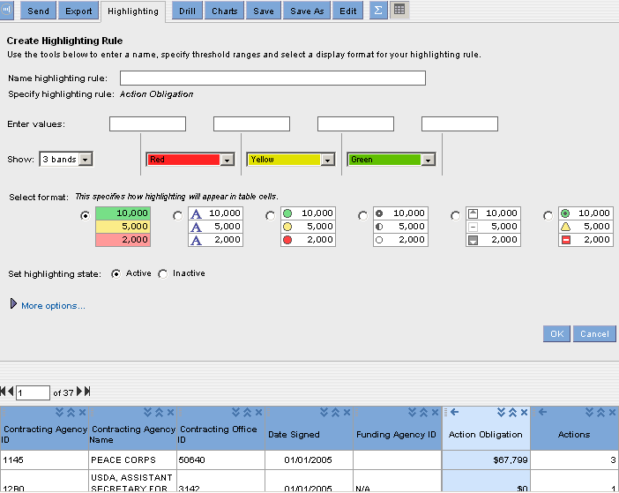

- Enter numeric values for each of the four value boxes.
- Choose how the highlighting will be displayed (Optional.)
- Enter a name in the “Name highlighting rule” field (Mandatory.)
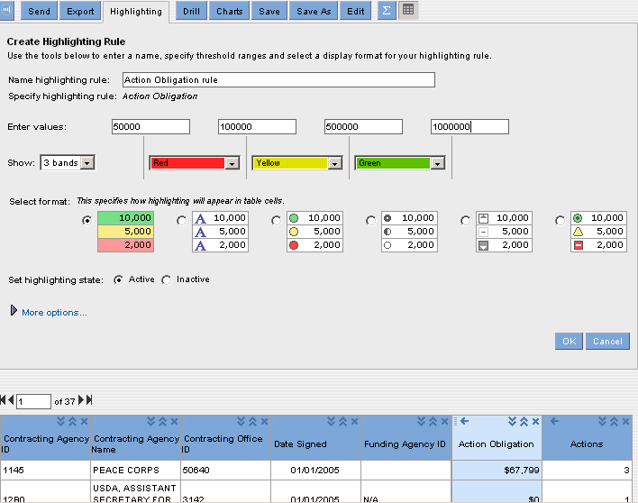

- Click on the “OK” button and you will see the highlighting displayed in the report table.
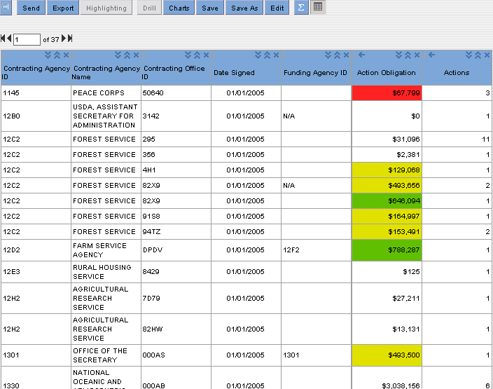
Exercise to Create a Highlighting Rule

- Open the report where you want to create a highlighting rule.
- Click on the header of the metric name for which you want to create the highlighting rule for. The reporting tool selects the proper metric column.
- Click on the “Highlighting” button.

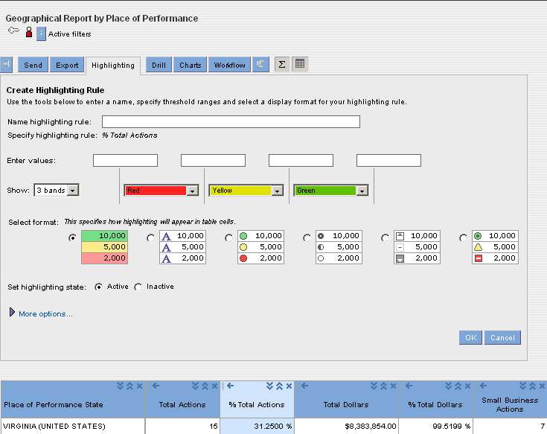

- Enter the following information:

Property | Required/optional | Description
Name the highlighting rule field | This field is required | This field is used to name the highlighting rule. After the highlighting rule is named, and then saved, it is stored on the Analyze section where it can be edited or deleted.
Specify numeric values for each field | These fields are required | The fields available specify numeric values for ranges for the metric or calculation.  The ranges must be in ascending order.
Then highlight | This function is optional | Select colors for each range of values. The system defaults with red for low numeric values, yellow for medium numeric values, and green for high numeric values.
Specify formatting for highlighting | This function is optional | Select the type of formatting you want to use for highlighting the range of numeric values. The system defaults with a background color for each numeric value.
Set Highlighting Rule As | Optional | Select one of the following options to set the state of the highlighting rule:  - Active  - Inactive  The system default is active.
More Options | Optional | Select to display additional fields for the highlighting rule.
Show Only Highlighting in the Table and Hide Numeric Data | Optional | Select this function to show highlighting only in the table. By default the system highlighting and numeric data appear in the report table.
Control user access of a highlighting rule. | Optional | Select one of the following options to set user access for highlighting.  - Public  - Personal  The system defaults to public.
Apply Highlighting Rule on All Occurrences of Selected Metric in the Report | Optional | This option displays for cross tabular report tables and reports with time settings. By default the system highlights all occurrences of the selected metric in the report table. Clear the check box to highlight one occurrence of the selected metric.

- Click on the “OK” button. The highlighting rule appears in the Highlighting task area and the highlighting is displayed in the report result.

Modifying a Highlighting Rule
You can modify the name, value ranges, colors, format, state, and user access of a highlighting rule.
The existing highlight rule can be modified to accommodate the new information that needs to be included in the report.
Exercise to Modify a Highlighting Rule
- Open the report where you want to modify a highlighting rule.
- Click on the highlighting rule that you want to modify.
- Choose “Active” to activate an inactive highlighting rule.
- In order to modify any aspect of the highlighting rule in the Highlighting task area, click on the name of the highlighting rule. The reporting tool displays the Highlighting tab.
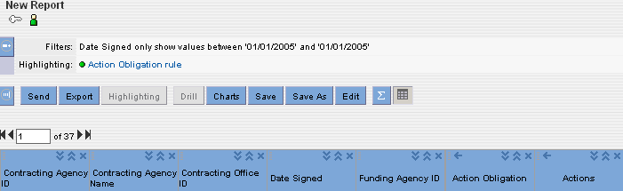
- On the Highlighting tab, make the necessary changes and then click on the “OK” button.
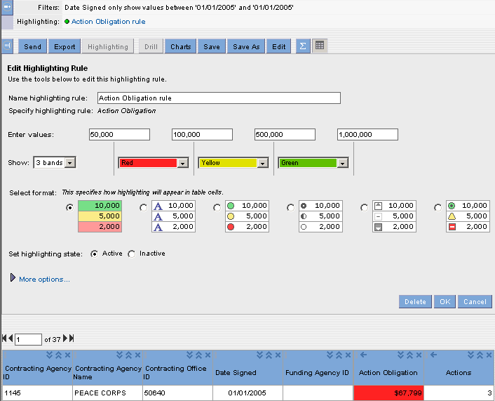

Deleting a Highlighting Rule
When you delete a highlighting rule, the reporting tool deletes the highlighting from the report table and the highlighting rule name from the Highlighting task area.
Exercise to Delete Highlighting
- Open the report where you want to delete a highlighting rule.
- In the Highlighting task area, click on the name of the highlighting rule. The reporting tool displays the Highlighting tab.
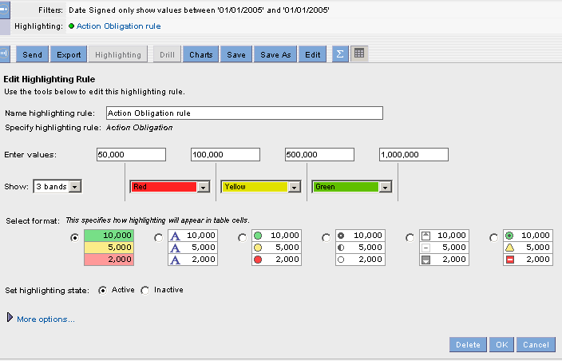
- Click on the “Delete” button. The reporting tool deletes the highlighting from the report table and the highlighting rule name from the Highlighting task area.

Drilling into a Report
The users can drill into a report to get more detail report information with a detail view.
In order to use the “Drill” feature with all the available attributes, one of the following attributes values will need to be included in the Ad Hoc report – Section 2 Select Attributes:
  - Contracting Department ID
  - Contracting Agency ID
  - Contracting Office Region
  - Contracting Office ID
  - Vendor Name
  - Referenced IDV PIID
  - PIID
  - Modification Number
If the DOD users want to get the information that is associated with their commands or is associated with certain transaction, they will need to include one of the following attribute values in their Ad Hoc report – Section 2 Select Attributes:
  - Transaction Number
  - Major Command Code
  - Sub Command1 Code
  - Sub Command2 Code
  - Sub Command3 Code
The reporting tool uses these attribute values as a drill filter. The drill filter determines the data you see in the drill results. You can select more than one attribute value for the drill. You can select multiple attribute values in one of the following ways:
- Select multiple attribute values in the report table.
- Click on the header of the attribute column to select all the attribute values.

The users can select an attribute higher or lower in the drill path hierarchy than the current attribute in the report.
- Execute the report where you want to conduct a drill.
- Click on the attribute name or attribute values to create the drill filter.
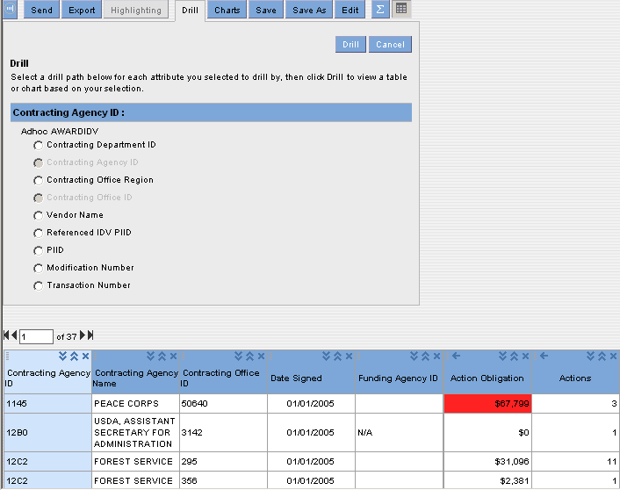
- Select the attribute to drill down to and to be displayed in the report.
- Click on the “Drill” button . You will see the additional attribute in the report. The drill results display only the attribute values that you select from the drill path.
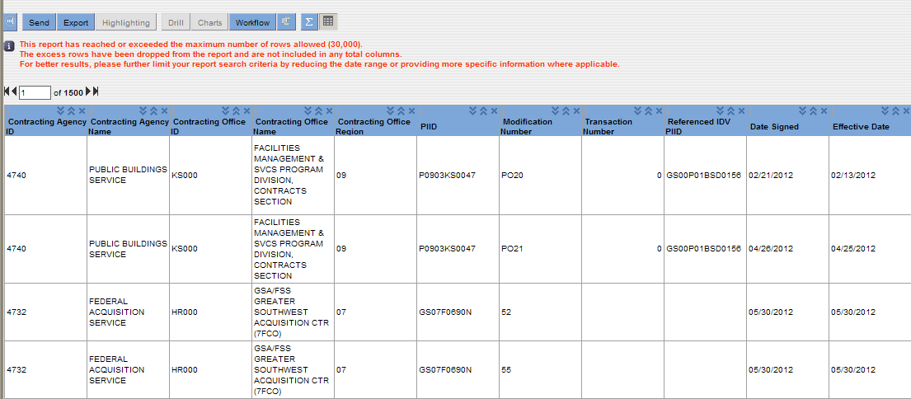

Or-
- In the report table, right-click on the header of the selected attribute column and then click on the attribute for the drill to view available data elements that are included in the drill path.
You can select those attributes from the available drill path that are not already part of the report.
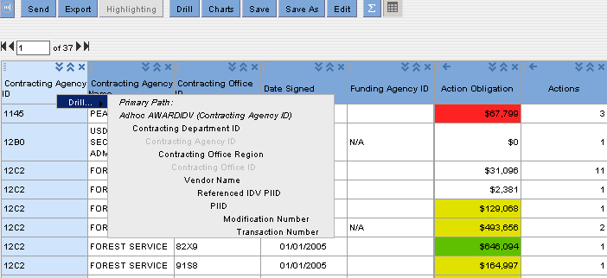
- To go back to a previous drill result, click on the drill result link in your current drill path. To go back to the original report, click on the Original Table link in your current drill path.

Exercise to Drill into a Report
- Open the report you want to drill into.

- Select the attribute value for the drill. You can select more than one attribute value for the drill filter.

- Shift-click to select a contiguous range of values.

- Ctrl-click to select a non-contiguous range of values. You can also click a metric value to select all associated attribute values.

- To select all attribute values for an attribute, click on the header of the attribute column.

- Click on the “Drill” button. The reporting tool displays the available drill path on the Drill tab.
-Or-
In the report table, right-click on the selected values and then click on the “Drill” button to view available data elements that are included in the drill path.
You can select those attributes from the available drill path that are not already part of the report.
- From the available drill paths, select the attribute that you want it to be displayed in the report.

- Click on the “Drill” button and the report will display the report with the selected attribute. The data in the report is generated based on the attribute values you select for the drill filter. In order to get more detail information from the report result, repeat steps 2 to 5.

- To go back to a previous drill result, click on the drill result link in your current drill path. To go back to the original report, click the Original Table link in your current drill path.

ezSearch

 ezSearch feature provides the ability to search for contracts based on free text. All contracts that are included in the ezSearch are in Final status. Any DoD contract that is less than 90 days old will not be included in the search.

- To begin your ezSearch, type in one or more keywords that will be searched for in the contracts that you would like to find.
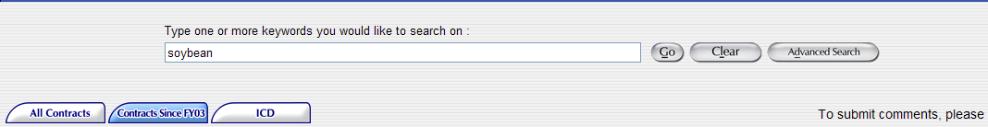
- Click on the “Go” button. A list of contracts will be displayed on the result page section that matches with your search criteria. To remove your search criteria text, click the “Clear” button.
- You can refine your search by using the three filter boxes on the left-hand side of the screen. You can drill down by Department, Agency, and Vendor. The information in each filter box is displayed in the descending order; only the top 10 results will be displayed.
- Click on the appropriate link in each filter box. Your results will be displayed in the Results Page section.

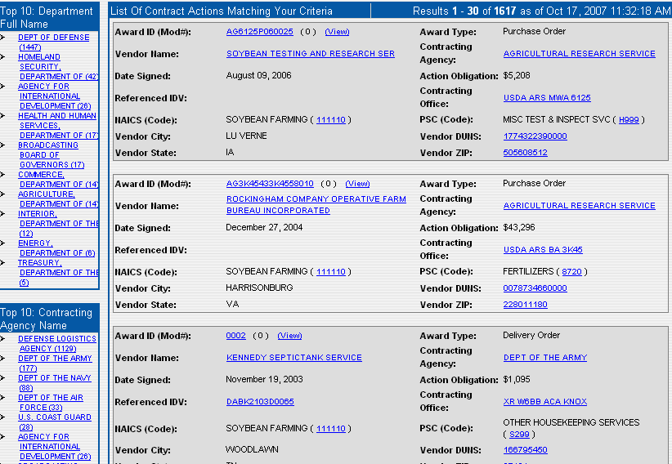

Search Criteria

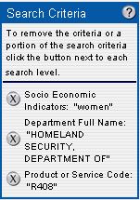

The Search Criteria box that is located on the top right-hand corner of the screen displays your current search criteria. To remove the specific criteria or a portion of the search criteria from the search results, click on the “Remove” button that is listed next to each search level.

Sort By

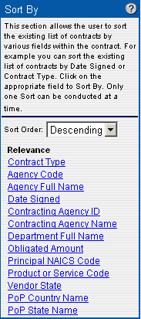

The “Sort By” box allows the user to sort the existing list of contracts by various fields within the contract. For example, you can sort the existing list of contracts by the “Date Signed” or “Contract Type” values.
The user can click on the appropriate field to Sort the report result and only one “Sort” function can be conducted at a time.

Recent Searches

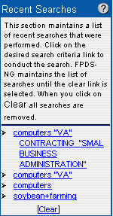

The Recent Searches box maintains a list of recent searches that have been performed. The use can click on the desired search criteria link to conduct the search. The FPDS-NG system maintains the list of searches until the clear link is clicked. After you click on the “Clear” link, all the searches are removed.

Clicking on the links inside the documents allows you to further refine your search and drill down to specific information. For example, by clicking on a specific PSC Code you will only see contracts for that PSC Code.

Advanced Search

To conduct an Advanced Search
- Click on the Advanced Search button
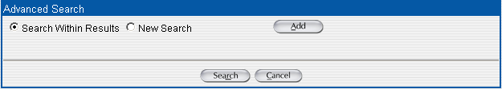

- You can select to conduct a search from an existing search result or you can choose to conduct a new search.
- Click on the “Add” button and then click on the dropdown box to make a selection. When making a selection from the drop down box, a list of data element names will be displayed on the screen. You can access the Data Dictionary which will provide you with a description of acceptable values to enter in the search criteria’s “Like” box. You can use the following link to access the Data Dictionary (https://www.fpds.gov/downloads/FPDS-Data-Dictionary-Version1.5.pdf)
and view the descriptions for each data element.
- Enter a value in the “Like” box.
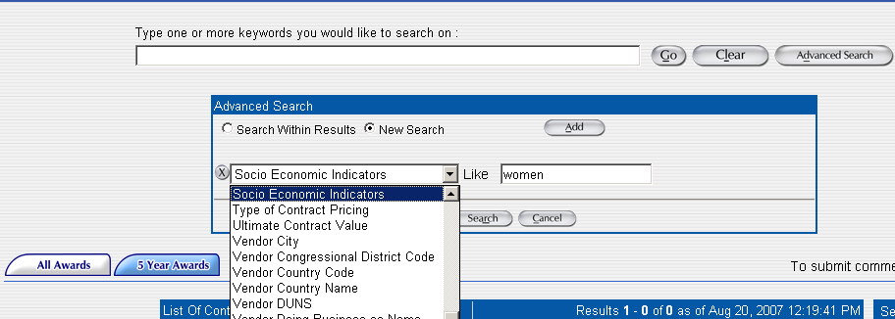

- Click on the “Search” button.
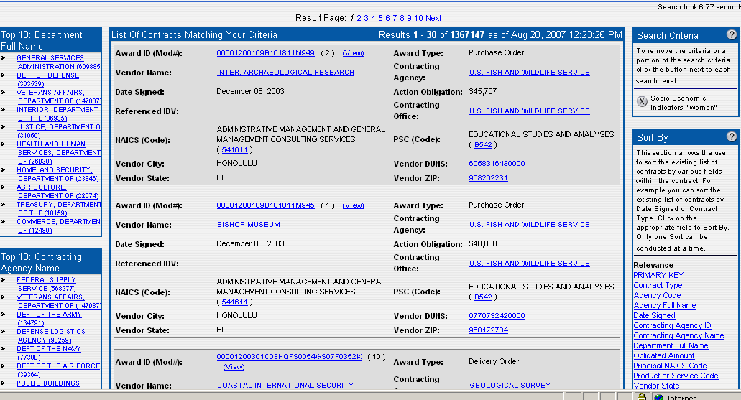
Exercise: Wrap-up! Create a new Ad Hoc Report include all Functionality

- Click on the “Ad Hoc Reports” icon from the Home Page.

- Click on the “Personal Folder”.

- You can click on the “New Folder” button to create a new Folder for the new report or you can save all the reports to the existing “Personal Folder.”
- Click on the “New” button to create a new report.

- From the Create Report screen, click on the Section 1: Select metrics and add all the desired metrics.

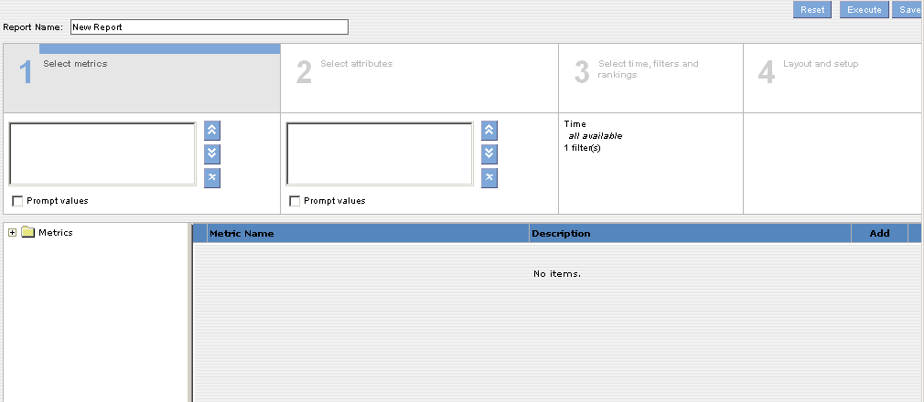
- Click on Section 2: Select attributes and add all the desired attributes.
- Click on Section 3: Select time, filters and rankings and add the desired attribute and metric filters with some restricted prompts.
- Click on Section 4: Layout and setup and drag an attribute to the “Section Heading” to re-arrange the columns. Click on the “Sorting” button to sort the report. Click on the “Formatting” button to make any desired format changes. Click on the “Calculations” button to add calculations to your report.
- Click on the “Save” button to save the report.
- Click on the “Execute” button to execute the report.
- Click on the “Display Report” button run the report and see the results.
- Click on the “Charts” button to create the Chart for the report. You can choose “Show More Options” to increase the size of the chart or make any other adjustments to the chart.
- Click on the “Export” button to export the report to Excel or other applicable formats.
- Select a metric and click on the “Highlighting” button to create the highlighting rule that is associated with your report. Give the rule a name and enter values in all four of the numeric value boxes.
- Click on the “Ok” button to complete the setup for the highlighting rule.
- Click on the “Send” button to email the report to other users.
- Select an attribute value from the drill path and then click on the “Drill” button to drill into the report with the added Attribute value.
- After getting the report result, you can click on the “Edit” button to make any desired changes to the report. For example, you can add/delete an Attribute or add/modify an Attribute or Metric filter.
- Click on the “Save” button to save the report.
- Click on the “Execute” button to execute the report and then click on the “Display Report” button to display the report with results.
- Click on the “Close” button to close the Ad Hoc report session.
- Congratulations!

