

FPDS V1.5 Quick Start Guide– v1.4

May 21, 2022

Revision History
Version | Date Modified | Author | Description of Changes
1.0 | 4/10/2018 | IBM | First version of document published.
1.1 | 6/12/2021 | IBM | Updated vernacular throughout the document including:  - Updating any instance of ‘Vendor’ and ‘Contractor’ to ‘Entity’.  - Updating any instance of DUNS Number data element name to ‘Unique Entity ID (DUNS)’.  - Removing any instance of ‘-NG’  Added the new sections below:  - Section 14: Displaying the “Unique Entity ID (SAM)” on Contract Actions.  - Section 15: Add Approval Information to FPDS
1.2 | 10/30/2021 | IBM | Updated Section 14 – Unique Entity ID (SAM) to be an optional data element, as part of V1.5 Service Pack 11 updates.
1.3 | 4/2/2022 | IBM/Octo | - Removed any reference to Unique Entity ID (DUNS).  - Changed all references of ‘Unique Entity ID (SAM)’ to ‘Unique Entity ID’.  - Any reference of SAM Exception has been updated to FAR 4.1102 Exception.  - Updated ‘Additional Reporting’ data values to reflect current system functionality.
1.4 | 5/21/2022 | IBM/Octo | - Updated all instances of ‘Commercial Item Test Program’ to ‘Simplified Procedures for Certain Commercial Products and Commercial Services’.  - Updated all instance of ‘Commercial Item Acquisition Procedures’ to ‘Commercial Products and Services Acquisition Procedures’.

Table of Contents
1 Background 5
1.1 List of Updates included in V1.5 5
2 Add “Inherently Governmental Functions” as a new Data Element 6
2.1 Validation Rule Changes 6
2.2 V1.5 Use Cases 7
3 Updated for Legislative Mandates Data Elements 7
3.1 Validation Rule Changes 7
3.2 V1.5 Use Case 9
4 Updating two existing dollar value names and adding a new Data Element “Total Estimated Order Value” 10
4.1 Validation Rule Changes 11
4.2 V1.5 Use Cases 11
5 Updates to Part 13 BPA Call and Simplified Procedures for Certain Commercial Products and Commercial Services 12
5.1 Validation Rule Changes 12
5.2 V1.5 Use Cases: 12
6 Updates for Consolidated Contract Data Element for FSS and GWAC 13
6.1 Validation Rule Changes 13
6.2 V1.5 Use Cases 13
7 Displaying the CAGE Code Data Element to the Contract Action 13
7.1 Validation Rule Changes 14
7.2 V1.5 Use Cases: 14
8 Displaying four “Women Owned” business types to the Contract Action 14
8.1 Validation Rule Changes 15
8.2 V1.5 Use Cases 15
9 Add Close-Out Functionality to FPDS 15
9.1 Validation Rule Changes 16
9.2 V1.5 Use Cases 17
10 Adding IDV Type of Set Aside, Type of Set Aside Source and Number of Offers Source Data Elements 17
10.1 Validation Rule Changes 18
10.2 V1.5 Use Cases 18
11 Subcontracting Plan Phase 2 18
11.1 Validation Rule Changes 18
11.2 V1.5 Use Cases: 19
12 New Data Element “Additional Reporting” 19
12.1 Validation Rule Changes 20
12.2 V1.5 Use Cases 20
13 Generic/Blank XML Tags 20
13.1 Validation Rule Changes 21
13.2 V1.5 Use Cases 22
14 Displaying the Unique Entity ID (UEI) Data Element on Contract Actions 22
14.1 Validation Rule Changes 22
14.2 V1.5 Use Cases 22
15 Add Approval Information to FPDS 23
15.1 Validation Rule Changes 23
15.2 V1.5 Use Cases 23

Background

The purpose of this document is to provide an overview of the changes that were made to FPDS as part of the V1.5 release. For more specific details for the changes made, please reference the FPDS V1.5 Data Dictionary, Validation Rules document and User Manual. These documents will contain all the system information, including the updates that were made that are unique to the V1.5 release that are outlined in this document.

The Data Dictionary provides definitions and instructions for all the data elements in FPDS, not just the new ones outlined in this document. The Validation Rules document outlines the validation rules implemented in FPDS to ensure data integrity. The User Manual outlines system functionality and details on how to use features within the application.

The documents can be found at the following URL:
  - https://www.fpds.gov/fpdsng_cms/index.php/en/worksite.html

List of Updates included in V1.5

The following items will be updated as part of the V1.5 release:

V1.5 Updte
Add “Inherently Governmental Functions” as a new Data Element (formerly collected in the “Description of Requirements” data element).
The names for Legislative Mandates will change based on the FAR.
Updating two dollar value names and adding a new Data Element “Total Estimated Order Value”.
Part 13 BPA Call and Simplified Procedures for Certain Commercial Products and Commercial Services.
Data Element “Consolidated Contract” for FSS and GWAC.
Displaying CAGE Code on the CAR.
Displaying four Women Owned Business Types on the CAR.
Close Out Function.
IDV Type of Set Aside, Type of Set Aside Source and Number of Offers Source.
Subcontracting Phase II.
New Data Element “Additional Reporting”.
Generic/Blank XML Tags.

Add “Inherently Governmental Functions” as a new Data Element

This item adds a unique data element for reporting inherently governmental functions. This data element was collected previously as part of the description of requirement data element. There are four values that can be selected in the drop-down-list for the new data element:

Data Element Value
Closely Associated
Critical Functions
Other Functions
Closely Associated, Critical Functions

Inherently Governmental Functions as shown on the Contract Action: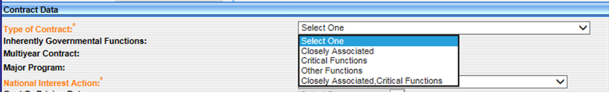

For older contract actions (i.e. V1.4) doing corrections, the inherently governmental functions will still be collected in the description of requirements field. Based on the information provided in the description of requirements the inherently governmental data element will derive the correct value based on the information in the description of requirements.

Validation Rule Changes

The following validation rules were created for this new data element. The validation rules are listed below:

Validation Rule:
An Inherently Governmental Function value must be entered for contracts signed on or after '<igfStartDate>' when PSC is entered as a 'Service'.
Inherently Governmental Function value is not valid. Please enter a valid IGF value. CWS only.
Inherently Governmental Function value combination is not valid. CWS only.
An Inherently Governmental Function value cannot be reported for a modification done against a base record with "Date Signed" prior to '<igfStartDate>'.
An Inherently Governmental Function value cannot be reported for a base record with "Date Signed" prior to '<igfStartDate>'.
If Inherently Governmental Function is reported as 'Closely Associated Functions' ('CL') or 'Critical Functions' ('CT') or the combination of 'CL' and 'CT', then "A76 Action" must be 'No'.

V1.5 Use Cases

The following use cases are outlined for this update based on the V1.5 data dictionary.

Inherently Governmental Functions:
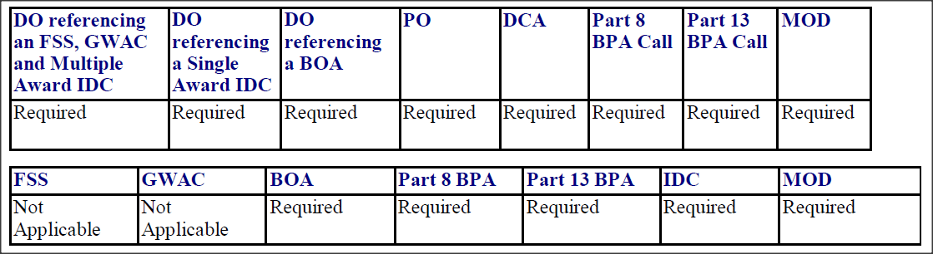

Updated for Legislative Mandates Data Elements

The legislative mandates data element names have been updated to align with the FAR data element names. This update only impacts the screen name of the data element. The Yes/No drop-down list answers have not been changed and should continue to be used as before.

Data Element # | Old Data Element Name | New Data Element Name
Element 7A | Clinger-Cohen Act | Clinger-Cohen Act
Element 7B | Walsh-Healey Act | Materials, Supplies, Articles, & Equip.
Element 7C | Service Contract Act | Labor Standards
Element 7D | Davis Bacon Act | Construction Wage Rate Requirements

Updated Legislative Mandate Names as shown on the Contract Action:
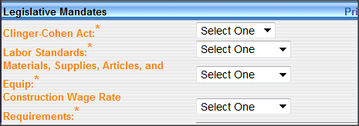

Validation Rule Changes

The following validation rules have been updated to reflect the updated data element names:

Validation Rule:
The "Materials, Supplies, Articles, and Equip" must be "Not Applicable" when the entity is UNICOR.
If "Commercial Products and Services Acquisition Procedures" is any value other than "Commercial Products/Services Procedures not used" then "Materials, Supplies, Articles, and Equip" must be "No" or "Not Applicable".
The "Materials, Supplies, Articles, and Equip" cannot be selected when the "Principal Place of Performance" is not the USA.
The "Materials, Supplies, Articles, and Equip" must be "Not Applicable" when the "Principal Place of Performance" is not the USA.
The "Labor Standards" must be "Not Applicable" when the entity is UNICOR.
The "Labor Standards" must be "Not Applicable" when the "Principal Place of Performance" is not the USA.
The "Construction Wage Rate Requirements" must be "Not Applicable" when the entity is UNICOR.
The "Construction Wage Rate Requirements" must be "Not Applicable" when the "Principal Place of Performance" is not the USA.
The "Product or Service Code" must be for a Service when the "Service Contract Act" is "Yes" or the "Product or Service Code" may be "9999" when the Unique Entity ID is “KA5HQCLKUVW1” or “NN2NGPDNCK23”.
If the "Davis Bacon Act" is "Yes" then the "Product or Service Code" must be "Construction", "Well Drilling" or "Demolition". The "Product or Service Code" may be miscellaneous (9999) if the Unique Entity ID is “KA5HQCLKUVW1”.
If Unique Entity ID is JKRMS84PMND5 (European Utility Companies), or KBD2CJ5JXJV5 (Navy Vessel Purchases), or NN2NGPDNCK23 (Undisclosed Foreign Entity), U9X7H1UVY6U5 (GPC Foreign Business) or L2UVLEUTJU39 (Spouses of Service Personnel), or LX9KAH68DKV5 (Students in Laboratories), or LN9PU5M2YZN5 (Miscellaneous Foreign Entity) then "Materials, Supplies, Articles, and Equip" must be "Not Applicable".
If Unique Entity ID is JKRMS84PMND5 (European Utility Companies), or KBD2CJ5JXJV5 (Navy Vessel Purchases), or NN2NGPDNCK23 (Undisclosed Foreign Entity), U9X7H1UVY6U5 (GPC Foreign Business) or L2UVLEUTJU39 (Spouses of Service Personnel), or LX9KAH68DKV5 (Students in Laboratories), or LN9PU5M2YZN5 (Miscellaneous Foreign Entity) then "Labor Standards" must be "Not Applicable".
If Unique Entity ID is JKRMS84PMND5 (European Utility Companies), or KBD2CJ5JXJV5 (Navy Vessel Purchases), or NN2NGPDNCK23 (Undisclosed Foreign Entity), U9X7H1UVY6U5 (GPC Foreign Business) or L2UVLEUTJU39 (Spouses of Service Personnel), or LX9KAH68DKV5 (Students in Laboratories), or LN9PU5M2YZN5 (Miscellaneous Foreign Entity) then "Construction Wage Rate Requirements" must be "Not Applicable".

V1.5 Use Case

The following use cases are outlined for this update based on the V1.5 data dictionary.

Clinger-Cohen Act:
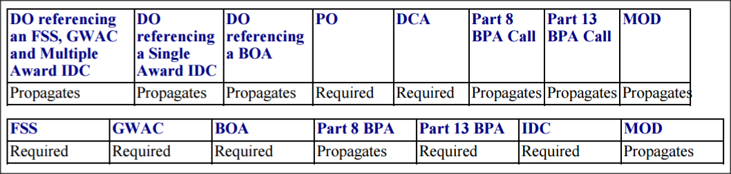

Labor Standards:
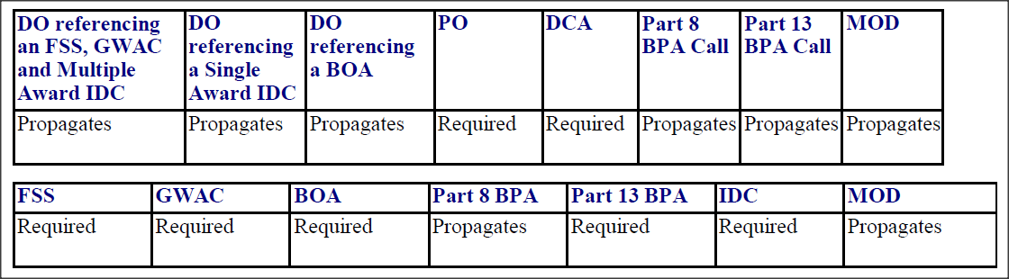

Materials, Supplies, Orders and Equip:
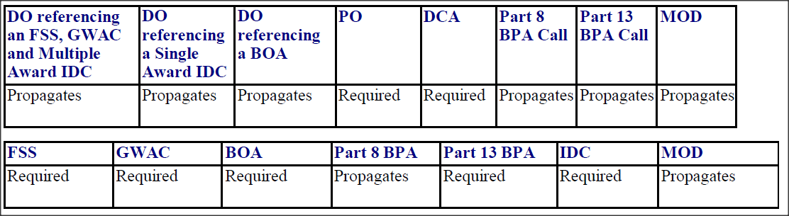

Construction Wage Rate Requirements:
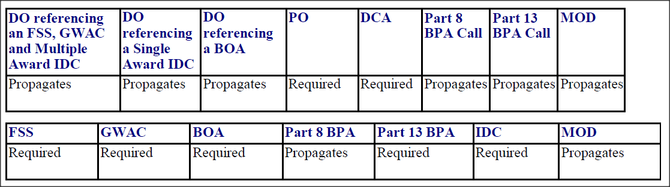

Updating two existing dollar value names and adding a new Data Element “Total Estimated Order Value”

As part of the V1.5 release, the “Base and all Option Value” data element name was changed to Base and all Option Value (Total Contract Value). The use and validation rules for the data element have not been updated and remain to be used as before.

The existing data element “Maximum Order Limit” name was changed to “Individual Order/Call Limit”. This is meant to be used as the maximum dollar amount that can be applied to a single order against the Indefinite Delivery Vehicle. In addition to this, the use case changed for a “Basic Ordering Agreement” (BOA) from Required to Not Applicable.

A new data element “Total Estimated Order Value” was added to the FSS, GWAC and IDC. This amount reflects the total estimated value of all potential orders that can be placed against this IDV. This amount should only reflect the estimated value of all orders. This does not include any obligated amounts that may have been placed on the IDV itself.

Base and All Options Value (Total Contract Value) As shown on the Contract Action:
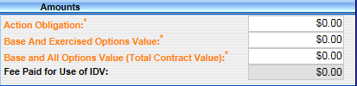

Individual Order / Call Limit as shown on the Contract Action:
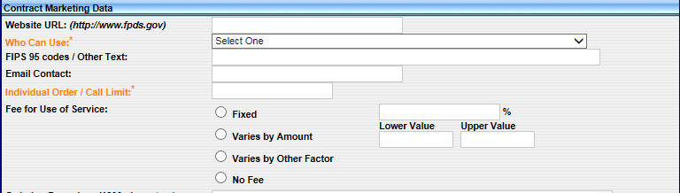

Total Estimated Order Value as shown on the Contract Action:
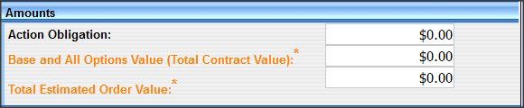

Validation Rule Changes

The following validation rules were added for the “Total Estimated Order Value” data element:

Validation Rule:
The "Total Estimated Order Value" must be greater than '0.00'
The total value of the "Individual Order / Call Limit" cannot be more than "Total Estimated Order Value"

V1.5 Use Cases

The following use cases are outlined for this update based on the V1.5 data dictionary.

Base and All Options Value (Total Contract Value)
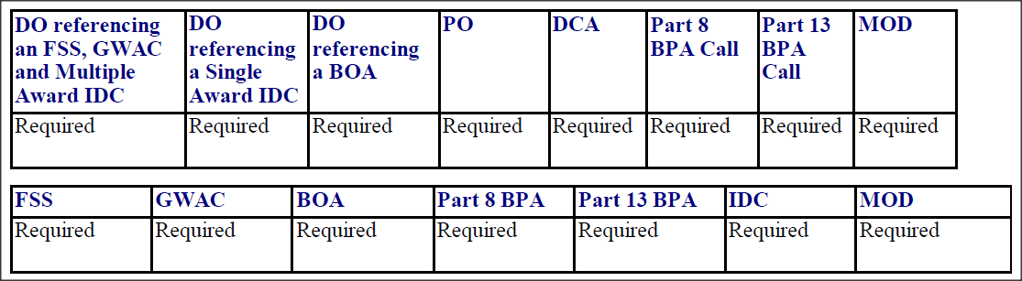

Individual Order/Call Limit:
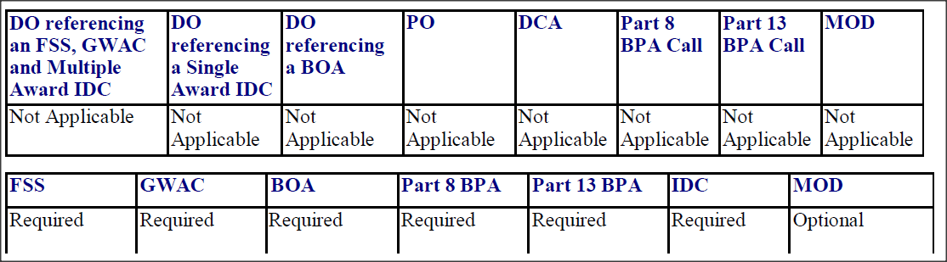

Total Estimated Order Value:
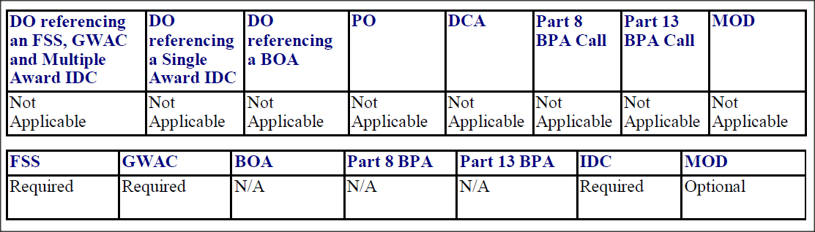

Updates to Part 13 BPA Call and Simplified Procedures for Certain Commercial Products and Commercial Services

The only change for this item was to make the use case for “Simplified Procedures for Certain Commercial Products and Commercial Services” Required on a Part 13 BPA Call. Prior to V1.5 the use case was Not Applicable.

Validation Rule Changes

All current valuation rules will now fire on a Part 13 BPA Call. No new validation rules were added for this data element.

V1.5 Use Cases:

The following use cases are outlined for this update based on the V1.5 data dictionary.

Simplified Procedures for Certain Commercial Products and Commercial Services:
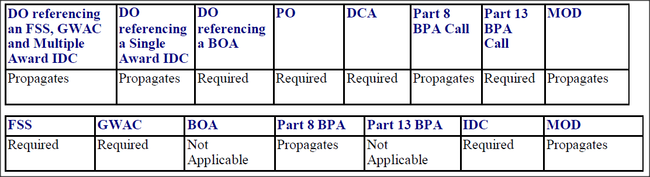

Updates for Consolidated Contract Data Element for FSS and GWAC

The only change for this item was to make the use case for “Consolidated Contract” Required on an FSS and GWAC. Prior to V1.5 the use case was Not Applicable.

Validation Rule Changes

The current valuation rules will now fire on an FSS and GWACs. No new validation rules were added for this data element.

V1.5 Use Cases

The following use cases are outlined for this update based on the V1.5 data dictionary.

Consolidated Contract:
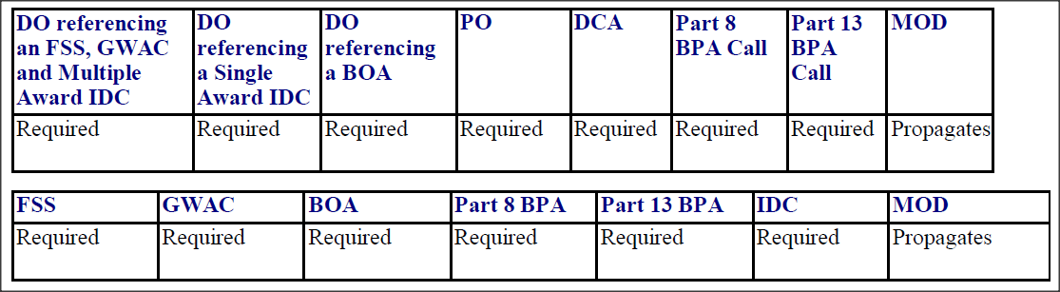

Contract Bundling:
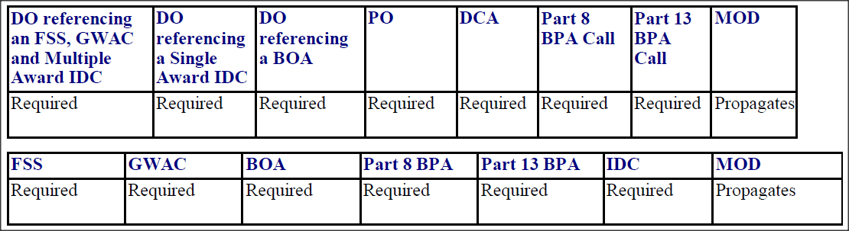

Displaying the CAGE Code Data Element to the Contract Action

The “CAGE Code” will be added as a data element on the contract action. This data is reference information from the SAM registration and cannot be edited by the user. This information is derived based on the Unique Entity ID that is provided on the contract action.

CAGE CODE as shown on the Contract Action:
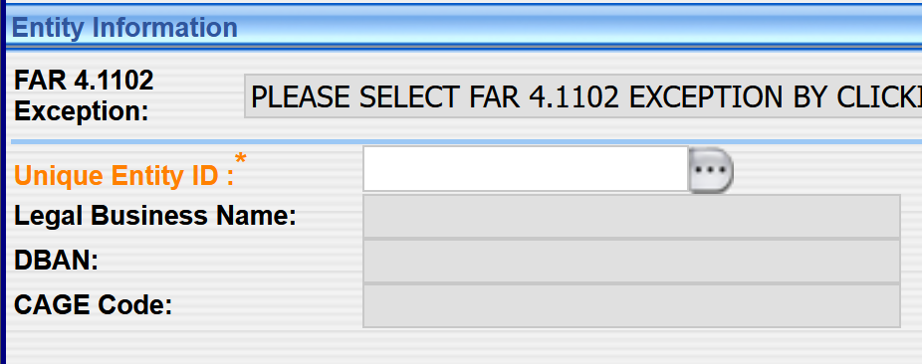

Validation Rule Changes

No validation rules were added for this data element. The information is sourced from the SAM data that is provided to FPDS.

V1.5 Use Cases:

The following use cases are outlined for this update based on the V1.5 data dictionary.

CAGE Code:
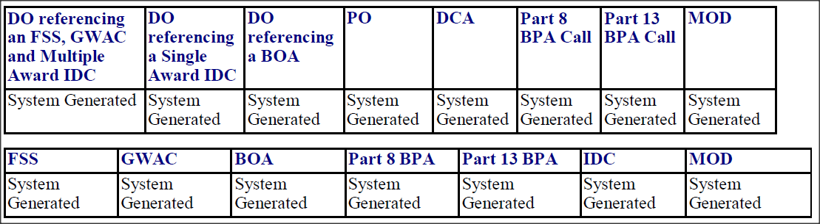

Displaying four “Women Owned” business types to the Contract Action

The following four women owned business types will be added to FPDS:

Women Owned Business Type:
Woman-Owned Small Business
Joint Venture Women-Owned Small Business
Economically Disadvantaged Women-Owned Small Business
Joint Venture Economically Disadvantaged Women-Owned Small Business

This data is reference information from the SAM registration and cannot be edited by the user. This information is derived based on the Unique Entity ID that is provided on the contract action.

Women-Owned Small Business as shown on the Contract Action:
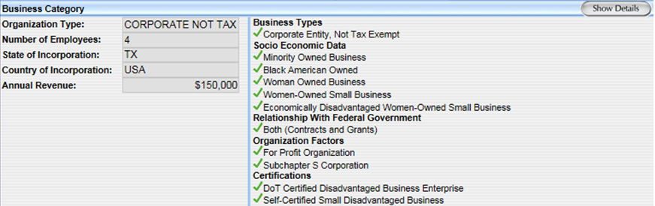

Validation Rule Changes

No validation rules were added for this data element. The information is sourced from the SAM data that is provided to FPDS.

V1.5 Use Cases

These data elements are derived from SAM reference data and will be present on all contract actions.

Add Close-Out Functionality to FPDS

The Close Out Function is a new functionality that allows Contracting Officers to Close Contracts. A new Close Out API will allow users to close out contracts through their interfacing contract writing systems. The functionality will also be available from the contract screen via the web portal and GUI services in V1.5. A “Close Out” button was added to the top of the contract action to be used similarly to the “Save Draft,” “Validate,” and “Approve” buttons.

A contract can only be closed if it is in final status. Once an action is closed, the entire contract family, including and previous modifications will also have their “close status” updated. Once an action is closed, the user cannot “unclose” a contract. If a contract was closed inadvertently or if a contract closed status needs to be changed back to “No,” please contact the FSD help desk and the change will be performed by FPDS Data Management updates.

As part of this update, three data elements were added in the “Transaction Information” section of the contract action:

Data Element Name:
Closed Status
Closed Status Date
Closed By

The new data elements will be shown on the screen as follows:

Closed Status, Closed Status Date, Closed By and the Close Out Button as shown on the Contract Action:
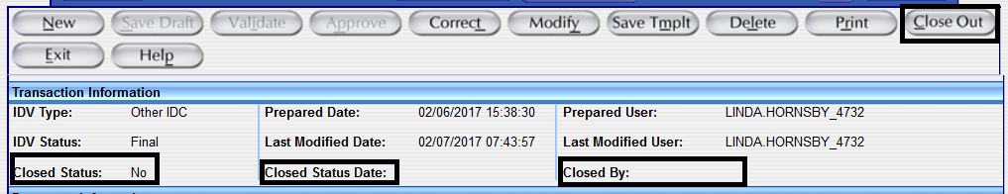

Validation Rule Changes

The following validation rules were added for the close out functionality:

Validation Rule:
User is not authorized to perform the Close action to this contract family as the contracting agency '<contractingOfficeAgencyID>' on the latest Modification belongs to a Department different than the Department of the Agency ID on the user profile.
If the Reason for Modification is 'Close Out' then the Contract Action cannot be corrected.
If the "Closed Status" for the CAR is 'Yes', then Reason for Modification cannot be 'Close Out'.
There exists a draft or an erred action against this contract. All the actions against this contract must be finalized before a Modification with Reason for Modification 'Close Out' can be finalized.
The Reason for Modification cannot be corrected to "Close Out".
A record that is in final status and has the "Reason for Modification" as "Close Out" cannot be deleted. Please contact your system administrator for further assistance.
Contract is already closed.
The Close Out Date must be equal to or later than the Date Signed of the Base Contract.
There exists a draft or an erred action against this contract. All the actions against this contract must be finalized before the contract can be closed.
The PIID is not unique, multiple records exist with PIID. To close out this record you may need to provide additional information such as the AgencyID, contractActionType, referenced IDVPIID or referencedIDVagencycode (if applicable)
The record does not exist.
The PIID must be provided.
The current user does not have the required 'CLOSE' privilege.

V1.5 Use Cases
The added data elements to the contract action screen contain transaction level information and is system generated. Because of this, the data elements will be present on any closed contract action.

Adding IDV Type of Set Aside, Type of Set Aside Source and Number of Offers Source Data Elements

The following new Data Elements were added to the CAR screen on orders under multiple award IDC’s, FSS, GWACS, Part 8 and Part 8 BPA calls, and ATOM feeds. These data elements will provide clarity as to which values are propagated from the Referenced IDV and which values are selected on the Award.

Data Element Name:
IDV Type of Set-Aside
Type of Set-Aside Source
IDV Number of Offers Received
Number of Offers Source

These data element are derived based on the selections made by the user and do not require the contracting office to provide answers in these specific fields.

IDV Type of Set-Aside and Type of Set-Aside Source as shown on the Contract Action:
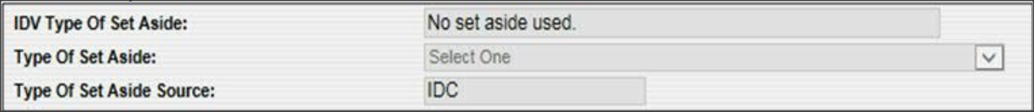

IDV Number of Offers and Number of Offers Source as shown on the Contract Action:

The “Number of Offers Source” represents the number of offers on either the IDV or the action that is being entered. In this example, the Number of Offers Source is referring to the current action. If it was referring to the number of Offers on the IDV the entry would say that the source was the either the FSS, GWAC or IDC (shown in the screenshot above as “IDC” since the type of set aside value reflects what was on the IDC contract action). This data element is system generated and is for display only. Adding these data elements will assist the users and the public, when running reports on https://www.sam.gov/, to determine the source of the data.

Validation Rule Changes

These new data elements are system generated and cannot be entered by the user. Because of this there are no validation rules associated with these new data elements.

V1.5 Use Cases

These new data elements are system generated and are based on information either entered by the user or from the referenced IDV.

Subcontracting Plan Phase 2

Phase 1 of the subcontracting plan changes were implemented as part of SP32. The details of what is included in that update can be found in the release notes for SP32 which can be found here:

  - https://www.fpds.gov/wiki/index.php/V1.4_SP_32.0

Phase 2 of the Subcontracting Plan updates will change the use case of the “Subcontracting Plan” data element. In V1.5 the use case for Subcontracting plan will now be required on DO under BOA and Part 13 BPA Calls; Propagate on DO referencing FSS, GWAC, and multiple award IDV and Propagate on DO referencing a Single Award IDV

In addition to this, the subcontracting plan will no longer be required on Part 13 BPAs and BOAs

Validation Rule Changes

The following validation rules were added as part of this change:

Validation Rule
If Award type is Part 8 BPA Call or Delivery Order referencing an FSS, GWAC, or IDC, then "Reason for Modification" cannot be 'Add Subcontracting Plan'.
If the IDV Type is BOA or BPA, then the "Reason for Modification" cannot be 'Add Subcontracting Plan'.

V1.5 Use Cases:

The following use cases are outlined for this update based on the V1.5 data dictionary.

Subcontracting Plan:
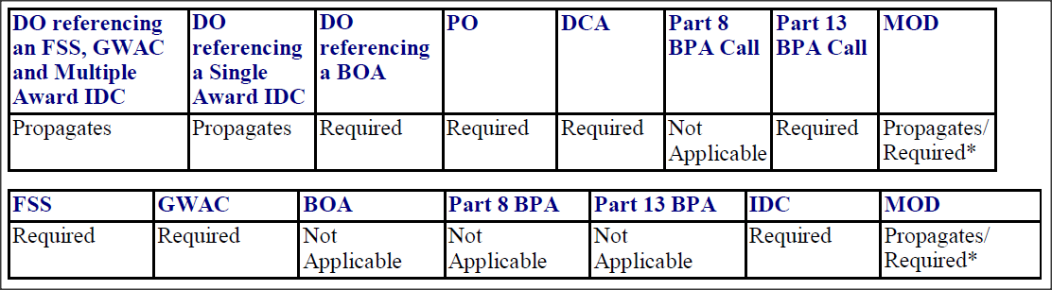

New Data Element “Additional Reporting”

A new data element “Additional Reporting” will be added to the legislative mandates section of the contract action. This data element allows the user to select the additional reporting requirements that apply to the contract action.

The user should select all the applicable reporting requirements for the contract action. If none of the reporting requirements in the list apply to the contract action, select "None of the Above.”

Currently there are three values that can be selected in “Additional Reporting,” as shown below. New values can be added to the list in future service pack releases of FPDS:

List Value:
Employment Eligibility Verification
Service Contract Inventory
None of the Above

Additional Reporting as shown on the Contract Action:
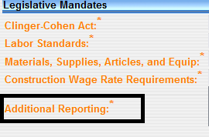

Validation Rule Changes

The following validation rules are being added for the “Additional Reporting” data element:

Validation Rule:
Multiple Values can be selected for "Additional Reporting" unless "None of the above" is selected.
Mandatory element: "Additional Reporting" is missing for <Contract_Type>

V1.5 Use Cases

The following use cases are outlined for this update based on the V1.5 data dictionary.

Additional Reporting:
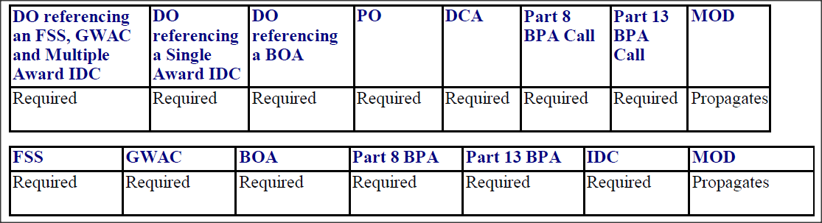

Generic/Blank XML Tags

As part of the V1.5 release FPDS will add several Generic/Blank XML tags to mitigate future version changes of FPDS. New data elements can be added to the contract action by utilizing these tags. These data elements will be added to all contract types. The generic data elements will be hidden on the screen until a new data element is added that will utilize the given Generic/Blank tag based on the tag type. Future use of the Generic/Blank tags is to be decided by the FPDS PCE following the implementation of V1.5.

As of right now, the Generic/Blank XML tags will only be shown in the XML schema’s, as shown below. If a new data element is determined to be added to use a Generic/Blank tag, then the data element will be added to the Contract Action screen, the data dictionary, users guide, and validation rules document as applicable.

Generic String data elements as shown on the XML Request:
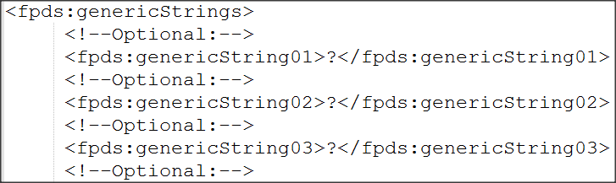

Generic Boolean as shown on the XML Request:
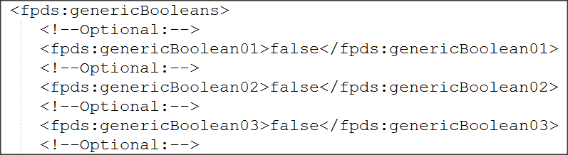

Generic Float and Generic Integer as shown on the XML Request:
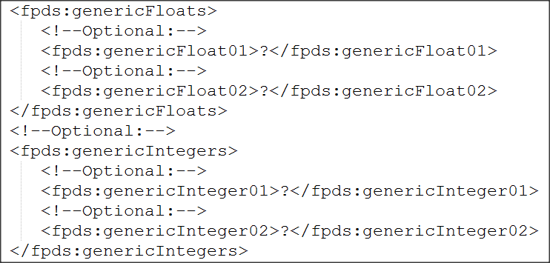

Validation Rule Changes

These tags are reserved for future use. Once a new data element is determined to be used for a generic tag, validation rules will be added as appropriate. Until that time, no new validation rules have been added to FPDS because of these changes.

V1.5 Use Cases

These tags are reserved for future use. Once a new data element is determined to be used for a generic tag, validation rules will be added as appropriate. Until that time, no new use cases are created for the Generic/Blank tags.

Displaying the Unique Entity ID (UEI) Data Element on Contract Actions

As part of V1.5 SP13 Phase 3 Unique Entity ID integration, the data element “Unique Entity ID,” located in the “Entity Information” section of Contract Action Records, has become the primary entity data element. The details of what is included in this update can be found in the release notes for V1.5 SP13, which can be found here:

- https://www.fpds.gov/wiki/index.php/V1.5_SP_13.0

This data element will contain a unique identifier, assigned to an entity after their registration with SAM.gov, and can be edited by the user.

Data element as shown on the Contract Action Record screen:

Validation Rule Changes

Multiple validation rules have been modified and added for the “Unique Entity ID” data element. These rules can be found in the FPDS V1.5 Validation Rules document.

V1.5 Use Cases

The following use cases are outlined for this update based on the V1.5 data dictionary.
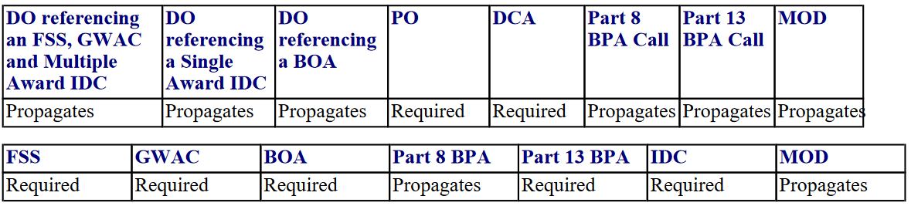

Add Approval Information to FPDS

The following two data elements were added to the “Transaction Information” section of Contract Action Records:

Data Element Name:
Approved Date
Approved By

Previously, these elements only appeared on data feeds, and were not visible for Contract Action Records. These data elements will provide clarity as to when and by who the record was approved. The new data elements will be shown on the screen as follows:

Approved Date, and Approved By as shown on the Contract Action Record:
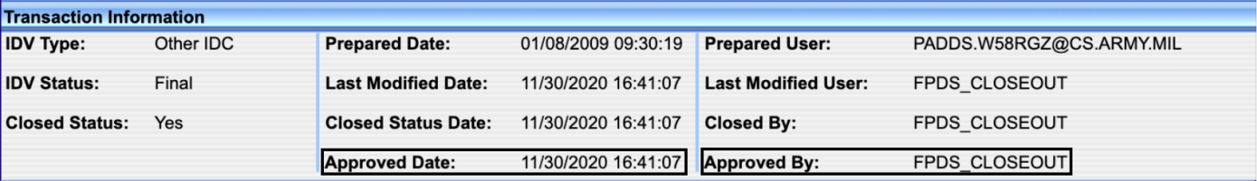

Validation Rule Changes

These data elements are system-generated after a user approves a record and cannot be entered by the user. Thus, there are no validation rules associated with these data elements.

V1.5 Use Cases
These data elements contain transaction level information and are system-generated. The data elements and any associated values will display on all Contract Action Record types.

