FPDS-NG

Specification Changes for Version 1.2

Draft

Prepared by



Global Computer Enterprises, Inc.
10780 Parkridge Blvd., Suite 300
Reston, VA 20191

July 28, 2026

Table of Contents
1 Business Services 3
1.1 Create From Template Functionality 3
1.1.1 Award.wsdl 3
1.1.2 IDV.wsdl 4
2 GUI Services 5
2.1 Get New URL from Template Functionality 5
2.1.1 Award.wsdl 5
2.1.2 IDV.wsdl 6
3 Changes for PIID uniqueness 7
4 Versions of XSDs Used 8
5 New Services Added 8
6 Schema Changes 9
6.1 Changes in new XSDs 9
6.2 New XSDs added 17
6.3 Summary of dependency changes 17
6.4 Changes that are carried forward from version 1.1 18
6.5 Newly Added XSD Changes (July-13-2004) 22
6.5.1 Changes to competitionType 22
6.5.2 Consolidated Contracts 24

Business Services

Create From Template Functionality

A new method is added to Award and IDV to create documents from a pre-defined template. This resulted in adding a new method in Award and IDV WSDLs

Award.wsdl

This new method allows creation of award from a template

<operation name="createFromTemplate">
<input message="FPDS:createFromTemplateInput"/>
<output message="FPDS:createFromTemplateOutput"/>
</operation>

message createFromTemplateInput
parts
  authenticationKey
  type | FPDS:userAuthenticationKeyType
  createFromTemplateAwardRequest
  type | FPDS:createFromTemplateAwardRequestType
used by
  PortType AwardPortType in Operation createFromTemplate
source | <message name="createFromTemplateInput">  <part name="authenticationKey" type="FPDS:userAuthenticationKeyType"/>  <part name="createFromTemplateAwardRequest" type="FPDS:createFromTemplateAwardRequestType"/>  </message>

Create from template output is defined as
message createFromTemplateOutput
parts
  createFromTemplateAwardResponse
  type | FPDS:createFromTemplateAwardResponseType
used by
  PortType AwardPortType in Operation createFromTemplate
source | <message name="createFromTemplateOutput">  <part name="createFromTemplateAwardResponse" type="FPDS:createFromTemplateAwardResponseType"/>  </message>

Following complex types are added in the Award.wsdl

<complexType name="createFromTemplateAwardRequestType">
<sequence>
<element name="templateName" type="FPDS: templateNameType"/>
<element name="award" type="FPDS:awardType"/>
</sequence>
</complexType>

<complexType name="createFromTemplateAwardResponseType">
<complexContent>
<extension base="FPDS:responseType">
<sequence>
<element minOccurs="0" name="award" nillable="true" type="FPDS:awardType"/>
</sequence>
</extension>
</complexContent>
</complexType>

IDV.wsdl

This method allows creation of an IDV from a pre-defined template

Following is the description for the operation createFromTemplate

<operation name="createFromTemplate">
<input message="FPDS:createFromTemplateInput"/>
<output message="FPDS:createFromTemplateOutput"/>
</operation>

message createFromTemplateOutput
parts
  createFromTemplateIDVResponse
  type | FPDS:createIDVFromTemplateResponseType
used by
  PortType IDVPortType in Operation createFromTemplate
source | <message name="createFromTemplateOutput">  <part name="createFromTemplateIDVResponse" type="FPDS:createIDVFromTemplateResponseType"/>  </message>

message createFromTemplateInput
parts
  authenticationKey
  type | FPDS:userAuthenticationKeyType
  createFromTemplateIDVRequest
  type | FPDS:createFromTemplateIDVRequestType
used by
  PortType IDVPortType in Operation createFromTemplate
source | <message name="createFromTemplateInput">  <part name="authenticationKey" type="FPDS:userAuthenticationKeyType"/>  <part name="createFromTemplateIDVRequest" type="FPDS:createFromTemplateIDVRequestType"/>  </message>

New complex types included in IDV.wsdl
<complexType name="createFromTemplateIDVRequestType">
<sequence>
<element name="templateName" type="FPDS: templateNameType"/>
<element name="IDV" type="FPDS:IDVType"/>
</sequence>
</complexType>
<complexType name="createIDVFromTemplateResponseType">
<complexContent>
<extension base="FPDS:responseType">
<sequence>
<element name="IDV" type="FPDS:IDVType" nillable="true" minOccurs="0"/>
</sequence>
</extension>
</complexContent>
</complexType>

GUI Services

Get New URL from Template Functionality

A new method is added to Award and IDV to get URL from a pre-defined template. This resulted in adding a new method in Award and IDV WSDLs

When accessed from a browser, the web page shows up pre-populated with the template data and Award data send in the request.

Award.wsdl

This method returns an URL to launch an award from a pre-defined template

Following is the description for the operation getNewAwardRLFromTemplate

<operation name="getNewAwardURLFromTemplate">
<input message="FPDS:getNewAwardURLFromTemplateInput"/>
<output message="FPDS:getNewAwardURLFromTemplateOutput"/>
</operation>

message getNewAwardURLFromTemplateInput
parts
  authenticationKey
  type | FPDS:userAuthenticationKeyType
  getNewAwardURLFromTemplateRequest
  type | FPDS:getNewAwardURLFromTemplateRequestType
used by
  PortType AwardPortType in Operation getNewAwardURLFromTemplate
source | <message name="getNewAwardURLFromTemplateInput">  <part name="authenticationKey" type="FPDS:userAuthenticationKeyType"/>  <part name="getNewAwardURLFromTemplateRequest" type="FPDS:getNewAwardURLFromTemplateRequestType"/>  </message>
message getNewAwardURLFromTemplateOutput
parts
  getNewAwardURLFromTemplateResponse
  type | FPDS:getNewAwardURLFromTemplateResponseType
used by
  PortType AwardPortType in Operation getNewAwardURLFromTemplate
source | <message name="getNewAwardURLFromTemplateOutput">  <part name="getNewAwardURLFromTemplateResponse" type="FPDS:getNewAwardURLFromTemplateResponseType"/>  </message>

New complex types were added in the Award WSDL file,

<complexType name="getNewAwardURLFromTemplateRequestType">
<sequence>
<element name="templateName" type="FPDS:templateNameType"/>
<element name="award" type="FPDS:awardType"/>
</sequence>
</complexType>

<complexType name="getNewAwardURLFromTemplateResponseType">
<complexContent>
<extension base="FPDS:responseType">
<sequence>
<element name="awardURL" type="FPDS:urlType" nillable="true" minOccurs="0"/>
</sequence>
</extension>
</complexContent>
</complexType>

IDV.wsdl

This method returns an URL to launch an IDV from a pre-defined template

Following is the description for the operation getNewIDVURLFromTemplate

<operation name="getNewIDVURLFromTemplate">
<input message="FPDS:getNewIDVURLFromTemplateInput"/>
<output message="FPDS:getNewIDVURLFromTemplateOutput"/>
</operation>

message getNewIDVURLFromTemplateInput
parts
  authenticationKey
  type | FPDS:userAuthenticationKeyType
  getNewIDVURLFromTemplateRequest
  type | FPDS:getNewIDVURLFromTemplateRequestType
used by
  PortType IDVPortType in Operation getNewIDVURLFromTemplate
source | <message name="getNewIDVURLFromTemplateInput">  <part name="authenticationKey" type="FPDS:userAuthenticationKeyType"/>  <part name="getNewIDVURLFromTemplateRequest" type="FPDS:getNewIDVURLFromTemplateRequestType"/>  </message>

message getNewIDVURLFromTemplateOutput
parts
  getNewIDVURLFromTemplateResponse
  type | FPDS:getNewIDVURLFromTemplateResponseType
used by
  PortType IDVPortType in Operation getNewIDVURLFromTemplate
source | <message name="getNewIDVURLFromTemplateOutput">  <part name="getNewIDVURLFromTemplateResponse" type="FPDS:getNewIDVURLFromTemplateResponseType"/>  </message>

New complex types were added in the IDV WSDL file,

<complexType name="getNewIDVURLFromTemplateRequestType">
<sequence>
<element name="templateName" type="FPDS:templateNameType"/>
<element name="IDV" type="FPDS:IDVType"/>
</sequence>
</complexType>

<complexType name="getNewIDVURLFromTemplateResponseType">
<complexContent>
<extension base="FPDS:responseType">
<sequence>
<element name="IDVURL" type="FPDS:urlType" nillable="true" minOccurs="0"/>
</sequence>
</extension>
</complexContent>
</complexType>

Changes for PIID uniqueness
Effective from version 1.2 of Award, award PIID is unique in combination with referenced IDV’s PIID. This functionality requires changes in input parameters of some methods in Award service (Award.wsdl)

For operations get, delete, exists, isExistingAwardCompelete and approve, following changes are made

- element type is changed from awardContractIDType to awardIDType

Following is an example of input change to approve method in Award.wsdl (approveInput)

<message name="approveInput">
<part name="authenticationKey" type="FPDS:userAuthenticationKeyType"/>
<part name=" awardID" type="FPDS:awardIDType"/>
</message>

Versions of XSDs Used
Following are the version of XSDs used in corresponding WSDLs

  - BusinessServices/contracts/Award.wsdl
    - 1.2 version of Award xsd is included in the wsdl.
    - 1.0 version of Template.xsd is included in the wsdl.
  - BusinessServices/ contracts/IDV.wsdl
    - 1.2 version of IDV xsd is included in the wsdl.
    - 1.0 version of Template.xsd is included in the wsdl
  - GUIServices/ contracts/Award.wsdl
    - 1.2 version of Award xsd is included in the wsdl.
  - GUIServices / contracts/IDV.wsdl
    - 1.2 version of IDV xsd is included in the wsdl.

New Services Added
Following are the new services added (version 1.0)
- FPDS\BusinessServices\DataCollection\locations\1.0\State
- FPDS\BusinessServices\DataCollection\locations\1.0\Zip

Schema Changes

Changes in new XSDs
- Added SDBParticipatingProgram in competetionType (contract.xsd)

- numberOfActions is added to awardContractDataType in Award.xsd

complexType awardContractDataType
diagram | 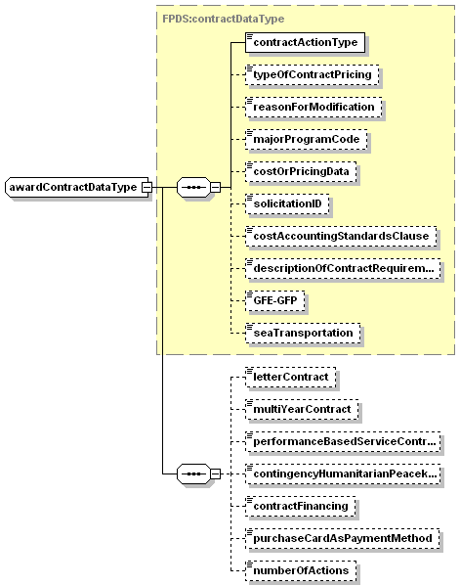
namespace | https://www.fpds.gov/FPDS
type | extension of FPDS:contractDataType
children | contractActionType typeOfContractPricing reasonForModification majorProgramCode costOrPricingData solicitationID costAccountingStandardsClause descriptionOfContractRequirement GFE-GFP seaTransportation letterContract multiYearContract performanceBasedServiceContract contingencyHumanitarianPeacekeepingOperation contractFinancing purchaseCardAsPaymentMethod numberOfActions
used by
  element | awardType/contractData
source | <complexType name="awardContractDataType">  <complexContent>  <extension base="FPDS:contractDataType">  <sequence>  <element name="letterContract" type="boolean" minOccurs="0"/>  <element name="multiYearContract" type="boolean" minOccurs="0"/>  <element name="performanceBasedServiceContract" type="FPDS:performanceBasedServiceContractFlagType" minOccurs="0"/>  <element name="contingencyHumanitarianPeacekeepingOperation" type="FPDS:contingencyHumanitarianPeacekeepingOperationType" nillable="true" minOccurs="0"/>  <element name="contractFinancing" type="FPDS:financingType" nillable="true" minOccurs="0"/>  <element name="purchaseCardAsPaymentMethod" type="boolean" minOccurs="0"/>  <element name="numberOfActions" type="nonNegativeInteger" nillable="true" minOccurs="0"/>  </sequence>  </extension>  </complexContent>  </complexType>

- Added new simp letypes vendorAlternateNameType and vendorLegalOrganizationNameType. These are referred in vendorHeaderType
element vendorHeaderType/vendorLegalOrganizationName
diagram
namespace | https://www.fpds.gov/FPDS
type | FPDS:vendorLegalOrganizationNameType
facets
  maxLength | 120
source | <element name="vendorLegalOrganizationName" type="FPDS:vendorLegalOrganizationNameType" nillable="true" minOccurs="0"/>
element vendorHeaderType/vendorDoingAsBusinessName
diagram
namespace | https://www.fpds.gov/FPDS
type | FPDS:vendorDoingAsBusinessNameType
facets
  maxLength | 80
source | <element name="vendorDoingAsBusinessName" type="FPDS:vendorDoingAsBusinessNameType" nillable="true" minOccurs="0"/>

complexType vendorHeaderType
diagram | 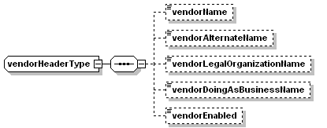
namespace | https://www.fpds.gov/FPDS
children | vendorName vendorAlternateName vendorLegalOrganizationName vendorDoingAsBusinessName vendorEnabled
used by
  elements | vendorType/vendorHeader vendorInstanceType/vendorHeader
source | <complexType name="vendorHeaderType">  <sequence>  <element name="vendorName" type="FPDS:vendorNameType" nillable="true" minOccurs="0"/>  <element name="vendorAlternateName" type="FPDS:vendorAlternateNameType" nillable="true" minOccurs="0"/>  <element name="vendorLegalOrganizationName" type="FPDS:vendorLegalOrganizationNameType" nillable="true" minOccurs="0"/>  <element name="vendorDoingAsBusinessName" type="FPDS:vendorDoingAsBusinessNameType" nillable="true" minOccurs="0"/>  <element name="vendorEnabled" type="boolean" default="false" minOccurs="0"/>  </sequence>  </complexType>

- Following are the changed related to Award ID.
  - awardID element is declared as awardIDType
element awardID
diagram | 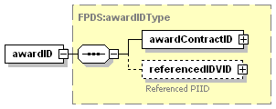
namespace | https://www.fpds.gov/FPDS
type | FPDS:awardIDType
children | awardContractID referencedIDVID
source | <element name="awardID" type="FPDS:awardIDType"/>

  - awardContractID element is defined as awardContractIDType

element awardContractID
diagram | 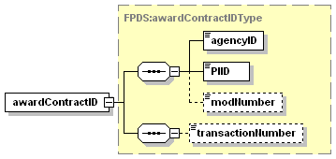
namespace | https://www.fpds.gov/FPDS
type | FPDS:awardContractIDType
children | agencyID PIID modNumber transactionNumber
source | <element name="awardContractID" type="FPDS:awardContractIDType"/>

  - awardType the ID defined as awardID instead of contracted

element award
diagram | 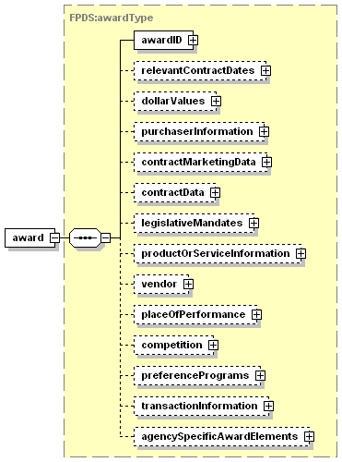
namespace | https://www.fpds.gov/FPDS
type | FPDS:awardType
children | awardID relevantContractDates dollarValues purchaserInformation contractMarketingData contractData legislativeMandates productOrServiceInformation vendor placeOfPerformance competition preferencePrograms transactionInformation agencySpecificAwardElements
source | <element name="award" type="FPDS:awardType"/>

  - Element name for awardContractIDType is changed to awardContractID from awardID

element awardID
diagram
namespace | https://www.fpds.gov/FPDS
type | FPDS:awardIDType
children | awardContractID referencedIDVID
source | <element name="awardID" type="FPDS:awardIDType"/>

- Changes to VendorSocioEconomic Inidicators:
  - hospitalFlag is added to Vendor Socio Economic Data
  - Correction in spell check for educationalInstitutionFlag

complexType vendorSocioEconomicIndicatorsType
diagram | 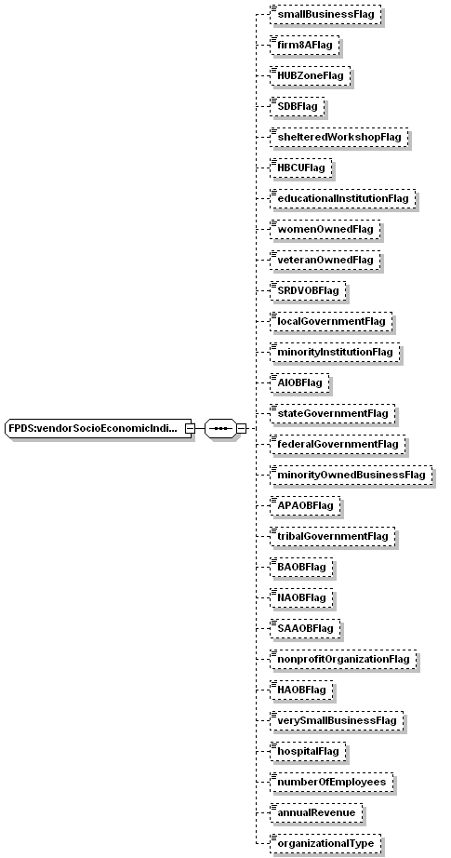
namespace | https://www.fpds.gov/FPDS
children | smallBusinessFlag firm8AFlag HUBZoneFlag SDBFlag shelteredWorkshopFlag HBCUFlag educationalInstitutionFlag womenOwnedFlag veteranOwnedFlag SRDVOBFlag localGovernmentFlag minorityInstitutionFlag AIOBFlag stateGovernmentFlag federalGovernmentFlag minorityOwnedBusinessFlag APAOBFlag tribalGovernmentFlag BAOBFlag NAOBFlag SAAOBFlag nonprofitOrganizationFlag HAOBFlag verySmallBusinessFlag hospitalFlag numberOfEmployees annualRevenue organizationalType
used by
  elements | FPDS:vendorType/vendorSocioEconomicIndicators FPDS:vendorInstanceType/vendorSocioEconomicIndicators FPDS:vendorSearchCriteriaType/vendorSocioEconomicIndicators
source | <complexType name="vendorSocioEconomicIndicatorsType">  <sequence>  <element name="smallBusinessFlag" type="boolean" default="false" minOccurs="0"/>  <element name="firm8AFlag" type="boolean" default="false" minOccurs="0"/>  <element name="HUBZoneFlag" type="boolean" default="false" minOccurs="0"/>  <element name="SDBFlag" type="boolean" default="false" minOccurs="0"/>  <element name="shelteredWorkshopFlag" type="boolean" default="false" minOccurs="0"/>  <element name="HBCUFlag" type="boolean" default="false" minOccurs="0"/>  <element name="educationalInstitutionFlag" type="boolean" default="false" minOccurs="0"/>  <element name="womenOwnedFlag" type="boolean" default="false" minOccurs="0"/>  <element name="veteranOwnedFlag" type="boolean" default="false" minOccurs="0"/>  <element name="SRDVOBFlag" type="boolean" default="false" minOccurs="0"/>  <element name="localGovernmentFlag" type="boolean" default="false" minOccurs="0"/>  <element name="minorityInstitutionFlag" type="boolean" default="false" minOccurs="0"/>  <element name="AIOBFlag" type="boolean" default="false" minOccurs="0"/>  <element name="stateGovernmentFlag" type="boolean" default="false" minOccurs="0"/>  <element name="federalGovernmentFlag" type="boolean" default="false" minOccurs="0"/>  <element name="minorityOwnedBusinessFlag" type="boolean" default="false" minOccurs="0"/>  <element name="APAOBFlag" type="boolean" default="false" minOccurs="0"/>  <element name="tribalGovernmentFlag" type="boolean" default="false" minOccurs="0"/>  <element name="BAOBFlag" type="boolean" default="false" minOccurs="0"/>  <element name="NAOBFlag" type="boolean" default="false" minOccurs="0"/>  <element name="SAAOBFlag" type="boolean" default="false" minOccurs="0"/>  <element name="nonprofitOrganizationFlag" type="boolean" default="false" minOccurs="0"/>  <element name="HAOBFlag" type="boolean" default="false" minOccurs="0"/>  <element name="verySmallBusinessFlag" type="boolean" default="false" minOccurs="0"/>  <element name="hospitalFlag" type="boolean" default="false" minOccurs="0"/>  <element name="numberOfEmployees" type="nonNegativeInteger" nillable="true" minOccurs="0"/>  <element name="annualRevenue" type="nonNegativeInteger" nillable="true" minOccurs="0"/>  <element name="organizationalType" type="FPDS:organizationalTypeType" nillable="true" minOccurs="0"/>  </sequence>  </complexType>

- Removed the mininclusive restriction on amountType in Common.xsd to allow negative amounts

simpleType amountType
namespace | https://www.fpds.gov/FPDS
type | restriction of decimal
facets
  totalDigits | 15
  fractionDigits | 4
source | <simpleType name="amountType">  <restriction base="decimal">  <fractionDigits value="4"/>  <totalDigits value="15"/>  </restriction>  </simpleType>

New XSDs added
- schema\DataCollection\vendors\1.1\Vendor.xsd
- schema\DataCollection\locations\1.0\State.xsd
- schema\DataCollection\locations\1.0\ZIP.xsd
- schema\DataCollection\locations\1.1\State.xsd
- schema\DataCollection\locations\1.1\ZIP.xsd
- schema\common\1.1\Common.xsd
- schema\SystemAdministration\users\1.1\User.xsd

Summary of dependency changes
- Award.xsd
Updated to refer 1.2 version of contract.xsd
- AwardTemplate.xsd
Updated to refer 1.2 version of Award.xsd
- Contract.xsd
Updated to refer 1.1 version of Vendor.xsd
- IDV.xsd
Updated to refer 1.2 version of Contract.xsd
- IDVTemplate.xsd
Updated to refer 1.2 version of IDV.xsd
- AwardExtension.xsd & IDVExtension.xsd
Updated to include NASA specific definitions

Changes that are carried forward from version 1.1
Following are some changes that are carried forward from version 1.1.
Note: These changes do not effect normal operation of data submission. These are added as optional elements only.
- Added Funding Agency/Office to Advanced Search Criteria for award
New elements fundingRequestingAgencyID and fundingRequestingOfficeID are added to awardSearchCriteriaType in award.xsd
complexType awardSearchCriteriaType

diagram | 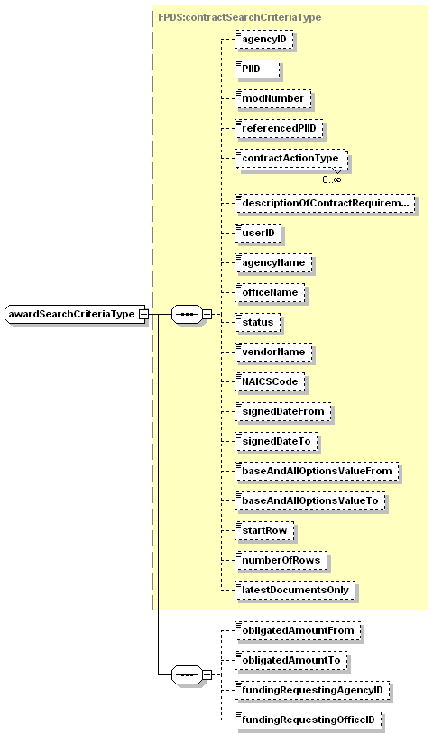
namespace | https://www.fpds.gov/FPDS
type | extension of FPDS:contractSearchCriteriaType
children | agencyID PIID modNumber referencedPIID contractActionType descriptionOfContractRequirement userID agencyName officeName status vendorName NAICSCode signedDateFrom signedDateTo baseAndAllOptionsValueFrom baseAndAllOptionsValueTo startRow numberOfRows latestDocumentsOnly obligatedAmountFrom obligatedAmountTo fundingRequestingAgencyID fundingRequestingOfficeID
used by
  element | awardSearchCriteria
source | <complexType name="awardSearchCriteriaType">  <complexContent>  <extension base="FPDS:contractSearchCriteriaType">  <sequence>  <element name="obligatedAmountFrom" type="FPDS:amountType" minOccurs="0"/>  <element name="obligatedAmountTo" type="FPDS:amountType" minOccurs="0"/>  <element name="fundingRequestingAgencyID" type="FPDS:agencyIDType" nillable="true" minOccurs="0"/>  <element name="fundingRequestingOfficeID" type="FPDS:officeIDType" nillable="true" minOccurs="0"/>  </sequence>  </extension>  </complexContent>  </complexType>

3. Added obligatedAmount in IDV getList response.
- Added new element obligatedAmount to the IDVSummaryType

IDV.xsd

complexType IDVSummaryType
diagram | 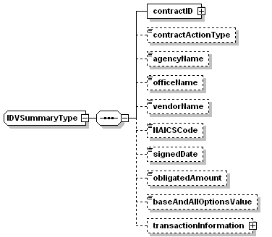
namespace | https://www.fpds.gov/FPDS
children | contractID contractActionType agencyName officeName vendorName NAICSCode signedDate obligatedAmount baseAndAllOptionsValue transactionInformation
used by
  element | listOfIDVSummariesType/IDVSummary
source | <complexType name="IDVSummaryType">  <sequence>  <element name="contractID" type="FPDS:IDVIDType"/>  <element name="contractActionType" type="FPDS:contractActionTypeType" nillable="true" minOccurs="0"/>  <element name="agencyName" type="FPDS:agencyNameType" minOccurs="0"/>  <element name="officeName" type="FPDS:unitNameType" nillable="true" minOccurs="0"/>  <element name="vendorName" type="FPDS:vendorNameType" minOccurs="0"/>  <element name="NAICSCode" type="FPDS:NAICSCodeType" nillable="true" minOccurs="0"/>  <element name="signedDate" type="FPDS:FPDSDateType" nillable="true" minOccurs="0"/>  <element name="obligatedAmount" type="FPDS:amountType" minOccurs="0"/>  <element name="baseAndAllOptionsValue" type="FPDS:amountType" minOccurs="0"/>  <element name="transactionInformation" type="FPDS:transactionInformationType" minOccurs="0"/>  </sequence>  </complexType>

- Vendor Doing As Business Name
Length of this field need to be increased from 60 to 80 in vendor.xsd

simpleType vendorDoingAsBusinessNameType
namespace | https://www.fpds.gov/FPDS
type | restriction of string
used by
  elements | vendorHeaderType/vendorDoingAsBusinessName listOfVendorDoingAsBusinessNamesType/vendorDoingAsBusinessName vendorSearchCriteriaType/vendorDoingAsBusinessName
facets
  maxLength | 80
source | <simpleType name="vendorDoingAsBusinessNameType">  <restriction base="string">  <maxLength value="80"/>  </restriction>  </simpleType>

- PSC search to include category of PSC
New element PSCCategoryType is created and added to PSCType and PSCSearchCriteriaType
<simpleType name="PSCCategoryType">
<restriction base="string">
<maxLength value="1"/>
<enumeration value="P"/>
<enumeration value="S"/>
</restriction>
</simpleType>

<complexType name="PSCType">
<sequence>
<element name="PSCCode" type="FPDS:PSCCodeType"/>
<element name="parentPSCCode" type="FPDS:PSCCodeType" nillable="true" minOccurs="0"/>
<element name="PSCName" type="FPDS:PSCNameType" nillable="true" minOccurs="0"/>
<element name="PSCCategory" type="FPDS:PSCCategoryType " nillable="true" minOccurs="0"/>
<element name="startDate" type="FPDS:FPDSDateType" nillable="true" minOccurs="0"/>
<element name="endDate" type="FPDS:FPDSDateType" nillable="true" minOccurs="0"/>
<element name="auditInformation" type="FPDS:auditInformationType" nillable="true" minOccurs="0"/>
</sequence>
</complexType>
<complexType name="PSCSearchCriteriaType">
<sequence>
<element name="PSCCode" type="FPDS:PSCCodeType" nillable="true" minOccurs="0"/>
<element name="parentPSCCode" type="FPDS:PSCCodeType" nillable="true" minOccurs="0"/>
<element name="PSCName" type="FPDS:PSCNameType" nillable="true" minOccurs="0"/>
<element name="canUseOnContract" type="boolean" nillable="true" minOccurs="0"/>
<element name="PSCCategory" type="FPDS:PSCCategoryType " nillable="true" minOccurs="0"/>
<element name="startDate" type="FPDS:FPDSDateType" nillable="true" minOccurs="0"/>
<element name="endDate" type="FPDS:FPDSDateType" nillable="true" minOccurs="0"/>
</sequence>
</complexType>

- Contract.xsd
  - Enumeration is removed from definition of contractActionType.

Changes in version 1.0

Note: These changes do not effect normal operation of data submission to FPDS-NG

- User.xsd
  - Added a new type fullNameType as a combination of firstName, middleName, lastName
  - Moved types objectNameType and functionNameType to Service.xsd
- Common.xsd
  - Updated date definition to make time as optional
  - Changed type of elements total and fetched to ‘nonNegativeInteger’
- Service.xsd
  - Moved in types objectNameType and functionNameType

Newly Added XSD Changes (July-13-2004)

Changes to competitionType
XSD representation of the elements competitiveProcedures is restructured. These two are restructured as following new elements under competitionType in contract.xsd
- solicitationProcedures
- typeOfSetAside
- evaluatedPreference
- research
- statutoryExceptionToFairOpportunity

complexType competitionType
diagram | 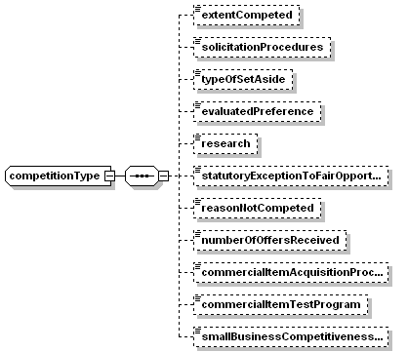
namespace | https://www.fpds.gov/FPDS
children | extentCompeted solicitationProcedures typeOfSetAside evaluatedPreference research statutoryExceptionToFairOpportunity reasonNotCompeted numberOfOffersReceived commercialItemAcquisitionProcedures commercialItemTestProgram smallBusinessCompetitivenessDemonstrationProgram
source | <complexType name="competitionType">  <sequence>  <element name="extentCompeted" type="FPDS:extentCompetedType" nillable="true" minOccurs="0"/>  <element name="solicitationProcedures" type="FPDS:solicitationProceduresType" nillable="true" minOccurs="0"/>  <element name="typeOfSetAside" type="FPDS:typeOfSetAsideType" nillable="true" minOccurs="0"/>  <element name="evaluatedPreference" type="FPDS:evaluatedPreferenceType" nillable="true" minOccurs="0"/>  <element name="research" type="FPDS:researchType" nillable="true" minOccurs="0"/>  <element name="statutoryExceptionToFairOpportunity" type="FPDS:statutoryExceptionToFairOpportunityType" nillable="true" minOccurs="0"/>  <element name="reasonNotCompeted" type="FPDS:reasonNotCompetedType" nillable="true" minOccurs="0"/>  <element name="numberOfOffersReceived" type="FPDS:numberOfOffersReceivedType" nillable="true" minOccurs="0"/>  <element name="commercialItemAcquisitionProcedures" type="boolean" minOccurs="0"/>  <element name="commercialItemTestProgram" type="boolean" minOccurs="0"/>  <element name="smallBusinessCompetitivenessDemonstrationProgram" type="boolean" minOccurs="0"/>  </sequence>  </complexType>

Consolidated Contracts
A new element consolidatedContract is added under contractDataType in Contract.xsd
complexType contractDataType
diagram | 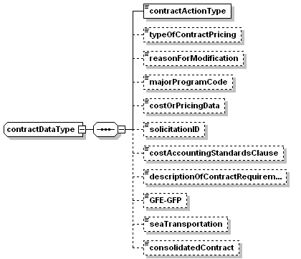
namespace | https://www.fpds.gov/FPDS
children | contractActionType typeOfContractPricing reasonForModification majorProgramCode costOrPricingData solicitationID costAccountingStandardsClause descriptionOfContractRequirement GFE-GFP seaTransportation consolidatedContract
source | <complexType name="contractDataType">  <sequence>  <element name="contractActionType" type="FPDS:contractActionTypeType"/>  <element name="typeOfContractPricing" type="FPDS:typeOfContractType" nillable="true" minOccurs="0"/>  <element name="reasonForModification" type="FPDS:reasonForModificationType" nillable="true" minOccurs="0"/>  <element name="majorProgramCode" type="FPDS:majorProgramCodeType" nillable="true" minOccurs="0"/>  <element name="costOrPricingData" type="FPDS:pricingDataType" nillable="true" minOccurs="0"/>  <element name="solicitationID" type="string" nillable="true" minOccurs="0"/>  <element name="costAccountingStandardsClause" type="boolean" minOccurs="0"/>  <element name="descriptionOfContractRequirement" type="FPDS:contractDescriptionType" nillable="true" minOccurs="0"/>  <element name="GFE-GFP" type="boolean" minOccurs="0"/>  <element name="seaTransportation" type="FPDS:seaTransportationType" nillable="true" minOccurs="0"/>  <element name="consolidatedContract" type="boolean" nillable="true" minOccurs="0"/>  </sequence>  </complexType>

